**Empowering Women, Protecting Wildlife: The Namo Drone Didi Initiative**

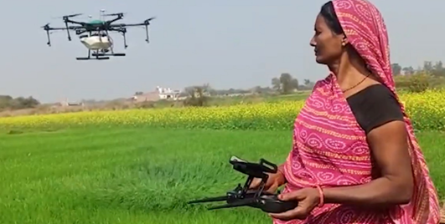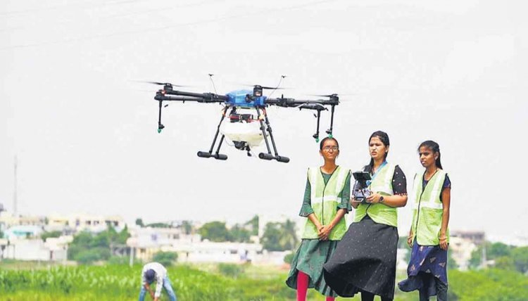

*Image 1 Credits*: <https://risingkashmir.com/drones-for-rural-womens-self-help-groups-scheme-e9711668-b8ef-4474-bea1-f6a77a3b8258>

*Image 2 credits:* [*https://eng.ruralvoice.in/latest-news/pm-launches-drone-didi-yojana-to-ensure-women-led-development.html*](https://eng.ruralvoice.in/latest-news/pm-launches-drone-didi-yojana-to-ensure-women-led-development.html)

In a landmark initiative aimed at empowering women and revolutionizing agriculture, Prime Minister Narendra Modi introduced the 'Namo Drone Didi' program. The announcement came during his interaction with beneficiaries of the [Viksit](https://www.indiatoday.in/india/story/namo-drone-didi-pm-narendra-modi-launches-scheme-to-provide-drones-to-women-self-help-groups-2469441-2023-11-30) Bharat Sankalp Yatra, underlining the government's commitment to ensuring the timely delivery of benefits from flagship schemes across the nation last November.

Originally known as the 'Drone Didi' program, PM Modi's decision to rename it as 'Namo Drone Didi' signifies a tribute to the women who are mastering drone technology for the betterment of society. This visionary program aims to distribute drones to 15,000 women Self Help Groups (SHGs) between 2024 and 2026, facilitating rental services to farmers for agricultural purposes.

The 'Namo Drone Didi' scheme represents a significant step towards empowering women SHGs and integrating cutting-edge technology into the agricultural sector. By providing access to drones, these women are not only becoming active participants in their local farming supply chains but are also driving innovation and efficiency in agriculture practices. These women, often from rural areas, are being trained to operate drones and provide valuable services to farmers, ranging from crop monitoring to pest control. The initiative aligns with PM Modi's vision of harnessing the potential of women, particularly in rural areas, to drive economic growth and transform livelihoods. By equipping women with the tools and knowledge to operate drones, the 'Namo Drone Didi' program is not only empowering individuals but also revitalizing rural economies and promoting sustainable agricultural practices.

As we celebrate the achievements of women participating in the 'Namo Drone Didi' initiative, it's essential to recognize the broader implications of their contributions. By bridging the gap between technology and agriculture, these women are not only enhancing productivity and efficiency but also promoting sustainability and resilience in the face of environmental challenges. Moreover, the 'Namo Drone Didi' program is fostering a culture of innovation and entrepreneurship among women, empowering them to become leaders and change-makers in their communities. As they acquire new skills and knowledge in drone technology, they are not just providing agricultural services but also exploring new opportunities for economic growth and social development.

The success stories emerging from the 'Namo Drone Didi' initiative serve as powerful examples of the transformative impact of empowering women in traditionally male-dominated fields. From remote villages to skyscrapers of cities, women are breaking barriers, defying expectations, and driving progress in agriculture and beyond.

PM Modi's vision of 'Namo Drone Didi' as a symbol of women's empowerment and technological advancement resonates deeply with the spirit of India's Nari Shakti. As the nation celebrates Women's Day next month and reflects on the contributions of women to its development journey, initiatives like 'Namo Drone Didi' serve as beacons of hope and inspiration for a more inclusive and equitable future.

In his recent [Mann](https://timesofindia.indiatimes.com/videos/toi-original/up-women-farmers-benefit-from-drone-didi-scheme-pm-interacts-with-sitapurs-drone-didi/videoshow/108005240.cms) Ki Baat broadcast, PM Modi underscored the government's commitment to leveraging technology for wildlife conservation. He emphasized the importance of World Wildlife Day as an opportunity to raise awareness about the need to protect and preserve our natural heritage. Through digital innovation and strategic partnerships, India is taking proactive steps to safeguard its rich biodiversity and promote sustainable environmental practices.

During a recent episode of 'Mann Ki Baat', Prime Minister Narendra Modi personally lauded Sunita Devi from Sitapur, Uttar Pradesh, for her exemplary contributions to agriculture. [Sunita's](https://economictimes.indiatimes.com/news/politics-and-nation/meet-sunita-a-drone-didi-who-was-lauded-by-pm-modi-in-mann-ki-baat/videoshow/107990443.cms?from=mdr) commendation resonates deeply with the essence of the 'Drone Didi' initiative, a pioneering effort aimed at empowering women in the agricultural sector. Under this visionary program, 15,000 drones are deployed, and women from Self Help Groups (SHGs) are trained to operate them efficiently. Sunita's tribute highlights the transformative impact of the initiative, debunking stereotypes and showcasing women's ability to excel beyond traditional household roles. She emphasized the practical benefits of using drones in agriculture, citing the significant time and resource savings achieved through efficient field spraying. Sunita's story serves as a compelling illustration of the potential of women in agriculture and the transformative power of innovative initiatives like '[Drone Didi,](https://www.ndtv.com/video/news/news/meet-sunita-drone-didi-praised-by-pm-modi-in-mann-ki-baat-764397)' which are reshaping rural communities and driving progress across India.

Another significant example PM Modi cited is the use of [AI-powered](https://news.abplive.com/elections/pm-modi-talks-nari-shakti-wildlife-drone-didi-110th-broadcast-mann-ki-baat-ls-polls-1667269) cameras to track tigers in protected areas. By deploying advanced surveillance technology, authorities can monitor tiger populations more effectively and gather valuable data on their behavior, habitat usage, and population dynamics. This data informs conservation strategies and helps ensure the long-term survival of these iconic species. Moreover, PM Modi highlighted initiatives to develop drones for wildlife monitoring, exemplifying India's commitment to embracing cutting-edge technology for conservation purposes. Drones offer a versatile and non-invasive approach to monitoring wildlife populations, allowing researchers to survey vast areas quickly and efficiently. Whether tracking the movements of endangered species or monitoring the health of ecosystems, drones play a crucial role in conservation efforts. Additionally, PM Modi's mention of collaboration between Roter Precision Groups and the Wildlife Institute of India to develop a drone for tracking alligators in the Ken River underscores the importance of public-private partnerships in advancing conservation technology. By combining expertise from various sectors, India can accelerate progress towards its conservation goals and protect vulnerable species and habitats. Furthermore, PM Modi's reference to [apps](https://news.abplive.com/elections/pm-modi-talks-nari-shakti-wildlife-drone-didi-110th-broadcast-mann-ki-baat-ls-polls-1667269) like 'Garuda' and 'Bagheera' developed by Bengaluru-based companies highlights the role of technology in enhancing wildlife tourism and management. These apps enable real-time monitoring of vehicles during jungle safaris, ensuring responsible tourism practices and minimizing disturbances to wildlife.

Overall, PM Modi's emphasis on digital innovation in wildlife conservation reflects India's proactive approach to addressing environmental challenges. By harnessing the power of technology, India is not only protecting its natural heritage but also fostering sustainable development and ensuring a harmonious coexistence between humans and wildlife. As the nation continues to prioritize conservation efforts, initiatives like these will play a pivotal role in safeguarding biodiversity for future generations.

As the 'Namo Drone Didi' scheme continues to unfold, it stands as a proof to the transformative power of technology and the resilience of women in shaping the future of agriculture in India. With each drone flight, these women are breaking barriers, challenging stereotypes, and paving the way for a more inclusive and prosperous agricultural sector.