Content Management System of MKCF web portal

(PIA-User Manual)

Submitted by:

Indev Consultancy Pvt. Ltd.

[A-61/1, 1st Floor, Okhla Phase II, Okhla Industrial Estate, New Delhi, Delhi 110020](https://www.google.com/maps?q=28.5397001,77.2697137&z=17&hl=en)

Contact: +91 11 4905 0111

Email: [Contact@indevconsultancy.com](mailto:Contact@indevconsultancy.com)

URL: <http://indevconsultancy.com/>

Date of Submission:

# Table of Contents

Table of Contents 2

Introduction 3

Abbreviations 3

Login of PIA Panel 7

Dashboard/ Home Screen 7

List 13

News 13

Impact Story 15

Report and Publication 17

Announcement 19

Multimedia 22

Project 24

# Introduction

The overall objective of the assignment is to develop and implement an interactive MKCF web-based platform to enable the visibility of MKCF and its projects and contributes proper branding of MKCF.

The Mekong Korea Corporation Fund (MKCF) was established in 2013 to support cooperation in seven priority areas outlined in the Han River Declaration of 2011, following the initiation of the Mekong-ROK partnership in 2011.

The MKCF provides grants for regional projects aligned with the priorities of the Mekong countries and the Republic of Korea. These projects address national issues and facilitate the regional integration process in seven key sectors: Culture & Tourism; Human Resources Development; Agriculture & Rural Development; Infrastructure; Information & Communication Technology (ICT); Environment; and Non-traditional Security Challenges.

The purpose of the CMS is to give an in-depth idea about the dynamic components of the portal and behaviour of the functionalities such as addition/updation of news/articles, creating new projects, changing their status etc.

The proposed CMS has two roles:

1. Admin
2. Project Implementation Agency (PIA)

PIAs will be registered by the admin from the CMS and separate log-in credentials will be created for every PIAs.

PIAs will have pre-defined functionality and features such as Add/Edit/Delete any information. Whereas the admin will have the rights to approve/reject any information before publishing it publicly.

# Abbreviations

These are commonly used acronyms and abbreviations in the web portal.

|  |  |
| --- | --- |
| ACIA | ASEAN Comprehensive Investment Agreement |
| ACMECS | Ayeyawady – Chao Phraya – Mekong Economic Cooperation Strategy |
| ADB | ASIAN Development Bank |
| ADC | Agricultural Development and Commercialization |
| AEC | ASEAN Economic Community |
| AFAS | ASEAN Framework Agreement on Services |
| AFTA | ASEAN Free Trade Area |
| AIC | ASEAN-India Centre |
| AIIB | Asian Infrastructure Investment Bank |
| APEC | Asia-Pacific Economic Cooperation |
| APTA | Asia-Pacific Trade Agreement |
| ASEAN | Association of Southeast Asian Nations |
| ATIGA | ASEAN Trade in Goods Agreement |
| BIMSTEC | Bay of Bengal Initiative for Multi-Sectoral Technical and Economic Cooperation |
| CAMT-CMU | College of Arts, Media and Technology of Chiang Mai University |
| CBEZ | Cross-Border Economic Zones |
| CBTA | Cross-Border Transport Agreement |
| CLM | Cambodia, Lao PDR and Myanmar |
| CLMV | Cambodia, Lao PDR, Myanmar and Vietnam |
| CLMVT | Cambodia, Lao PDR, Myanmar, Vietnam, and Thailand |
| CLV | Cambodia, Lao PDR and Vietnam |
| COMET | Connecting the Mekong through Education and Trade |
| CSG/YNPG | China Southern Power Grid Co.,Ltd/ Yunnan Power Grid Co.,Ltd |
| DFC | Dedicated Freight Corridor |
| DMIC | Delhi-Mumbai Industrial Corridor |
| DPR | Democratic People’s Republic |
| ECSAF | Export Capacity Support for Small Exporters from Asia-Pacific |
| EEC | Eastern Economic Corridor |
| EPPO | Energy Policy and Planning Office, Ministry of Energy, Thailand |
| ERIT | Economic Research Institute for Trade- Ministry of Industry and Commerce, Lao PDR |
| EWEC | East West Economic Corridor |
| EU | European Union |
| EZ | Economic Zone |
| FAO | Food and Agriculture Organization of the United Nations |
| FAO RAP | FAO Regional Office for Asia and the Pacific |
| FDI | Foreign Direct Investment |
| FTA | Free Trade Agreement |
| GAP | Good Agricultural Practices |
| GDP | Gross Domestic Product |
| GIZ | Deutsche Gesellschaft für Internationale Zusammenarbeit GmbH  (German Corporation for International Cooperation GmbH) |
| GMS | Greater Mekong Subregion |
| HRD | Human Resource Development |
| ICO NIDA | The International College of National Institute of Development  Administration |
| IDRC | International Development Research Centre of Canada |
| IIFT | Indian Institute of Foreign Trade |
| ITD | International Institute for Trade and Development |
| Lao PDR | Lao People’s Democratic Republic |
| LMCSF | Lancang-Mekong Cooperation Special Fund |
| LMI | Lower Mekong Initiative |
| MASHAV | Israel’s Agency for International Development Cooperation |
| MI | Mekong Institute |
| MICE | Meetings, Incentives, Conferences and Exhibitions |
| MIEC | Mekong India Economic Corridor Development |
| MIYSP | Mekong Institute Young Scholars Program |
| MKCF | Mekong-Republic of Korea Cooperation Fund |
| NEDA | Neighbouring Countries Economic Development Cooperation Agency |
| NTFC | National Transport Facilitation Committees |
| NZAP | New Zealand Aid Programme |
| OBOR | One Belt One Road |
| ODA | Official Development Assistance |
| OECD | The Organization for Economic Co-operation and Development |
| OTOP | One Tambon One Product |
| P.R. China | People’s Republic of China |
| PARI | Policy Alternatives Research Institute |
| PDR | People’s Democratic Republic |
| PPCP | Public-Private and Community Partnership |
| PRC | People’s Republic of China |
| PROSAFE | Project Promoting Safe Food for Everyone Project |
| R-GVC | Regional and Global Value Chain |
| RCEP | Regional Comprehensive Economic Partnership |
| ROK | Republic of Korea |
| SAARC | South Asian Association for Regional Cooperation |
| SDC | Swiss Agency for Development and Cooperation |
| SDGs | Sustainable Development Goals |
| SEE | Sustainable Energy and Environment |
| SEZ | Special Economic Zone |
| SIP | Sustainable Infrastructure Partnership |
| SME | Small- and Medium-Sized Enterprise |
| SPU | Sripatum University |
| SU | Souphanouvong University |
| TCEB | Thailand Convention and Exhibition Bureau |
| TICA | Thailand International Cooperation Agency |
| TIF | Trade and Investment Facilitation |
| TLH | India–Myanmar–Thailand Trilateral Highway |
| TPP | Trans-Pacific Partnership |
| TPSO | Trade Policy and Strategy Office, Thailand Ministry of Commerce |
| UK | United Kingdom |
| UN | United Nations |
| UNCTAD | United Nations Conference on Trade and Development |
| UNESCAP | United Nations Economic and Social Commission for Asia and the Pacific |
| US | United States |
| USAID | United States Agency for International Development |
| WTO | World Trade Organization |

# PIA Panel

## Login of PIA Panel

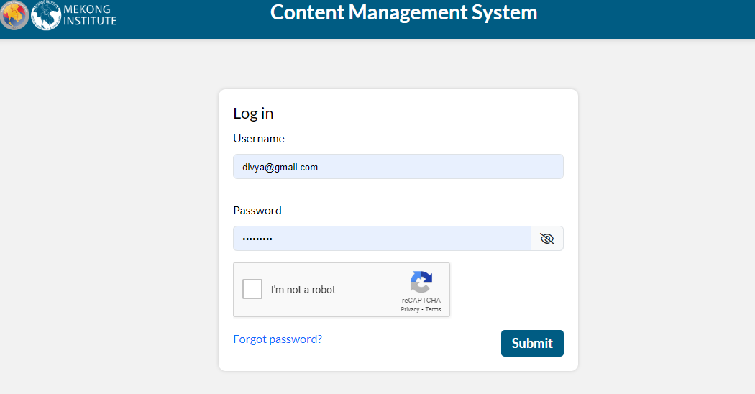

This is the view of the login panel of the PIA. PIA can login by using the following credentials:

URL: <https://mekongrok.org/admin/>

Username: xxxxx@gmail.com

Password: xxxxxxxx

If you forget your password then click on the Forgot password.

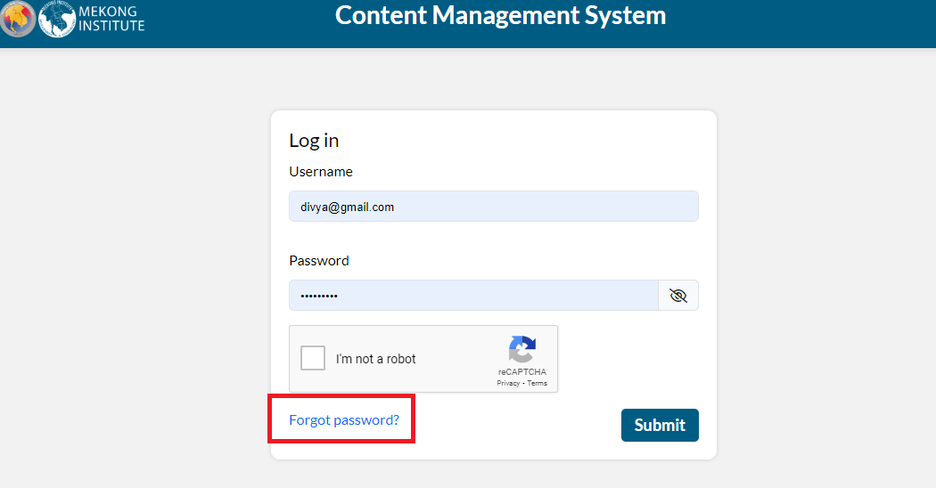

Here enter your Email-ID and click on the submit cms send a link…

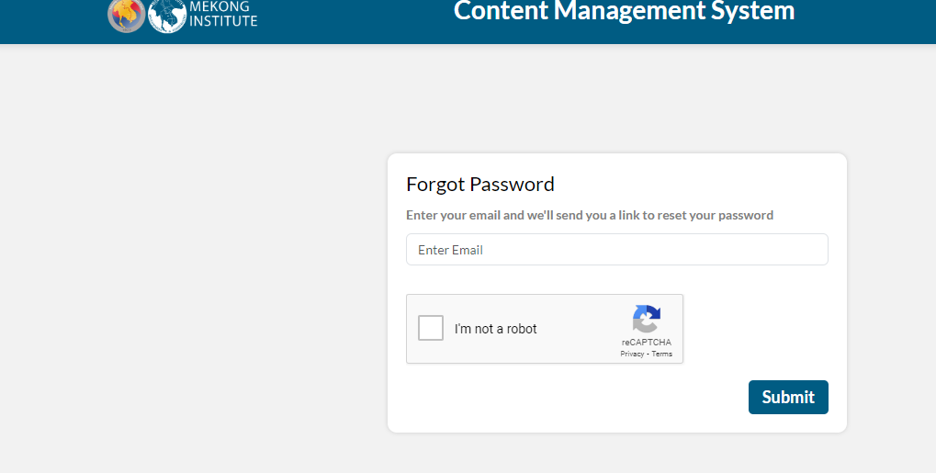click on the PIA, you can see the option see your profile and change password.

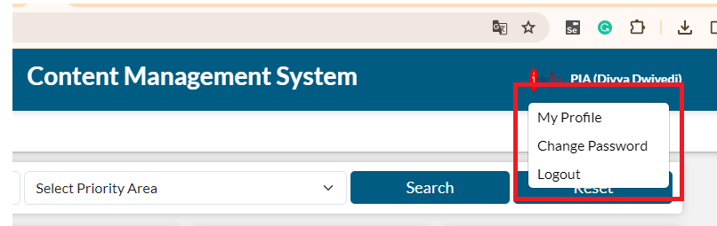

## My Profile

Here is showing PIA profile details and PIA can change their profile by click on edit button.

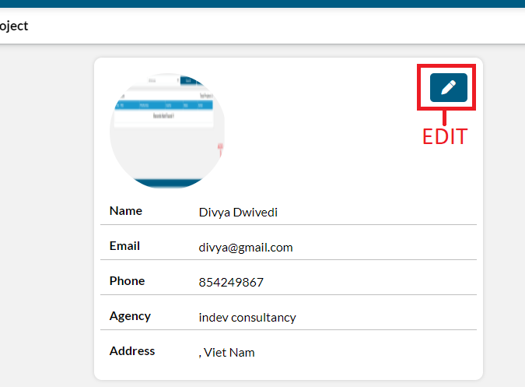

When you click on edit button, you can edit your profile but you cannot edit your Email ID then after editing you have to click on the update button your profile goanna to change.

And you can change your profile image by click on edit button.

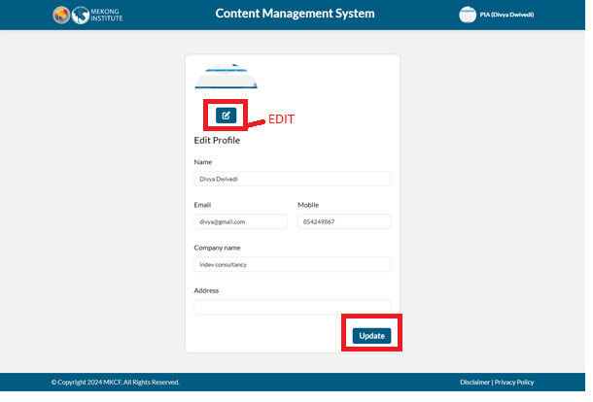

When you click on the edit button popup is open, you have to enter your image and click on the update and your profile goanna to change.

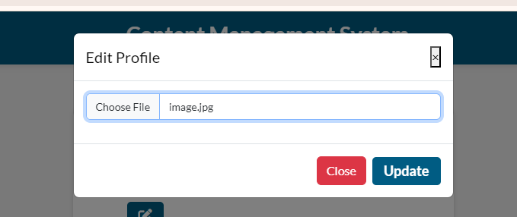

## Change Password

If you want to change your password click on the change password from the profile and the page opens for changing the password, you have to enter your old password and create a new password and your new password and confirm password should be the same then click on the submit, you password goanna change.

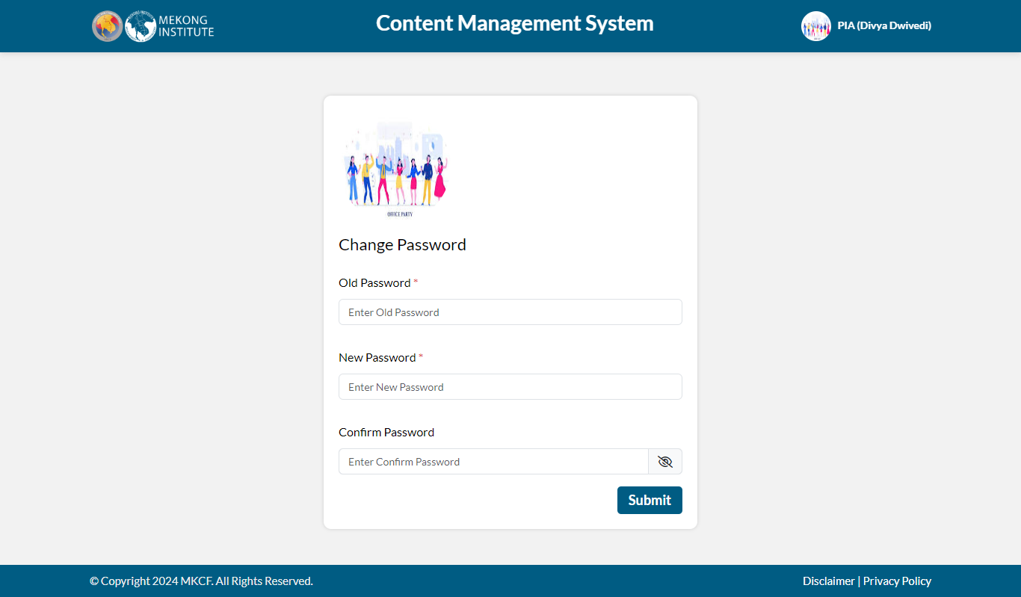

## Dashboard/ Home Screen

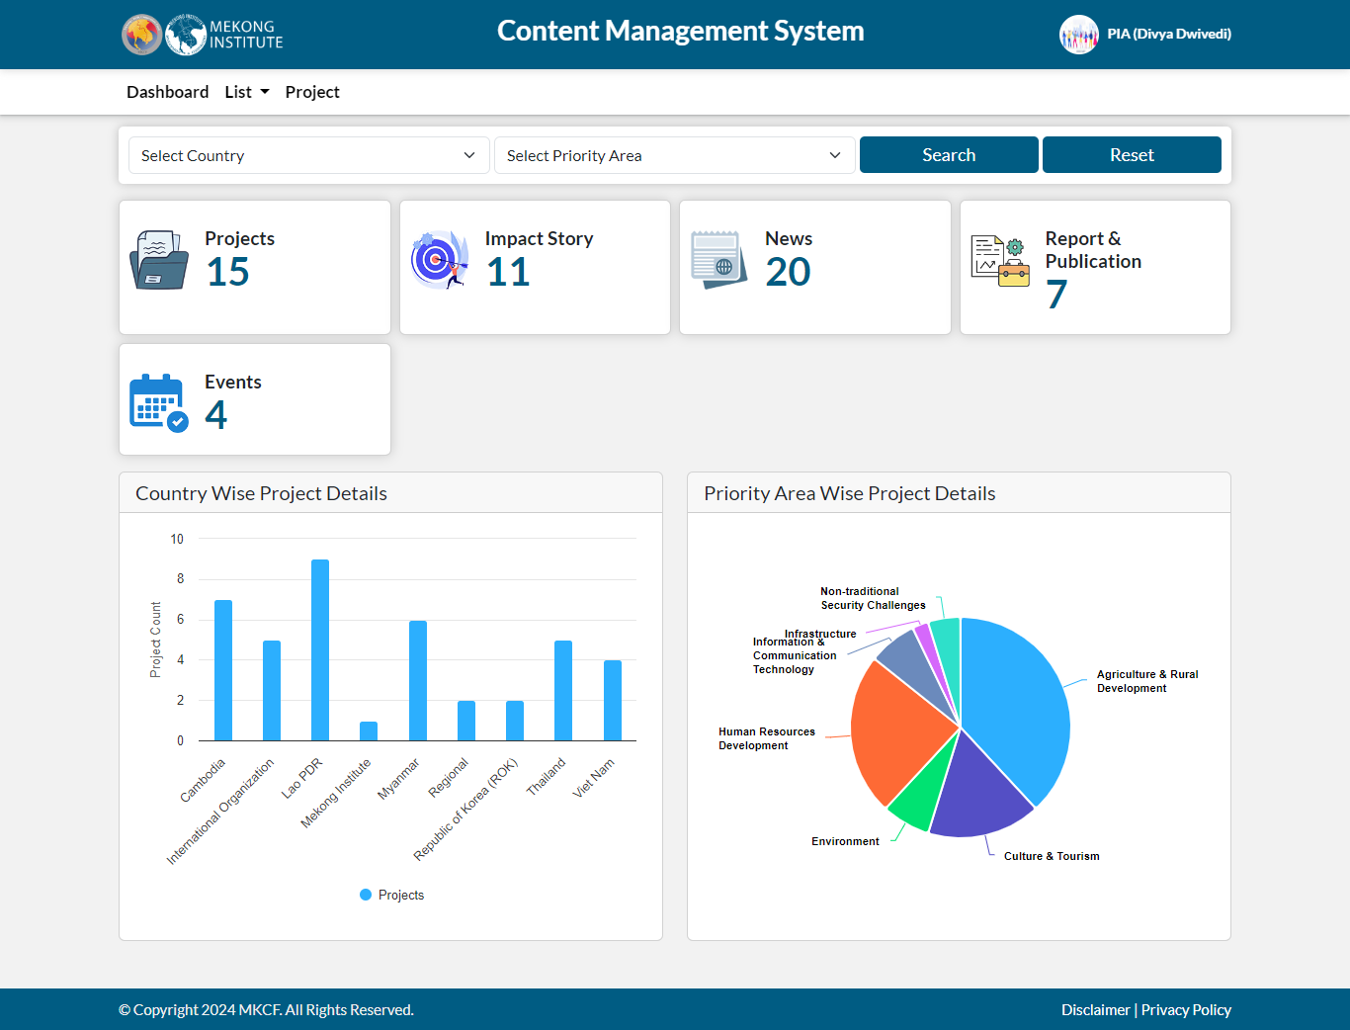

The PIA can see a dashboard comprising of following:

**Project**

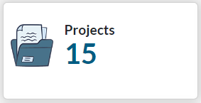The card represents the number of projects, both ongoing and completed covering all the seven priority areas.

Clicking on the card displays a list of projects with details like project title, its priority area, country in which its being implemented, working status, and actions of edit, add and delete that PIA can take.

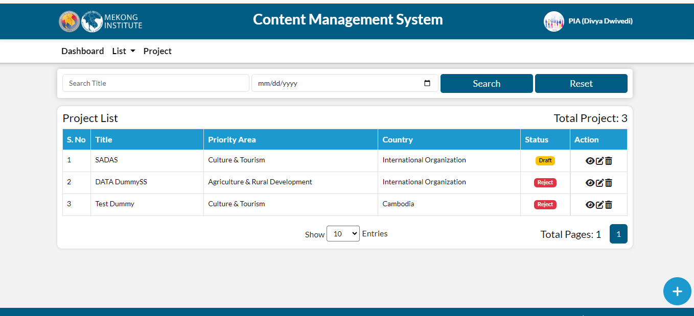

**Impact Story**

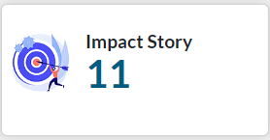The card represents the total number of impact stories created on the intended beneficiaries after the completion of various projects, initiatives, and campaigns.

Clicking on the card displays the list of impact stories, along with their associated priority areas.

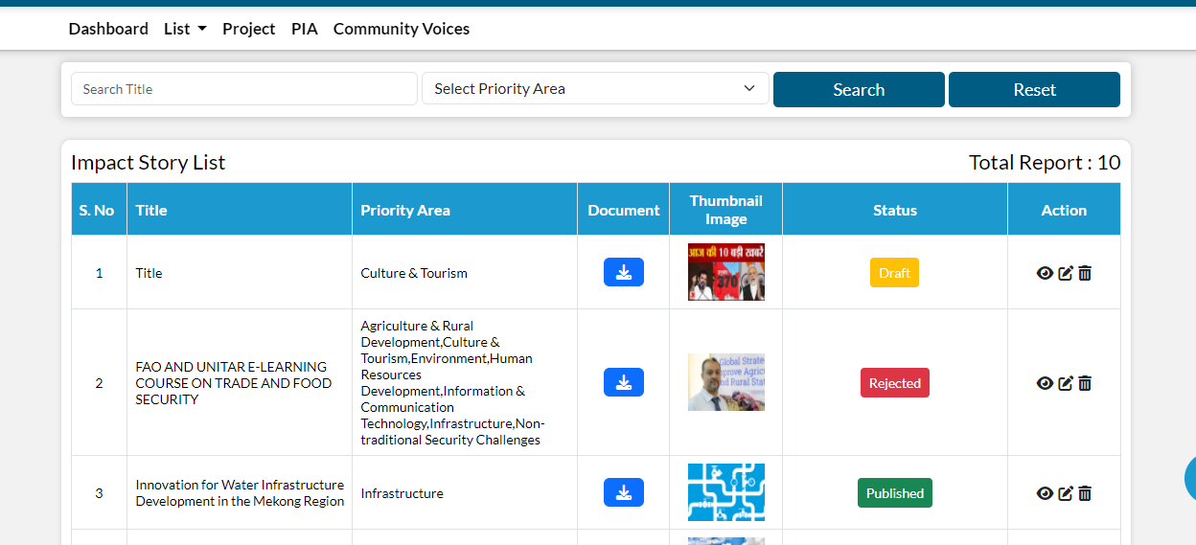

**News**

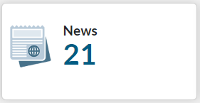The card represents the total number of news items added to the various elements of the Mekong Republic Cooperation Fund to date.

Clicking on the card displays the list of news added, along with their associated priority areas.

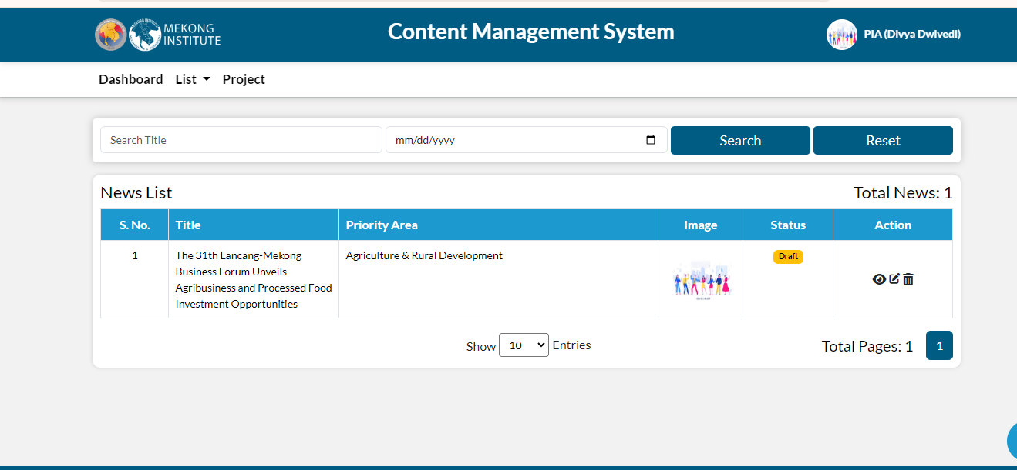

**Report & Publication**

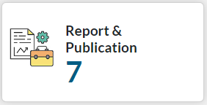The card represents the total number of reports and publications released on the relevant focus areas, initiatives, and projects.

Clicking on the card displays the list of reports and publications.

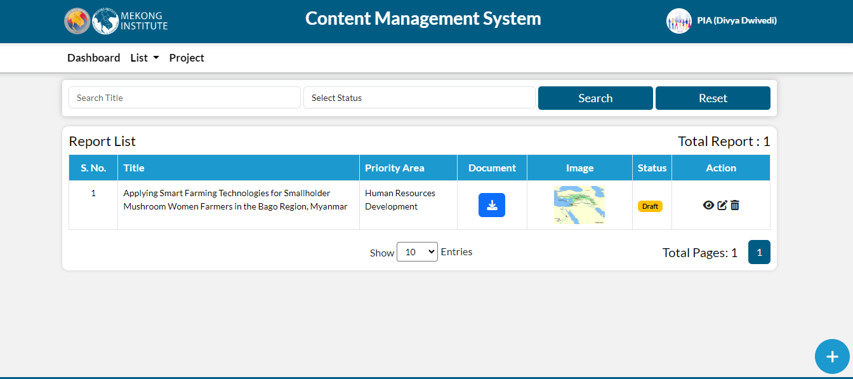

Event

The card represents the total number of forthcoming and past activities related to the formation of the Mekong Korea Cooperation Fund.

Clicking on the card displays the list of events including their participants and implementing partners.

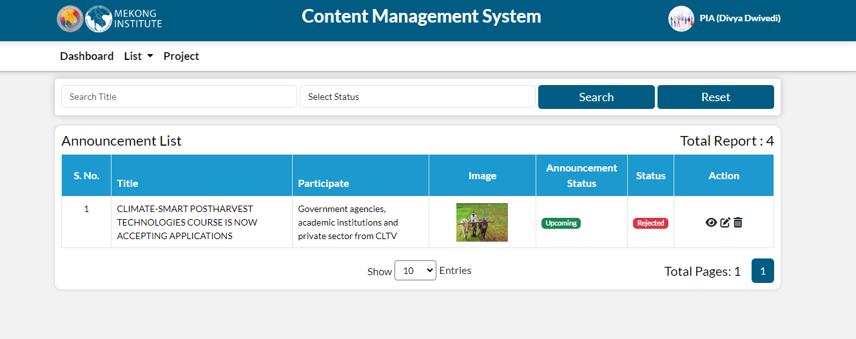

**Country Wise Project Details**

The project indicator below displays overall count of ongoing and completed projects by country.

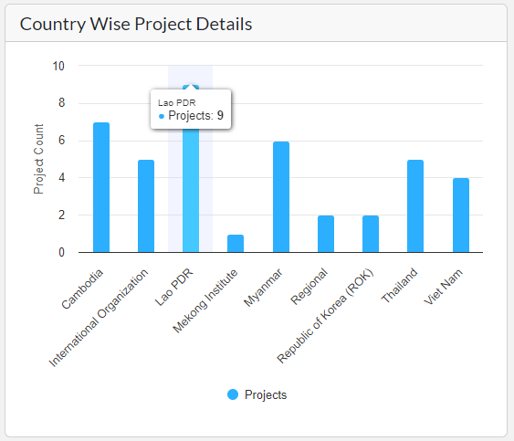

**Priority Area Wise Project Details**

This pie chart indication follows, displaying the percentage of overall projects by priority areas.

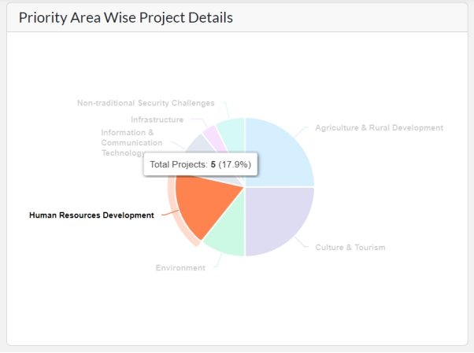

Here PIA can filter the data by country and priority area to get more specific information.

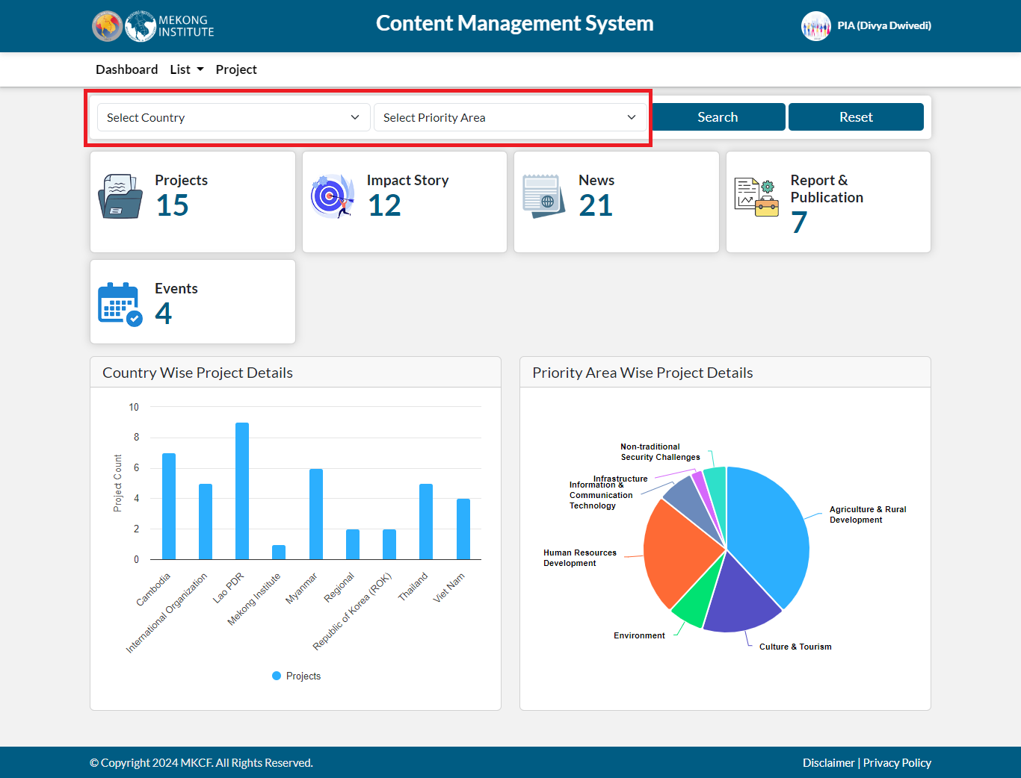

## List

The List on the header includes news, impact stories, reports and publications, announcements, priority areas, and multimedia. PIA can view all the list of total News, Impact Story, Report and publication, announcement, priority area, and multimedia added, by clicking on the following options.

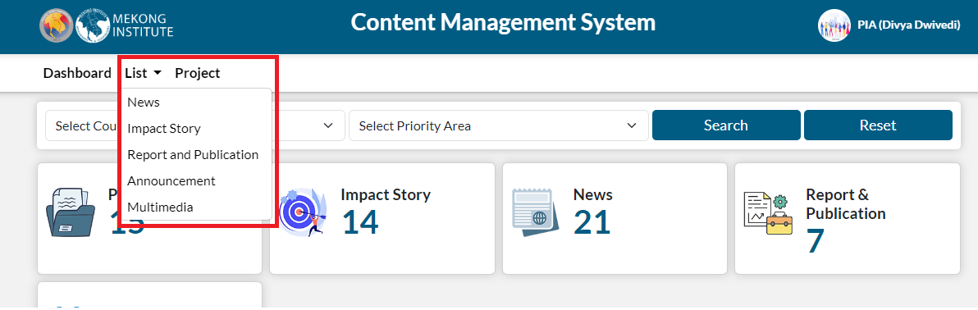

News

The News section provides updates on recent developments and events related to MKCF projects and initiatives. It offers concise summaries of articles, highlighting key information such as project relevance and purpose. PIA can access news articles for insights into ongoing activities, achievements, and challenges. With featured images and clear categorization by priority area, the News section serves as a dynamic resource for staying informed about MKCF's impact and contributions in the Mekong region.

PIA can see the list of news submitted and can filter the data by title and date. For adding a news, click on add button present on the right corner.

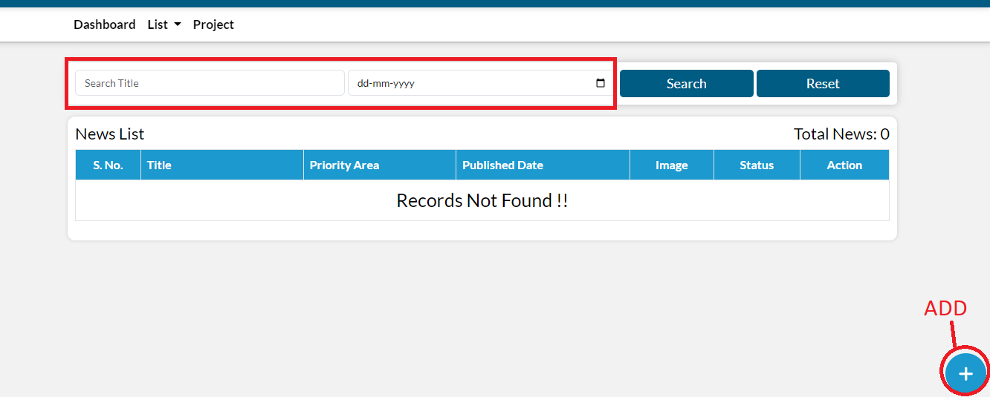

After clicking on add icon, fill the following details and then click on submit button.

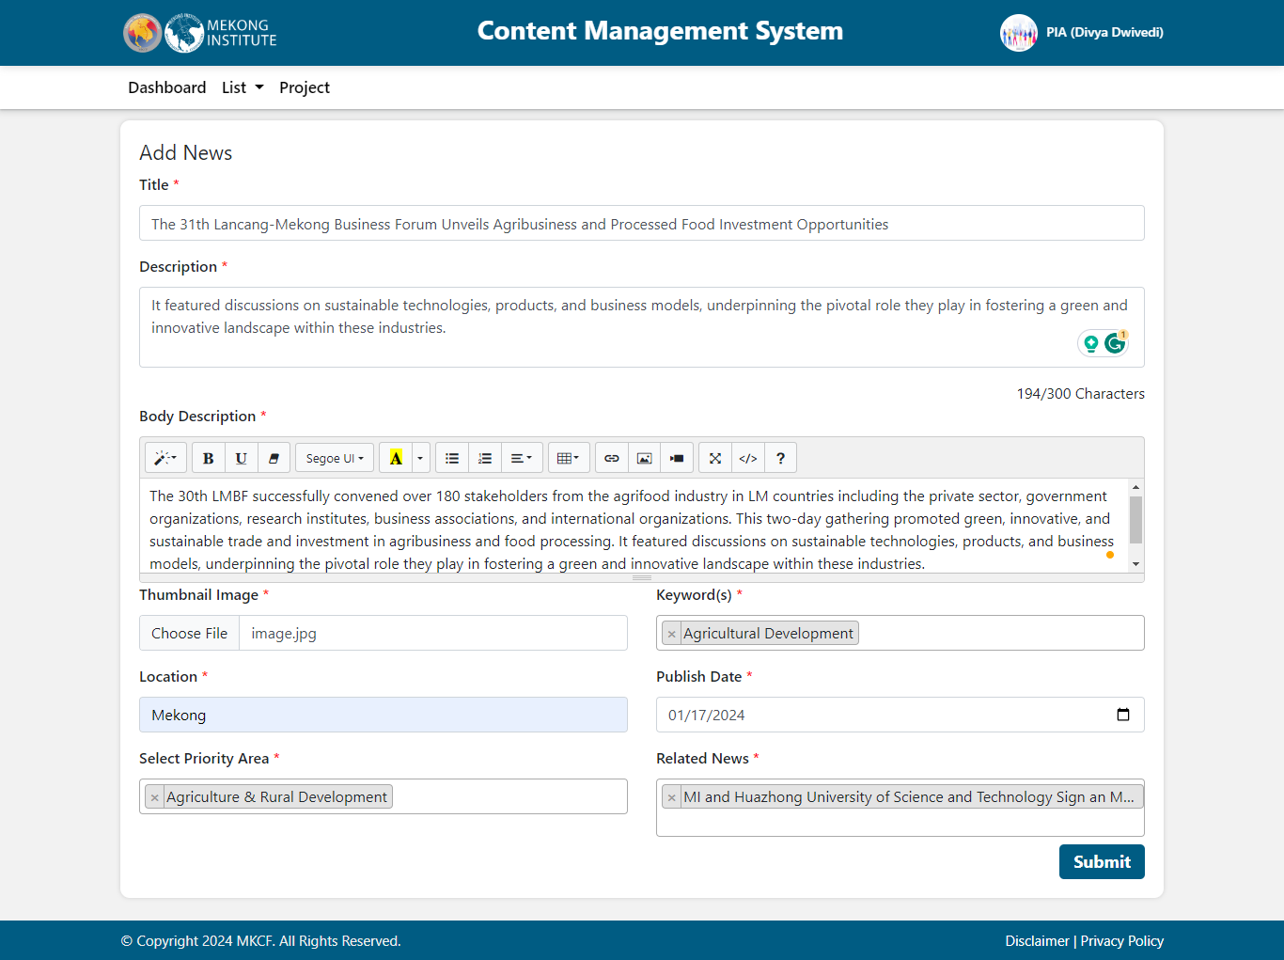

When PIA submit a news, a draft will be created. If Admin want to publish or unpublish this news, click on the draft icon then select publish or reject.

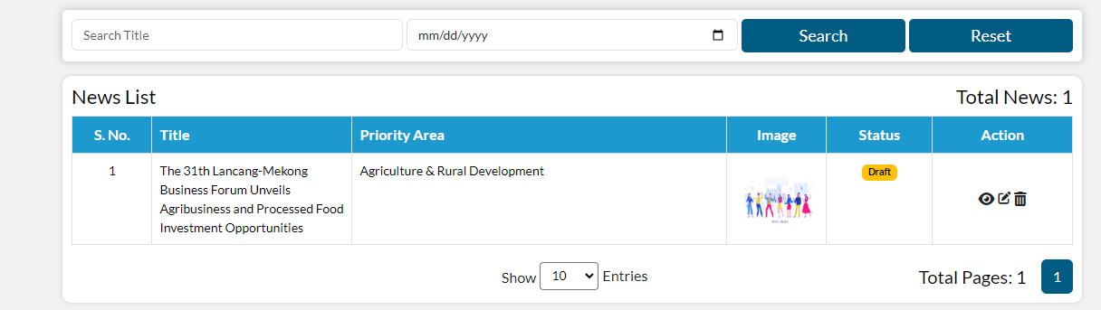

Using the options shown under action section, PIA can take any action of viewing, editing and deleting.

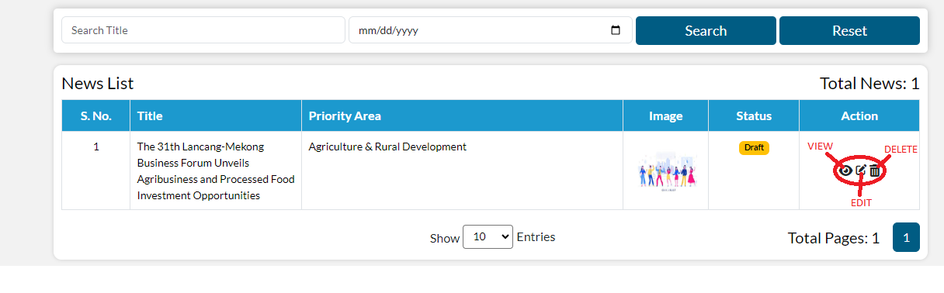

 When PIA clicks on the view button, the news details page opens, displaying how news will appear on the webpage once published. PIA can also view the news in further detail, as well as related news.

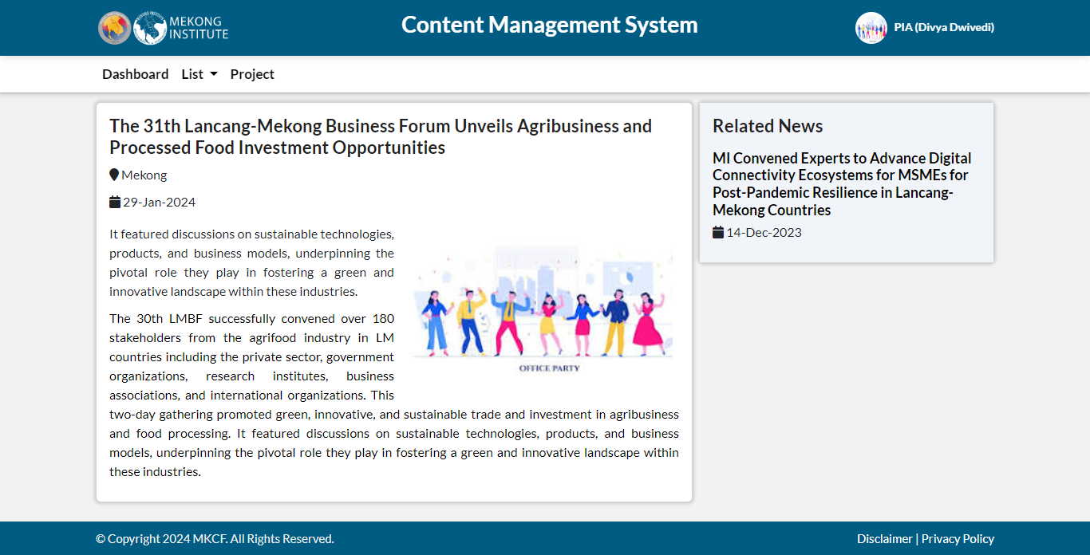

When you click on edit, edit form is open and you can edit all the fields and update the news.

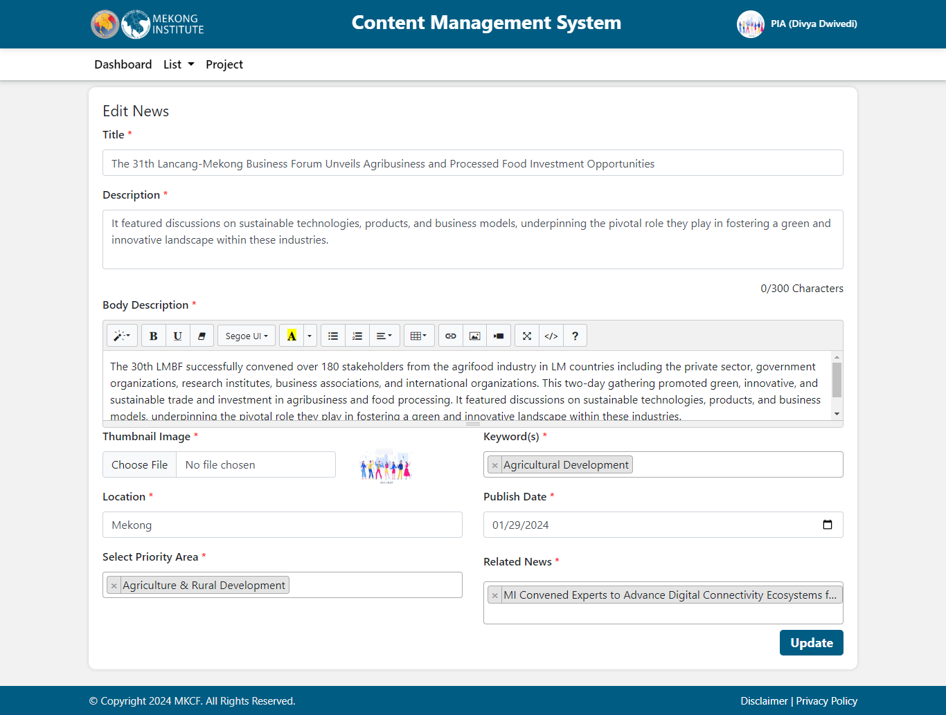

When PIA clicks on the delete button, a popup message appears allowing PIA to delete the news and it is removed from the list.

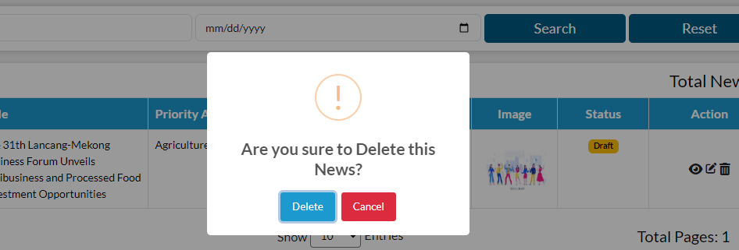

### Impact Story

The Impact Story section features remarkable narratives of MKCF's influence and outcomes. Every story depicts the practical results of efforts in various priority areas. It gives thorough accounts of good developments, accompanied by documents and thumbnail photos for visual context. These tales provide insights into MKCF's transformative contributions throughout the Mekong region, including project impact, priority area alignment, and status. The Impact Story section demonstrates MKCF's dedication to promoting sustainable development and regional integration.

PIA can see the list of impact stories already submitted. For adding an Impact Story, click on add button present on the right corner.

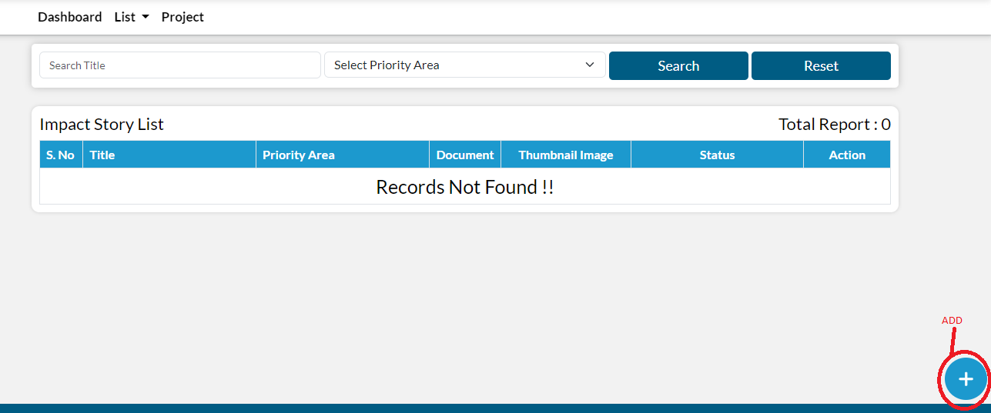

After clicking on add icon, fill the following details and then click on submit button.

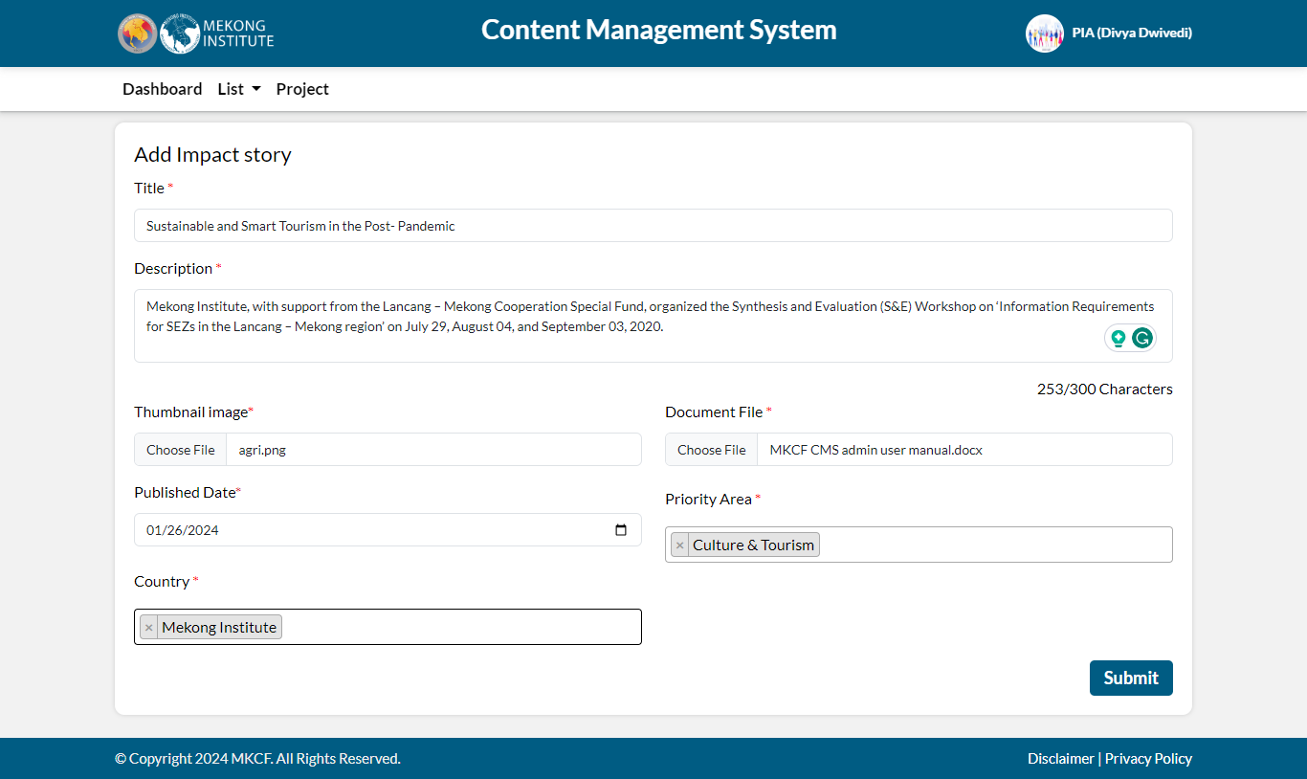

When PIA submits an impact story a draft will be created. If Admin want to publish or unpublish this impact story clicks on the draft icon then select published or rejected.

By clicking on the download button in the document section, PIA can download the file.

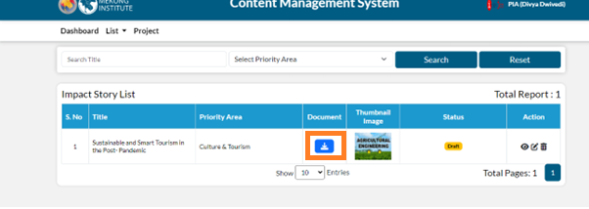

PIA can filter the data by title and Priority area. Using the options shown under action icon, PIA can take any action of viewing, editing and deleting.

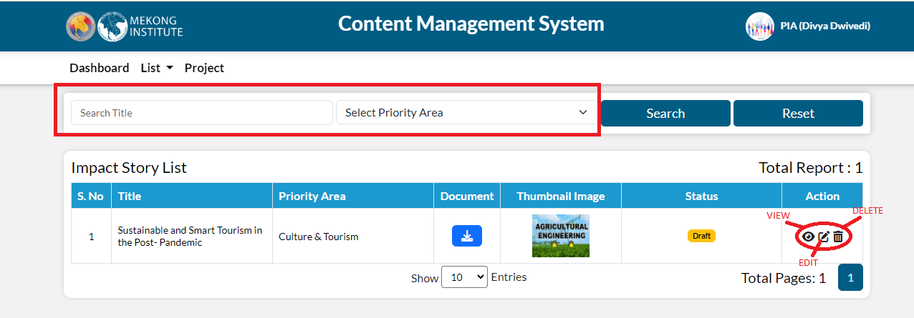

 When PIA click on the view button, the impact story detail page opens, displaying how it will appear on the webpage once published.

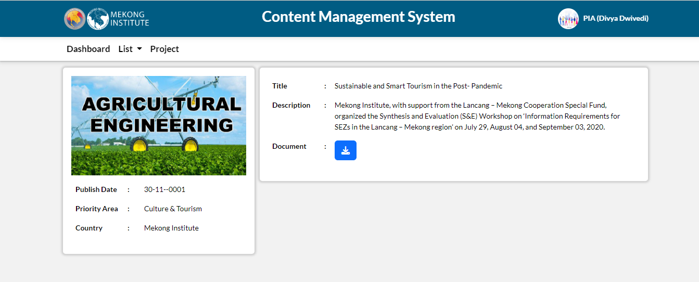

When you click on edit, the edit form opens, allowing PIA to change all of the fields and update the impact story.

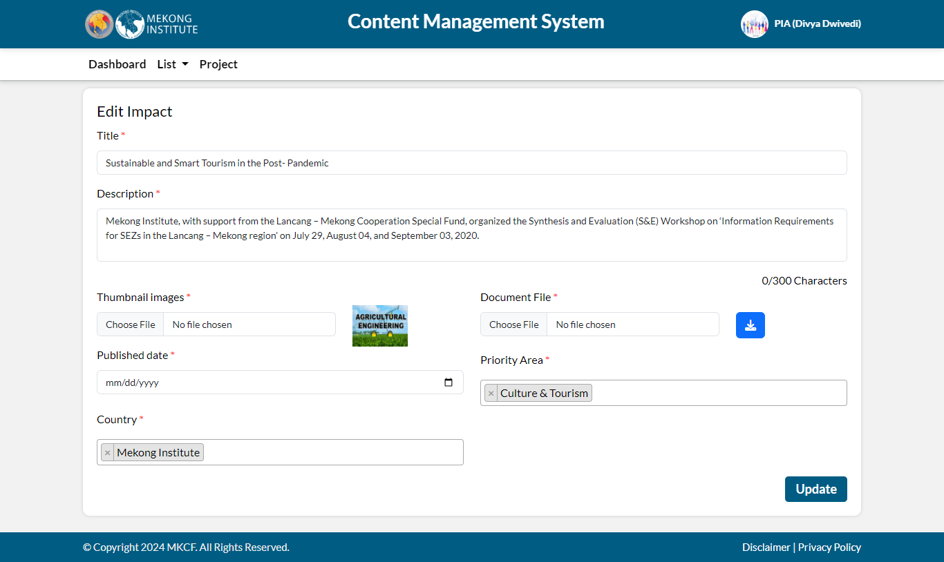

When PIA click on the delete button, a popup message appears, allowing PIA to delete the impact story and it is removed from the list.

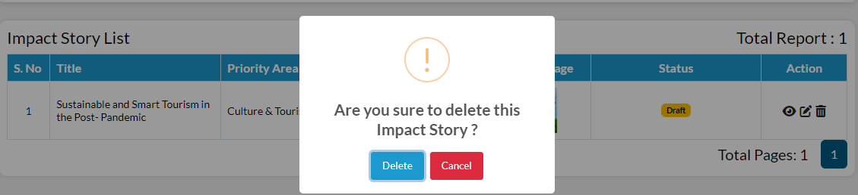

### Report and Publication

The Reports and Publications section contains a collection of documents and resources created by MKCF and its partners. It provides an archive for research findings, papers, and publications relevant to the seven priority areas. It offers to learn more about significant results and recommendations by exploring titles, accessing documents, and viewing associated photos. This section, which is clearly organized by priority area and status indicators, is an invaluable resource for constituents, scholars, and policymakers interested in the Mekong-Korea partnership's programs and outcomes.

PIA can see the list of report and publication already submitted.For adding a report or publication, click on add button present on the right

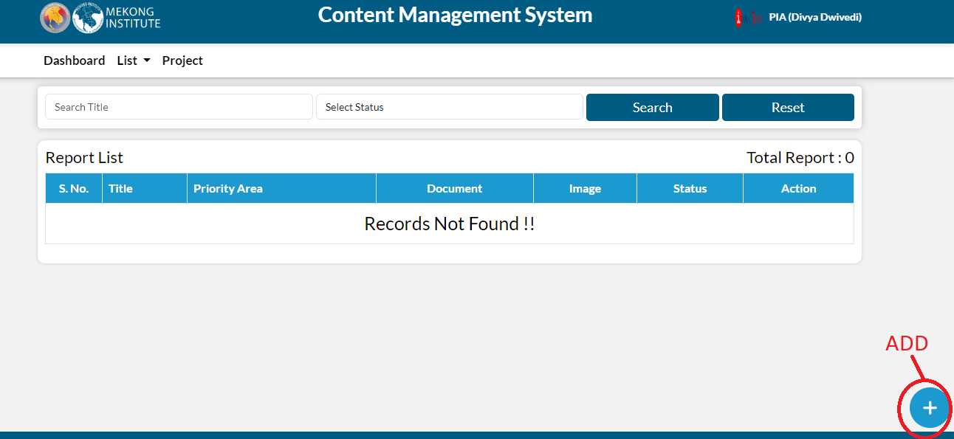

After clicking on add icon, fill the following details and then click on submit button

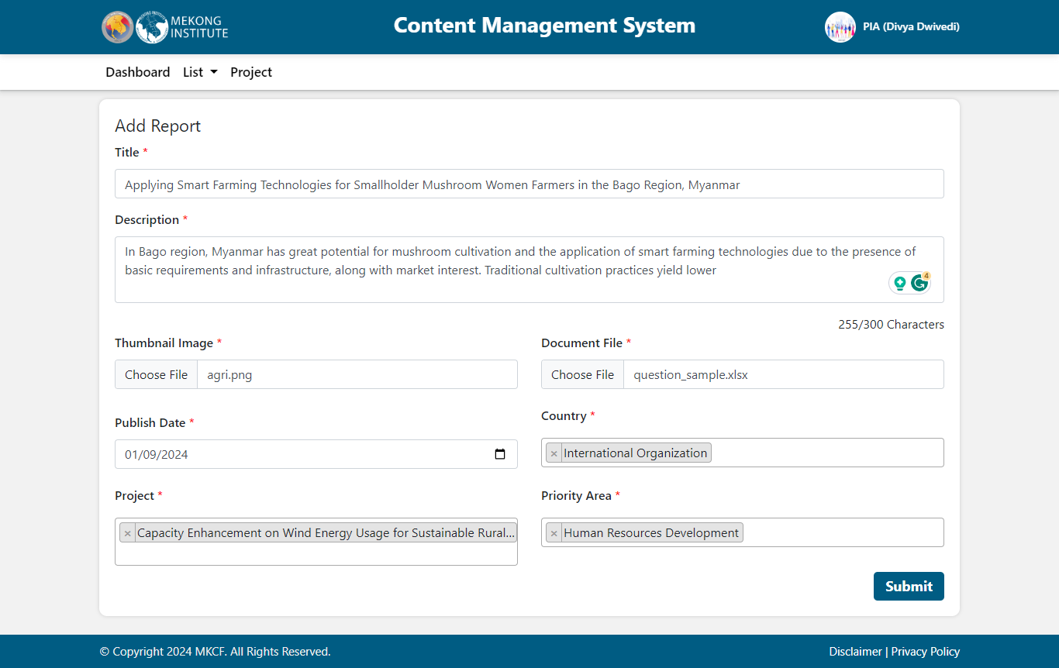

When PIA submits a report or publication a draft will be created. If the Admin want to publish or unpublish this report or publication, click on the draft icon then select publish or reject.

By clicking on the download button in the document section, PIA can download the file. 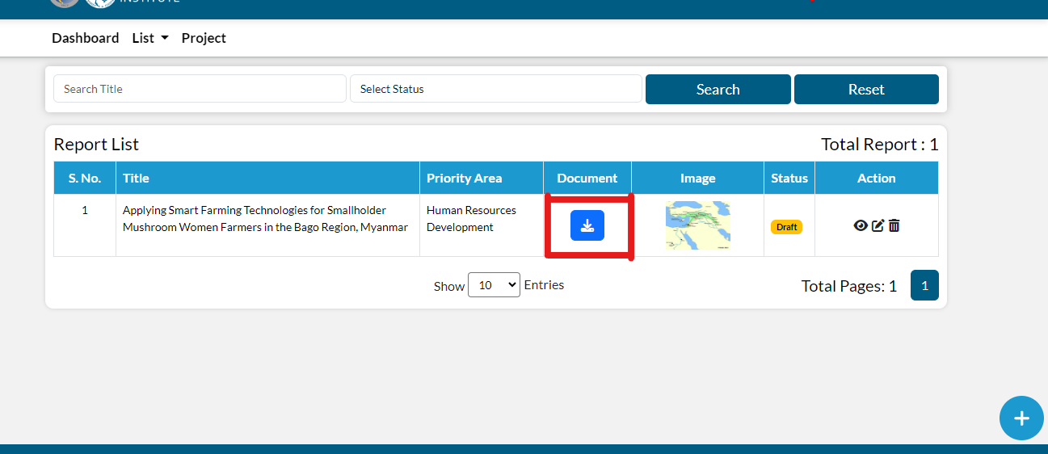

PIA can filter the data by title and Status. Using the options shown under action, you can take any action of viewing, editing and deleting.

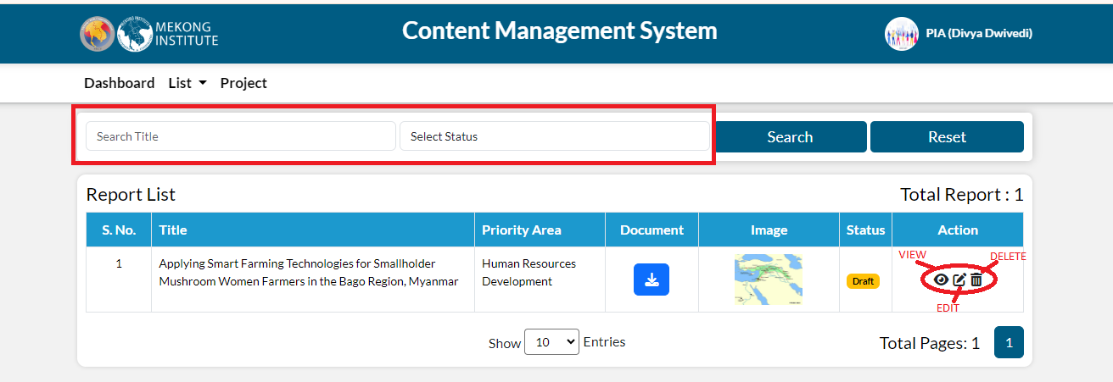

 When PIA click on the view button, the detail page opens, displaying how it will appear on the webpage once published.

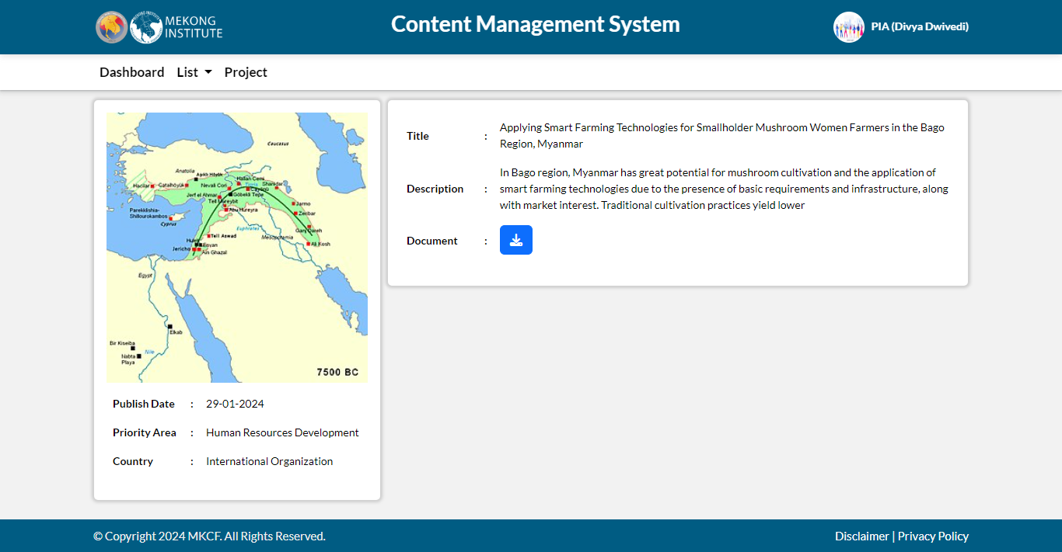

When PIA click on edit, the edit form opens, allowing PIA to change all of the fields and update the reports and publications.

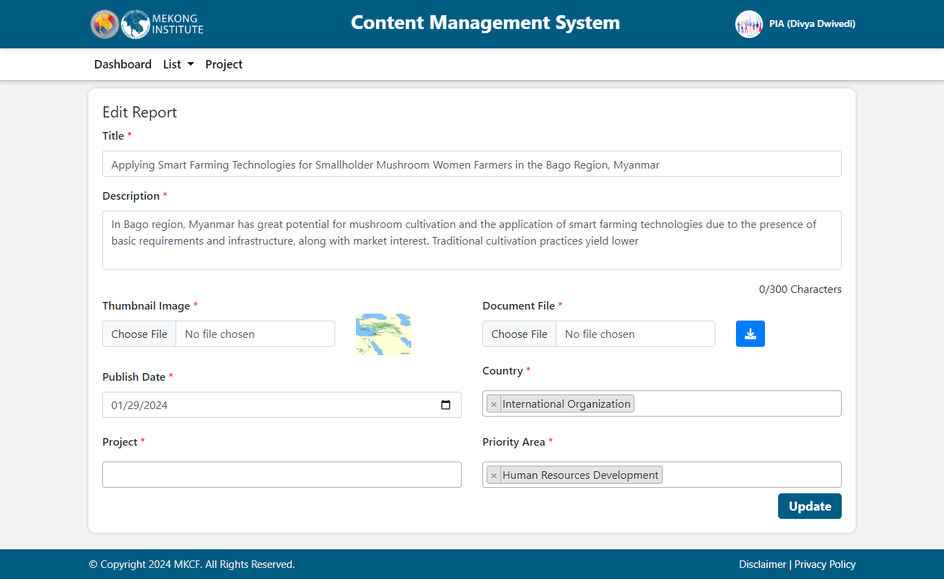

When PIA clicks on the delete button, a popup message appears allowing PIA to delete the report/publication and it is removed from the list.

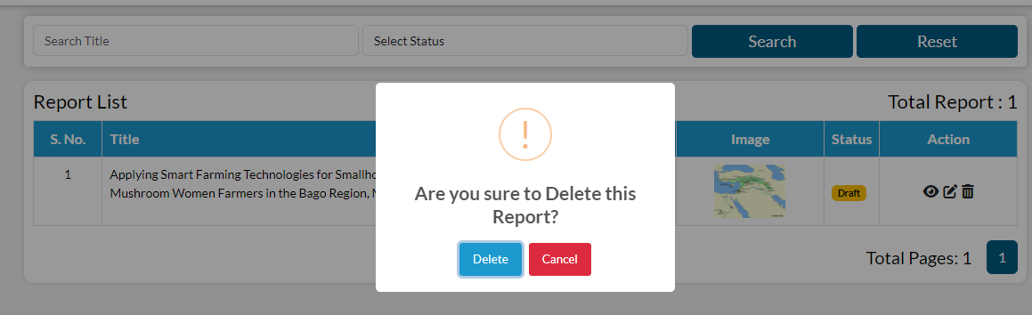

### Announcement

The Announcement section provides a notice board for important updates and notifications about MKCF events and initiatives. It provides brief updates on future events, project milestones, and organizational announcements. It offers to learn about recent developments and prospects in the MKCF collaborations

PIA can see the list of announcement already submitted. For adding announcement, click on add button present on the right corner.

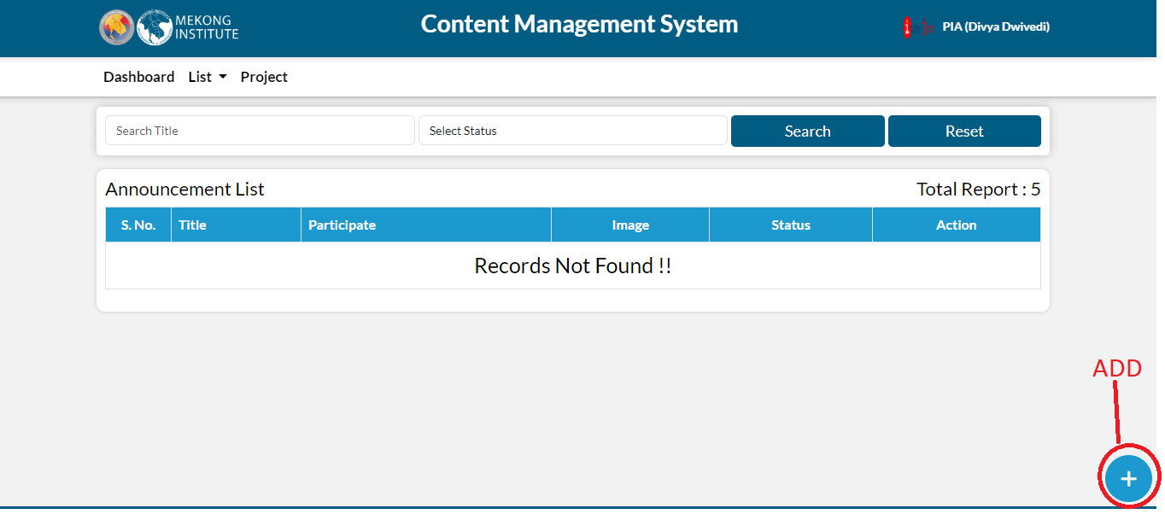

After clicking on add icon, fill the following details and then click on submit button.

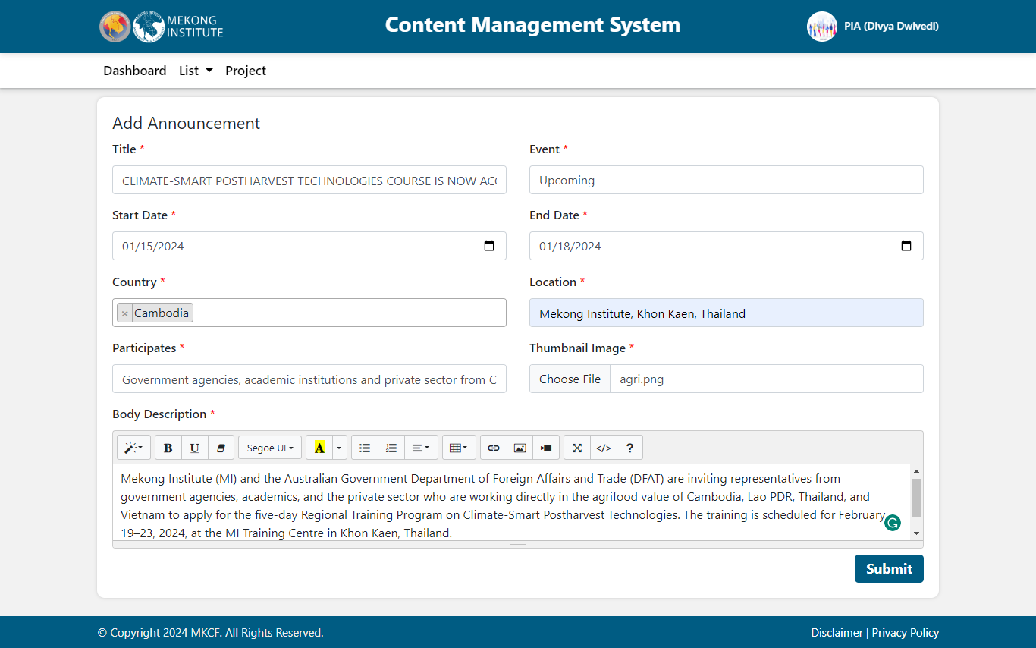

When PIA submits an announcement a draft will be created. If the Admin want to publish or unpublish this announcement, click on the draft icon then select publish or reject.

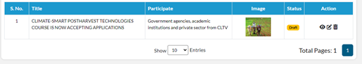

You can filter the data by title and Status. Using the options shown under action, you can take any action of viewing, editing and deleting.

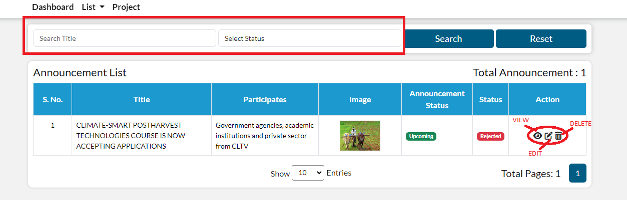

 When PIA clicks on the view button, the detail page opens, displaying how it will appear on the webpage once published.

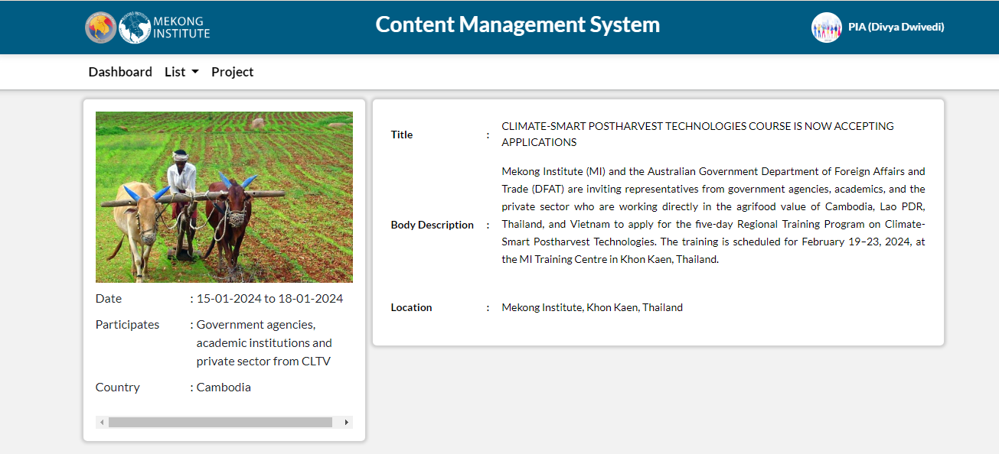

When PIA click on edit, the edit form opens, allowing PIA to change all of the fields and update the announcement.

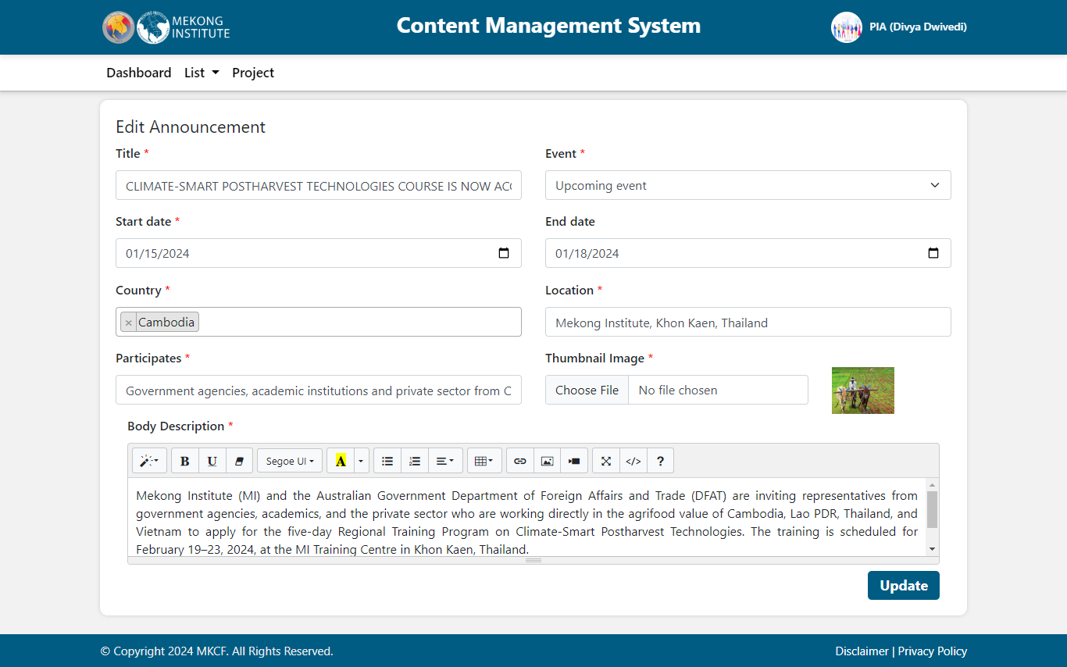

When PIA click on the delete button, a popup message appears allowing PIA to delete the announcement and it is removed from the list.

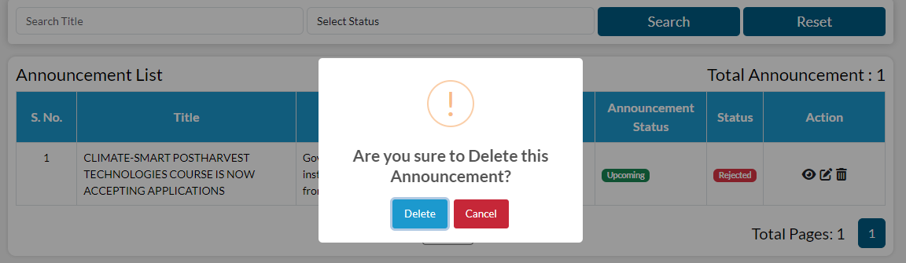

## Multi-media

The Multimedia section is a live library of various media types, such as videos, photos, and interactive information, relating to MKCF projects and activities. It offers look at visual representations of project outcomes, success stories, and interact with interactive resources that demonstrate the impact of MKCF's work throughout the Mekong area. With a range of multimedia forms available, this part provides an immersive experience that supplements textual content, allowing readers to obtain a deeper understanding of MKCF's contributions to regional development and collaboration.

PIA can see the list of multimedia already submitted. For adding a multimedia, click on add button present on the right corner.

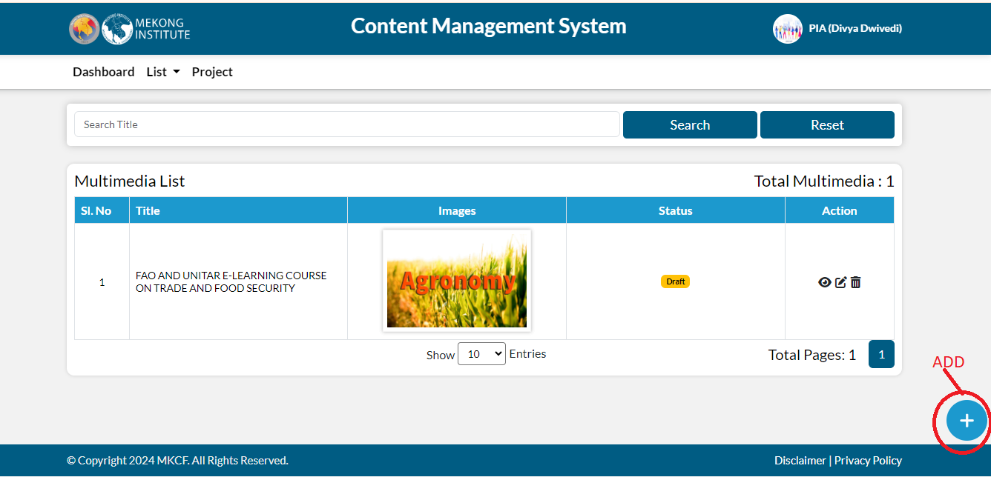

After clicking on add icon, fill the details and then click on submit button.

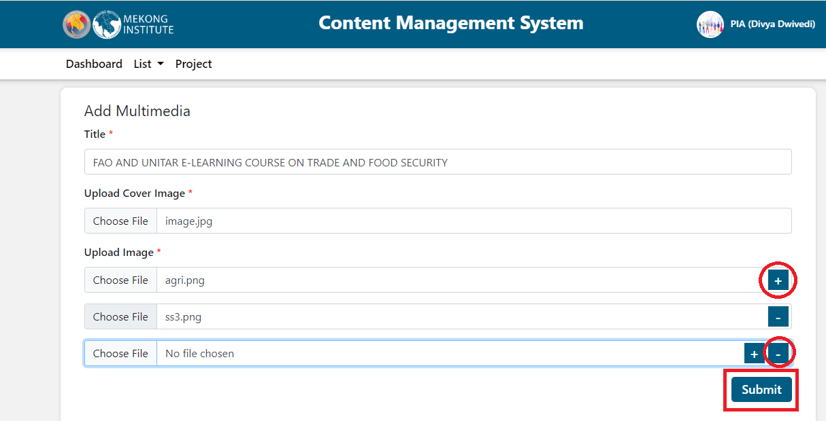

When PIA submits a multi media a draft will be created. If the admin wants to publish or unpublish this multimedia, click on the draft icon then select publish or reject.

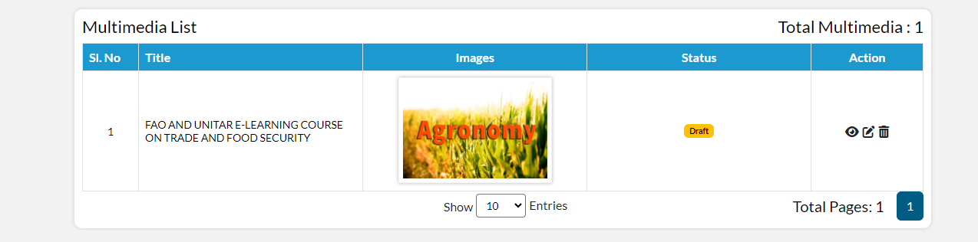

PIA can filter the data by title. Using the options shown under action, you can take any action of viewing, editing and deleting.

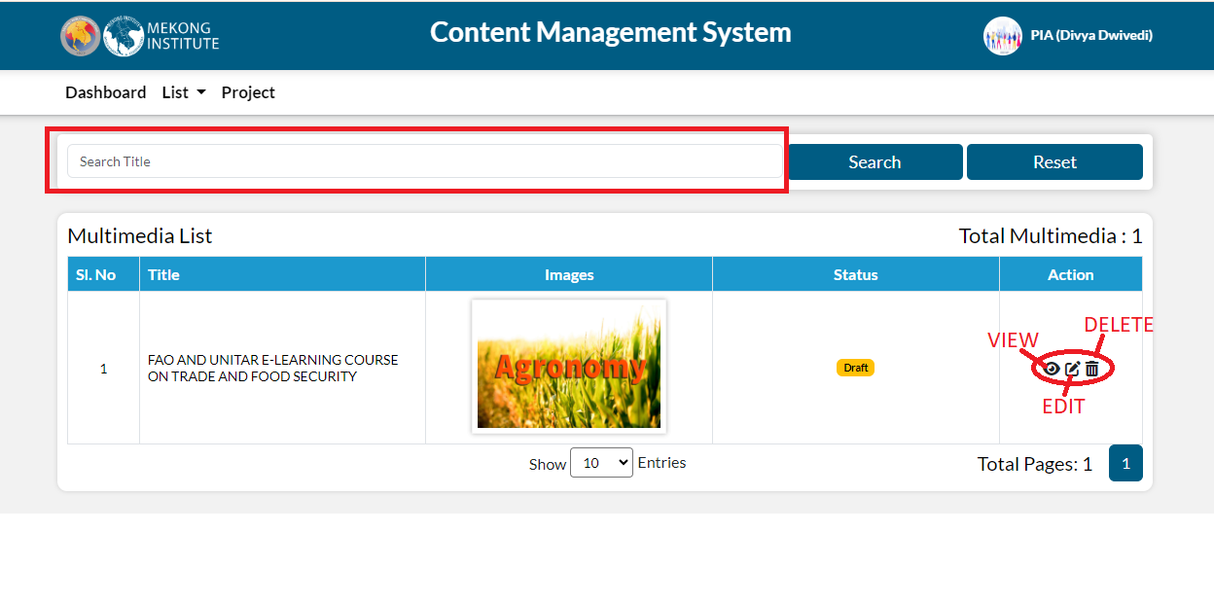

 When PIA click on the view button, the detail page opens, displaying how it will appear on the webpage once published.

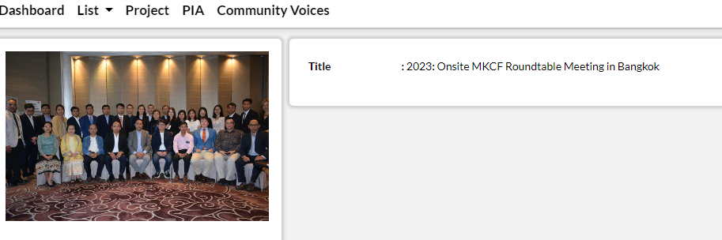

When PIA click on edit, the edit form opens, allowing PIA to change all of the fields and update the multimedia.

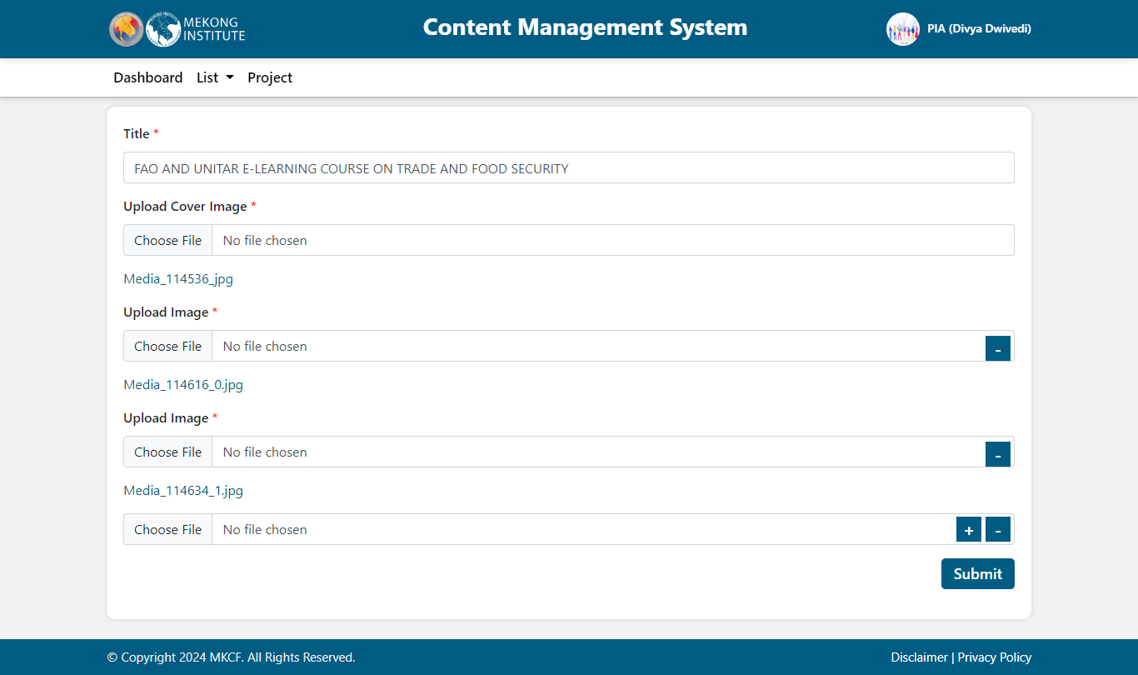

When PIA click on the delete button, a popup message appears allowing PIA to delete the media and it is removed from the list

.

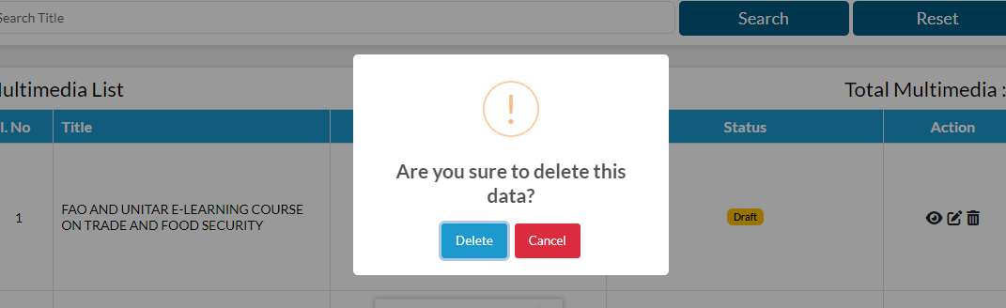

## Project

The Projects section highlights the projects performed by MKCF throughout its priority areas. It offers full information on both ongoing and completed projects, such as their titles, priority areas, countries of implementation, and current status. Each project listing may include extra information like objectives, timeframes, and significant milestones. This section provides a comprehensive resource for participants, policymakers, and laypeople to understand MKCF's work to create regional integration, address issues, and promote sustainable development in the Mekong region.

PIA can see the list of projects already submitted. For adding a project, click on add option present on the right corner.

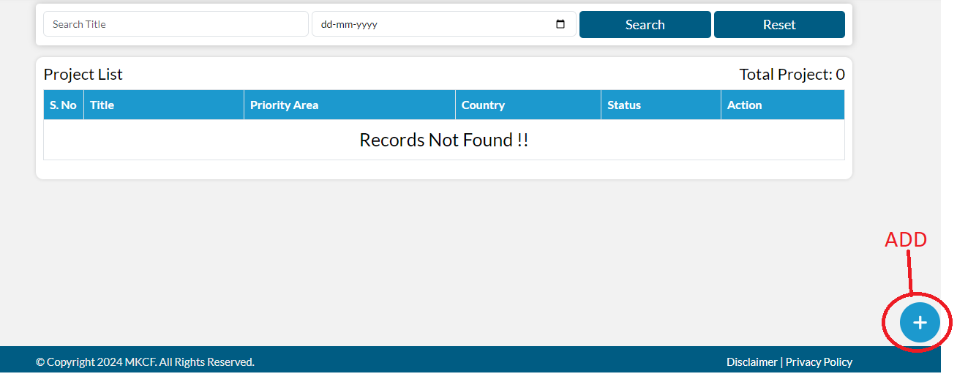

After clicking on add icon, fill the following details and then click on submit button.

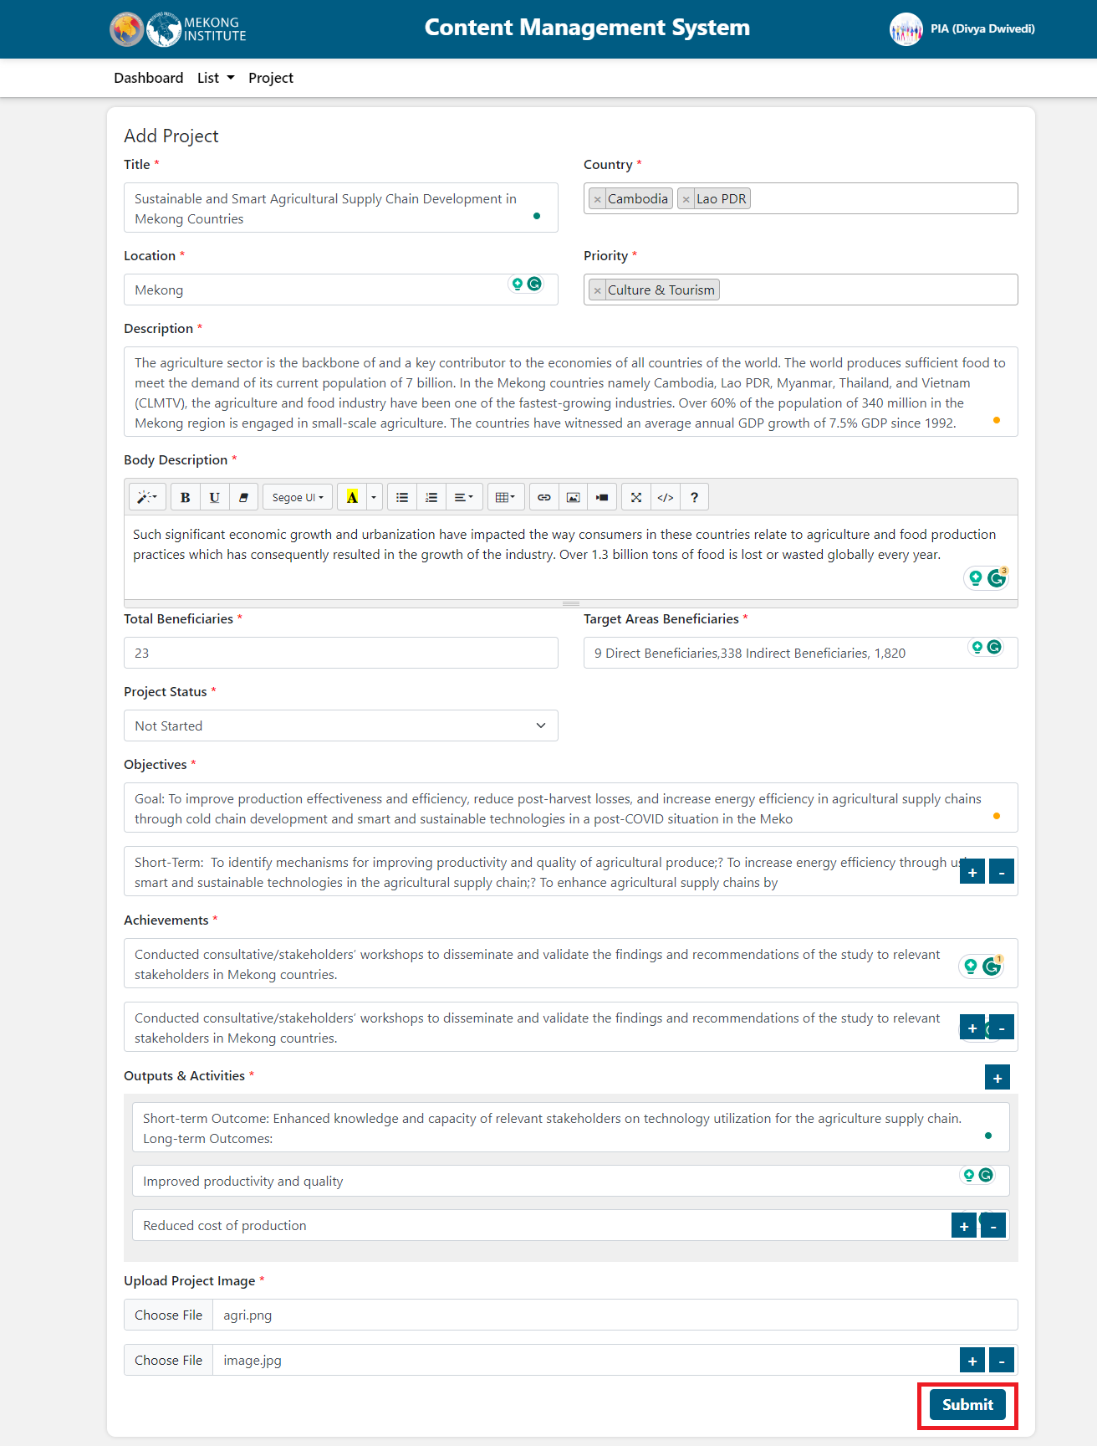

When PIA submits a project, a draft will be created. If the admin wants to publish or unpublish this project, click on the draft icon then select publish or reject.

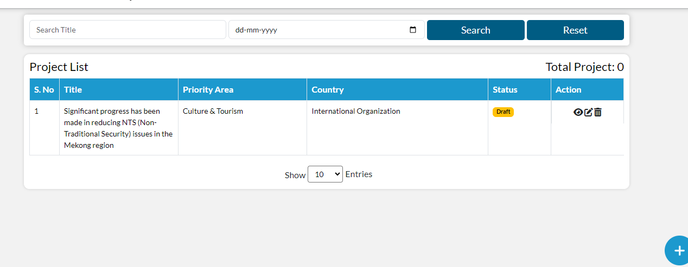

PIA can filter the data by title and Date. Using the options shown under action, you can take any action of viewing, editing and deleting.

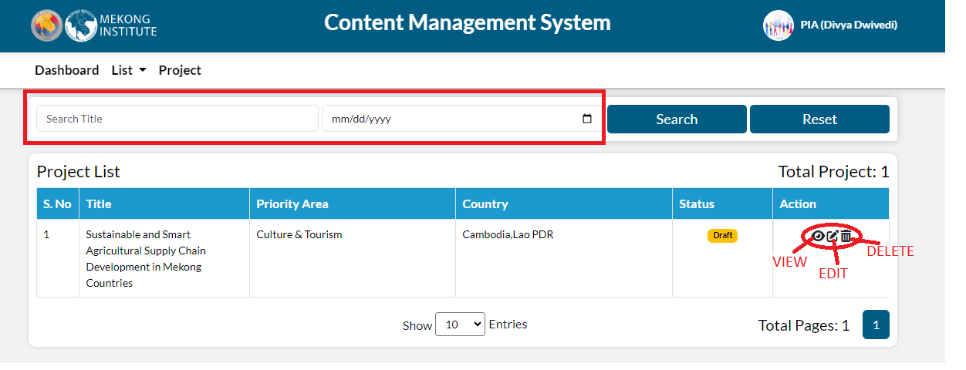

 When PIA click on the view button, the detail page opens, displaying how it will appear on the webpage once published.

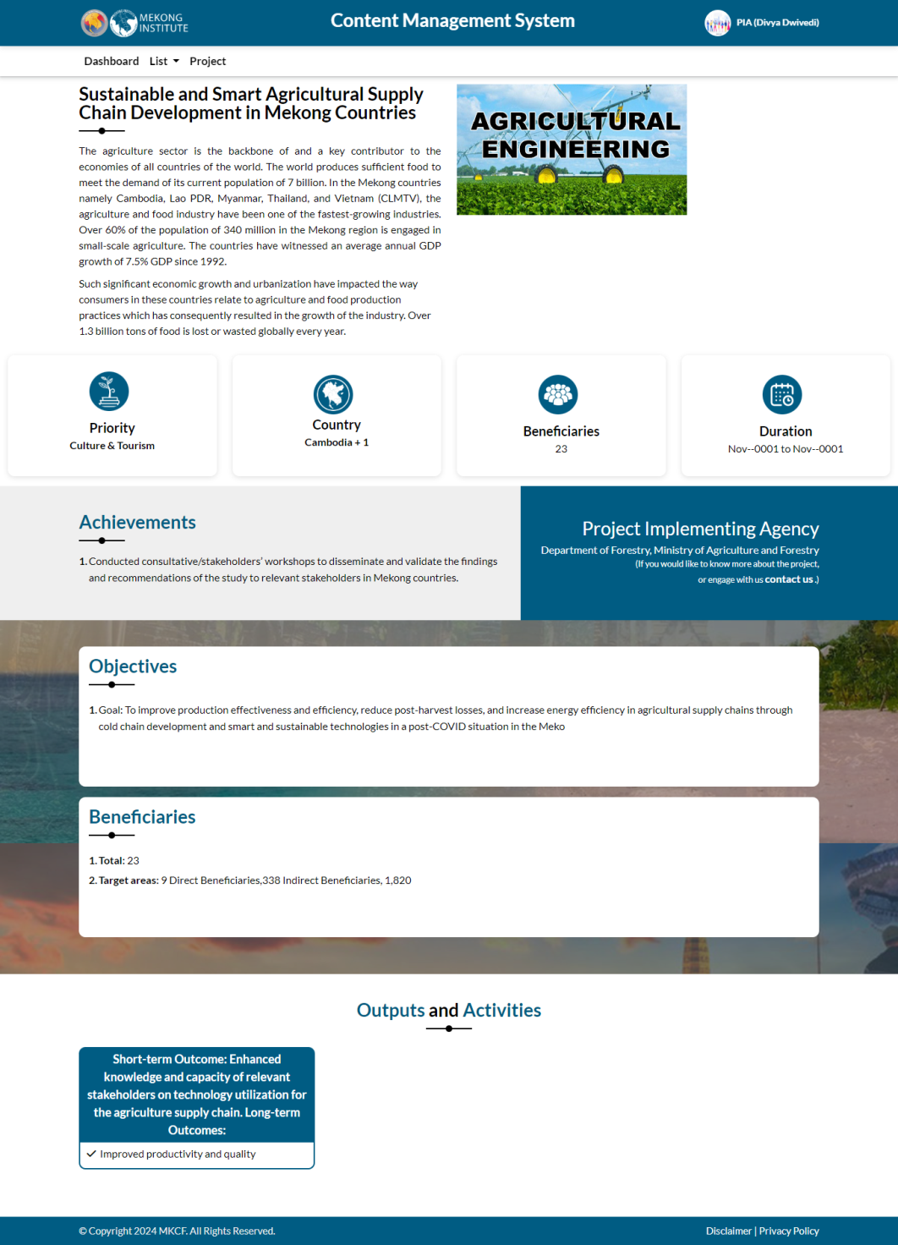

When PIA click on edit, the edit form opens, allowing PIA to change all of the fields and update the project.

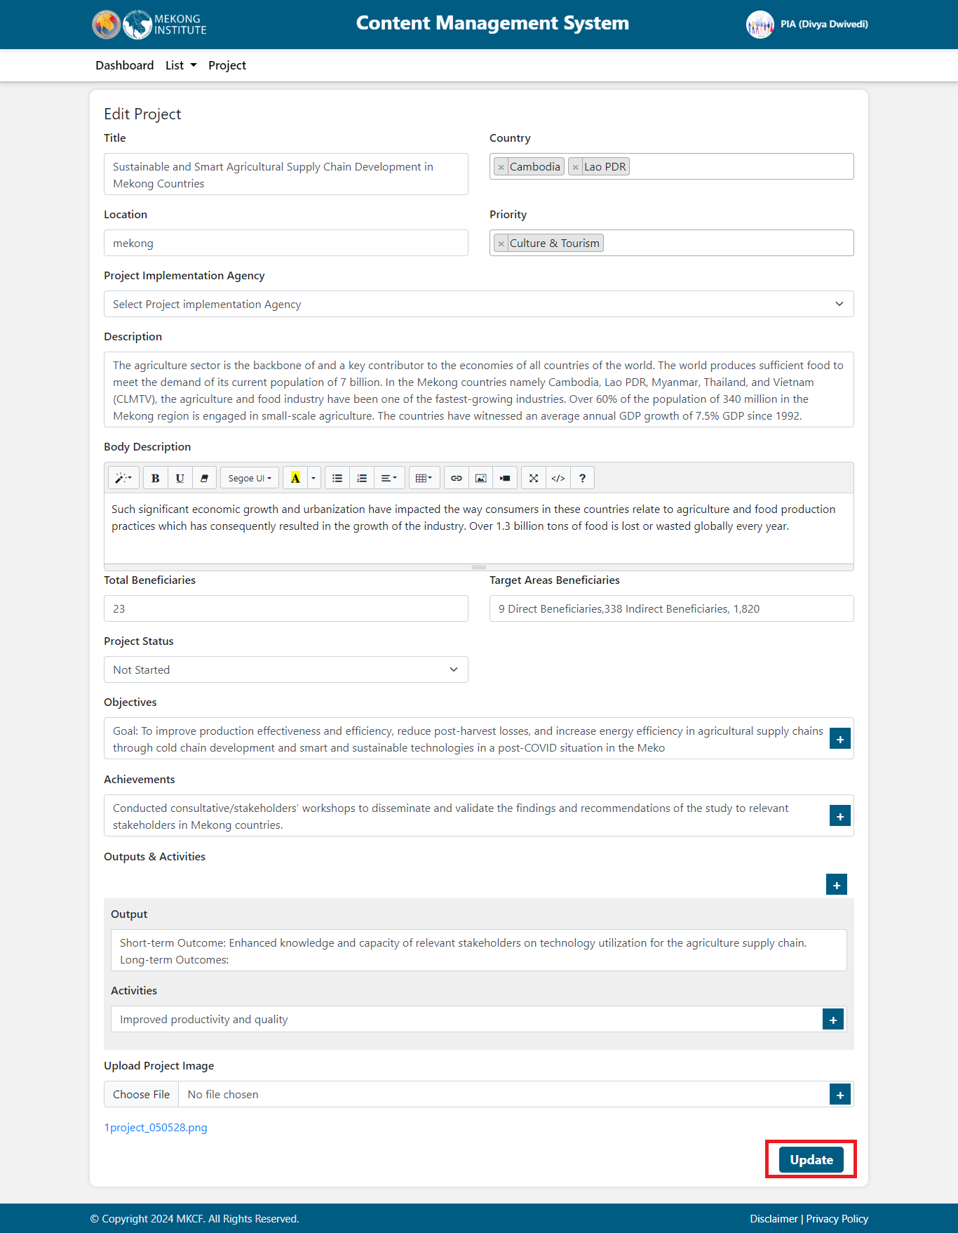

When PIA click on the delete button, a popup message appears allowing PIA to delete the project and it is removed from the list

.

