REPORT ON CLIMATE PLEDGE WEBINAR

ABSTRACT

The Report outlines the detailed activities undertaken in the mobilization and organization of the event.

Indev Consultancy Pvt Ltd

A61/1, First Floor, Pocket D, Okhla Phase II, Okhla Industrial Estate, New Delhi, Delhi 110019

INTRODUCTION

On 1**st December 2023**, a **Webinar** was organized in a hybrid mode across different schools of New Delhi. The theme of this webinar was – **Biofuel - a Renewable Energy Resource.** The webinar was organized to raise awareness among school-going children under the age group of 9-16 about biofuel as an alternative to fossil fuels contributing to Global Warming. Children were educated about the part how biofuel is derived from biomass which is environment friendly and cost effective reducing the emissions of Greenhouse gases.

Around 80 students participated in this webinar were mobilized by partner organization Moinee Foundation from Guru Tegh Bahadur Khalsa Boys Sr Sec and Ramjas Sr Sec schools across Delhi.

POINTS OF DISCUSSION

The event started with the introduction to biofuel and its role as a renewable energy resource. The webinar focused on the below mentioned points:

* Different types of biofuels and their production processes
* Environmental benefits and challenges associated with biofuel usage
* Discussion on the integration of biofuels into existing energy systems
* Closing remarks and emphasis on the sustainable use of biofuel

ORGANIZING THE EVENT

The orientation on the theme **‘Biofuel- A Renewable Energy Resource’** was given to provide event background and to spread awareness among the participants about the biofuel, the renewable energy resources and the alternative of fossil fuels.

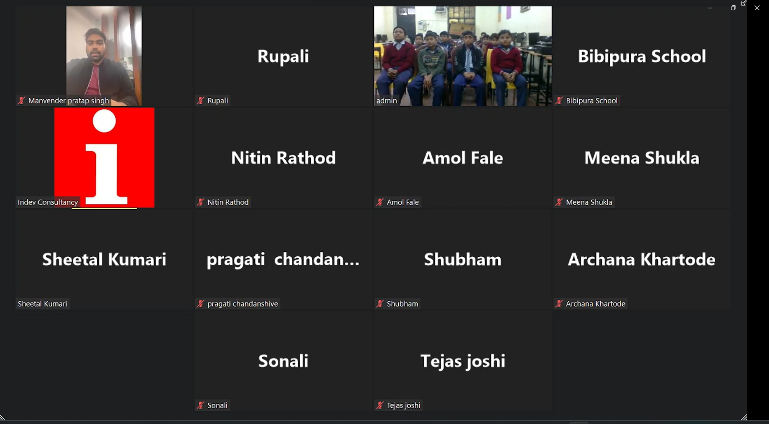

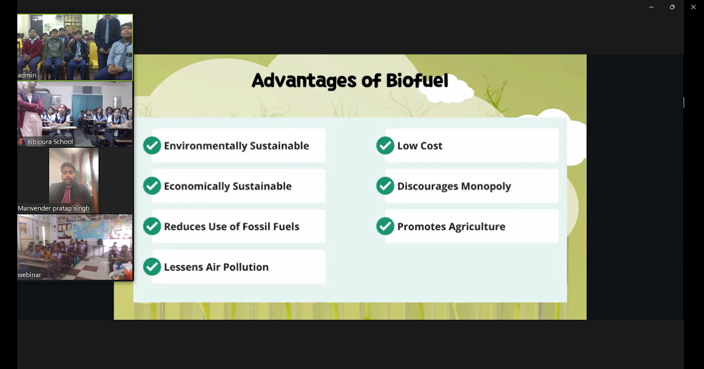

During the session, students were advised to engage in the discussions to get a better understanding of the various concepts related to renewable resources. It was also briefed to the students to ask questions whenever they face any difficulty in understanding the particular concept, or term related to the question.

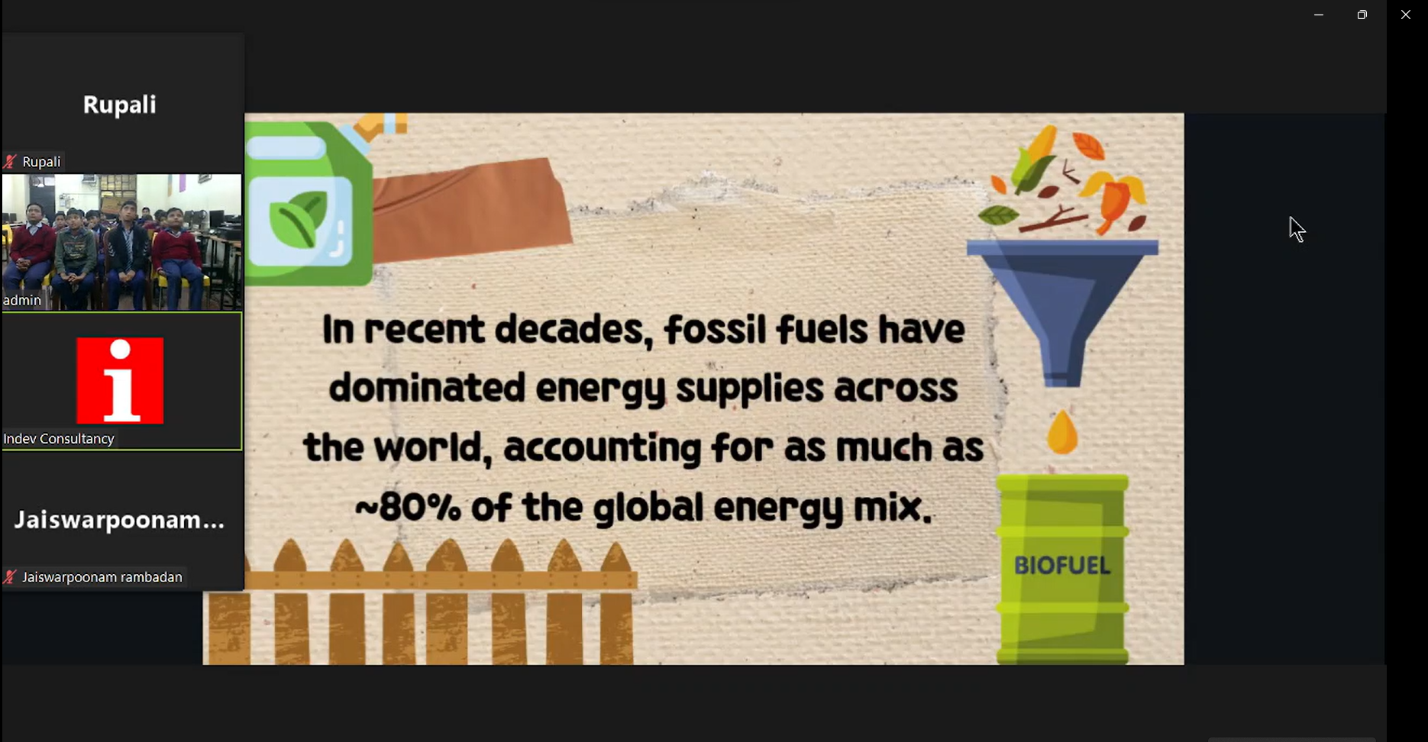

During the open discussion session in between the session, the students actively participated in the discussion and shared their understanding biofuel, renewables and various facets related to it.

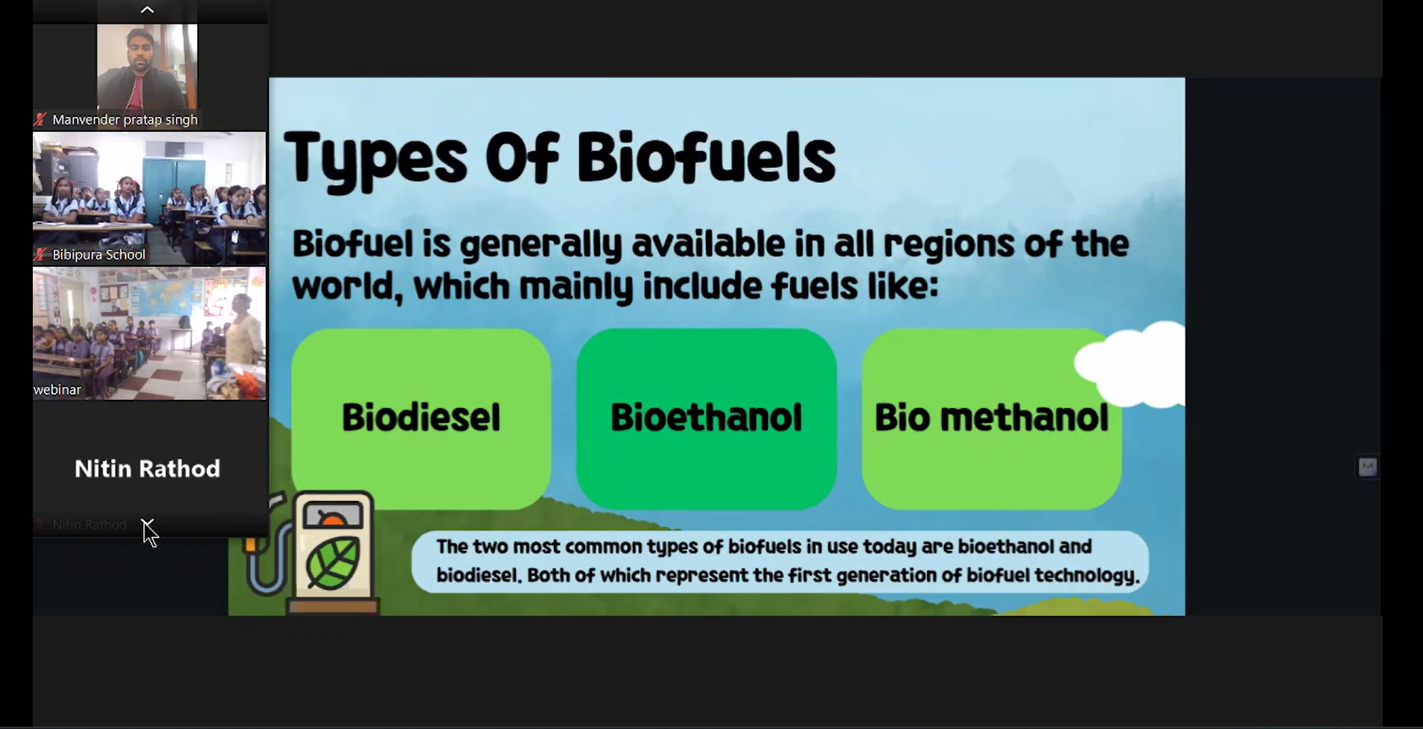

The views and the understanding of biofuels and the impacts they are having on our daily lives were shared by the students. Measures and initiatives that can help alleviate carbon emissions and mitigate the impacts of climate change were also communicated by the participants beautifully. The delightful faces portrayed the excitement among the participants and the celebratory actions expressed the level of happiness after attending the whole session. The webinar lasted 60 minutes including the discussions and education the topic.

END NOTE

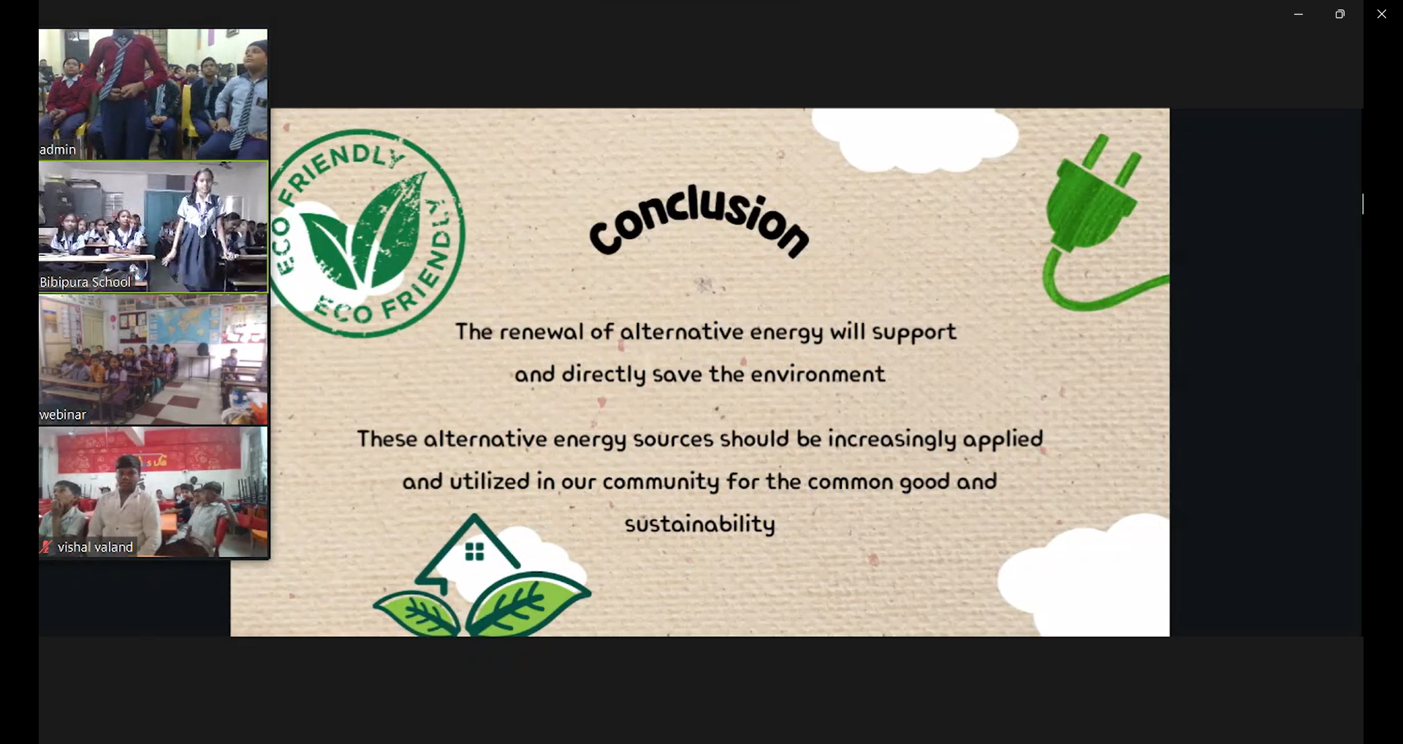

The students were greeted for their concentration and listening performance while watching the webinar by the attendees. It was conveyed to all the attendees and the students that in the future more events like this will be organized where all can join and have a fruitful discussion to bring a positive change to help in alleviating climate change impacts.