Content Management System of MKCF web-portal
(User Manual-Web Admin Panel)

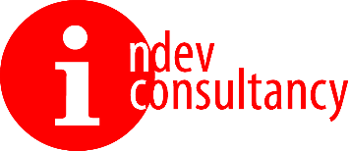
Submitted by:

Indev Consultancy Pvt. Ltd.
A-61/1, 1st Floor, Okhla Phase II, Okhla Industrial Estate, New Delhi, Delhi 110020
Contact: +91 11 4905 0111

Email: Contact@indevconsultancy.com
URL: http://indevconsultancy.com/

Date of Submission:

Table of Contents

Table of Contents 2
Introduction 3
Abbreviations 3
Admin Panel 7
Login of Administrator Panel 7
Dashboard/ Home Screen 7
List 13
News 13
Impact Story 15
Report and Publication 17
Announcement 19
Priority Area 21
Multimedia 22
Project 24
PIA 25
Community Voices 27

Introduction
The overall objective of the assignment is to develop and implement an interactive MKCF web-based platform to enable the visibility of MKCF and its projects and contributes proper branding of MKCF.
The Mekong Korea Corporation Fund (MKCF) was established in 2013 to support cooperation in seven priority areas outlined in the Han River Declaration of 2011, following the initiation of the Mekong-ROK partnership in 2011.

The MKCF provides grants for regional projects aligned with the priorities of the Mekong countries and the Republic of Korea. These projects address national issues and facilitate the regional integration process in seven key sectors: Culture & Tourism; Human Resources Development; Agriculture & Rural Development; Infrastructure; Information & Communication Technology (ICT); Environment; and Non-traditional Security Challenges.

The purpose of the CMS is to give an in-depth idea about the dynamic components of the portal and behaviour of the functionalities such as addition/updation of news/articles, creating new projects, changing their status etc.
The proposed CMS has two roles:
- Admin
- Project Implementation Agency (PIA)
PIAs will be registered by the admin from the CMS and separate log-in credentials will be created for every PIAs.
PIAs will have pre-defined functionality and features such as Add/Edit/Delete any information. Whereas the admin will have the rights to approve/reject any information before publishing it publicly.

Abbreviations
These are commonly used acronyms and abbreviations in the web portal.
ACIA | ASEAN Comprehensive Investment Agreement
ACMECS | Ayeyawady – Chao Phraya – Mekong Economic Cooperation Strategy
ADB | ASIAN Development Bank
ADC | Agricultural Development and Commercialization
AEC | ASEAN Economic Community
AFAS | ASEAN Framework Agreement on Services
AFTA | ASEAN Free Trade Area
AIC | ASEAN-India Centre
AIIB | Asian Infrastructure Investment Bank
APEC | Asia-Pacific Economic Cooperation
APTA | Asia-Pacific Trade Agreement
ASEAN | Association of Southeast Asian Nations
ATIGA | ASEAN Trade in Goods Agreement
BIMSTEC | Bay of Bengal Initiative for Multi-Sectoral Technical and Economic Cooperation
CAMT-CMU | College of Arts, Media and Technology of Chiang Mai University
CBEZ | Cross-Border Economic Zones
CBTA | Cross-Border Transport Agreement
CLM | Cambodia, Lao PDR and Myanmar
CLMV | Cambodia, Lao PDR, Myanmar and Vietnam
CLMVT | Cambodia, Lao PDR, Myanmar, Vietnam, and Thailand
CLV | Cambodia, Lao PDR and Vietnam
COMET | Connecting the Mekong through Education and Trade
CSG/YNPG | China Southern Power Grid Co.,Ltd/ Yunnan Power Grid Co.,Ltd
DFC | Dedicated Freight Corridor
DMIC | Delhi-Mumbai Industrial Corridor
DPR | Democratic People’s Republic
ECSAF | Export Capacity Support for Small Exporters from Asia-Pacific
EEC | Eastern Economic Corridor
EPPO | Energy Policy and Planning Office, Ministry of Energy, Thailand
ERIT | Economic Research Institute for Trade- Ministry of Industry and Commerce, Lao PDR
EWEC | East West Economic Corridor
EU | European Union
EZ | Economic Zone
FAO | Food and Agriculture Organization of the United Nations
FAO RAP | FAO Regional Office for Asia and the Pacific
FDI | Foreign Direct Investment
FTA | Free Trade Agreement
GAP | Good Agricultural Practices
GDP | Gross Domestic Product
GIZ | Deutsche Gesellschaft für Internationale Zusammenarbeit GmbH  (German Corporation for International Cooperation GmbH)
GMS | Greater Mekong Subregion
HRD | Human Resource Development
ICO NIDA | The International College of National Institute of Development  Administration
IDRC | International Development Research Centre of Canada
IIFT | Indian Institute of Foreign Trade
ITD | International Institute for Trade and Development
Lao PDR | Lao People’s Democratic Republic
LMCSF | Lancang-Mekong Cooperation Special Fund
LMI | Lower Mekong Initiative
MASHAV | Israel’s Agency for International Development Cooperation
MI | Mekong Institute
MICE | Meetings, Incentives, Conferences and Exhibitions
MIEC | Mekong India Economic Corridor Development
MIYSP | Mekong Institute Young Scholars Program
MKCF | Mekong-Republic of Korea Cooperation Fund
NEDA | Neighbouring Countries Economic Development Cooperation Agency
NTFC | National Transport Facilitation Committees
NZAP | New Zealand Aid Programme
OBOR | One Belt One Road
ODA | Official Development Assistance
OECD | The Organization for Economic Co-operation and Development
OTOP | One Tambon One Product
P.R. China | People’s Republic of China
PARI | Policy Alternatives Research Institute
PDR | People’s Democratic Republic
PPCP | Public-Private and Community Partnership
PRC | People’s Republic of China
PROSAFE | Project Promoting Safe Food for Everyone Project
R-GVC | Regional and Global Value Chain
RCEP | Regional Comprehensive Economic Partnership
ROK | Republic of Korea
SAARC | South Asian Association for Regional Cooperation
SDC | Swiss Agency for Development and Cooperation
SDGs | Sustainable Development Goals
SEE | Sustainable Energy and Environment
SEZ | Special Economic Zone
SIP | Sustainable Infrastructure Partnership
SME | Small- and Medium-Sized Enterprise
SPU | Sripatum University
SU | Souphanouvong University
TCEB | Thailand Convention and Exhibition Bureau
TICA | Thailand International Cooperation Agency
TIF | Trade and Investment Facilitation
TLH | India–Myanmar–Thailand Trilateral Highway
TPP | Trans-Pacific Partnership
TPSO | Trade Policy and Strategy Office, Thailand Ministry of Commerce
UK | United Kingdom
UN | United Nations
UNCTAD | United Nations Conference on Trade and Development
UNESCAP | United Nations Economic and Social Commission for Asia and the Pacific
US | United States
USAID | United States Agency for International Development
WTO | World Trade Organization

Admin Panel

Login of Administrator Panel

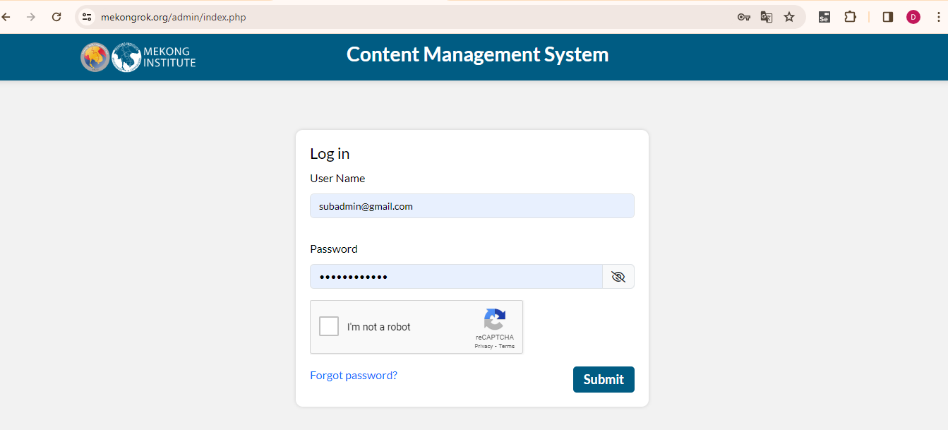

This is the view of the login panel of the administrator. Admin can login by using the following credentials:

URL: https://mekongrok.org/admin/
Username: subadmin@gmail.com
Password: xxxxxxxx

Dashboard/ Home Screen
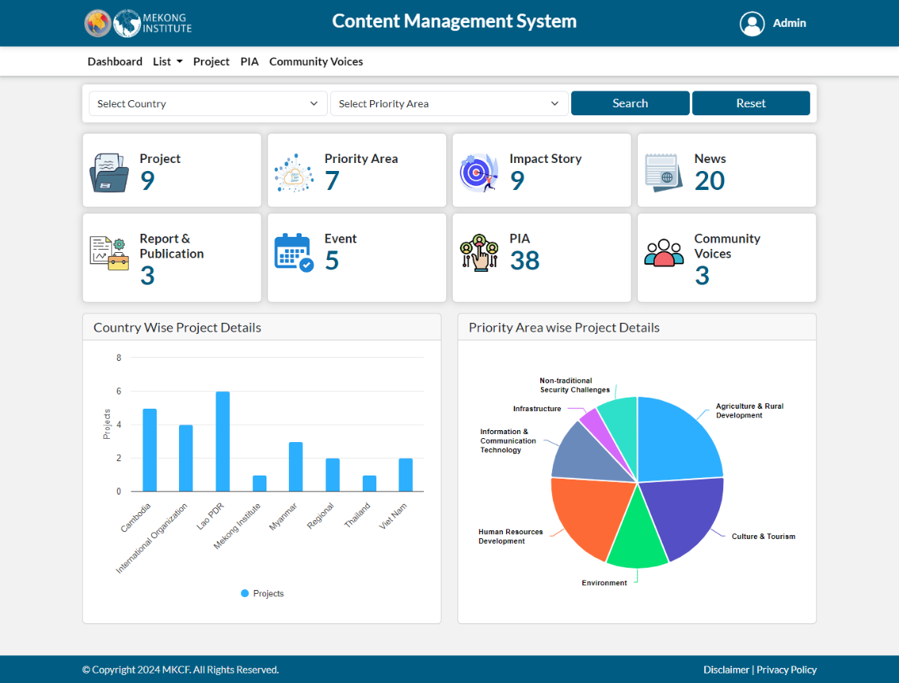
The admin can see a dashboard comprising of following:

Project
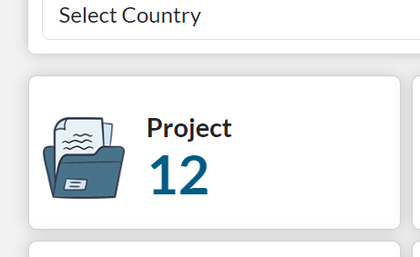
The card represents the number of projects, both ongoing and completed covering all the seven priority areas. Which is added by the CMS.

When you click on the card list of projects appears. Included project title, project priority area, project country, project status, and action.
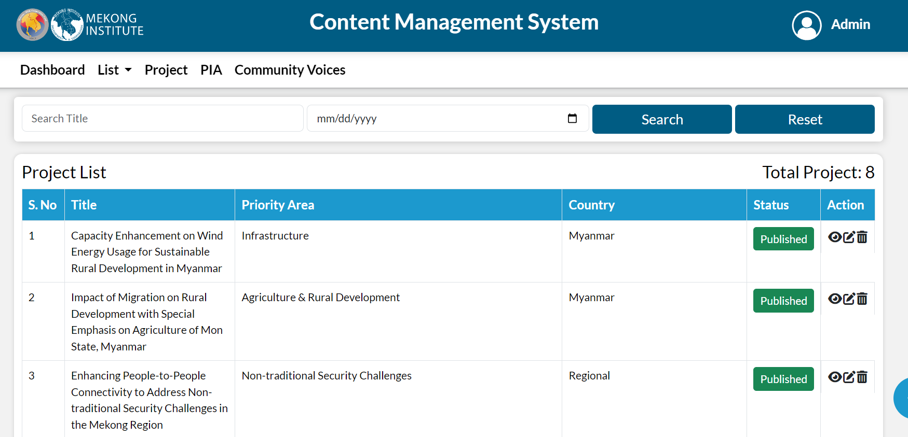

Priority Area
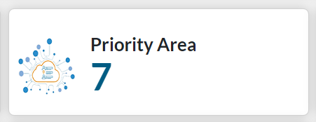
The card represents all the seven priority areas, which is added by the CMS.

- Culture & Tourism
- Human Resources Development
- Environment
- Agriculture & Rural Development
- Infrastructure
- Information & Communication Technology
- Non-traditional Security Challenges

When you click on the card list of priority areas appears: included title and action.

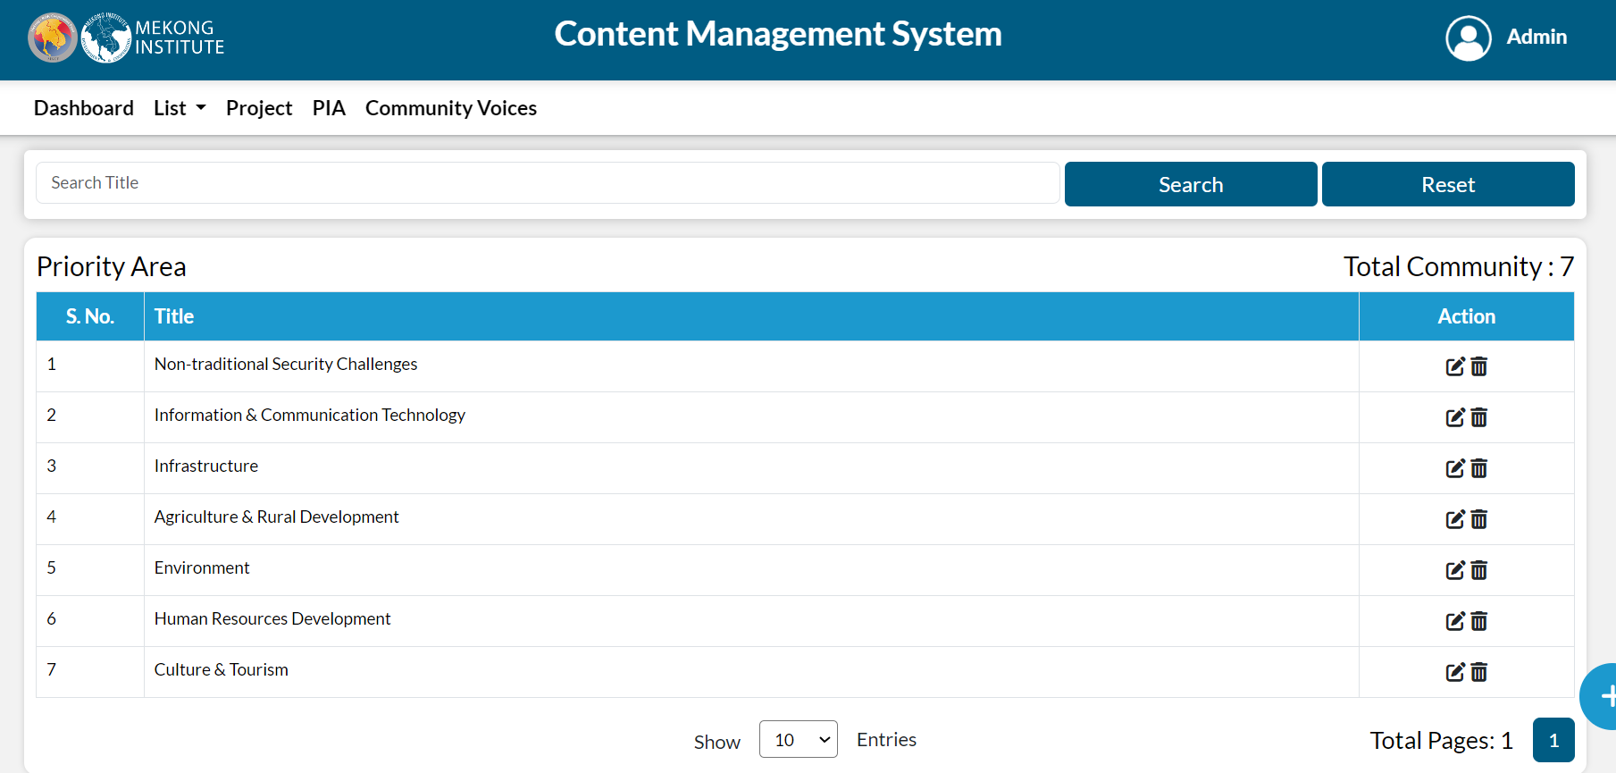

Impact Story
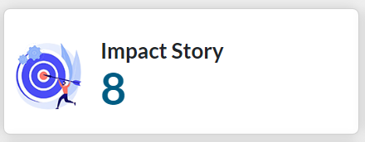
The card represents all the count of impact stories, which is added by the CMS.
When you click on the card, the number of impact story is appears. Included title, priority area, document, thumbnail image, status, and action.
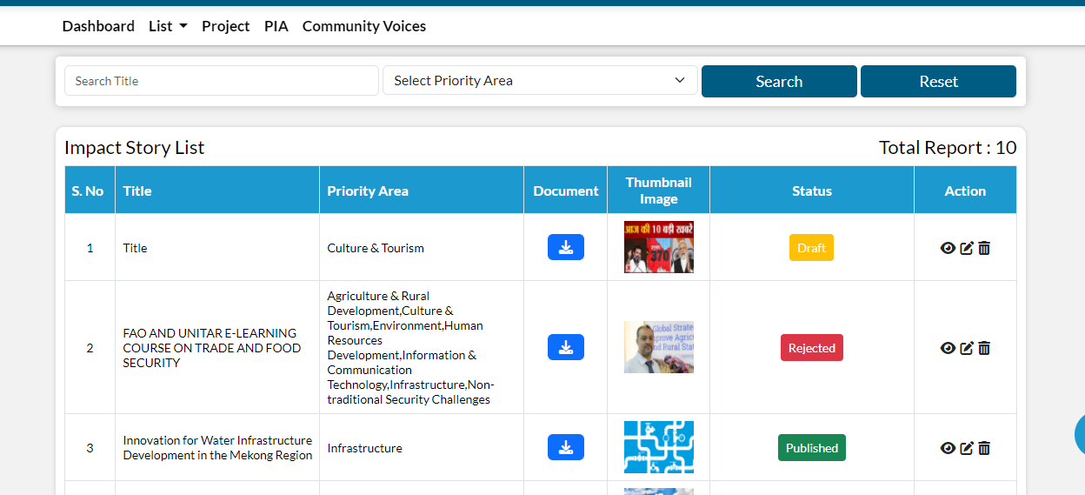

News

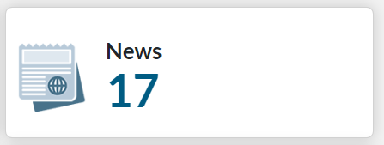
The card represents all the count of news, which is added by the CMS.

When you click on the card, the number of news is appears. Included title, priority area, image, status, and action.
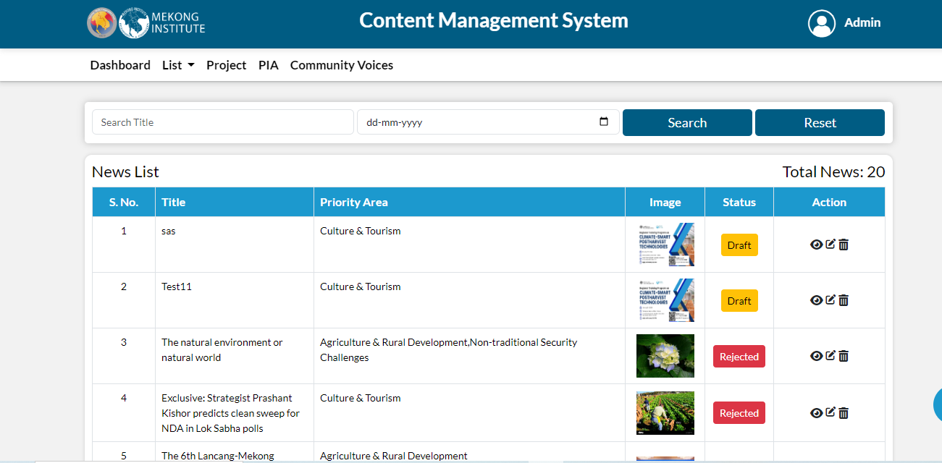
Report & Publication
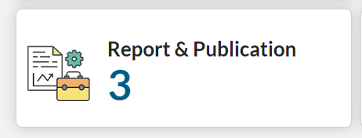
The card represents all the count of the report & publication, which is added by the CMS.
When you click on the card, the number of report & publication is appears. Included title, priority area, document, image, status, and action.
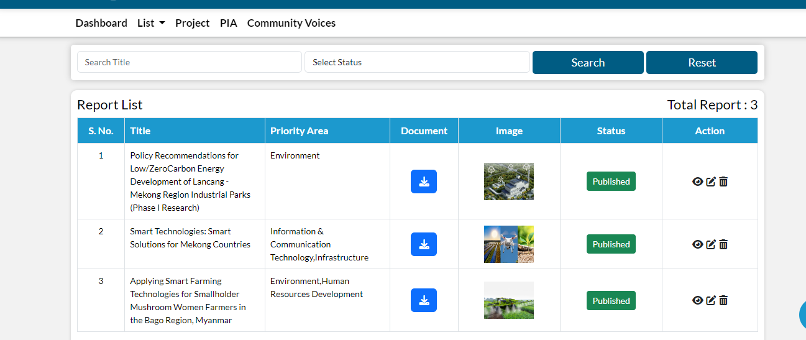

Event
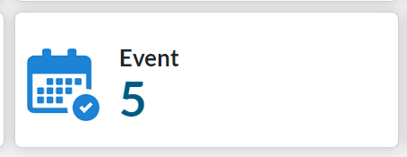
The card represents all the count of event, which is added by the CMS.
When you click on the card, the number of event is appears. Included title, participate, image, status, and action.

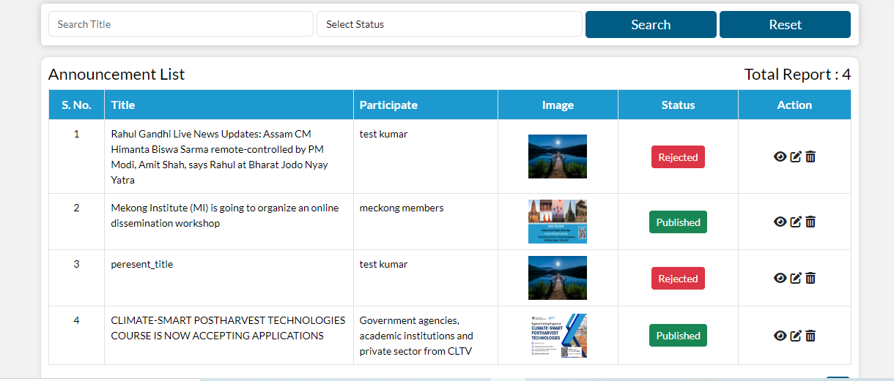

PIA
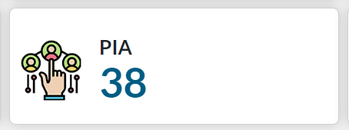
The card represents all the Count of PIA, which is added by the CMS.

When you click on the card, the number of PIA is appears. Included Name, Email-ID, Company name, Image, status, Action.

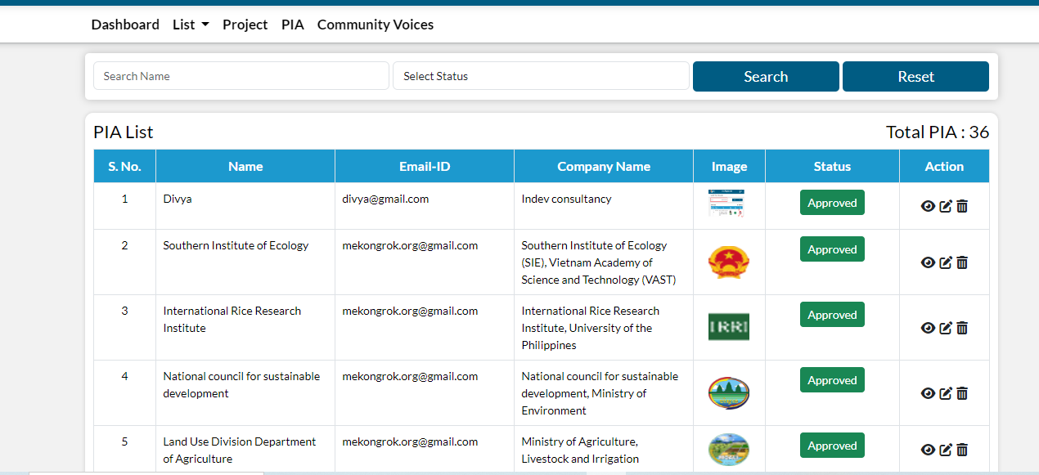
Community Voices
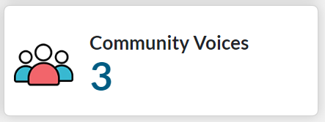
The card represents all the count of community voices, which is added by the CMS.

When you click on the card, the number of community voices is appears. Included Name, Profession, story, image, status, and action.

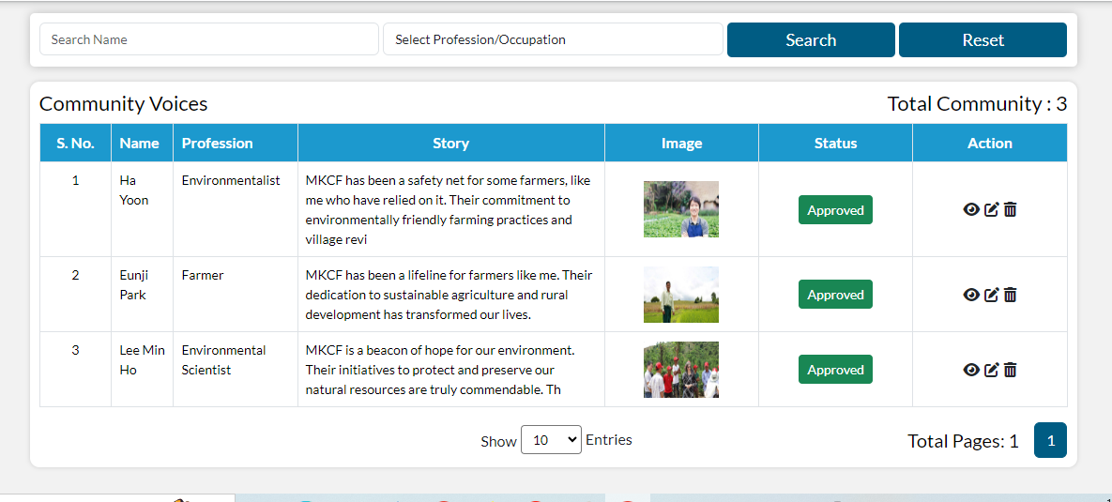

Below is the project indicator which shows the projects country wise.

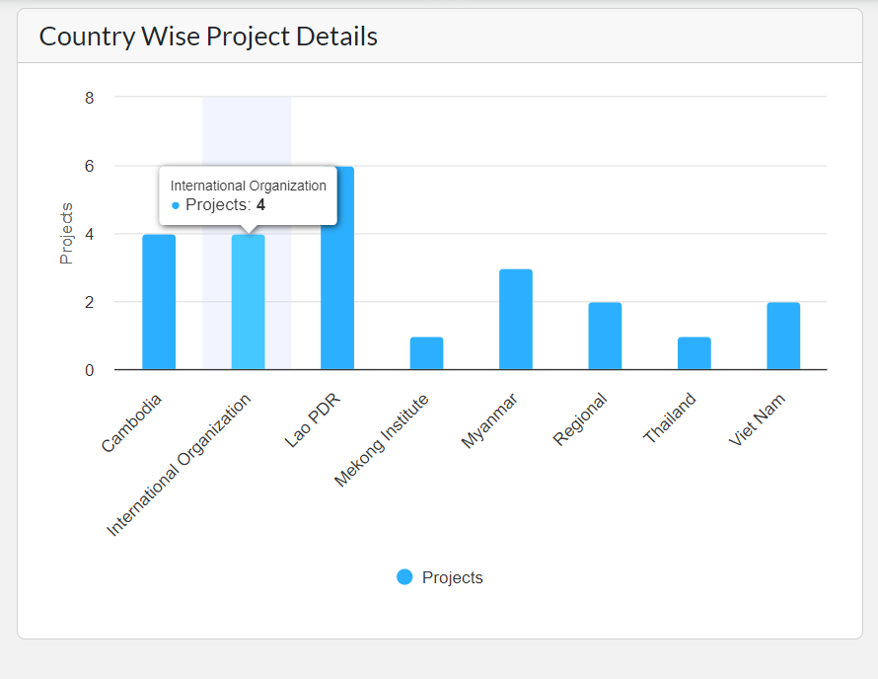

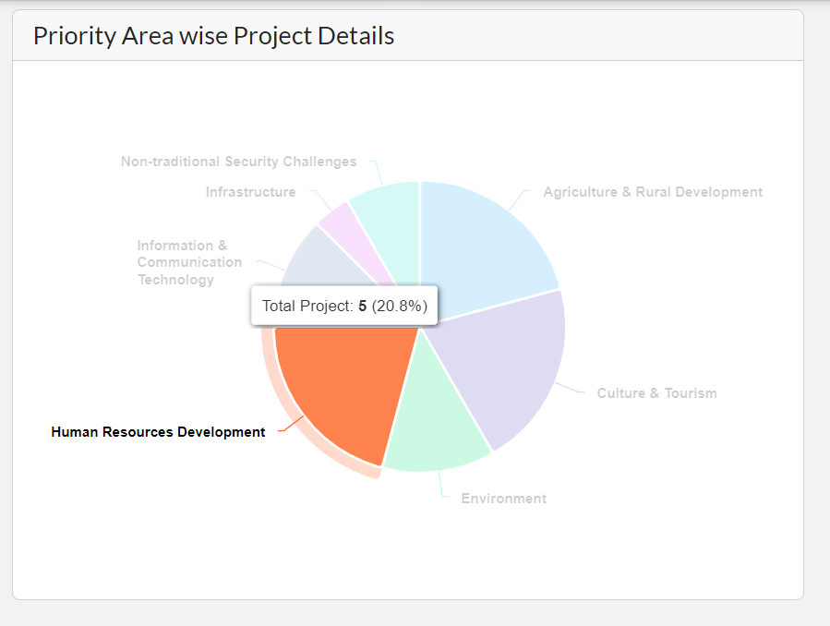

Here admin can filter the data by country and priority area wise for more accurate information.

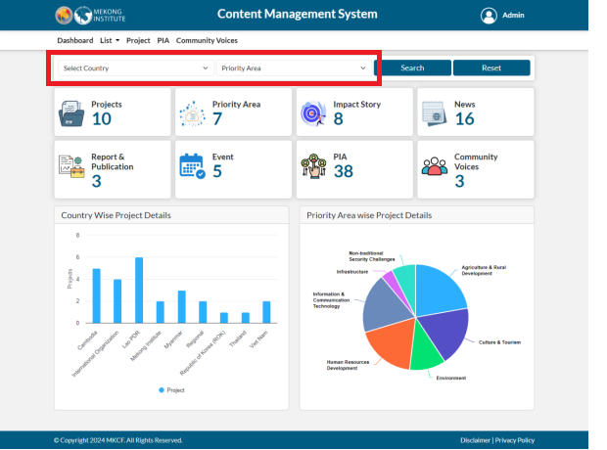

List
Admin can see the list on the header which comprises of news, impact story, report, and publication, announcement, priority Area, and multimedia.

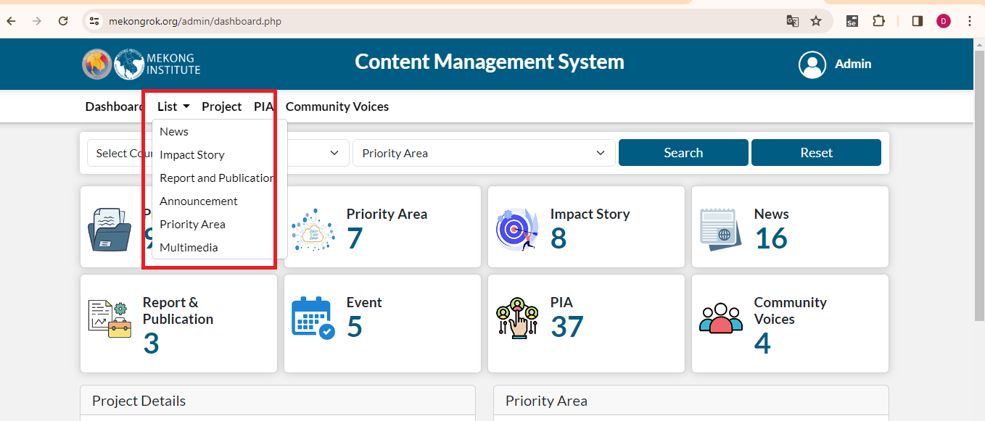
Admin can view all the list of News, Impact Story, Report and publication, announcement, priority area, and multimedia by clicking on the following options.

News
Admin can see the list of news submitted and admin can filter the data by title and news. For adding a news, click on add button present on the right corner.

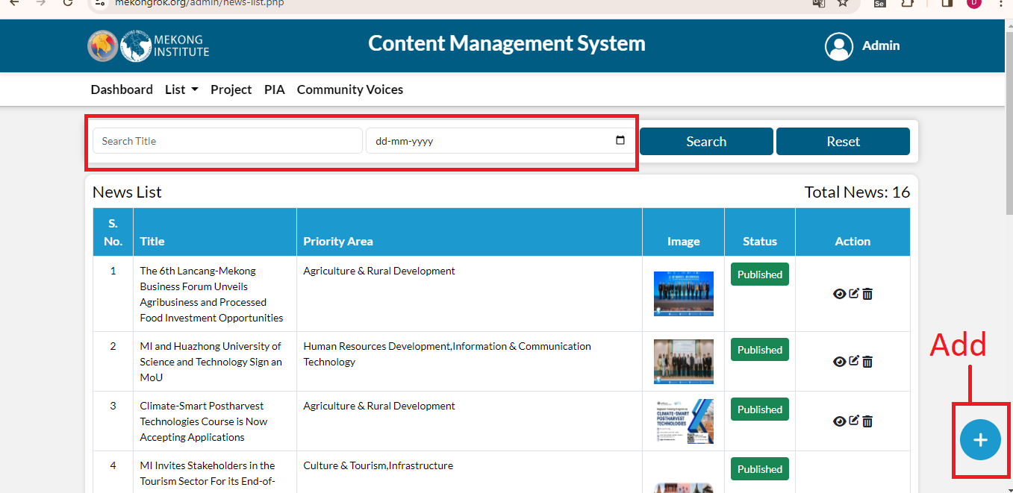

After clicking on add icon, fill the following details and then click on submit button.
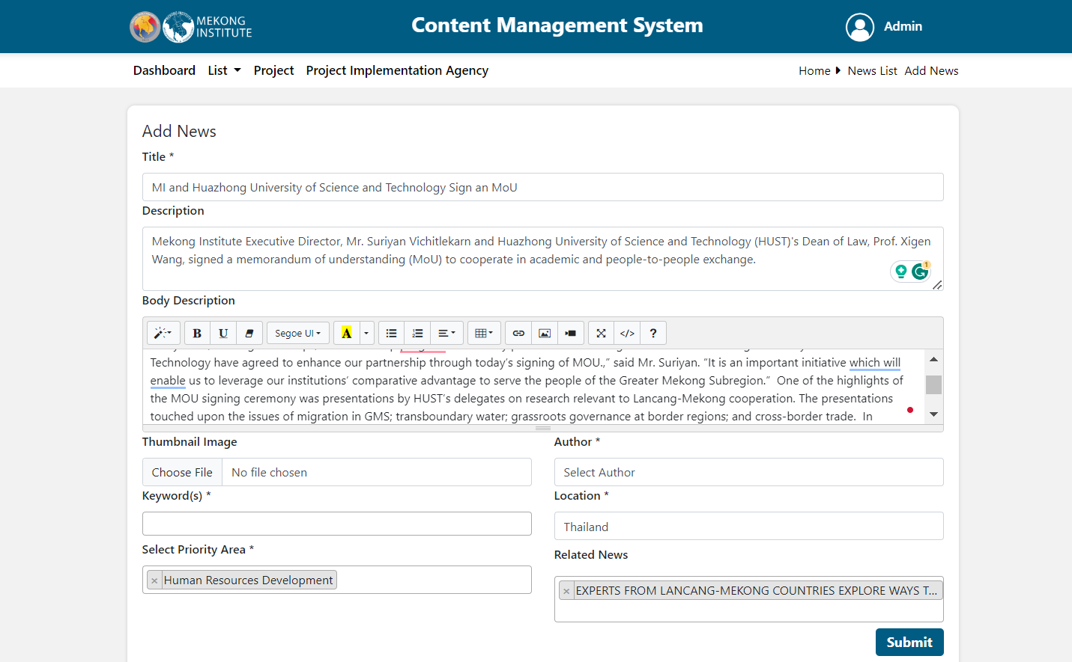

When admin submit a news, a draft will be created. If user want to publish or unpublish this news, click on the draft icon then select publish or reject.
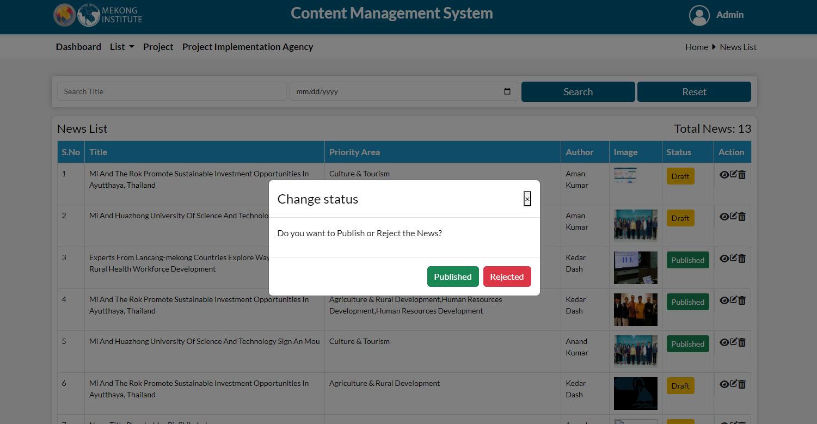

Using the options shown under action section, admin can take any action of viewing, editing and deleting.
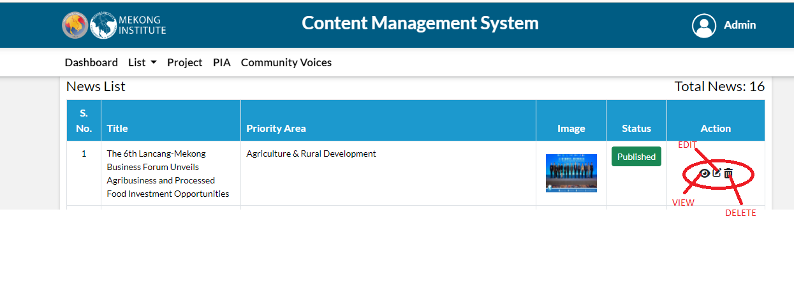
When you click on the view button news details page is open, here you can see the news in details also see the related news.
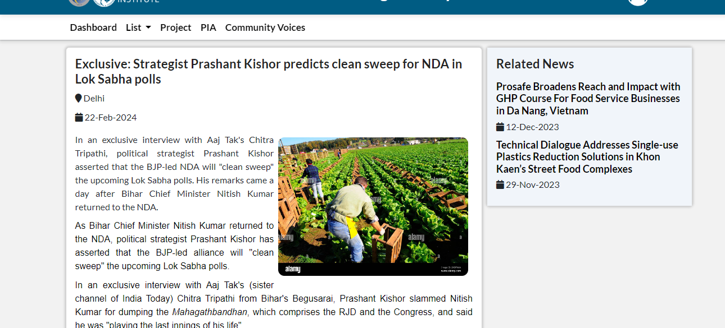

When you click on edit, edit form is open and you can edit all the fields and update the news.
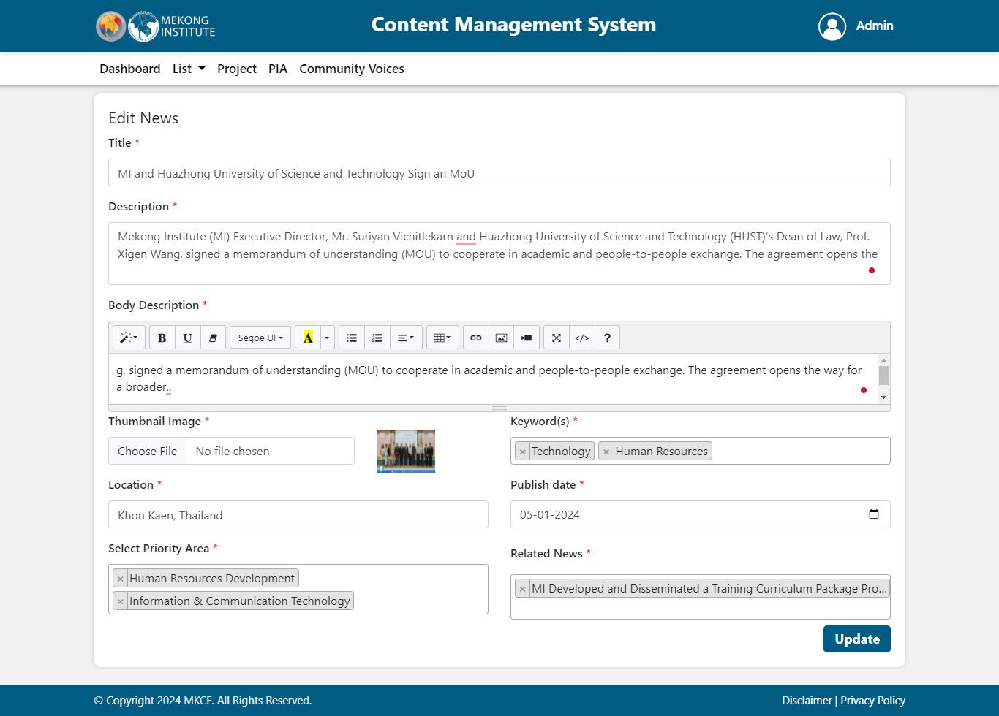
When you click on the delete popup message is shows, if you click on the delete that news is deleted from the list.
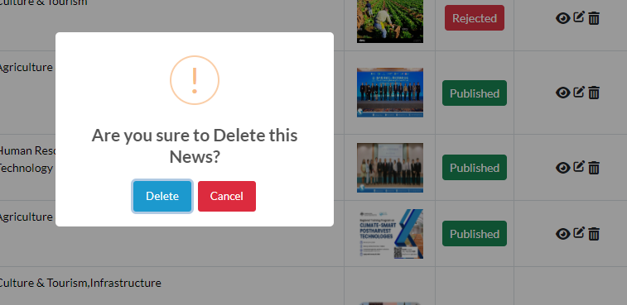

Impact Story
Admin can see the list of impact stories already submitted. For adding an Impact Story, click on add button present on the right corner. By clicking on the download button in the document section, user can download the file.

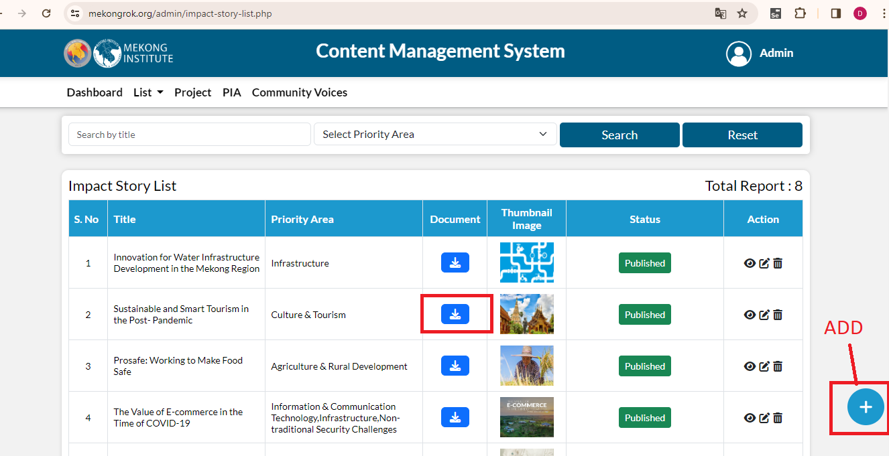
After clicking on add icon, fill the following details and then click on submit button.
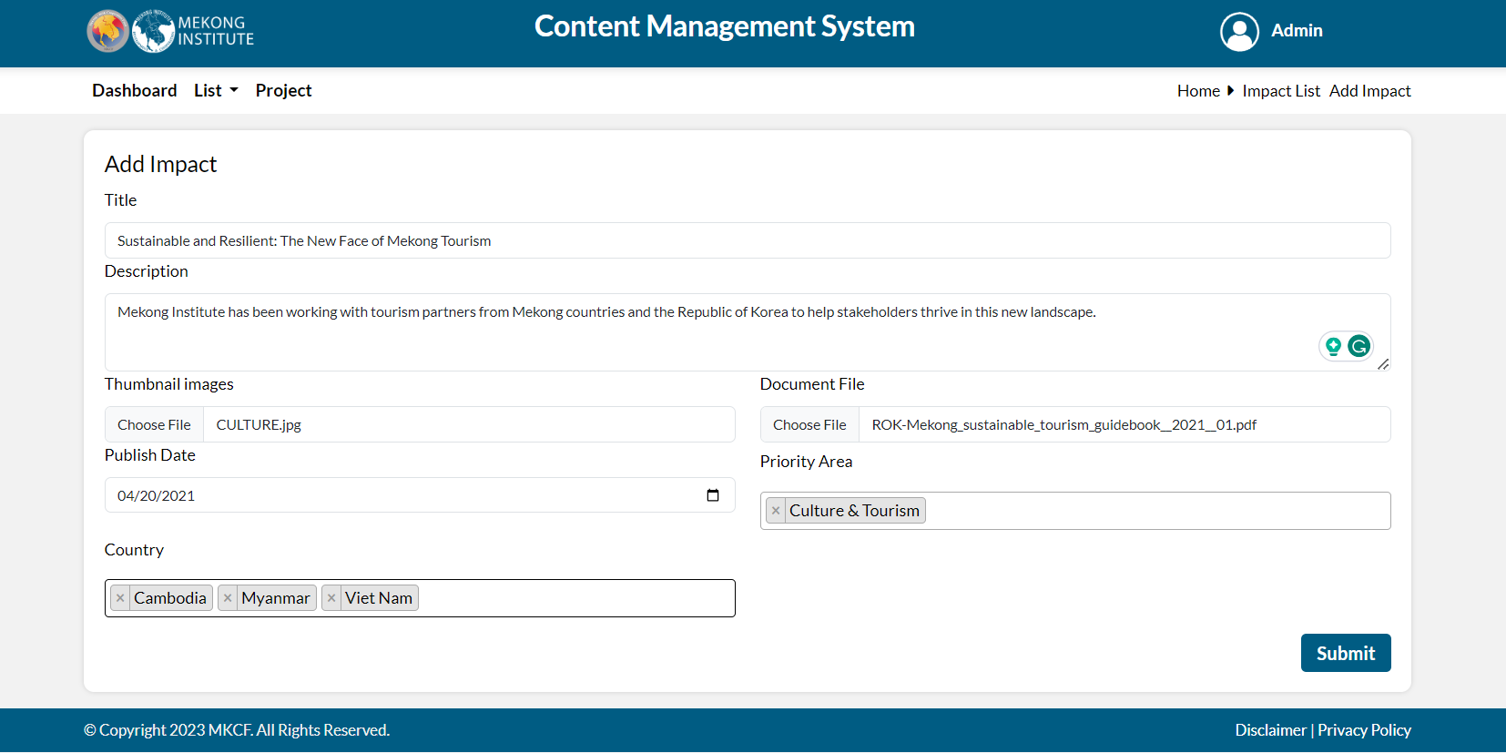
When user submit an impact story a draft will be created. If user want to publish or unpublish this impact story click on the draft icon then select published or rejected.
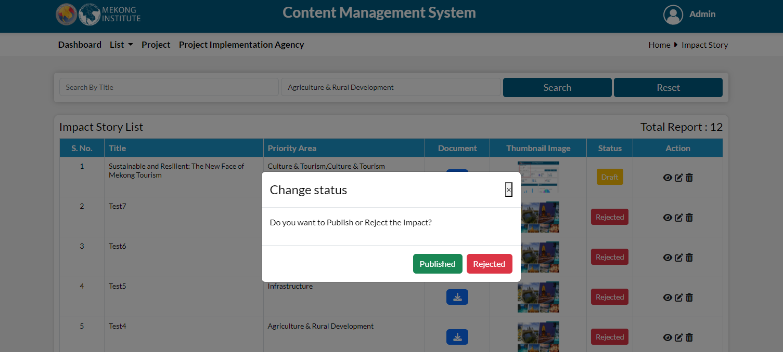
Admin can filter the data by title and Priority area. Using the options shown under action icon, admin can take any action of viewing, editing and deleting.
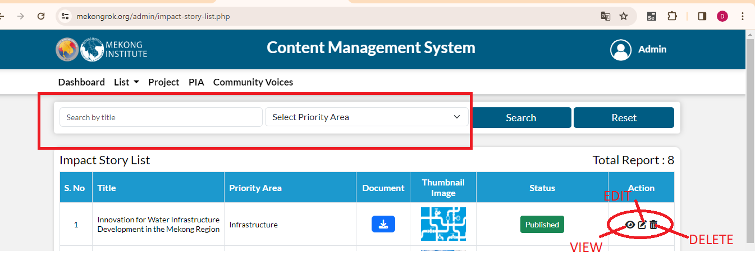

When you click on the view button details page is open, here you can see the impact story in details.
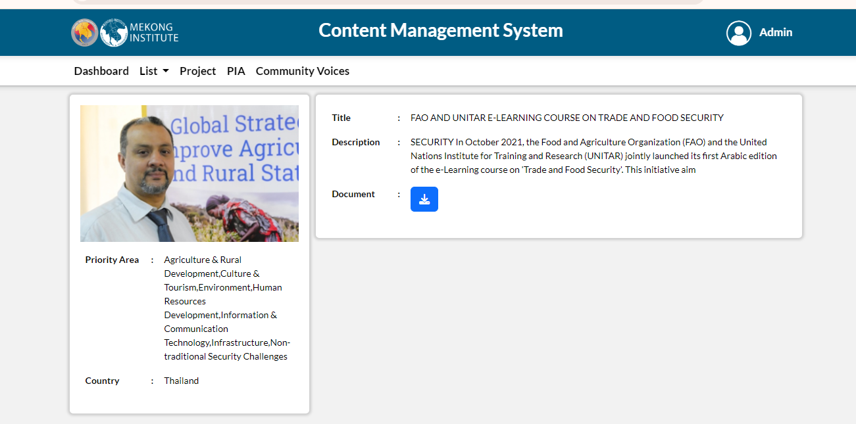

When you click on edit, edit form is open and you can edit all the fields and update the story.
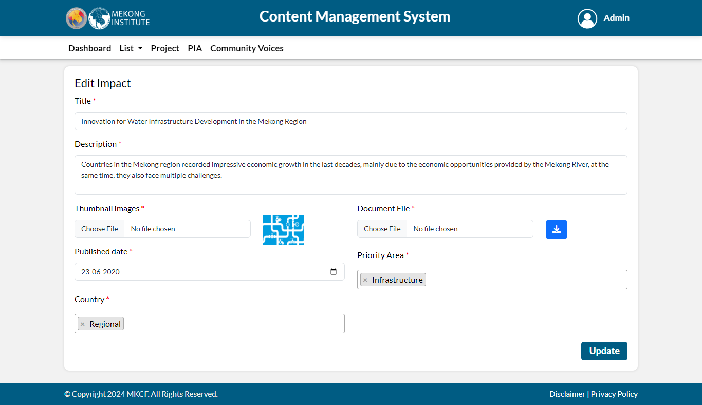

When you click on the delete, popup message is shows, if you click on the delete that story is deleted from the list.
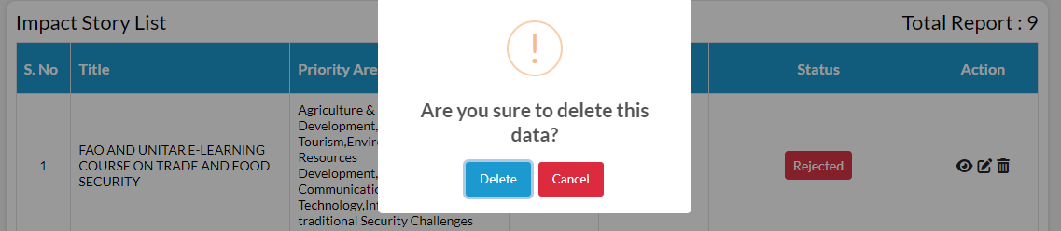

Report and Publication
Admin can see the list of report and publication already submitted. By clicking on the download button in the document section, user can download the file. For adding a report or publication, click on add button present on the right corner.

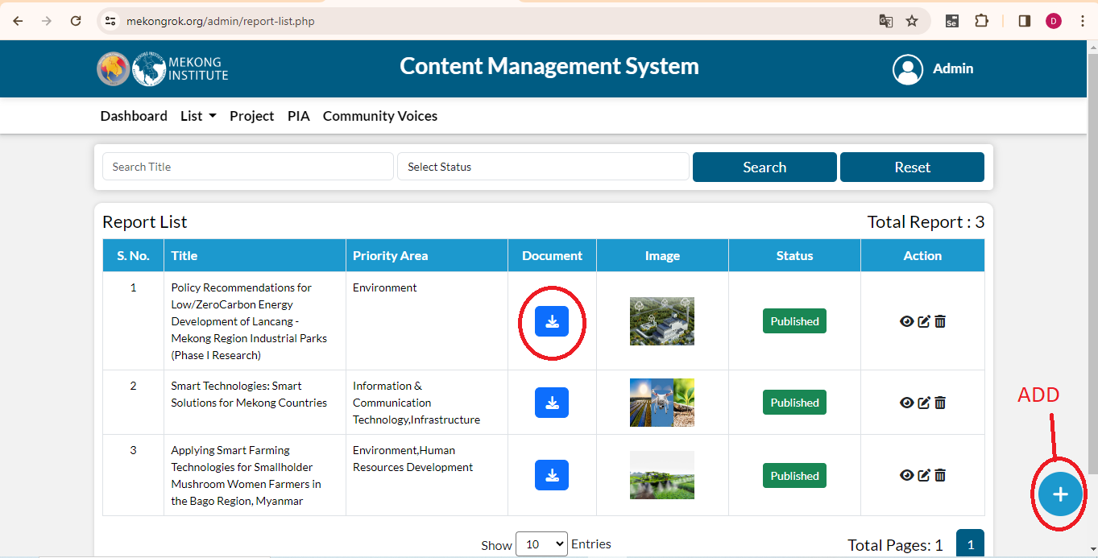
After clicking on add icon, fill the following details and then click on submit button
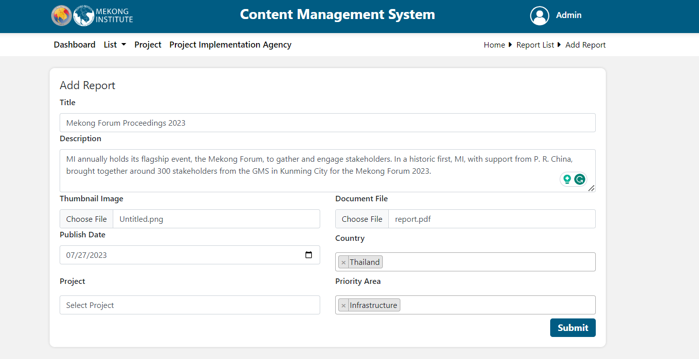
When user submit a report or publication a draft will be created. If the user want to publish or unpublish this report or publication, click on the draft icon then select publish or reject.
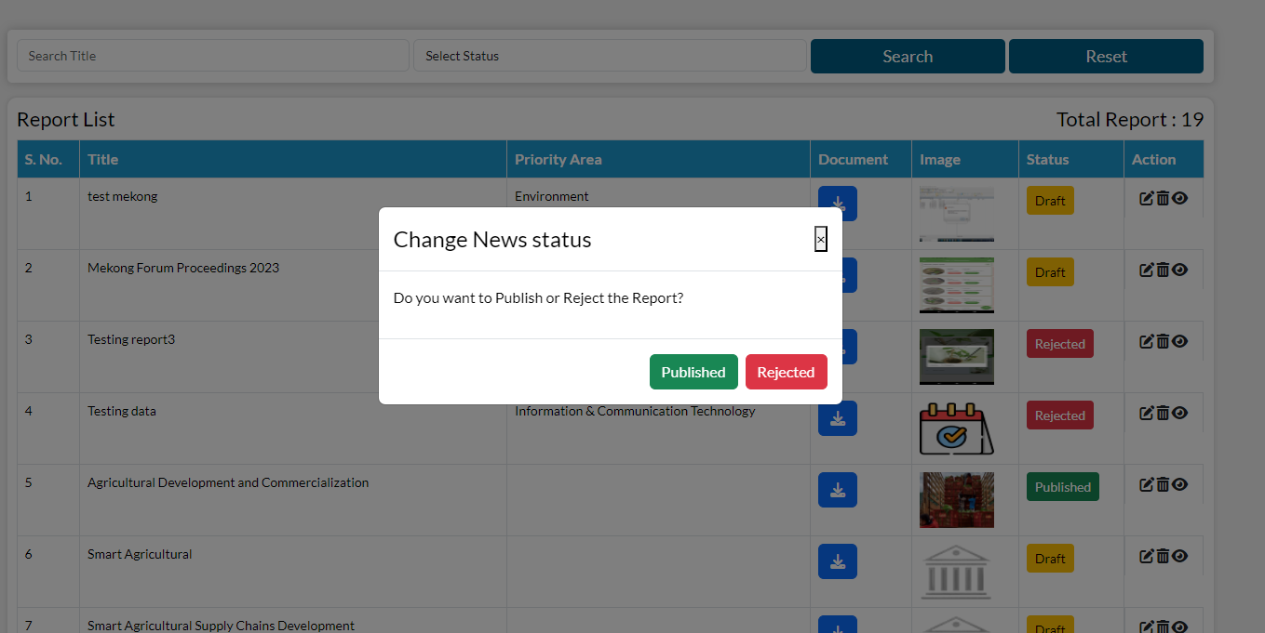
Admin can filter the data by title and Status. Using the options shown under action, user can take any action of viewing, editing and deleting.
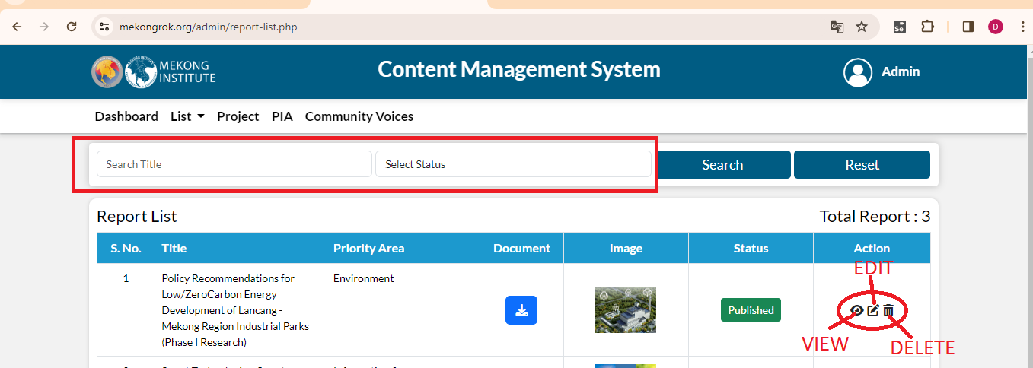

When you click on the view button details page is open, here you can see the report in details.
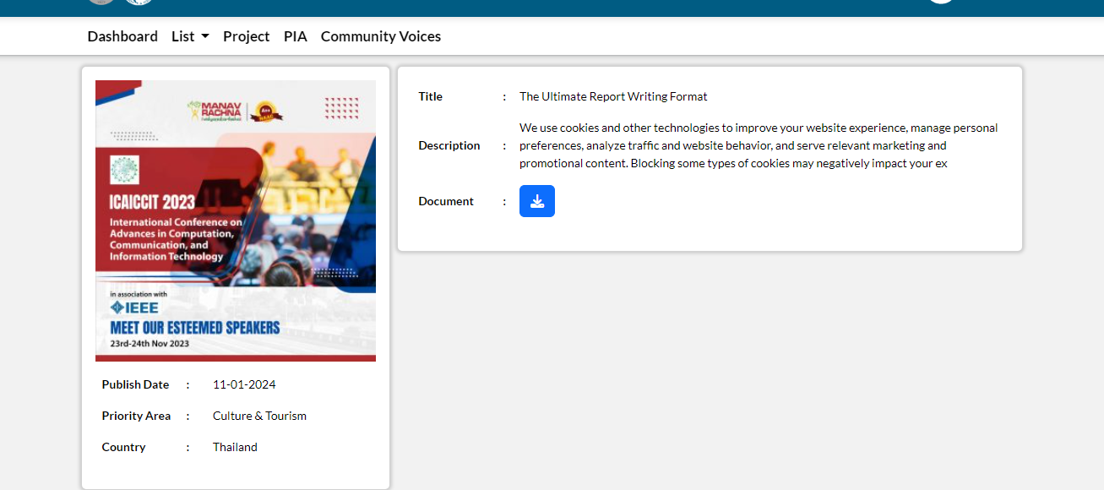
When you click on edit, edit form is open and you can edit all the fields and update the report.
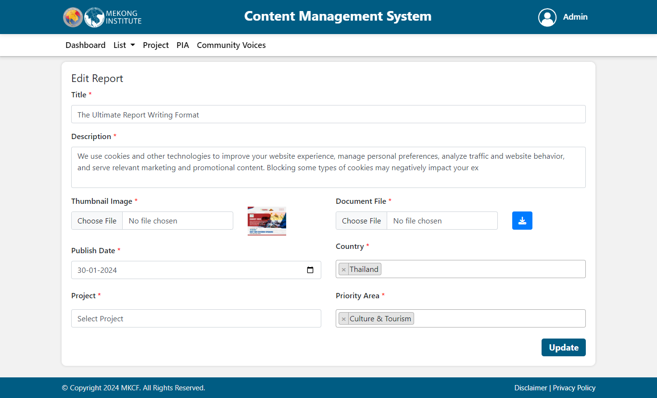
When you click on the delete popup message is shows, if you click on the delete that report is deleted from the list.
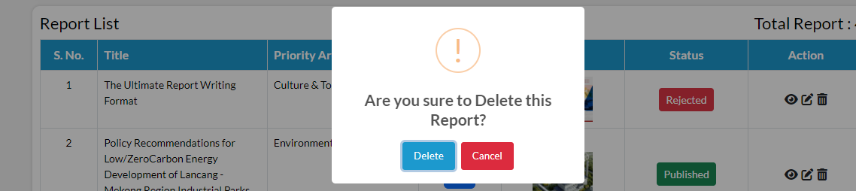

Announcement
Admin can see the list of report and publication already submitted. For adding a report or publication, click on add button present on the right corner.
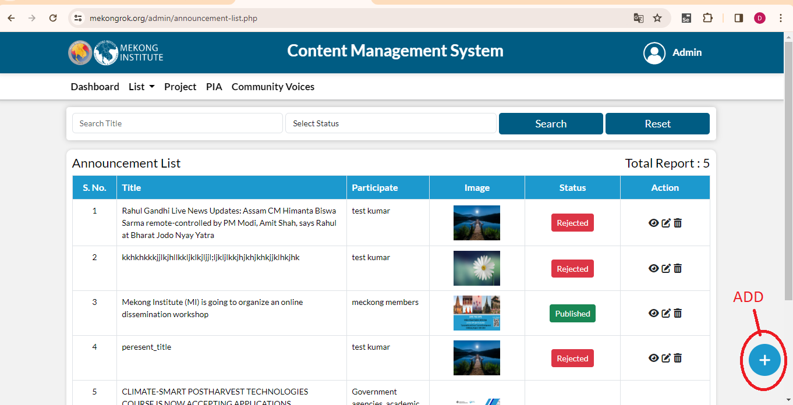
After clicking on add icon, fill the following details and then click on submit button.
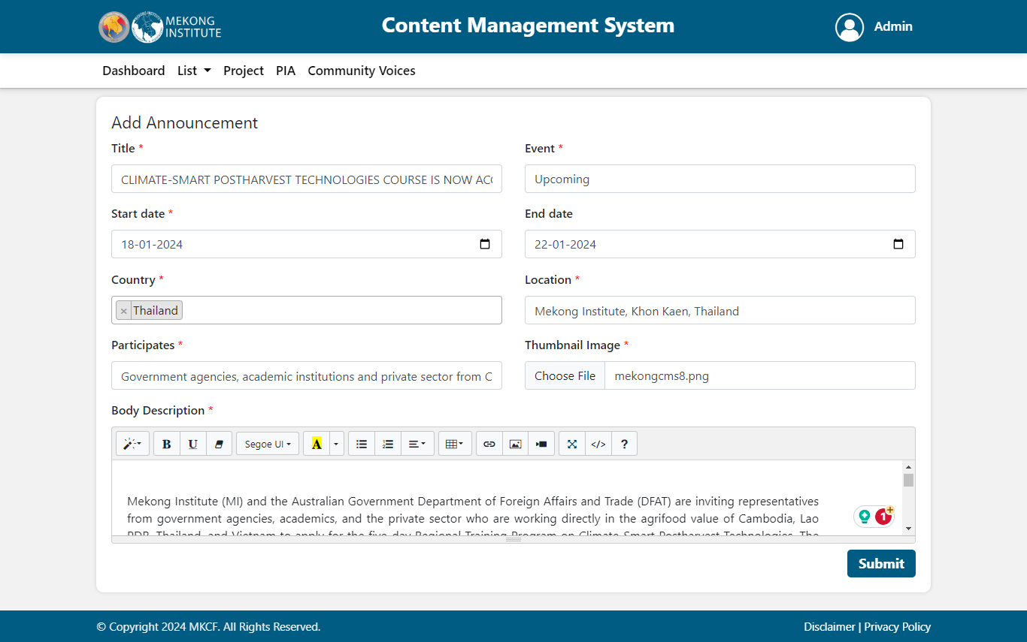
When user submit a report or publication a draft will be created. If the user want to publish or unpublish this report or publication, click on the draft icon then select publish or reject.
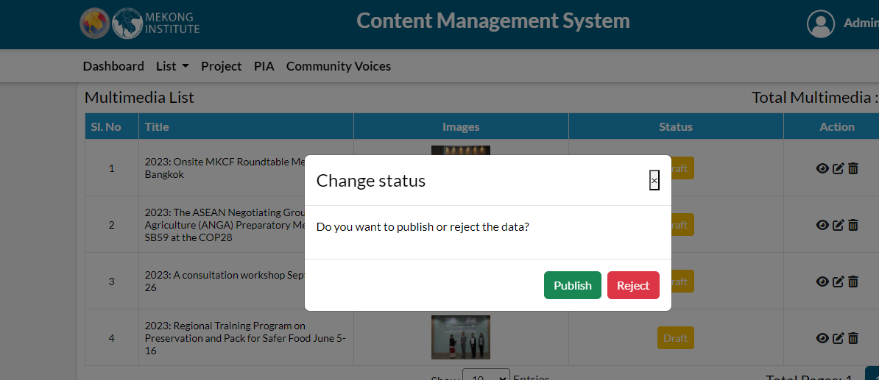
Admin can filter the data by title and Status. Using the options shown under action, user can take any action of viewing, editing and deleting.
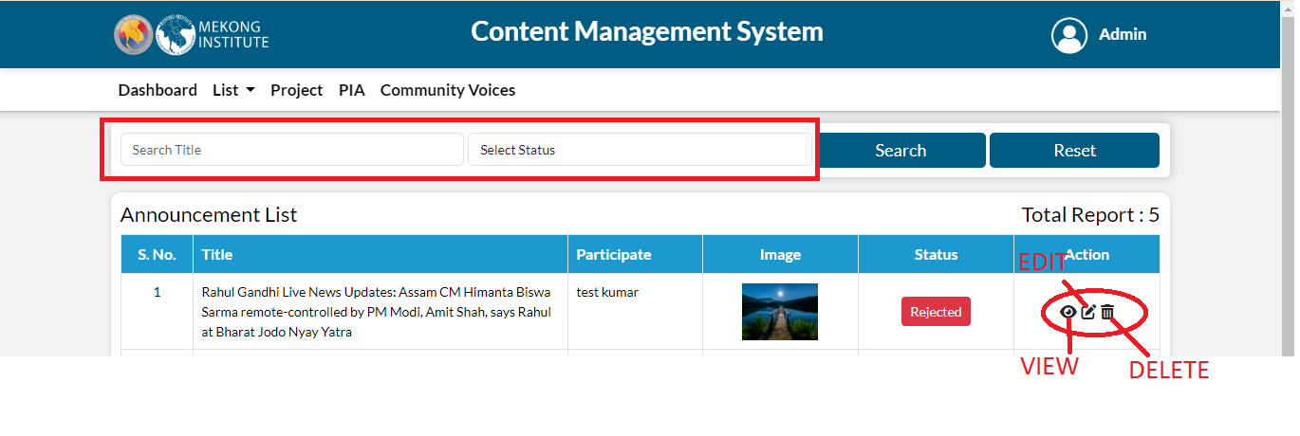
When you click on the view button event details page is open, here you can see the announcement in details.
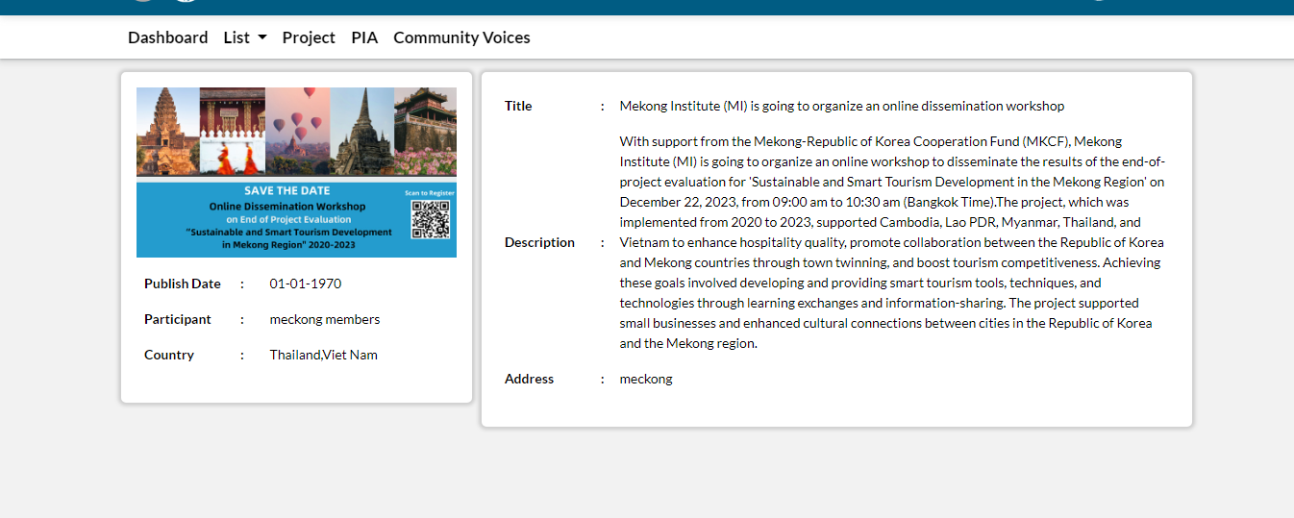
When you click on edit, edit form is open and you can edit all the fields and update the event.
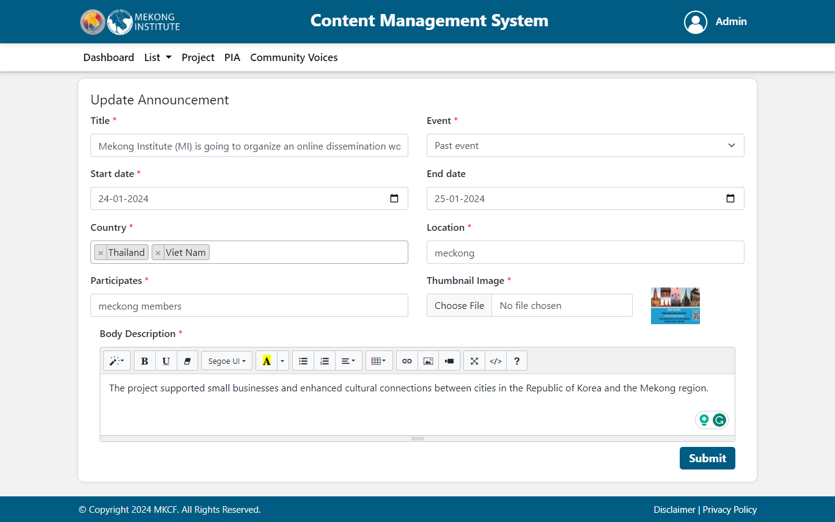
When you click on the delete popup message is shows, if you click on the delete that event is deleted from the list.
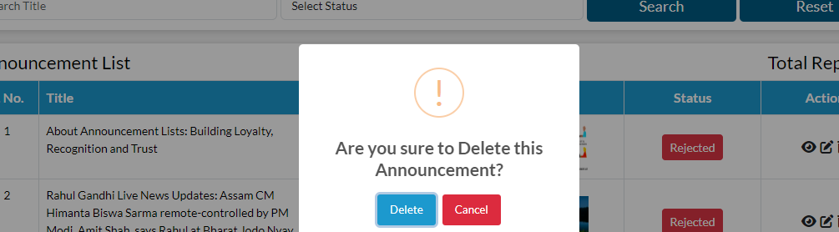

Priority Area
Admin can see the list of report and publication already submitted. For adding a report or publication, click on add button present on the right corner.
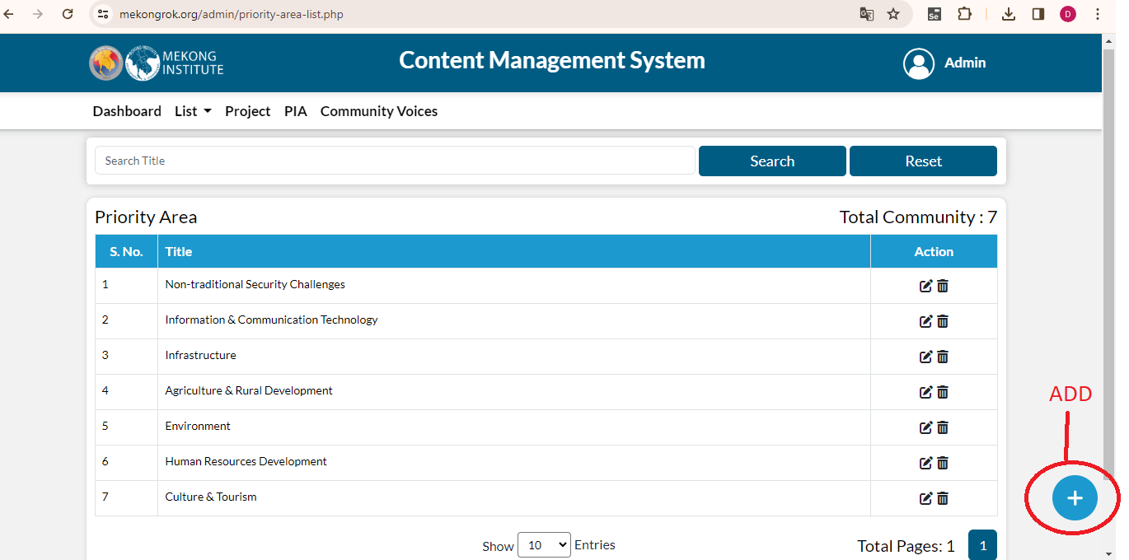
After clicking on add icon, fill the details and then click on submit button.
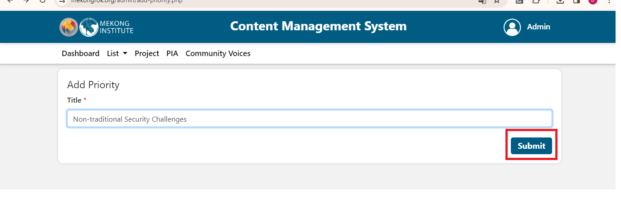
Admin can filter the data by title.Using the options shown under action, user can take any action editing and deleting.
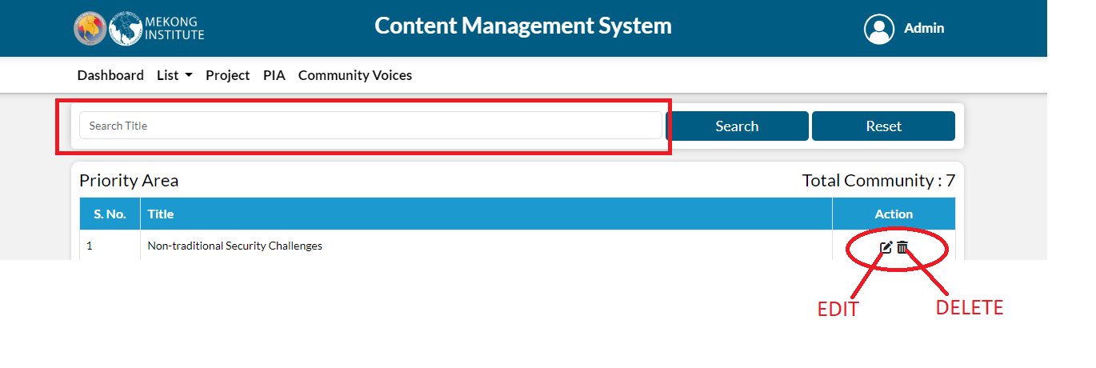
When you click on edit, edit form is open and you can update the priority area.
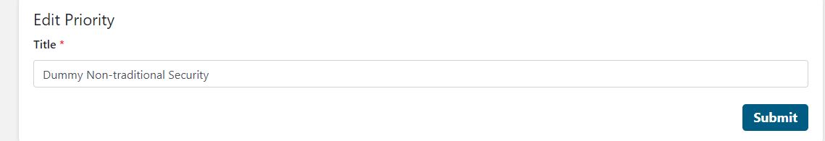
When you click on the delete popup message is shows, if you click on the delete that priority area is deleted from the list.
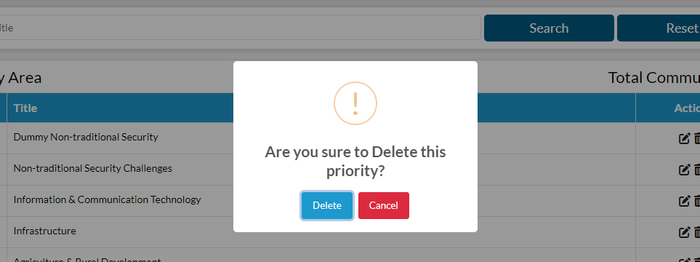

Multi-media
Admin can see the list of multimedia already submitted. For adding a multimedia, click on add button present on the right corner.
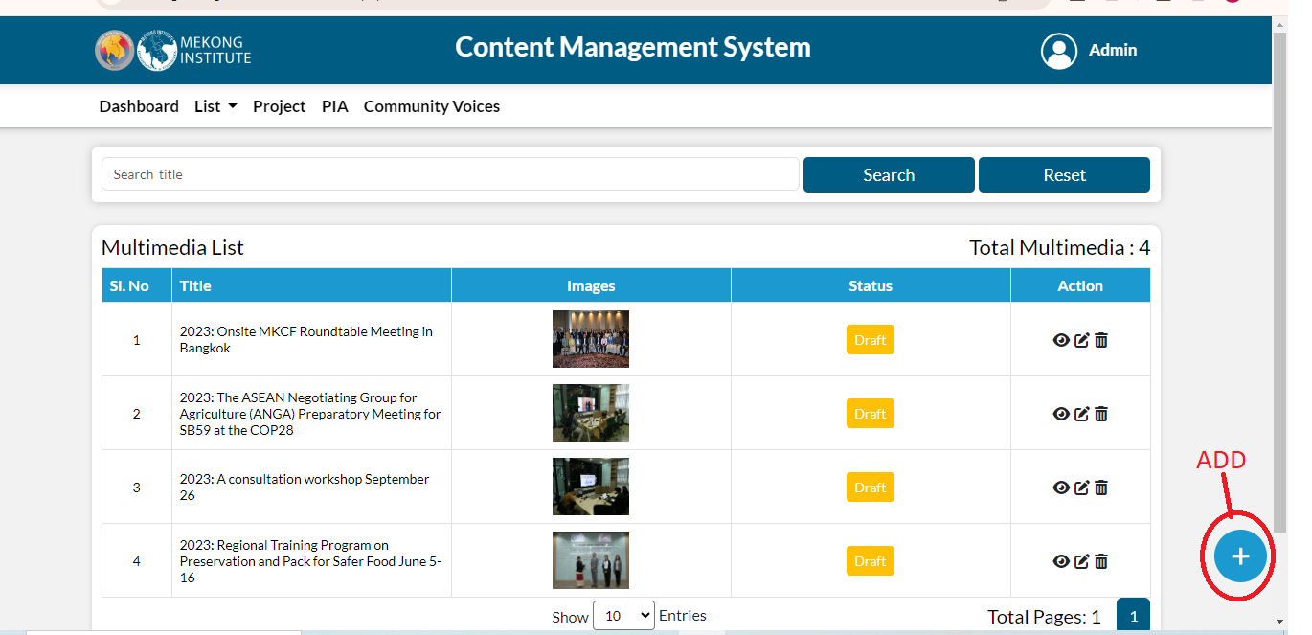
After clicking on add icon, fill the details and then click on submit button.
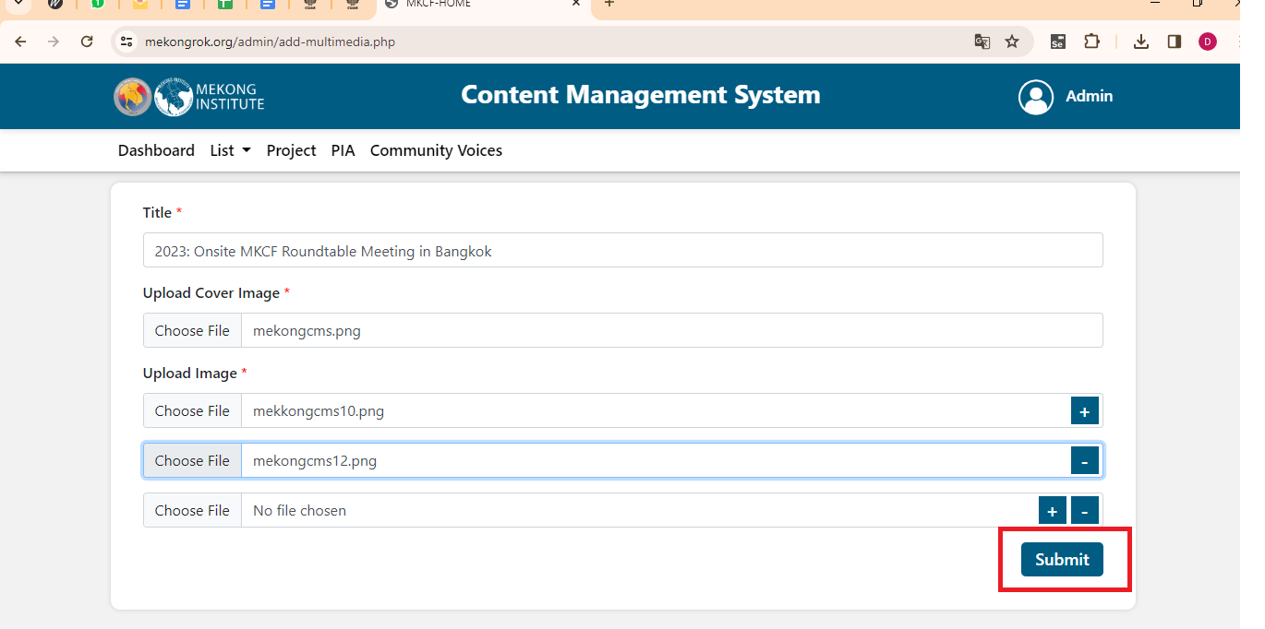
When user submit a multimedia a draft will be created. If the user want to publish or unpublish this multimedia, click on the draft icon then select publish or reject.
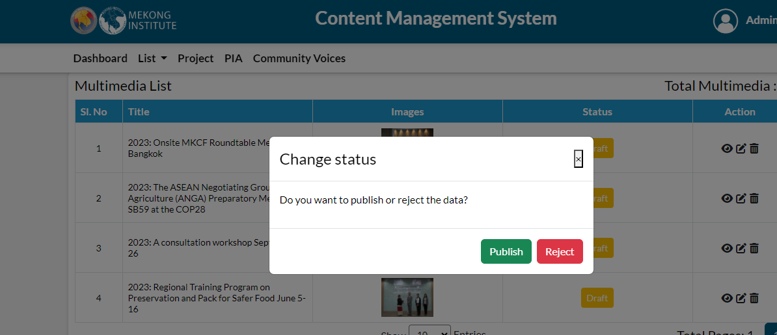
Admin can filter the data by title.Using the options shown under action, user can take any action of viewing, editing and deleting.
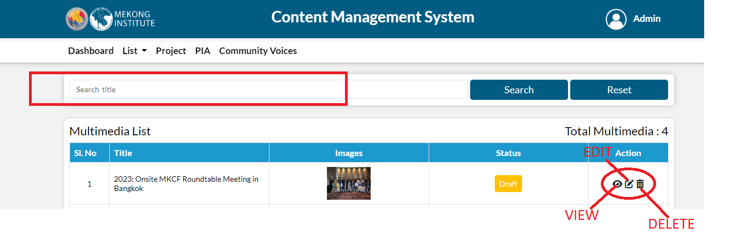
When you click on the view button details page is open, here you can see the media in details.
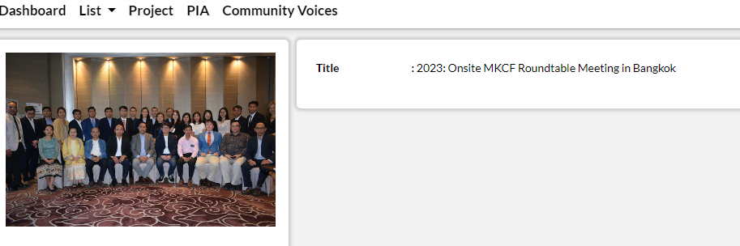
When you click on edit, edit form is open and you can edit all the fields and update the multimedia.
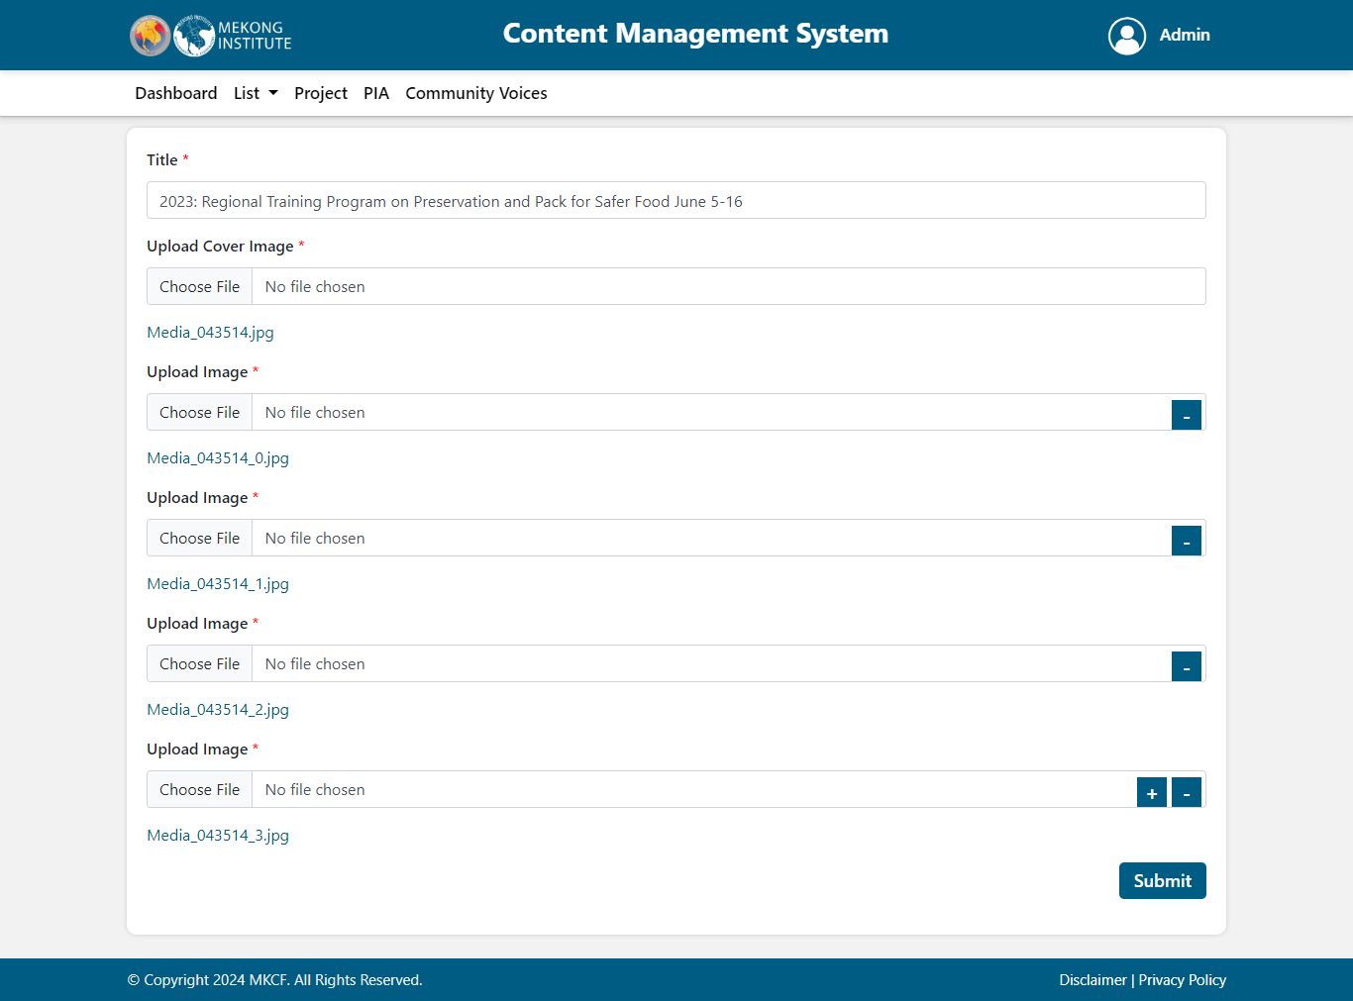
When you click on the delete popup message is shows, if you click on the delete that media is deleted from the list.
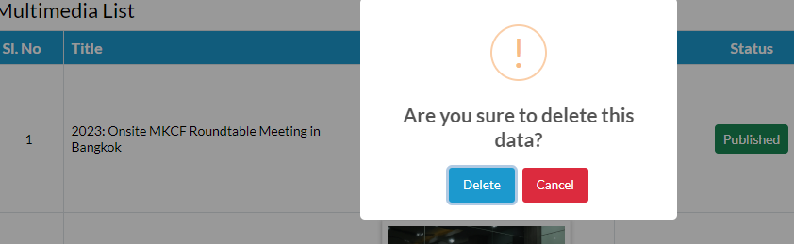

Project
Admin can see the list of projects already submitted. For adding a project, click on add option present on the right corner.

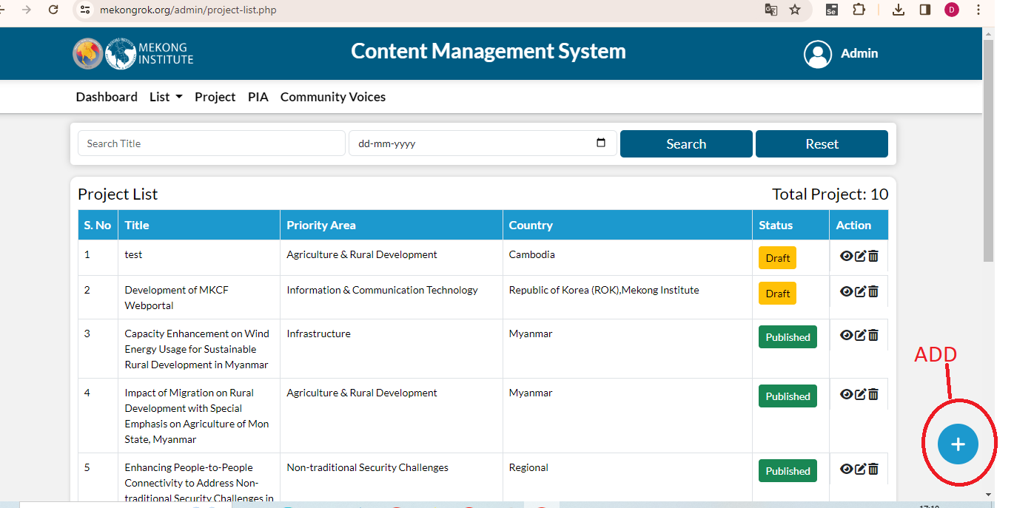
After clicking on add icon, fill the following details and then click on submit button.
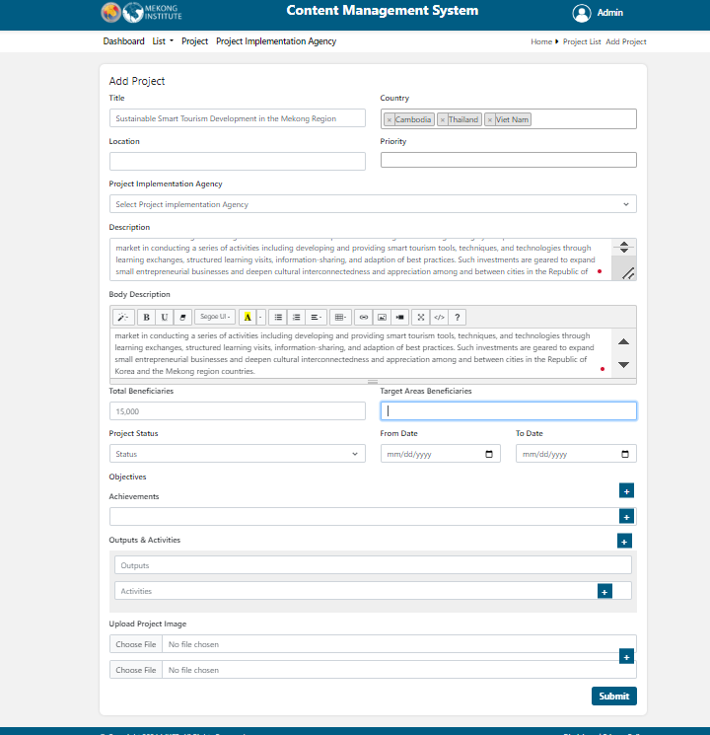
After submitting a project, the admin will approve or reject the project then it will be shown on the web portal.
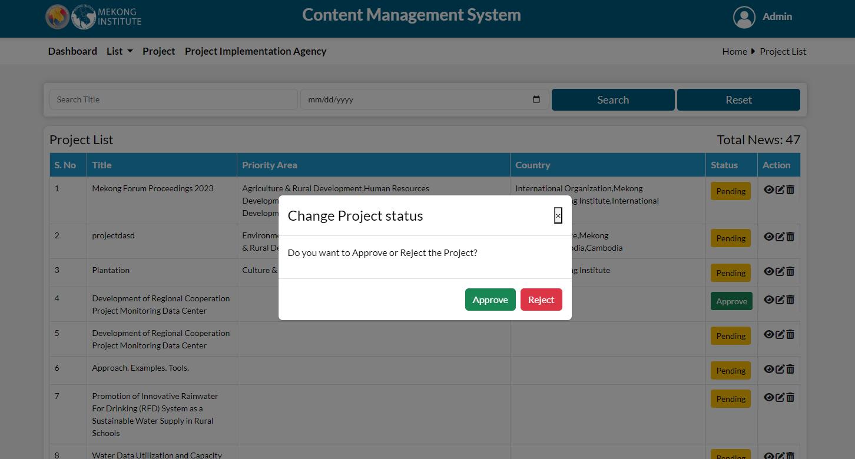
Admin can filter the data by title and Date. Using the options shown under action, user can take any action of viewing, editing and deleting.
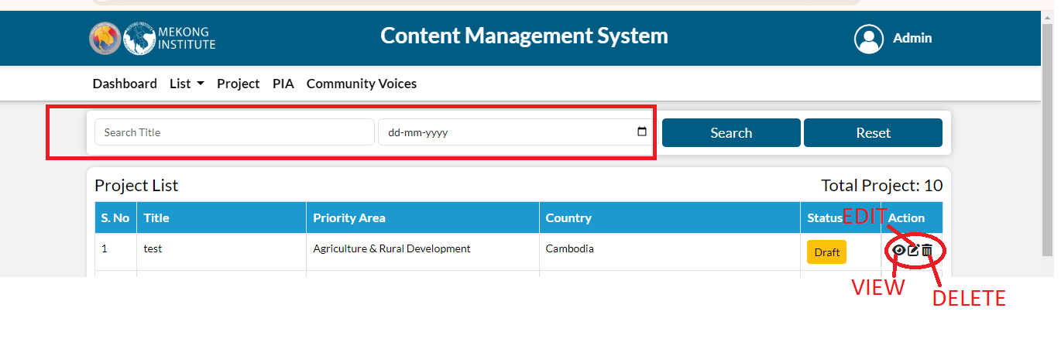
When you click on the view button project details page is open, here you can see the project in details.
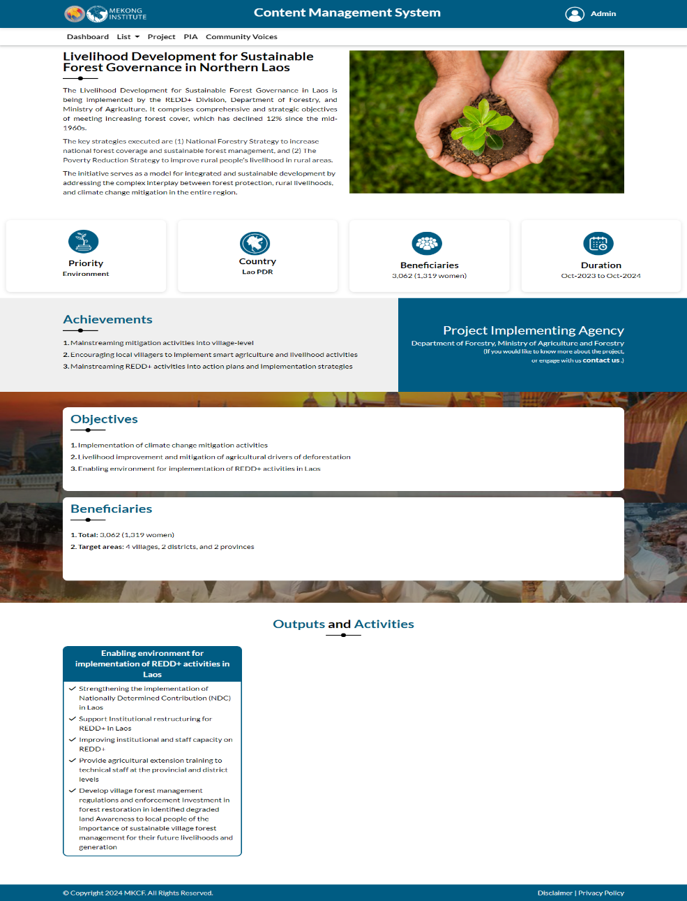

When you click on edit, edit form is open and you can edit all the fields and update the project.
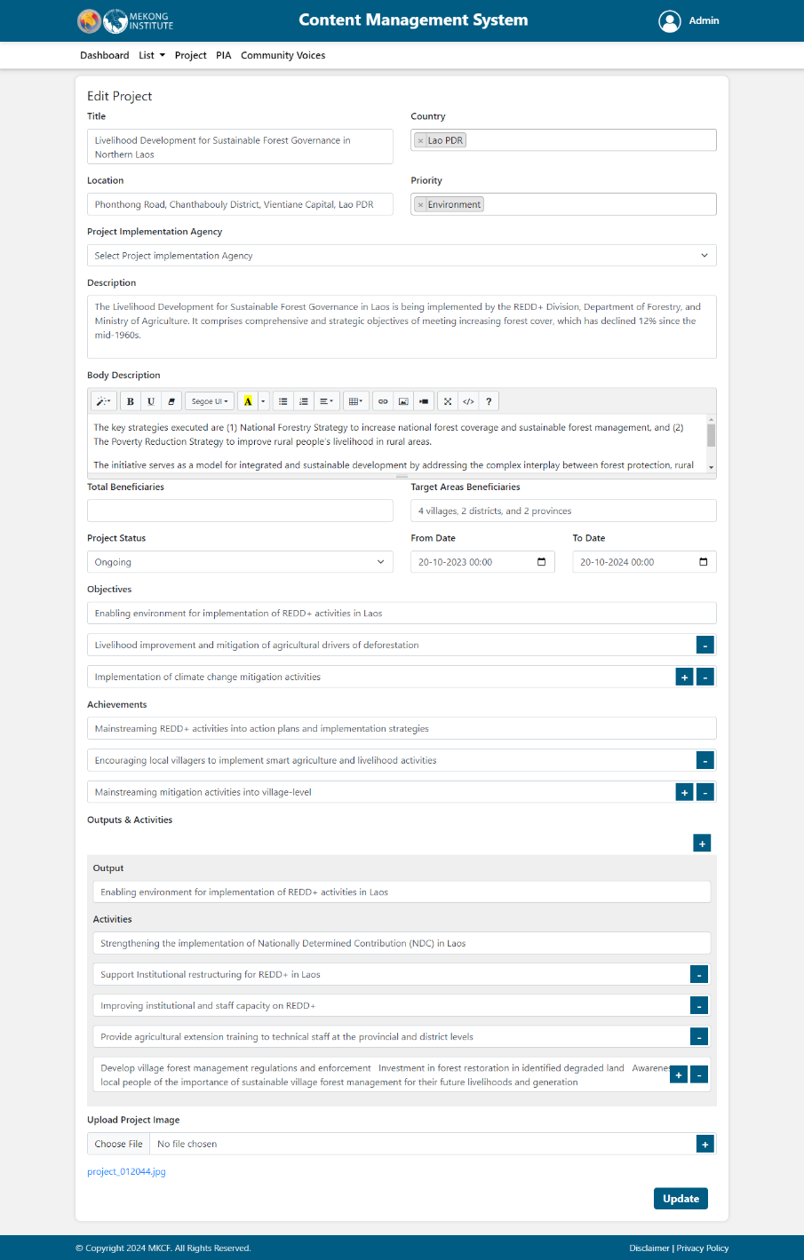
When you click on the delete popup message is shows, if you click on the delete that project is deleted from the list.
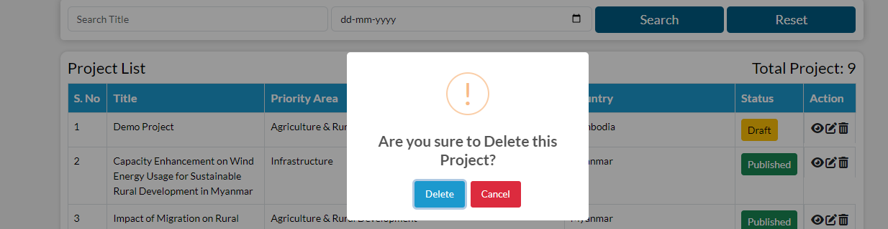

PIA
Admin can see the list of PIA already submitted. For adding a PIA, click on add option present on the right corner.
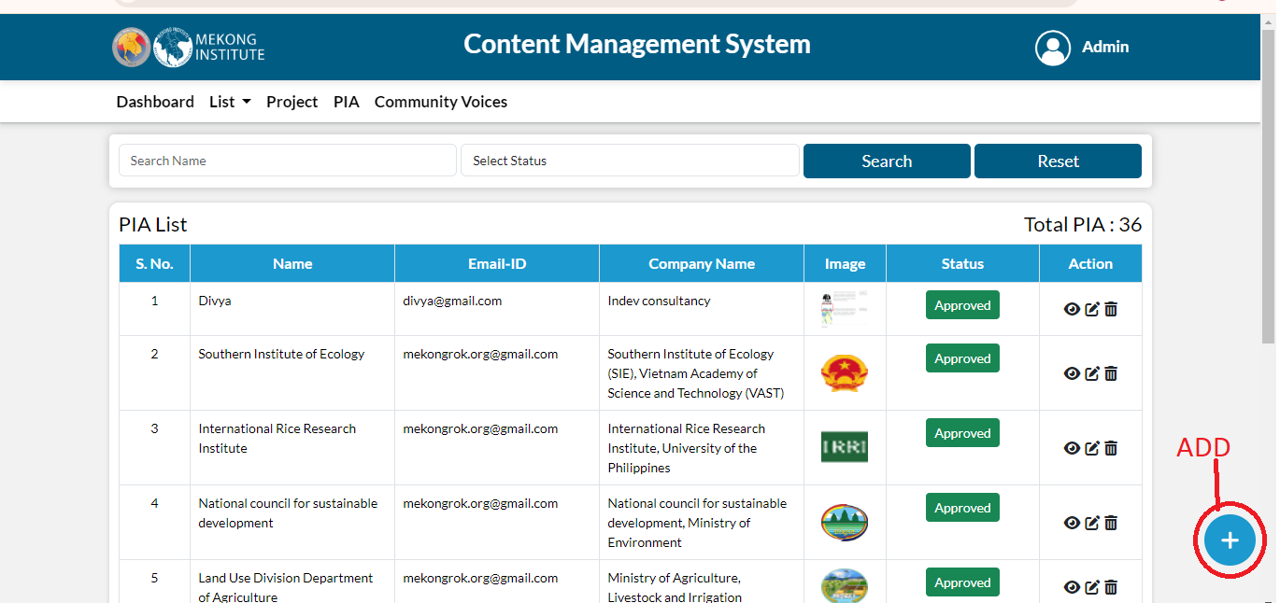
After clicking on add icon, fill the following details and then click on submit button.
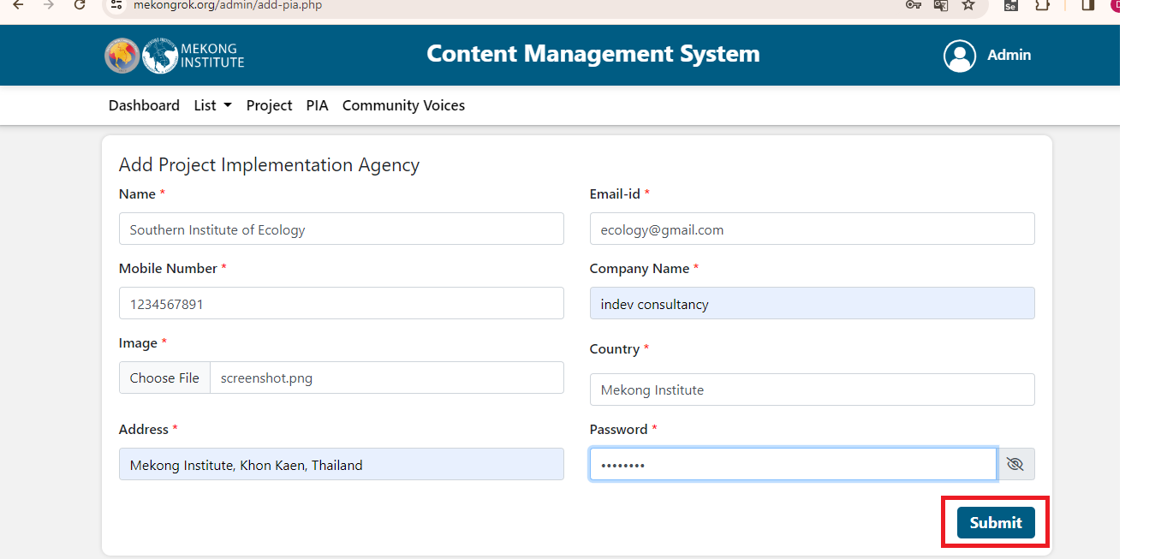
After submitting, the admin will approve or reject the PIA then it will be able to login on the web portal.
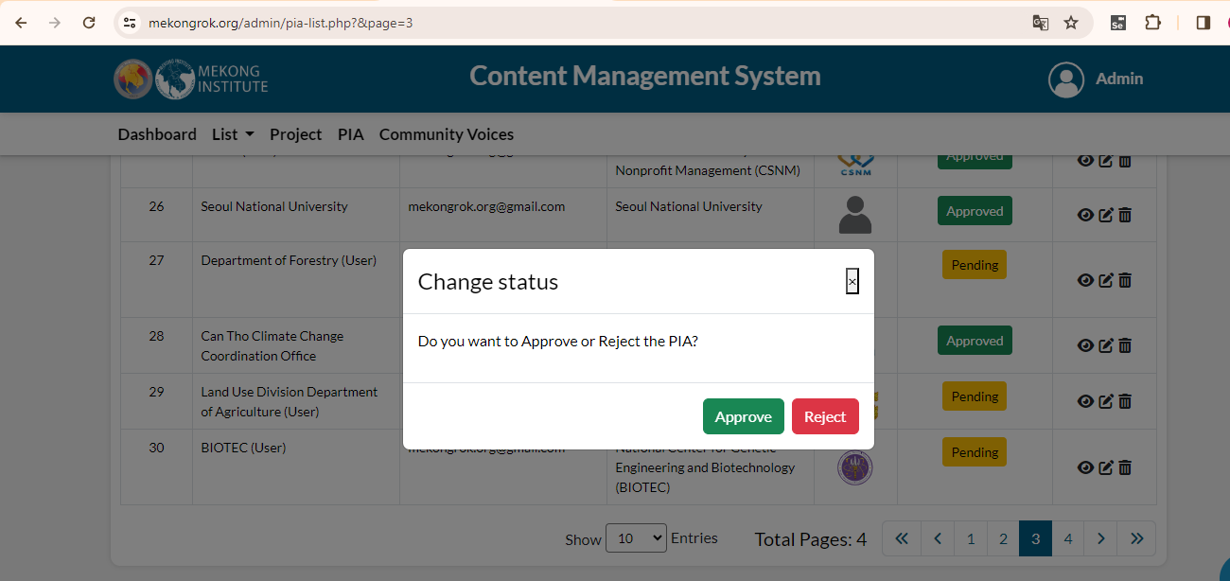
Admin can filter the data by Name and Status. Using the options shown under action, user can take any action of viewing, editing and deleting.
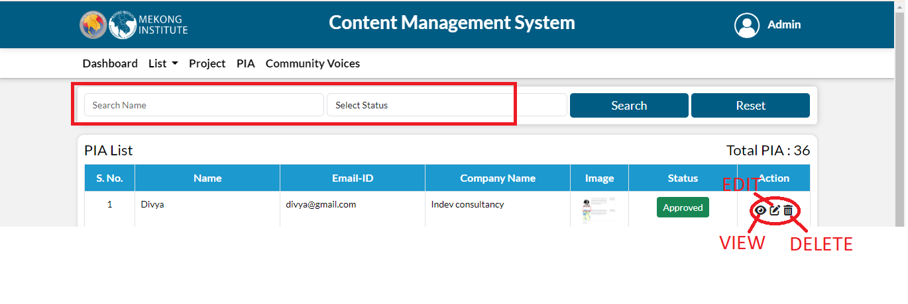
When you click on the view button details page is open, here you can see the PIA in details.
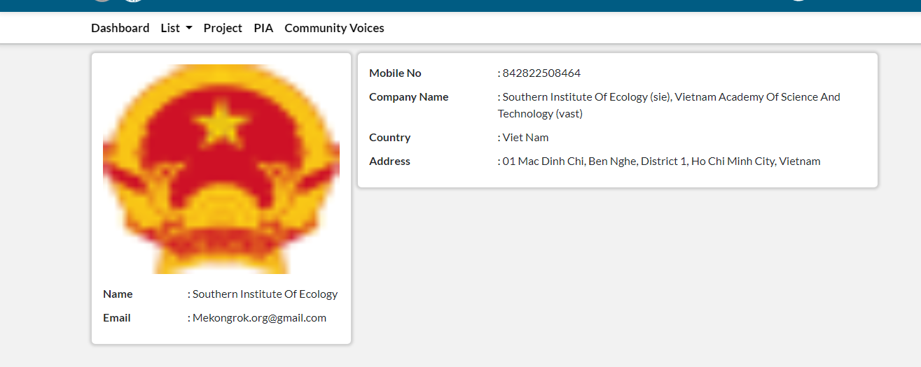
When you click on edit, edit form is open and you can edit all the fields and update the PIA.
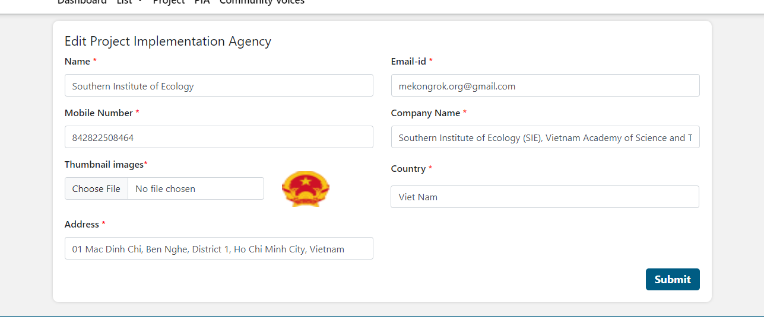
When you click on the delete popup message is shows, if you click on the delete that PIA is deleted from the list.
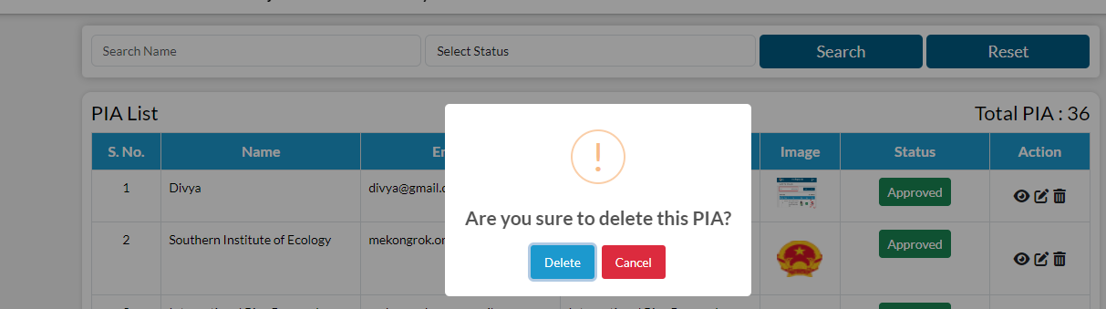

Community Voices
Admin can see the list of projects already submitted.
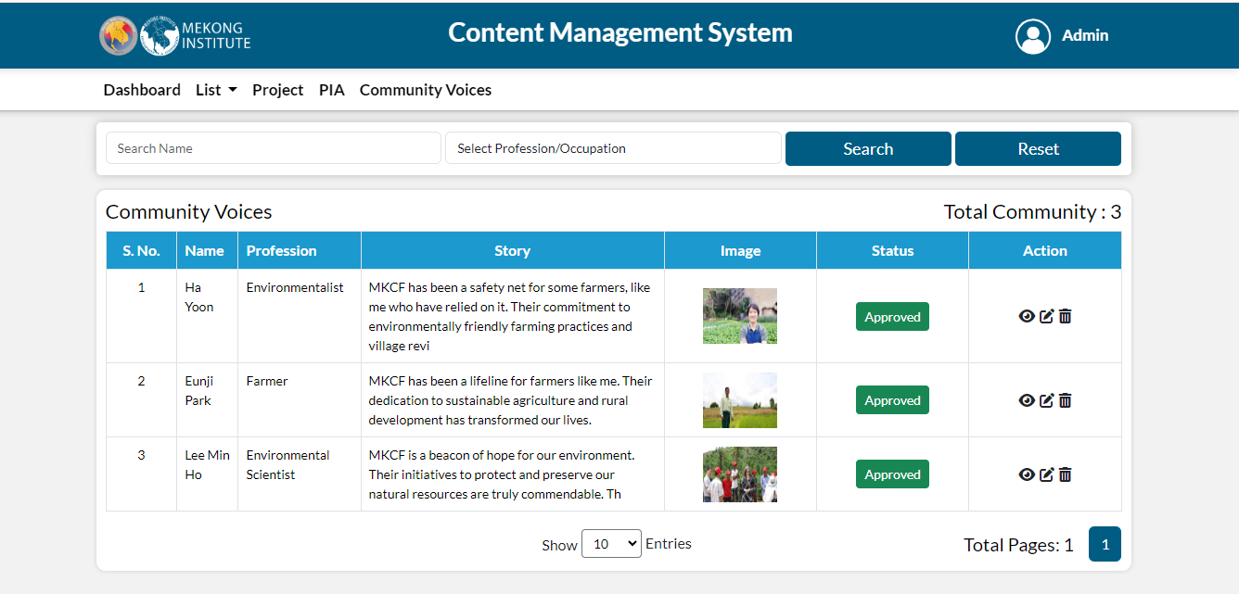
The admin will Change the status approve or reject.
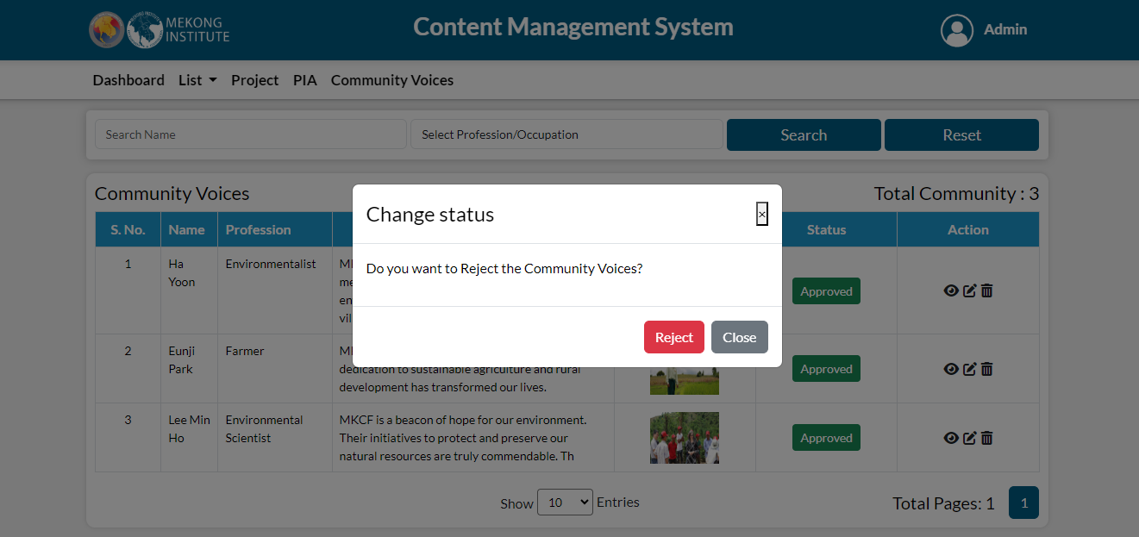
Admin can filter the data by Name and Profession. Using the options shown under action, user can take any action of viewing, editing and deleting.
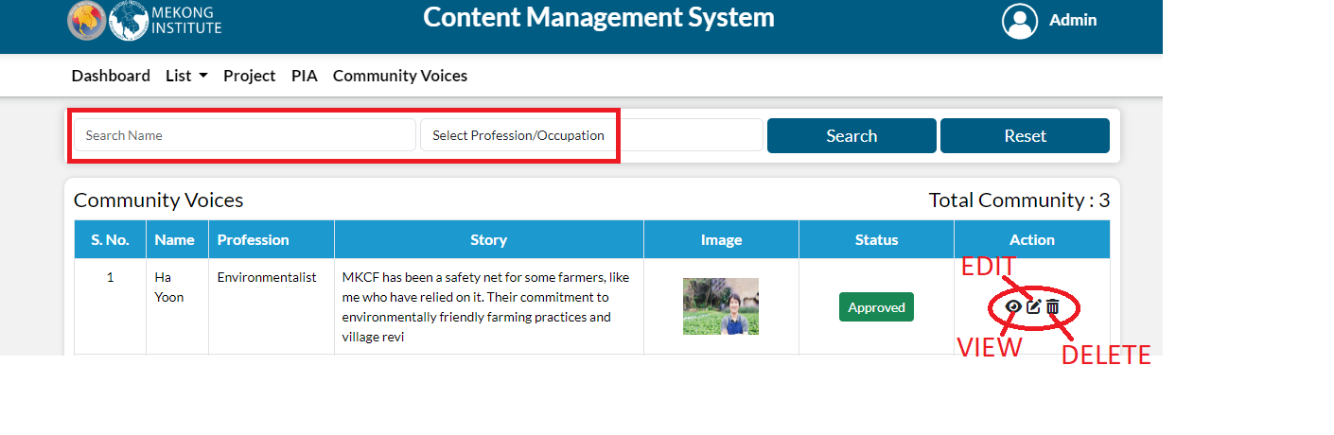
When you click on the view button details page is open, here you can see the community voices in details.
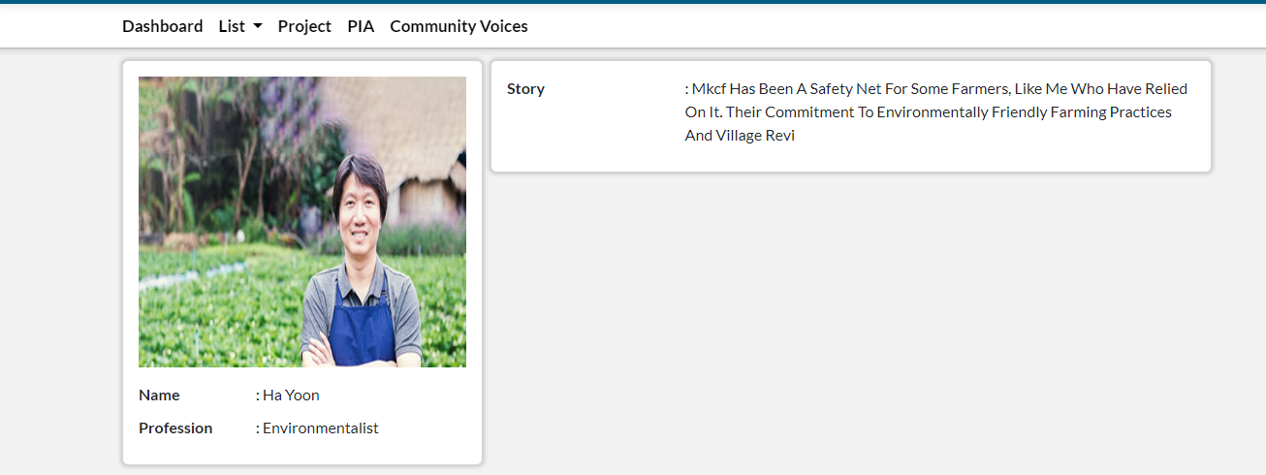
When you click on edit, edit form is open and you can edit all the fields and update the community voices.
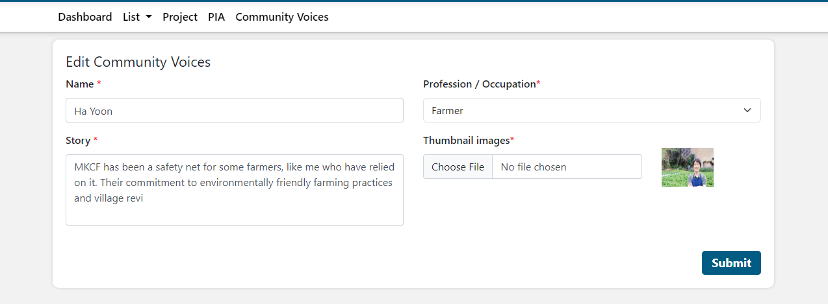
When you click on the delete popup message is shows, if you click on the delete that community voice is deleted from the list.
