K A S I



K A S I

Korea-ASEAN Solidarity Initiative

Korea-ASEAN Solidarity Initiative

# Importance of Cooperation with ASEAN

ASEAN plays a central role in the regional architecture as the anchor of multilateral cooperation

Strategically located between the Indian and Pacific Oceans, ASEAN possesses immense growth potential

***Pacific Ocean***

**3rd Largest Population**

**5th Largest Economy**

**(to be 4th Largest by 2030)**

# Milestones of ASEAN-ROK Partnership

|  |  |
| --- | --- |
| **1989** | Sectoral Dialogue Partnership |
| **1991** | Full Dialogue Partnership |
| **1997** | Inaugural ASEAN+3 Summit and ASEAN-ROK Summit |
| **2004** | Comprehensive Cooperation Partnership |
| **2006** | Conclusion of AKFTA |
| **2009** | Inauguration of ASEAN-Korea Centre |
| **2009** | 1st ASEAN-ROK Commemorative Summit |
| **2010** | ASEAN-ROK Strategic Partnership |
| **2012** | Establishment of the ROK Mission to ASEAN |
| **2014** | 2nd ASEAN-ROK Commemorative Summit |
| **2017** | Opening of ASEAN Culture House |
| **2019** | 3rd ASEAN-ROK Commemorative Summit |
| **2022** | Launch of Korea-ASEAN Solidarity Initiative |

K A S I

Korea-ASEAN Solidarity Initiative

# BACKGROUND

ASEAN is ROK’s key partner in building a free, peaceful and prosperous Indo-Pacific region

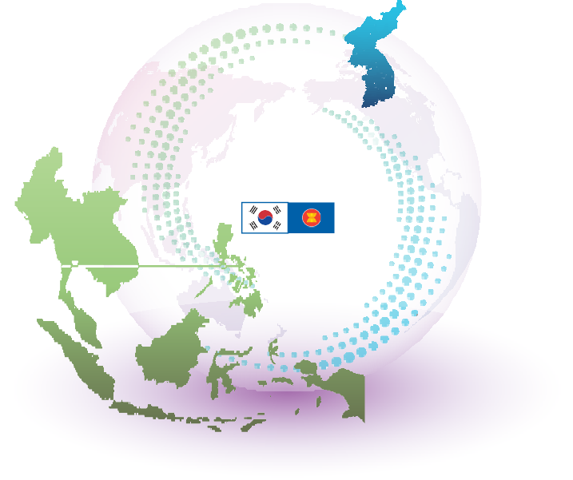

**Key Partners** in

the **Indo-Pacific Region**

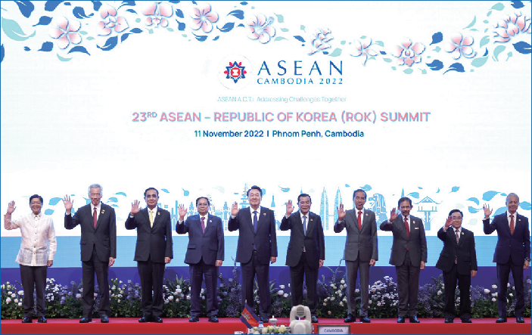President Yoon Suk Yeol announced KASI at the 23rd ASEAN- ROK Summit in November 2022 as ROK’s regional policy tailored to ASEAN

***Indian Ocean***

***Major SLOC***

ASEAN and the ROK has evolved into indispensable partners to each other since establishing dialogue relations in 1989

**No. 2**

**Trading Partner**

**No. 2 FDI**

**Destination**

**17,000 Korean local branches and subsidiaries in ASEAN**

**No.1 ODA**

**Partner**

**No.1**

**Travelling Destination**

**KASI aims to foster a more comprehensive**

### **ASEAN-ROK** partnership is the **nexus** of cooperation for freedom, peace, and prosperity in the region

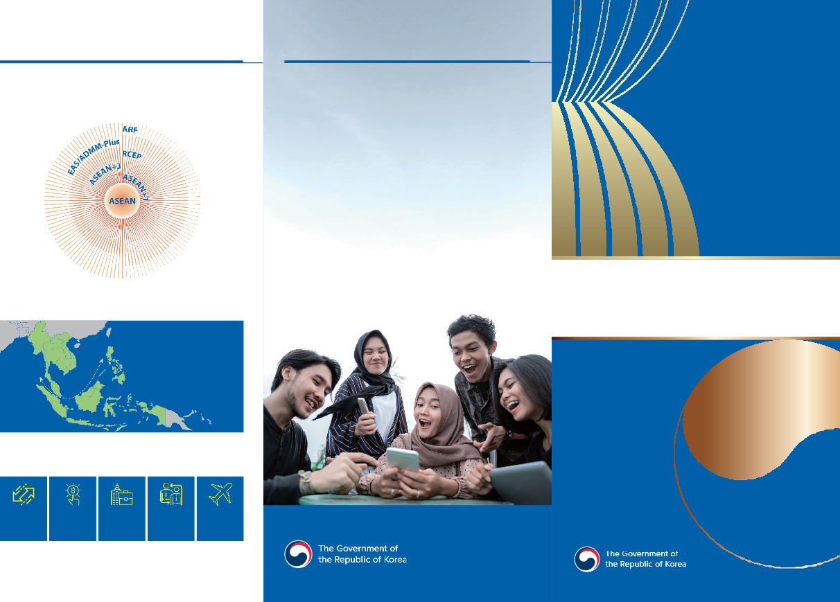

**partnership** with ASEAN spanning political-security, economic and social-cultural cooperation



K A S I

K o r e a - A S E A N

S olidarit y I nitiativ e



K A S I



# 8 Core Lines of Effort

### Eight core lines of effort that support ASEAN’s major initiatives and goals and are in line with the three key visions of ROK’s Indo-Pacific Strategy–freedom, peace, prosperity–have been identified to realize KASI’s goal of building a robust substantive and strategic partnership between ASEAN and the ROK



**FREEDOM**



**PEACE**



**PROSPERITY**



1

Upgrade ASEAN-ROK Partnership & Strengthen Bilateral Relations with ASEAN Member States



2

Enhance ASEAN-ROK Cooperation within ASEAN-led Mechanisms



3 Expand ASEAN-ROK Comprehensive Security Cooperation



4 Promote ASEAN-ROK Strategic Coordination



5

Expand Cooperation in Future & Emerging Areas for Shared Prosperity and Development



6

Jointly Address & Respond to Regional and Global Challenges



7

Promote Future Generation Exchanges as Drivers of Future Prosperity



8 Increase ASEAN-ROK Cooperation Resources

**Upgrade ASEAN-ROK Partnership & Strengthen Bilateral Relations with ASEAN Member States (AMS)**

* 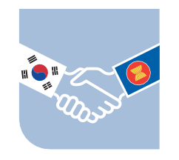establish Comprehensive Strategic Partnership (CSP) in 2024

1

* strengthen bilateral relations with AMS

based on the varying priorities of each country

* support capacity building of Timor-Leste for building a stronger ASEAN Community

2

## Enhance ASEAN-ROK Cooperation within ASEAN-led Mechanisms

* promote regional cooperation through active engagement in ASEAN-led mechanisms
* strengthen cooperation on the AOIP
* support mainstreaming of four priority areas
* launch flagship project on AOIP cooperation

3

## Expand ASEAN-ROK Comprehensive Security Cooperation

* increase cooperation in maritime and cyber security areas
* expand cooperation with individual AMS on defense industry and military logistics

4

## Promote ASEAN-ROK Strategic Coordination

* strengthen ASEAN-ROK defense cooperation
* expand ASEAN-ROK defense consultations
* implement ROK-ASEAN Defense Cooperation Plan
* strengthen engagement in ADMM+ activities
* continue close cooperation on ROK’s North Korea policy and North Korean nuclear issue

## Expand Cooperation in Future & Emerging Areas for Shared Prosperity and Development

* increase cooperation on future industries, including digitalization and e-mobility etc.

5

* explore upgrade of ASEAN-ROK FTA to ensure relevance in the evolving economic landscape
* foster a network of cooperation to strengthen economic security in the region

6

## Jointly Address & Respond to Regional and Global Challenges

* support ASEAN’s efforts to tackle climate change and environmental issues
* bolster ASEAN’s preparedness and resilience in public health emergencies
* strengthen sub-regional cooperation

for sustainable development in the region

7

## Promote Future Generation Exchanges as Drivers

**of Future Prosperity**

* strengthen cooperation on human resources development
* expand scholarship and P2P exchanges
* support women empowerment and TVET
* reinvigorate cooperation in culture, tourism and sports sectors



**O**

**D A**

8

## Increase ASEAN-ROK Cooperation Resources

* increase ASEAN-related cooperation funds to 48 million USD per annum by 2027
* ASEAN-ROK Cooperation Fund (AKCF): 32 million USD
* Mekong-ROK Cooperation Fund (MKCF): 10 million USD
* BIMP-EAGA-ROK Cooperation Fund (BKCF): 6 million USD

※ contribution of 200 million USD in 5 years (2022-27)

* expand ODA in the ASEAN region

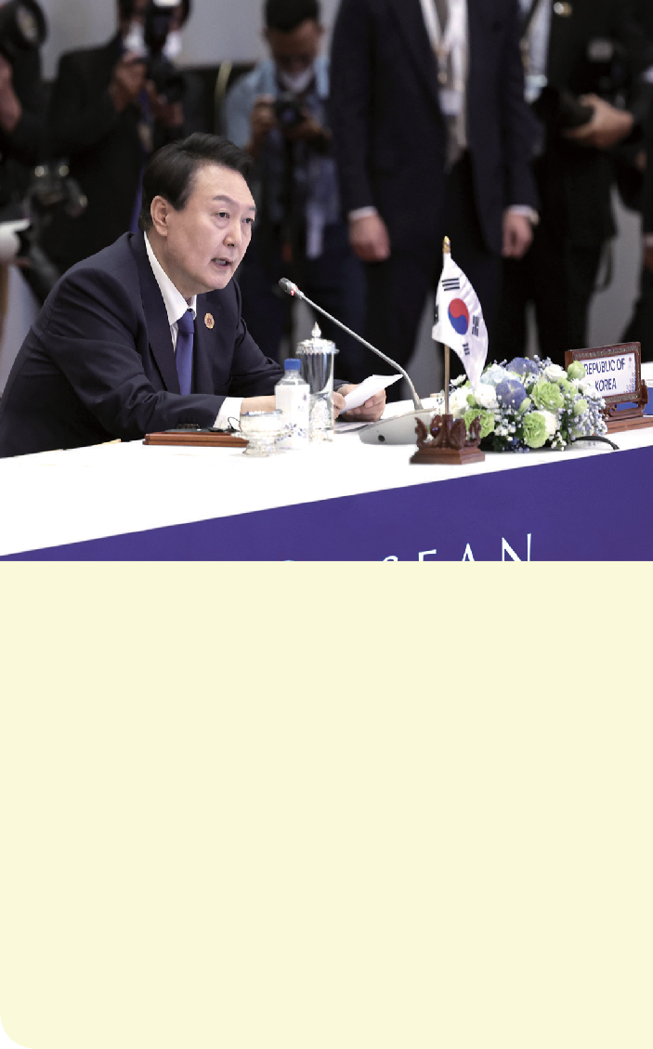

*“For the past 30 years, ASEAN and the ROK have advanced together overcoming challenges through collective efforts…our partnership has been a journey of cooperation and trust anchored on our shared interests”*

*“As a true friend to ASEAN…the ROK is committed to further bolstering our solidarity and cooperation through the Korea-ASEAN Solidarity Initiative”*

**President Yoon Suk Yeol’s remarks at the 23rd ASEAN-ROK Summit**

**(11 November 2022)**

Building on the impressive achievements of the past 30 years of **ASEAN-ROK partnership**, **KASI** aims to **strengthen substantive and strategic ties** that is mutually beneficial

Through these efforts, **KASI** will contribute to **freedom**, **peace** and **prosperity** in **ASEAN**, the **ROK** and the overall **Indo-Pacific region**