**0.** **Overall**

* Confirm that data entered into the content management system (CMS) is correctly displayed on the website (**IMPORTANT**).
* The team will arrange updated content based on the MKCF Factsheet (Booklet) and survey results and share it with INDEV for implementation.
* Prioritize content updates for **completed projects first**, followed by **ongoing projects**.

**1.** **Website Structure**

**1.1 Home**

* First landing page includes:
* Search bar for fast keyword-based navigation
* Brief introduction to the MKCF will provide the info
* Map of the Mekong region
* Project statistics (dynamic infographic format with chart): Total # of MKCF projects, # of MKCF projects by PIA location (country), # of MKCF projects by Sector, # of MKCF projects by Status (Ongoing/Completed) ** ​​Please implement a data visualization section that summarizes MKCF projects.
* Latest News & Events 5 five latest news & events

**1.2 About the MKCF (3 sub-menus)**

1. **Overview & History** will provide the info
2. **Mekong–ROK Plan of Action 2021–2025: Seven Priority Sectors** will provide the info

* Key Issues (not Priority Sectors)
* Description in the overview should be revised to sector-specific text
* Stories from the Field (for each sector)

1. **MKCF Secretariat (Team)** will provide the info

* **Mr. Madhurjya Kumar Dutta** – [Position] – [Email] *with Photo*
* **Ms. Mi Jung Im** – [Position] – [Email] *with Photo*
* **Mr. Ashutosh Kumar Jha** – [Position] – [Email] *with Photo*
* **Mr. Giwoong Son** – [Position] – [Email] *with Photo*

**1.3 Keep the “Priority Sectors” menu**

**1.4 Projects**

* Include a search bar for users to find projects by title or keyword
* Filterable by: Call, Country (PIA location), Sector, Status (Ongoing / Completed)

**1.5 News & Events (2 sub-menus)**

1. News
2. Events (**Display events in a calendar format)**

* Filterable by: Upcoming / Past, Country (PIA location), Sector, Project
* Add a monthly project calendar feature based on each project’s work plan

**1.6 Knowledge Hub (3 sub-menus)**

1. Publications
2. Stories from the Field/Testimonials *(as of now, Impact Stories + Community Voices)*

* Filterable by: Call, Country (PIA location), Sector, Status (Ongoing / Completed)
* Ensure ‘Stories from the Field’ are displayed under ‘the corresponding Project page’

1. Media Gallery *(as of now, Multimedia)*

* Include a search bar for users to find projects by title or keyword
* Filterable by: Call, Country (PIA location), Sector, Status (Ongoing / Completed)
* Link to the activity photos uploaded in the CMS (When uploading photos, users must upload them under the corresponding activity. These tagged photos should then automatically appear in the Media Gallery along with the activity description.)
* Videos

**1.7 Get Involved (2 sub-menus)**

1. Call for Proposals

* Guideline
* Call -> 9th call, 8th call, 7th call, and so on

1. Work with us

* Filterable by: Jobs, Consultancy, Internships

**1.8 Contact Us (2 sub-menus)**

1. Frequently Asked Questions (FAQ)
2. Still have questions? Contact us

**2. Cms**

* Change down-arrow icon for "Remove" to ❌ or 🗑️
* Change right-arrow for “Add” icon to ➕

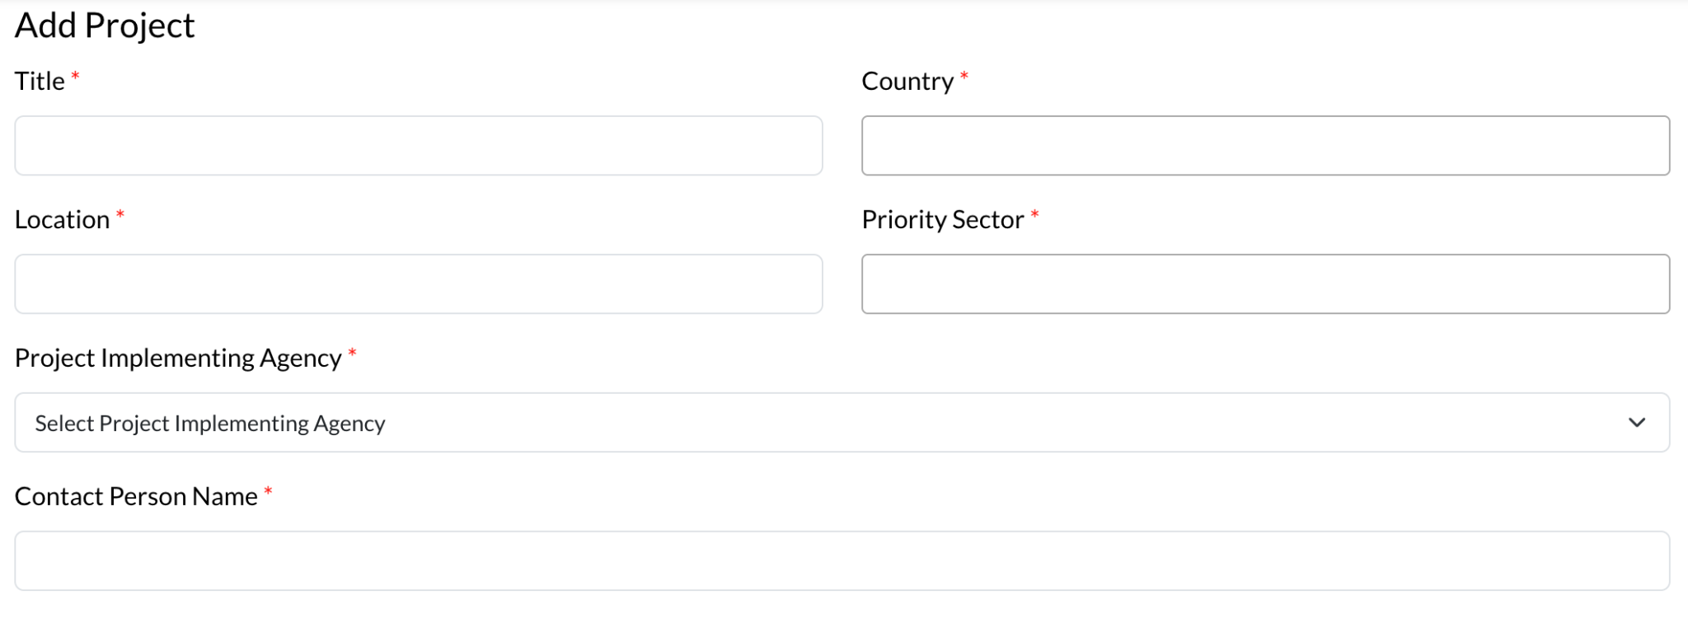

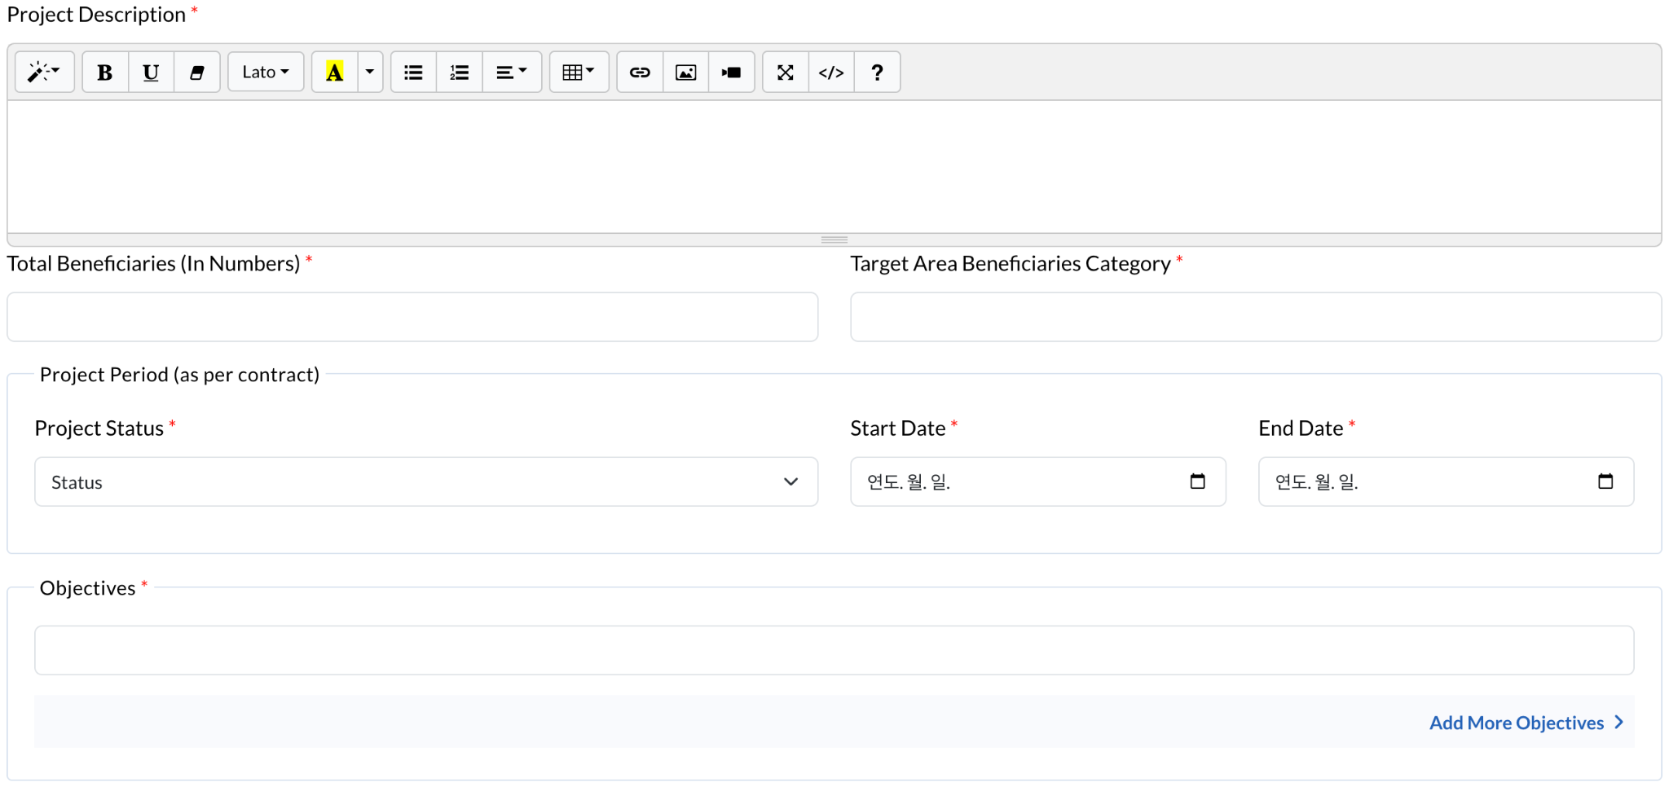

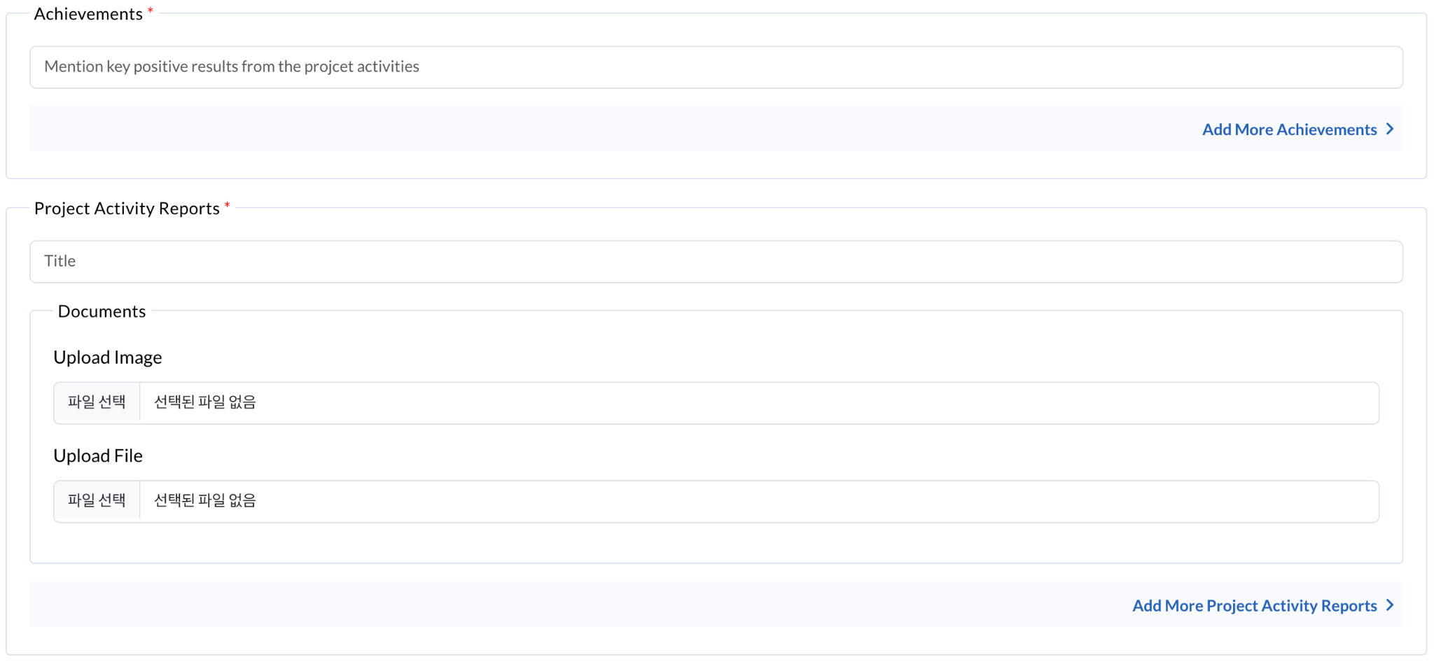

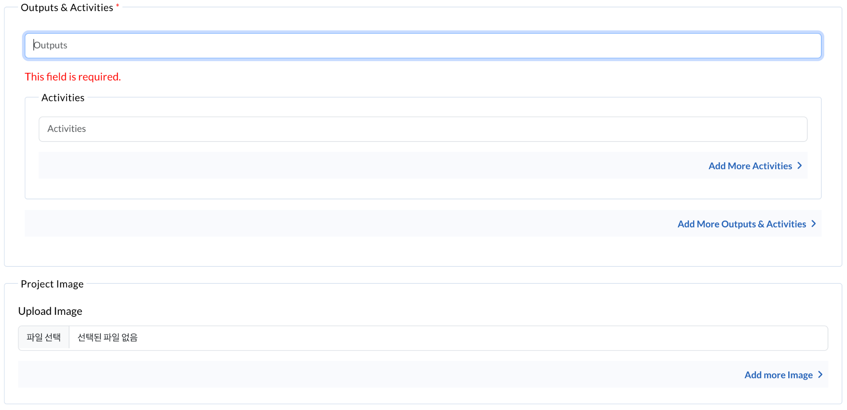

| **Field** | **Description** |
| --- | --- |
| **Project Title** | [Insert the official project name] |
| **PIA (Name, Type, Location)** | [Name of the Project Implementing Agency]  [Type (e.g., Government Body, University, NGO, etc.)]  [Location] |
| **MKCF Call** | [Call 1-8] |
| **Priority Sector** | [**Select one**: Culture and Tourism, Agriculture and Rural Development, Information and Communication Technology, Human Resource Development, Infrastructure, Environment, Non-Traditional Security Challenges] |
| **Total Budget** | [USD] |
| **Project Duration** | **Status:** [Ongoing / Completed]  **Start Date:** [Insert start date]  **End Date:** [Insert end date] |
| **Project Site** | [Country(ies) where the project is implemented / C, L, M, V, T, ROK - can choose multiple]  ** Please implement a feature where the country or countries entered in the "Project Site" field are automatically visualized **on an interactive map on the corresponding project page**. |
| **Number of Beneficiaries** | **[Direct]**  [Number] Description of type of beneficiaries - with clear identification such as by people, community, school, ministry, etc.  **[Indirect]**  [Number] Same as above if possible |
| **Project Description** | [Brief summary of the background, rationale, problems, context, and purpose of the project] |
| **Project Objectives** | [Clear and concise list of the main objectives] |
| **Activities** | [Photos should be uploaded separately for each key activity and featured in **the media gallery** as well as on **the corresponding project page**.] |
| **(Expected) Results** | [Key results achieved or expected outcomes] |
| **Success Factors / Strategies** | [Factors and strategies that contributed to project success] |
| **Future Strategies and Sustainability Plans** | [Plans for ensuring long-term impact and sustainability of results] |
| **Project files** | [Reports] collecting data only but not for publish  [Videos] featured in **the media gallery** as well as on **the corresponding project page**  etc. |
| **Contact Person** | **Name:** [Contact person’s full name]  **Position:** [Job title]  **Email:** [Contact email] |