MODULE 3- Contents of Session Plans

Module 3: Sustainable Tourism Governance and Strategic Planning

Session 1: Introducing Sustainable Tourism Governance

Market Participants: Session 1 is specifically tailored for a diverse range of individuals actively engaged in tourism governance and sustainable tourism practices. It encompasses government officials responsible for shaping tourism policies at the local, regional, and national levels. Moreover, it welcomes participation from tourism boards keen on charting a sustainable course for the tourism industry. Industry professionals, including tour operators, hospitality managers, and destination marketing specialists, are encouraged to join to gain insights into aligning their businesses with sustainable principles. Lastly, NGOs dedicated to the cause of sustainable tourism, environmental preservation, and community engagement will find this session invaluable for enhancing their advocacy and project planning efforts. This broad spectrum of market participants ensures a holistic exploration of sustainable tourism governance from multiple perspectives, fostering an enriched learning environment for all involved.
Summary: Kicking off Module 3, Session 1 is a gateway to the world of sustainable tourism governance. In this foundational session, participants are embarked on a comprehensive exploration of the intricate tapestry of local and regional governance models that underpin the sustainable tourism landscape. The journey delves deep into the workings of participatory bodies, the invaluable contributions of associations, and the transformative roles played by NGOs and various stakeholders within the dynamic tourism ecosystem. Governance, as the lynchpin of effective sustainable tourism practices, is meticulously dissected and discussed. The ultimate objective is to furnish participants with profound insights into the multifaceted world of governance structures and stakeholder engagement within the realm of sustainable tourism. By delving into these core foundations, participants lay the groundwork for a holistic comprehension of the governance frameworks that drive sustainable tourism, ensuring that they are well-equipped for future sessions that build upon this essential knowledge.
Key Words: Sustainable tourism governance, governance models, participatory bodies, associations, NGOs, stakeholders.
Objectives:
- Gain Insight into Governance Models: Participants will develop insights into local and regional governance models associated with sustainable tourism.
- Understand the Role of Stakeholders: This session will enable participants to comprehend the roles of participatory bodies, associations, NGOs, and other stakeholders in sustainable tourism governance.
Outcomes: By the culmination of Session 1, participants will emerge with a profound understanding of the complex tapestry of governance structures intertwined with sustainable tourism practices. They will have gained keen insights into the pivotal roles played by various stakeholders, recognizing their significance in the orchestration of sustainable tourism objectives. This session is meticulously designed to foster a deep comprehension of the governance underpinnings, empowering participants with the knowledge to appreciate the transformative impact of effective governance within the realm of sustainable tourism.
Methods: To facilitate an immersive and enlightening experience, Session 1 deploys a meticulously crafted blend of teaching methods that encompass a variety of interactive platforms. Through engaging presentations, participatory group discussions, and real-world case studies, participants are encouraged to actively immerse themselves in the subject matter. This multifaceted approach ensures that the session goes beyond passive learning, encouraging dynamic interaction and dialogue among participants. As a result, they gain a comprehensive grasp of sustainable tourism governance that transcends mere theoretical understanding.
Materials: Participants in Session 1 are equipped with a wealth of informative materials meticulously curated to support an in-depth exploration of sustainable tourism governance. These resources include insightful presentations that shed light on complex concepts, compelling case studies that offer practical perspectives, and comprehensive reference materials that serve as guides throughout the session. The rich repository of materials provided ensures that participants have a robust foundation upon which to build their knowledge of governance structures in sustainable tourism.

Content:
Section 1: Understanding Sustainable Tourism Governance (Approx. 25 minutes)
• Introduction to Governance: In this section, the session initiates with a comprehensive exploration of the fundamental concept of governance within the dynamic landscape of sustainable tourism. Participants are led into the heart of the subject, where the overarching significance of governance structures in sculpting sustainable practices is eloquently articulated. Through thought-provoking insights and practical examples, this segment equips participants with a solid foundation in comprehending how governance influences the realm of sustainable tourism.
• Local and Regional Governance Models: Participants are guided on an insightful journey through various governance models that come into play at local and regional levels. With a focused lens on these models, their mechanisms, and implications for sustainable tourism practices, this section paints a vivid picture of the intricate interplay between governance structures and the evolution of sustainable tourism. This immersive exploration encourages participants to reflect on the real-world impact of governance decisions at different scales, ultimately enriching their understanding of the broader context.
Section 2: The Role of Stakeholders (Approx. 25 minutes)
• Identifying Key Stakeholders: Delving deeper into the multifaceted realm of sustainable tourism governance, this segment offers a meticulous examination of the diverse spectrum of stakeholders who wield influence over its dynamics. Participants are provided with invaluable insights into the roles and contributions of various entities, including participatory bodies, associations, NGOs, and other essential stakeholders. By developing a nuanced understanding of these actors and their functions, participants are better equipped to navigate the complexities of sustainable tourism governance, making this knowledge transfer pivotal in shaping informed decision-making.
• Stakeholder Engagement Strategies: This section introduces participants to a palette of effective strategies tailored to engage with stakeholders successfully. By illuminating the various approaches and techniques employed to foster meaningful connections and collaborations within the sphere of sustainable tourism governance, this session equips participants with a set of practical tools. These tools empower participants to forge partnerships, initiate dialogues, and encourage cooperative efforts among stakeholders. As participants grasp the potential of these engagement strategies, they enhance their capacity to catalyze positive transformations in the landscape of sustainable tourism governance.
This carefully designed content plan for Session 1 serves as a foundational stepping stone. It offers participants an immersive journey into the realm of sustainable tourism governance, shedding light on governance structures, stakeholder intricacies, and collaborative engagement strategies. This multifaceted exploration provides participants with a comprehensive understanding that transcends theoretical knowledge, enabling them to navigate the intricacies of sustainable tourism governance with confidence and insight.

Session 2: Introducing Sustainable Tourism Governance (2)

Market Participants: Session 2 extends its invitation to a diverse spectrum of participants actively engaged in the sphere of tourism governance. This inclusive gathering encompasses government officials, policymakers, industry professionals, and individuals with a keen interest in orchestrating the alignment of local and regional stakeholders within the realm of sustainable tourism governance. With a tailored focus on the intricacies of leadership and shared visions, this session beckons those who seek to deepen their involvement in crafting sustainable tourism solutions.
Summary: As a natural progression from the solid foundation laid in Session 1, Session 2 embarks on an even more profound exploration of the intricacies involved in crafting sustainable tourism governance. This session immerses participants in the imperative need for a common vision among local and regional stakeholders, elucidating the pivotal role it plays in the sustainable tourism landscape. As the session unfolds, it meticulously dissects the multifaceted concept of leadership, casting light on the critical importance of effective leadership qualities and integrated governance structures. In the intricate tapestry of sustainable tourism, the achievement of objectives becomes intrinsically linked with shared visions and the presence of resolute leadership. Participants, through this engaging journey, will not only recognize the significance of stakeholder alignment but also comprehend the indispensable nature of leadership traits that fuel effective governance. This session is an enlightening opportunity to acquire a holistic perspective on the core components that drive sustainable tourism and align diverse stakeholders toward a common goal.
Key Words: Common vision, leadership skills, integrated governance, stakeholder alignment.

Objectives:
- Recognize the Importance of a Common Vision: Participants will understand why a shared vision among local and regional stakeholders is crucial for sustainable tourism governance.
- Understand Leadership Skills: This session will empower participants to identify leadership skills required for effective governance in sustainable tourism.
- Explore Integrated Governance Structures: Participants will gain insights into the concept of integrated governance structures and how they can enhance sustainable tourism efforts.
Outcomes: Upon successful completion of Session 2, participants will emerge with a profound appreciation for the vital components that constitute the backbone of sustainable tourism governance. They will gain a nuanced understanding of the pivotal role that a shared vision, effective leadership, and integrated governance structures play in the realm of sustainable tourism. Participants will not only recognize the significance of fostering alignment among diverse stakeholders but will also be adequately prepared to take up the mantle of leadership in governance matters. This session equips participants with the knowledge and insight required to orchestrate harmony among stakeholders and assert their leadership capabilities, ultimately contributing to effective governance within the domain of sustainable tourism.
Methods: Session 2 is a dynamic and interactive learning experience facilitated through a rich blend of pedagogical techniques. These include engaging presentations, thought-provoking group discussions, hands-on practical exercises, and the real-world application of case studies. These diverse methods are meticulously designed to foster active participation, encourage in-depth discussions, and ensure a comprehensive grasp of the importance of a common vision and leadership within governance structures. By actively engaging with these methods, participants gain a multifaceted understanding of these essential concepts in the context of sustainable tourism governance.
Materials: In pursuit of a profound exploration of integrated governance and leadership in the context of sustainable tourism, participants will have access to a wealth of educational materials. These materials encompass enlightening presentations that unravel the core principles, illustrative case studies that offer real-world insights, and comprehensive reference materials. This multifaceted resource library ensures that participants are well-equipped to navigate the complexities of integrated governance and leadership, enabling them to apply their learnings effectively in the field of sustainable tourism governance.

Content:
Section 1: The Need for a Common Vision (Approx. 25 minutes)
1. Understanding a Common Vision: This section embarks on a comprehensive exploration of the intricate concept of a common vision shared among local and regional stakeholders. Participants will dive deep into the intricacies of this fundamental concept, gaining a profound understanding of its pivotal role in shaping the landscape of sustainable tourism governance. The session will shed light on why a common vision is not merely a shared statement of intent but a powerful force that guides actions and decisions, fostering a collaborative and purpose-driven approach to sustainable tourism.
2. Strategies for Vision Alignment: In this segment, participants will be equipped with a toolkit of effective strategies aimed at aligning the visions and goals of the diverse array of stakeholders involved in sustainable tourism governance. The session will delve into practical approaches and tactics that facilitate the harmonization of often differing viewpoints. Drawing from real-world examples, participants will gain insights into how vision alignment can be achieved successfully, ultimately propelling sustainable tourism endeavors towards shared objectives.
Section 2: Leadership Skills and Integrated Governance (Approx. 25 minutes)
1. Leadership Qualities: This segment is dedicated to the meticulous exploration of leadership skills and qualities that are indispensable for steering effective governance within the domain of sustainable tourism. Participants will engage in an enlightening journey that uncovers the distinctive traits and competencies that define a successful leader in the context of sustainable tourism. Through real-world examples and practical insights, participants will not only grasp the essence of effective leadership but will also be empowered with the knowledge required to assume leadership roles confidently in sustainable tourism governance.
2. Integrated Governance Structures: The session on integrated governance structures will unveil the architecture of systems that facilitate alignment among diverse stakeholders. By delving into real-world examples of integrated governance in sustainable tourism, participants will glean actionable insights into how these structures can be harnessed to foster cooperation and coordination. This section demystifies the complex yet critical aspects of integrated governance, ensuring participants gain an in-depth understanding of their functionality and impact.
This content plan for Session 2 is meticulously designed to empower participants with the knowledge and skills necessary to drive a common vision and exhibit effective leadership in the realm of sustainable tourism governance. It provides a robust framework for participants to navigate the complexities and nuances of these vital aspects effectively.

Session 3: Presenting Strategic Planning
Market Participants: Session 3 caters to a diverse audience encompassing a broad spectrum of individuals with vested interests in the realm of sustainable tourism governance and strategic planning. This engaging session is specifically tailored for tourism professionals, individuals occupying governmental positions, strategic planners, and, in fact, anyone who shares a genuine curiosity and passion for understanding the intricate dynamics of sustainable tourism governance. Whether you're a seasoned expert seeking to expand your horizons or a newcomer eager to unravel the complexities of strategic planning, this session provides an invaluable platform for knowledge enrichment, making it an essential experience for all those engaged in the tourism industry and its sustainable development.
Summary: Session 3 unfolds as a pivotal juncture in our exploration of sustainable tourism governance and strategic planning. Within this session, participants embark on an enlightening journey into the heart of strategic planning, which serves as the cornerstone of effective governance within the context of sustainable tourism. This immersive experience goes beyond the surface, guiding individuals to set realistic goals and objectives that align harmoniously with the principles of sustainability. It lays a robust foundation for understanding the intricacies of strategy as a skill, a skill that plays an instrumental role in the realization of sustainability goals. Moreover, participants will delve into the various stages of the planning process, acquiring a comprehensive comprehension of the steps involved in the formulation of comprehensive destination management plans.
This session is meticulously designed to empower individuals with the tools, knowledge, and practical insights essential for conceiving sustainable, successful, and impactful destination management plans. It marks a significant stride towards equipping participants with the skills and expertise required to contribute positively to the realm of sustainable tourism governance and strategic planning. Whether you're a seasoned practitioner or an enthusiast eager to explore the depths of strategic planning in sustainable tourism, Session 3 holds the promise of an enlightening and transformative experience.
Key Words: Strategic planning, goals, objectives, strategy, planning process.
Objectives:
- Learn how to Set Realistic Goals: Participants will gain the ability to define achievable goals and objectives within the framework of sustainable tourism.
- Understand the Role of Strategy: This session will empower participants with an understanding of strategy as a crucial skill in achieving sustainability goals.
- Explore the Planning Process: Participants will gain insights into the stages of the planning process in sustainable tourism governance.

Outcomes: Upon the successful culmination of Session 3, participants will emerge with an enriched set of knowledge and skills, uniquely tailored for the initiation and execution of strategic planning within the domain of sustainable tourism governance. Equipped with these newfound capabilities, individuals will find themselves adept at setting realistic, achievable goals that harmoniously align with the principles of sustainability. They will grasp the significance of strategic thinking as an invaluable skill in the context of sustainable tourism governance, gaining the ability to navigate the planning process effectively and with a profound understanding of the nuances of strategic planning. Participants will be well-prepared to undertake the comprehensive task of conceiving and executing strategic plans, becoming catalysts for positive change within their respective roles.
Methods: In Session 3, a diverse range of pedagogical approaches will be employed to ensure an engaging and informative learning experience. Participants will find themselves immersed in a dynamic blend of presentations, interactive group discussions, and real-world case studies. These multidimensional teaching methods are meticulously designed to encourage active participation, foster insightful conversations, and ensure a comprehensive understanding of the fundamental principles underpinning strategic planning within sustainable tourism governance. By combining these varied approaches, this session provides participants with a well-rounded and immersive educational encounter.
Materials: Throughout Session 3, participants will have access to a curated selection of learning materials, meticulously designed to facilitate an in-depth exploration of strategic planning in the context of sustainable tourism governance. These materials include informative presentations that illuminate key concepts, as well as illustrative case studies that offer practical insights into real-world strategic planning endeavors. This comprehensive array of resources serves as a foundational knowledge base from which participants can draw to further their understanding, making Session 3 a rich and informative learning experience.
Content:
Section 1: Setting Realistic Goals (Approx. 25 minutes)
• Defining Objectives: This section delves into the intricacies of setting clear and achievable objectives within the sphere of sustainable tourism governance. Participants will not only understand the importance of these objectives but also learn how to define them in alignment with sustainability values, ensuring a strong foundation for their planning efforts.
• Goal Setting Strategies: Building on the foundational knowledge acquired in the first part of this section, participants will further explore effective strategies for goal setting. Practical tips for establishing objectives that are both realistic and attainable will be provided, offering a clear roadmap for translating goals into actionable plans.

Section 2: Strategy as a Skill (Approx. 25 minutes)
• The Essence of Strategy: This segment delves into the very essence of strategy as a skill, exploring its significance within the realm of sustainable tourism governance. Participants will gain a profound understanding of the concept of strategic thinking and planning, recognizing its essential role in ensuring the sustainability of the tourism sector.
• Developing Strategic Skills: Building upon the foundational knowledge presented earlier in the session, this part provides participants with insights into developing the strategic skills required for sustainability within the tourism industry. Individuals will not only learn to think strategically but also gain the ability to apply this invaluable skill to their governance strategies effectively, setting the stage for transformative change within their respective roles.

Section 3: The Planning Process (Approx. 25 minutes)
• Stages of Planning: This section offers an in-depth exploration of the various stages that constitute the planning process within the context of sustainable tourism governance. Participants will gain valuable insights into how planning unfolds, from its initial conception to the precise execution of well-thought-out strategies.
• Case Studies: As a practical application of the knowledge and skills acquired throughout the session, real-world case studies will be presented. These compelling examples effectively illustrate the nuances of effective strategic planning within sustainable tourism governance, offering valuable practical insights that inspire and empower participants as they embark on their own strategic planning endeavors.
This comprehensive content outline for Session 3 ensures a well-rounded, in-depth exploration of strategic planning, emphasizing the critical role it plays in achieving sustainability within the tourism industry. Participants will find themselves equipped with the knowledge, skills, and practical insights necessary for successful strategic planning in the realm of sustainable tourism governance.

.
Session 4: Strategic Planning and Policies Implementation

Market Participants: Session 4 is thoughtfully designed to cater to a diverse audience encompassing tourism professionals, government officials, policymakers, and individuals with a keen interest in comprehending the tangible aspects of implementing strategic planning and policies within the intricate realm of sustainable tourism governance. By engaging with this session, participants can anticipate gaining a comprehensive understanding of the pragmatic steps involved in turning strategic plans and policies into actionable results.
Summary: Session 4 embarks on a profound exploration of the practical implementation of strategic planning and policies within the realm of sustainable tourism governance. This session serves as a pivotal bridge, emphasizing the vital role of planning as the precursor for achieving well-defined and targeted outcomes. It unravels the nuanced process of transitioning from the carefully crafted plans to the actual execution and implementation of policies. Furthermore, it delves into the methodologies employed for the systematic measurement of policy outcomes and the imperative need for adaptive modifications when circumstances dictate. Effectual policy implementation is positioned at the core of realizing the multifaceted objectives of sustainable tourism, making it the linchpin for success. This session extends its focused lens to concentrate on the real-world, actionable aspects of policy implementation, monitoring, and the crucial art of adaptation, ensuring that sustainable tourism principles are effectively woven into the fabric of governance practices. Participants who engage with Session 4 can anticipate a profound dive into the practical facets of making strategic planning and policies thrive within the vibrant ecosystem of sustainable tourism.

Key Words: Policy implementation, planning outcomes, sustainable tourism objectives, adaptive management, policy monitoring.
Objectives:
- Understand the Importance of Planning Outcomes: Participants will appreciate the significance of planning toward specified results in sustainable tourism governance.
- Learn how to Transition from Planning to Implementing Policies: This session will empower participants with knowledge on how to transition effectively from planning to the practical implementation of policies.
- Explore Methods for Measuring Policy Outcomes and Adaptation: Participants will gain insights into methods for measuring policy outcomes and learn why these assessments are vital for governance.
- Recognize the Need for Policy Adjustments: Participants will understand the necessity of adapting policies based on measurement outcomes, ensuring a dynamic and responsive governance approach.

Outcomes: After fully engaging with Session 4, participants will emerge with a comprehensive skill set that empowers them to effectively navigate the practical implementation of strategic planning and policies within the realm of sustainable tourism governance. They will be adept at conceiving well-defined plans geared towards achieving specific, targeted outcomes. Additionally, participants will acquire the acumen necessary to seamlessly transition from the meticulously designed planning phase to the hands-on, real-world execution of policies. They will gain an appreciation for the essential art of measuring policy outcomes, employing various methodologies to ensure policies remain in alignment with sustainability objectives. Furthermore, participants will be well-prepared to recognize circumstances demanding policy adjustments and will possess the know-how to adapt policies appropriately to nurture sustainability.
Methods: Session 4 employs a multifaceted array of pedagogical methods strategically designed to provide an interactive and immersive learning experience. These methods include interactive presentations that facilitate active participation and engagement, group discussions that encourage collaborative learning, practical exercises to apply acquired knowledge, and real-world case studies that offer practical insights into the multifaceted world of policy implementation and adaptive governance. By integrating these diverse methods, the session offers participants a holistic understanding of policy implementation and the art of adaptive governance within the context of sustainable tourism.
Materials: Within the session, participants will have at their disposal a comprehensive and curated set of learning materials that serve as essential resources. These materials encompass informative presentations that guide in-depth exploration of the subject matter, as well as illustrative case studies that provide tangible examples to reinforce learning. These resources serve as the foundation upon which participants can construct their profound understanding of policy implementation and its crucial role in sustainable tourism governance.
Content:
Section 1: Planning Towards Specified Results (Approx. 25 minutes) • Defining Planning Outcomes: This section delves into the nuanced process of planning for specified results within the realm of sustainable tourism governance. Participants will be led to understand the critical importance of goal-oriented planning that underpins successful policy execution. • Effective Planning Strategies: Participants will be equipped with an arsenal of strategies to ensure planning that leads to the desired outcomes. Practical guidelines will be provided for the development and execution of plans meticulously aligned with sustainability goals.
Section 2: From Planning to Implementing Policies (Approx. 25 minutes) • The Implementation Phase: This segment is dedicated to unpacking the practical aspects involved in transitioning from the carefully crafted planning phase to the real-world execution of policies. Participants will gain the essential insights required to execute policies effectively. • Policy Rollout Strategies: Participants will acquire an understanding of effective strategies for rolling out policies, ensuring their enactment precisely as intended.
Section 3: Measuring Policy Outcomes and Adaptation (Approx. 25 minutes) • Policy Assessment Methods: This section delves into the diverse array of methods available for measuring policy outcomes. Participants will gain a comprehensive grasp of the various techniques at their disposal for rigorously evaluating the impact of policies. • The Adaptive Approach: Participants will be introduced to the vital concept of adaptive management in the sphere of sustainable tourism governance. They will learn to recognize the critical junctures demanding policy adjustments and understand how to skillfully implement changes based on measured outcomes. • Case Studies: Real-world case studies, thoughtfully curated for their instructive value, will be presented. These case studies serve to illuminate the practical aspects of policy implementation, measurement, and adaptation within the context of sustainable tourism governance. They provide tangible, practical insights and serve as a source of inspiration for participants in their governance endeavors.
This comprehensive content outline for Session 4 offers participants the means to grasp the practical knowledge and tools needed to navigate the intricate landscape of implementing strategic planning and policies effectively within the context of sustainable tourism governance.

Structured Learning Visit (SLV) on Sustainable and Smart Tourism
Target Group: Within the framework of this session, our audience comprises an expansive array of stakeholders representing the multifaceted nature of the Mekong tourism industry. The participants who engage in this enlightening experience include:
• National Ministries of Tourism and Local Tourism Departments: Key decision-makers and administrators who bear the pivotal responsibility of shaping tourism policies and strategies at both the national and local levels.
• Private Tour and Travel Operators, Along with Guides: The driving force propelling the tourism sector, offering an extensive array of diverse experiences and exceptional services to inquisitive travelers.
• Tourism Promotion Agencies: Dedicated organizations committed to promoting and celebrating the unique attractions and profound cultural heritage of the Mekong region.
• Tourism Enterprises: A diverse and vibrant spectrum of businesses, including hotels, restaurants, entertainment centers, souvenir shops, and local craft establishments, which collectively contribute to the rich tapestry of Mekong tourism.
• Creative Artists and Performers: The distinguished cultural ambassadors of the region, who artfully infuse artistic expression and heritage into the tourism experience.
• Travelers: The adventurous explorers who traverse the Mekong in pursuit of authentic experiences, forging meaningful connections with the vibrant tapestry of the region.
• Investors: Visionaries with an eye on the vast tourism potential of the region and a commitment to sustainable development.
• Tourism Media and Social Media Influencers: The influential storytellers and trendsetters, who wield their power to shape perceptions and disseminate inspiring stories and experiences.
• Universities and Hospitality Education Institutions: The cradles of knowledge, nurturing the future generation of tourism professionals and leaders.
• Tourism Training Centers: Institutions dedicated to enhancing the skills and knowledge of the industry's workforce, thereby contributing to its sustainable growth.
Structured Learning Visit (SLV): A Gateway to Transformation
Summary: The Structured Learning Visit (SLV) is not merely an excursion; it is a profound gateway to transformation. This immersive and enlightening experience transcends traditional learning, enabling participants to step out of the confines of the classroom and immerse themselves in the vibrant, living world of real-time tourism practices. In essence, it transforms participants into active explorers, investigators, and co-creators of insights, thereby redefining the very essence of experiential learning.
Objectives: The primary objectives of the SLV encompass the following dimensions:
- Enriching Understanding: To foster a profound and nuanced understanding of sustainable and smart tourism management and development by offering experiential learning as the ultimate pathway.
- Inspiration and Motivation: To function as a wellspring of inspiration and motivation, igniting fresh ideas, sparking innovative thinking, and rekindling the passion for driving sustainable tourism forward.
- Actionable Insights: To serve as a catalyst, compelling participants to translate their newfound insights into tangible, actionable wisdom. This involves distilling observations and insights into practical applications that yield tangible results.
- Cross-Cultural Exchange: To promote cross-cultural understanding by immersing participants in the rich and diverse tapestry of the Mekong region, thereby encouraging dialogue, collaboration, and the sharing of global perspectives.
- Knowledge Integration: To serve as a dynamic platform for the seamless integration of prior knowledge, insights gained during the SLV, and the rich tapestry of unique cultural contexts. This multidimensional approach results in a holistic comprehension of the subject matter.
- Strengthening Collaborative Networks: To foster collaboration and collaboration-building, enabling participants to forge connections and strengthen collaborative networks that extend beyond the boundaries of the SLV.
Group Activity: Navigating the SLV Experience as a Unified Team
Summary: The Group Activity conducted during the SLV is instrumental in fostering collaboration, ensuring the effective collection of data, and facilitating a holistic understanding of sustainable and smart tourism practices. The methodology revolves around dividing participants into specialized groups, each with a designated role, meticulously constructed to maximize efficiency.
Roles and Responsibilities: Each group assumes specific roles, including:
• Team Leader • Co-Team Leader • Translator • Note Taker or Documenter • Photographer
Immersive Exploration: These groups embark on an exploratory journey, immersing themselves in tangible sustainable and smart tourism practices. They witness innovative practices firsthand, capturing the very essence of these transformative experiences.
Building a Rich Repository: The direct engagement with sustainable tourism practices empowers participants to construct a repository filled with findings, insights, and intriguing queries. These insights lay the foundation for the creation of the Field Trip Report, a testament to the value of experiential learning.
Field Trip Report: Nurturing Insights for Sustainable Tourism
Summary: The Field Trip Report stands as a testament to the participants' dedication to advancing sustainable tourism practices in the Mekong region. It encapsulates the essence of their experiential learning journey during the SLV. The report is a meticulously curated document that includes a range of critical elements:
Summary of Answers: This section provides a lucid and comprehensive account of the inquiries made by participants during their SLV and the valuable responses received from local stakeholders.
Success Factors and Lessons Learned: This segment delves into the indispensable success factors underpinning sustainable tourism practices and distills the valuable lessons learned during the SLV.
Application of Insights: Participants are actively encouraged to reflect on how their newfound learnings can be meaningfully integrated into their daily work and overarching goals. This pragmatic application of insights is a central aspect of the report.
Topics for Discussion: Each group identifies specific topics that merit in-depth discussions on sustainable tourism practices. These discussions promote a deeper understanding and meaningful dialogue on key issues and emerging trends.
In essence, the Structured Learning Visit is a transformative journey, and the Field Trip Report is a tangible testament to the participants' unwavering commitment to advancing sustainable tourism practices within the Mekong region.

PRESENTATIONS

Session 1

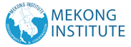

Sustainable & Smart Tourism
Training Program

Organized by Mekong Institute (MI)
Funded by Mekong – Korea Cooperation Fund (MKCF) November 2023

Sustainable Tourism Governance & Strategic Planning
MODULE 3

Trainer November 2023
1 2





Introducing Sustainable Tourism Governance (1)
Session 1

Monday

- Introduction to Governance
- Local & Regional Governance Models
- Identifying key Stakeholders
- Stakeholder Engagement Strategies

22 October 2023 page 4
3 4






Introduction to Governance & Tourism

Structures of governance schemes and tourism. Geographical aspects. DESTINATION
Governance takes a systematic approach to reveal the varying internal and external dynamics that influence tourism policy and strategy across regions and countries.
22 October 2023 page 5

Introduction to Governance & Tourism

Governance schemes vary from region to region and from country to country.
Various sociocultural values and administrative norms lead to different governance structures.
22 October 2023 page 6
5 6
k

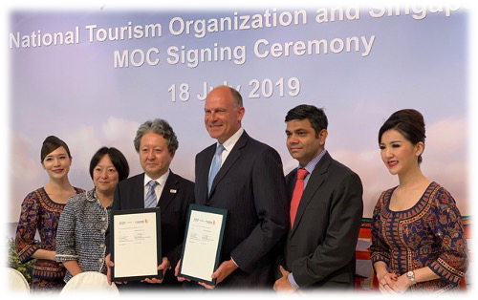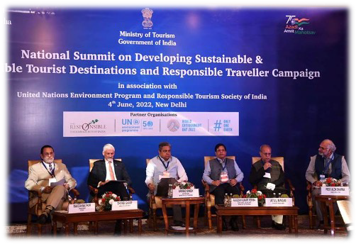

Introduction to Governance & Tourism

Presentation of Examples - Singapore

22 October 2023 page 7

Introduction to Governance & Tourism

Presentation of Examples - India

22 October 2023 page 8
7 8

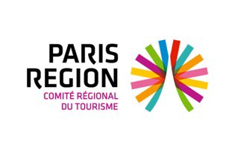





Local & Regional Governance Models

Local Authorities – Tourism Authorities Tourism Bodies and Associations CVBs - DMOs

22 October 2023 page 9

Local & Regional Governance Models

Is a DMO (Destination Management Organization) a Governance Model?

22 October 2023 page 10
9 10

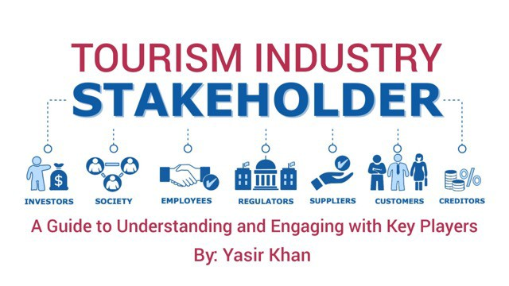
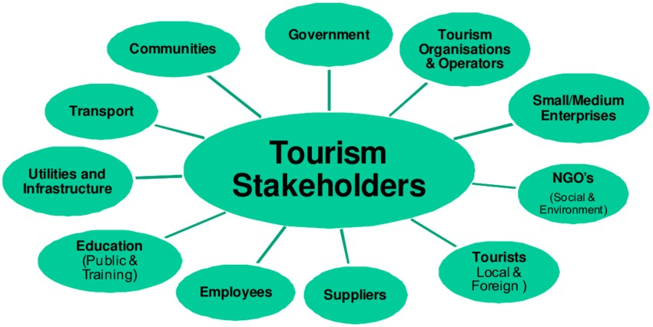

The Destination’s Stakeholders and their Role

- Identifying Key Stakeholders.
- Those that they are in the front line
- Those who are important but not “visible”
- Making CONNECTIONS

22 October 2023 page 11

The Destination’s Stakeholders and their Role

- Participation Initiatives.
- Multi-participation framewor
- Representation and Politics
- How to maintain Balance
- Focus on the BIG picture

22 October 2023 page 12
11 12

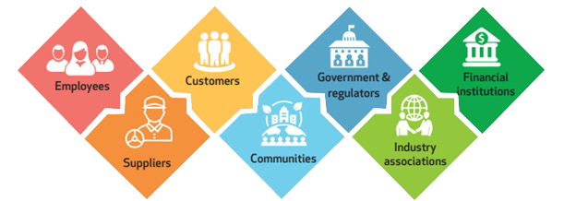

The Destination’s Stakeholders and their Role

Example of Key stakeholders in various DMOs MALTA https://www.mta.com.mt/

- CEO - Malta Tourism Authority https://www.mta.com.mt/
- Board of Tourism Authority
- Ministry of Tourism
- Tourism and Professional Associations
- Community Bodies
22 October 2023 page 13

Stakeholder Engagement Strategies

- Introducing an attractive common vision
- Present the benefits that they ALL share
- Indicate the Contribution required by EACH
- Analyze the decision-making processes

22 October 2023 page 14
13 14



Stakeholder Engagement Strategies

Provide Motivation and Support
Allow open communication and information flow Transparency & Trust
Consultant(s) or Expert(s) on Board Reporting and Dissemination

22 October 2023 page 15

Stakeholder Engagement Strategies

- Infuse Sustainability Values
- Focus on Local-Regional Resilience
- Make everybody proud for their Destination
- Monitor Governance outcomes and Analyze Data

22 October 2023 page 16
15 16

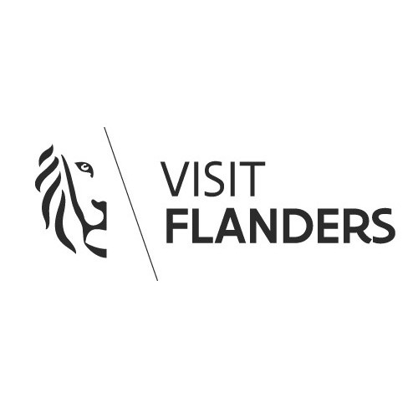


Stakeholder Engagement Strategies

Some successful DMO engagement Strategies

Visit Flanders
https://www.visitflanders.com

22 October 2023 page 17

Discussion about Sustainable Tourism Governance
17 18


Q & A Thank You!
mekonginstitute.org mekonginstitute.org Mekong Institute | MekongInstitute
Mekong Institute
123 Mittraphap Rd., Muang District, Khon Kaen 40002, THAILAND
Tel. : +66 (0) 4320 2411
Fax. : +66 (0) 4320 3656
Email : information@mekonginstitute.org
19

SESSION 2

Sustainable & Smart Tourism
Training Program

Organized by Mekong Institute (MI)
Funded by Mekong – Korea Cooperation Fund (MKCF) November 2023

Sustainable Tourism Governance & Strategic Planning
MODULE 3

Trainer November 2023
1 2

Introducing Sustainable Tourism Governance (2)
Session 2

Monday

- How to Develop a Common Vision
- Aligning different views to ONE Direction
- Destination Leadership
- Integrated Strategies

22 October 2023 page 4
3 4


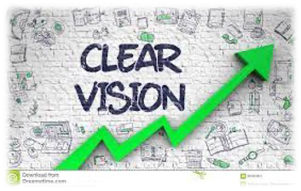



How to Develop a common Vision

As destination organizations globally are increasingly looking inward at stakeholders and residents, they’re addressing what organizational changes are needed to support a shared “social license” for tourism.
22 October 2023 page 5
How to Develop a common Vision
Organizations sometimes have to navigate very opinionated stakeholders, who are clamoring for change (or even to stay the same!). This brings us to the first reluctant behavior that can emerge during the visioning phase: feeling threatened by strong, even contrarian opinions, even going so far as to avoid
them by excluding certain people from the visioning process.
22 October 2023 page 6
5 6



Align Different Views to ONE Direction

Sometimes you need to change mindsets and world view From SMALL to BIG – From INDIVIDUAL to HOLISTIC

22 October 2023 page 7

Align Different Views to ONE Direction

Some higher, ethical values are stronger that individual needs and wants. Promote shared benefits – Not Individual Benefits

22 October 2023 page 8
7 8

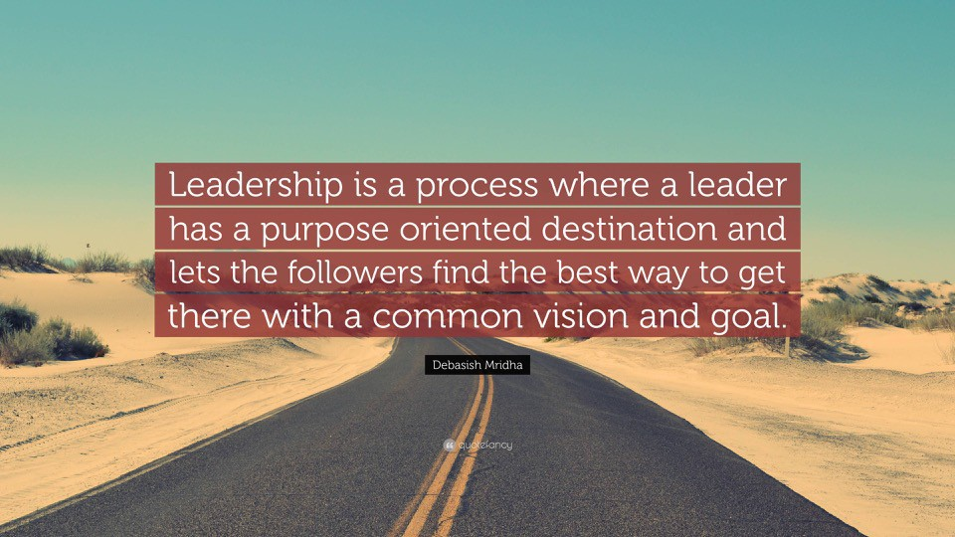


Destination Leadership

22 October 2023 page 9

Destination Leadership

Setting a vision is a test of leadership in other ways.
During this part of the process we assess leadership strengths and weaknesses.

22 October 2023 page 10
9 10




Destination Leadership

The visioning phase is critical for establishing the decision-making processes and structures that undergird the rest of the strategic planning process.
Leadership plays a Critical Role.

22 October 2023 page 11

Destination Leadership

It’s very common to set a 10-year vision and then want to start implementing it immediately. But even after the vision is set, there’s still a lot of work to be done to establish what exactly the organization intends to do to implement that vision.
Leadership is important for the Implementation Phase

22 October 2023 page 12
11 12

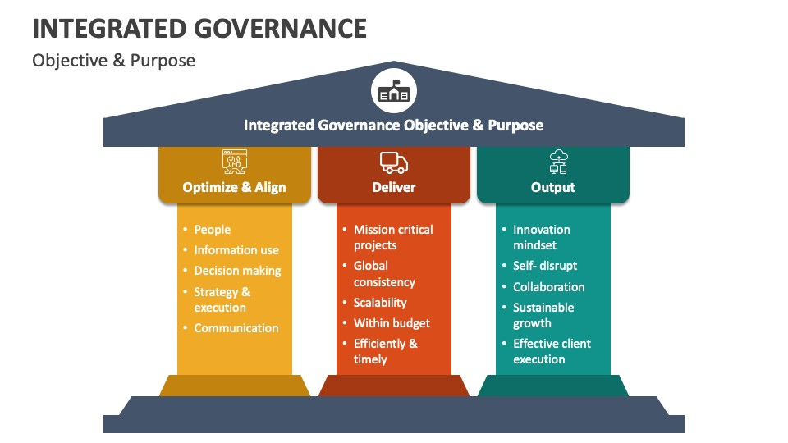

Integrated Governance Structures

22 October 2023 page 13

Integrated Governance Structures

- Understand all stakeholders
- Identify their expected roles
- Design Operational Mechanisms
- Integrate Operational Units

22 October 2023 page 14
13 14




Integrated Governance Structures

- Allocate resources
- Create balanced distribution of authority
- Clarify Decision-Making Processes
- Assign Objectives and Goals

22 October 2023 page 15

Integrated Governance Structures

- Describe the desired outcomes
- Establish monitoring systems
- Evaluate performance
- Identify gaps and Modify

22 October 2023 page 16
15 16

Discussion about Strategic Leadership
Q & A Thank You!
mekonginstitute.org mekonginstitute.org Mekong Institute | MekongInstitute
Mekong Institute
123 Mittraphap Rd., Muang District, Khon Kaen 40002, THAILAND
Tel. : +66 (0) 4320 2411
Fax. : +66 (0) 4320 3656
Email : information@mekonginstitute.org

17 18

SESSION 3

Sustainable & Smart Tourism
Training Program

Organized by Mekong Institute (MI)
Funded by Mekong – Korea Cooperation Fund (MKCF) November 2023

Sustainable Tourism Governance & Strategic Planning
MODULE 3

Trainer November 2023
1 2

Presenting Strategic Planning
Session 3

Monday

- Defining Goals and Objectives
- Goal Setting Strategies
- The Essence of Strategy and Strategic Skills
- Stages of Planning
- Successful Planning Cases

22 October 2023 page 4
3 4



Defining Goals and Objectives
Goals are specific, action-based, and quantitative and require focus and clarity from our side.
Many times people confuse resolutions with goals. You should not make this mistake. Resolutions are passive, while goals are active, and goal-setting
process will be the way to bring them to reality.
22 October 2023 page 5

Defining Goals and Objectives

Goal setting is a process of deciding what you want to achieve and laying out a plan on how to reach that goal. It involves identifying specific objectives, setting performance targets, and evaluating your progress in achieving those goals.
22 October 2023 page 6
5 6

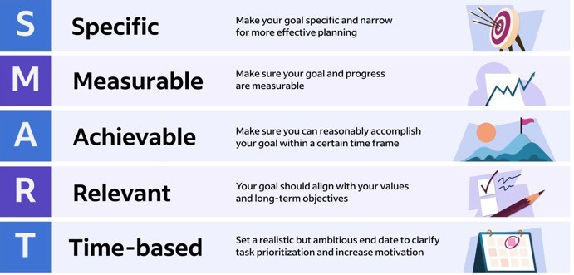

Defining Goals and Objectives

"The goal is the most critical part of the process; it's the plan you create and your actions that drive results"
James Fleming

22 October 2023 page 7

Goal Setting Strategies
Setting Goals means you can clarify your ideas and focus your efforts, which allows you to allocate your time in a way that promises the most return and the highest chance of achieving your goals.

22 October 2023 page 8
7 8



Goal Setting Strategies

1. Make your goal SPECIFIC
The first step in creating a SMART goal is to make it specific. Consider your goal in quantifiable terms by asking yourself the following questions:

What do I want to accomplish?
Will achieving this goal have an important impact? What actions will I need to take?

22 October 2023 page 9

Goal Setting Strategies

2. Make your goal MEASURABLE

This step in the process prompts you to apply methods of measuring your progress toward achieving your goal. Being measurable also takes into account any actions you would implement to help you further your progress toward your goal.

22 October 2023 page 10
9 10

Goal Setting Strategies

3. Make your goal ACHIEVABLE

This aspect of the strategy relates to your goal being achievable. Do you have the resources and time needed to achieve the goal? This may include gathering necessary data, asking team members for help and learning new skills. You're more likely to be successful in your goal once it is specific, measurable and deemed achievable.

22 October 2023 page 11

Goal Setting Strategies

4. Make your goal RELEVANT

A relevant goal will directly contribute to successful results. Keep in mind that every action you take should move you closer to your goal. In our example, a relevant goal will directly reduce expenses.

22 October 2023 page 12
11 12

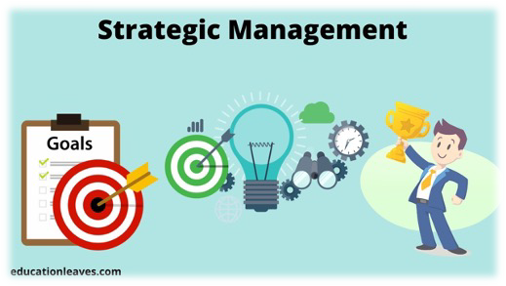

Goal Setting Strategies

5. Make your goal TIME-BASED

A time-based goal has a specific time deadline. You’ll want to determine if your goal is a short-term or long-term goal (or a combination of both). Your timeline should also be realistic and allow you plenty of opportunities to make adjustments to your goal regarding its relevance, specificity and achievability.

22 October 2023 page 13

The Essence of Strategy and Strategic Skills
Strategic management is the process of planning, monitoring, analysis, and assessment of all necessities an organization needs to meet its aims

22 October 2023 page 14
13 14

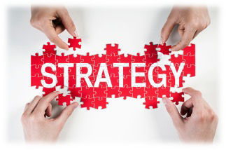


The Essence of Strategy and Strategic Skills

Strategic skills are abilities you can develop to help you think strategically and innovatively. These skills can help you adapt depending on the situation you're facing. Rather than being specific to an occupation or position, strategic skills focus on the personal and communicative abilities individuals need to thrive in a productive work environment.

22 October 2023 page 15
Stages of Planning
Planning is the first primary function of management that precedes all other
functions. The planning function involves the decision of what to do and how it is to be done?
So, managers focus a lot of their attention on planning and the planning
process.
22 October 2023 page 16
15 16

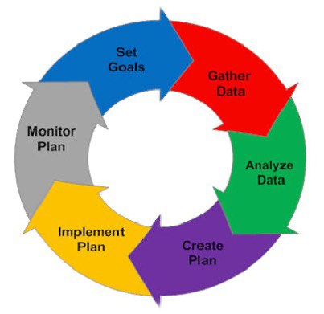


Stages of Planning

- Set Goals.
- Gather Data
- Analyze Data
- Create Plan
- Implement Plan
- Monitor Plan

22 October 2023 page 17

Successful Planning Cases

Promoting higher-end tourism within the Annapurna Conservation Area (ACA) and identifying private sector investment opportunities.

22 October 2023 page 18
17 18



Successful Planning Cases

- Supporting heritage villages to provide diversified offer in Lower Mustang through identifying specific investment concepts and developing investment pitchbooks to be taken to market
- Supporting linkages to market leaders for higher-end resorts and franchise opportunities along new trails in Manang.

22 October 2023 page 19

Successful Planning Cases
Major Activities

- Formulate investment plans/models for three integrated heritage villages (i.e. Tukuche, Marpha, Kagbeni) to support rural municipalities to manage the villages, with an overview of regulatory requirements to facilitate private sector
investments.
- Create an investment pitchbook of the potential traditional old heritage properties located in 3-4 villages (ie. Kagbeni, Tukuche, Marpha), approved by the ACA authorities (NTNC), and disseminate among potential investors.
- Facilitate linkage of existing lodges to local/global heritage boutique resorts for potential management through their own brands.
- Share global best practice examples through a seminar that includes breakout workshops and technical deep dive sessions
- Presentation of investment concepts and pitchbook at a final semina22 Orct.ober 2023 page 20
19 20



Successful Planning Cases

Results

Support the Government of Nepal on promoting higher end tourism in the Annapurna Conservation Area (ACA) and identifying private sector investment opportunities.

22 October 2023 page 21

Discussion about Goals & Plannng Processes
21 22

Q & A Thank You!
mekonginstitute.org mekonginstitute.org Mekong Institute | MekongInstitute
Mekong Institute
123 Mittraphap Rd., Muang District, Khon Kaen 40002, THAILAND
Tel. : +66 (0) 4320 2411
Fax. : +66 (0) 4320 3656
Email : information@mekonginstitute.org
23

SESSION 4

Sustainable & Smart Tourism
Training Program

Organized by Mekong Institute (MI)
Funded by Mekong – Korea Cooperation Fund (MKCF) November 2023

Sustainable Tourism Governance & Strategic Planning
MODULE 3

Trainer November 2023
1 2

Strategic Planning & Policies Implementation Structured Learning Visit (SLV)
Session 4

Monday

- SLV - Group Activity Structure and Deliverables
- Understand the Destination – Key Resources
- Sustainable and Smart Tourism Ideas
- Proposed Action Plans
- Groups Reporting and Presenting

22 October 2023 page 4
3 4

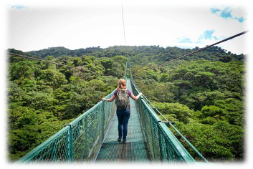
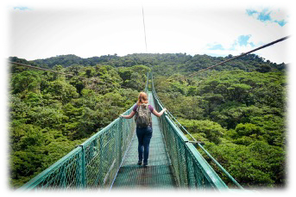

SLV - Group Activity Structure and Deliverables

Providing Essential Information to the 3 groups about their tasks
- Observations
- Keep Notes
- Identifying Challenges

22 October 2023 page 5

SLV - Group Activity Structure and Deliverables

Inspection Visit as a way to explore and analyze the local tourism ecosystem.
Holistic Approach and Overview.

22 October 2023 page 6
5 6

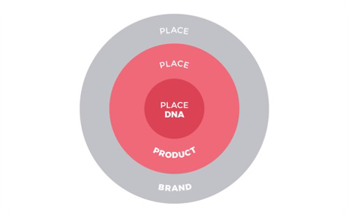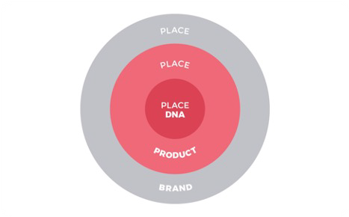

Understand the Visited Destination-Location

What are the key elements, resources that are integrated in the destination. Any hidden gems? What are the components of the Local DNA?

22 October 2023 page 7

Understand the Visited Destination-Location

Can you describe the Identity of the Place?
What are the challenges that you identify from a first overview? How their resources can contribute better for sustainable tourism?

22 October 2023 page 8
7 8

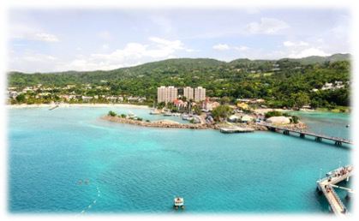


Understand the Visited Destination-Location

Can you imagine a promising development plan? What are the main Actions to be implemented?

22 October 2023 page 9

Sustainable and Smart Tourism Ideas
Describe how Sustainability and Digital Leadership can create a new path for the Destination

22 October 2023 page 10
9 10




Sustainable and Smart Tourism Ideas

Present 2-3 Ideas where selected resources with the use of technology can create a completive advantage with tangible outcomes that reflect to sustainability values

22 October 2023 page 11

Sustainable and Smart Tourism Ideas

What will be the benefit of these Ideas
- To the locals
- To the Visitors
- To the local ecosystem

22 October 2023 page 12
11 12

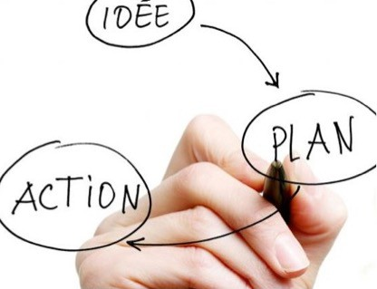

Proposed Action Plans Describe Action Plans
Action Plan 1

Action Plan 2

Action Plan 3

22 October 2023 page 13

Groups Reporting and Presenting
Prepare a Group Report including

- Concept
- Resources Evaluation
- Technology integration
- Sustainability Values served
- Action Plan Implementation
- Desired Outcomes
- Monitoring Process

22 October 2023 page 14
13 14



Groups Reporting and Presenting
Prepare a Group Presentation including

- Concept
- Resources Evaluation
- Technology integration
- Sustainability Values served
- Action Plan Implementation
- Desired Outcomes
- Monitoring Process

22 October 2023 page 15

Discussion about Group Reports
15 16

Q & A Thank You!
mekonginstitute.org mekonginstitute.org Mekong Institute | MekongInstitute
Mekong Institute
123 Mittraphap Rd., Muang District, Khon Kaen 40002, THAILAND
Tel. : +66 (0) 4320 2411
Fax. : +66 (0) 4320 3656
Email : information@mekonginstitute.org
17

