**MODULE 4- Contents of Session Plans**

**MODULE 4: Frameworks for Monitoring Sustainable Tourism**

**Session 1: Monitoring Sustainable Tourism**

**Market Participants:** Session 4 caters to a diverse and multifaceted audience actively engaged in the tourism sector. This includes government officials responsible for tourism policies, tourism professionals striving to enhance industry practices, environmentalists passionate about preserving natural resources, sustainability advocates advocating for responsible tourism, and, importantly, anyone who is deeply interested in ensuring that tourism practices are in complete alignment with sustainability values. This session welcomes participants from various backgrounds and fields, fostering a comprehensive dialogue and exchange of insights to bolster sustainable tourism management and measurement.

**Summary:** Module 4, aptly named "Frameworks for Monitoring Sustainable Tourism," embarks on a comprehensive exploration of the integral realm of sustainability monitoring within the intricate web of the tourism industry. Session 1, the module's inaugural chapter, provides a firm foundation by delving into the foundational aspects of monitoring sustainability. It meticulously unveils the critical reasons underpinning the pressing need for monitoring sustainability, offering participants a rich tapestry of various methodological approaches to achieve this fundamental goal. Moreover, this session masterfully underscores the vital components and facets of the tourism landscape that necessitate meticulous measurement and scrutiny, ensuring that the tourism industry perpetually resonates in harmonious synergy with sustainability values. Serving as the bedrock of the entire module, Session 1 is the starting point for comprehending the essence of sustainability monitoring in the dynamic and ever-evolving tourism industry.

**Key Words:** Sustainability, Monitoring, Tourism Practices, Methodological Approaches, Measurement, Alignment, Environmental Values, Sociocultural Values.

**Objectives:** By the end of this session, participants will:

1. Grasp the fundamental significance of monitoring sustainability in the tourism sector.
2. Explore a spectrum of methodological approaches adopted to monitor sustainability in tourism practices.
3. Identify and understand the key components that must be measured to preserve alignment with sustainability values.

**Outcomes:** Upon the successful culmination of Session 1, participants will find themselves endowed with a solid and foundational understanding that penetrates deep into the essence of monitoring sustainability within the intricate domain of tourism. This newfound comprehension will encompass not only the fundamental components that constitute the core of sustainability monitoring but also a versatile array of methodological approaches that serve as the tools of this trade. Furthermore, participants will emerge from this session with a profound appreciation of the paramount significance that monitoring sustainability bears, like a lighthouse guiding the course of a ship, for the tourism industry. This foundational knowledge forms the bedrock for the subsequent sessions, paving the way for a nuanced exploration of this dynamic and indispensable field.

**Methods:** This dynamic session expertly employs a comprehensive and blended teaching approach that combines the power of enlightening presentations, stimulating interactive group discussions, and illuminating case studies. These pedagogical methods synergize to create an immersive learning environment that transcends the ordinary. Participants are not passive observers but active explorers of knowledge, forging a profound connection with the intricate art of sustainable tourism monitoring. Through presentations, they gain valuable insights; via discussions, they engage in spirited intellectual exchange, and within the realm of case studies, they uncover real-world applications. This multifaceted approach ensures that by the end of the session, they don't just understand but internalize the nuances of sustainable tourism monitoring, ready to embrace its challenges and opportunities.

**Materials:** Embark on a knowledge-rich journey with unrestricted access to a treasure trove of enlightening presentations, illustrative case studies, and a vast array of invaluable reference materials. These educational resources are not mere tools; they are your companions in the quest to understand and master the art of sustainable tourism monitoring. The presentations will unravel complex concepts, the case studies will illuminate real-world applications, and the reference materials will serve as signposts on your path to exploration. Together, they form a robust foundation that amplifies your capacity to comprehend, question, and innovate within the realm of sustainable tourism monitoring.

**Content:**

**Introduction (5 minutes):** The session begins with a warm welcome and a succinct session overview. Participants are introduced to the importance of sustainable tourism monitoring, setting the stage for a comprehensive exploration of the subject matter. This introductory segment aims to engage the audience by conveying the significance of monitoring sustainability in the tourism sector, offering participants a clear purpose for the upcoming discussion.

**Why Monitor Sustainability in Tourism (15 minutes):** In this segment, the focus shifts to the reasons behind the critical need for monitoring sustainability within the tourism industry. Participants delve into the multifaceted rationale for monitoring sustainability, including environmental, social, and economic considerations. The discussion seeks to provide participants with a profound understanding of why sustainability monitoring is an essential component of responsible tourism management, aligning the practices with broader sustainability goals.

**Methodological Approaches to Monitoring Sustainability (20 minutes):** This part of the session takes a deep dive into the methodological approaches employed in the process of monitoring sustainability. Participants explore key metrics and data collection methods that underpin sustainability monitoring. This segment offers an opportunity for attendees to gain insights into the practical aspects of how sustainability is measured and tracked in the real-world context of the tourism industry.

**Measuring Sustainability (20 minutes):** Participants are guided through the specific elements and parameters that need to be measured in the context of sustainable tourism. This content segment underscores the importance of these measurements in ensuring that tourism practices remain aligned with sustainability values. It encourages participants to reflect on the practical application of these measurements and how they contribute to the overall sustainability of the tourism sector.

**Interactive Discussion and Q&A (15 minutes):** The session concludes with an interactive discussion and a dedicated Q&A segment. During this time, participants are actively engaged in a discussion about their understanding of the topics covered so far. They have the opportunity to ask questions, seek clarifications, and share their insights. This interactive element fosters a collaborative learning environment, ensuring that participants leave the session with a profound understanding of sustainable tourism monitoring.

These segments are designed to provide a comprehensive and engaging learning experience for participants during Session 1, facilitating a deeper understanding of the critical aspects of monitoring sustainability in the context of tourism.

**Section 2: Key Components of Measurement (Approx. 25 minutes)**

**Market Participants:** This section is intentionally designed to cater to a wide-ranging audience deeply entrenched in the multifaceted world of tourism. It beckons government officials, those at the helm of crafting tourism policies and regulations, to step forward. It extends its reach to embrace tourism industry professionals, the lifeblood of this sector, whose actions shape the daily experiences of travelers. It invites environmentalists, the dedicated stewards of our planet, and sustainability advocates, fervent champions of ethical and responsible tourism, to join the discourse. And it leaves the door wide open for anyone who seeks to unravel the intricate machinery that powers the measurement of sustainability within tourism. In essence, it is a call to assemble a diverse congregation, each with their unique perspectives and roles, to embark on a collective journey into the heart of sustainability measurement in tourism.

**Summary:** As Module 4 unfurls its mission to illuminate the path towards Monitoring Sustainable Tourism, Session 2, "Key Components of Measurement," beckons us to explore the intricate gears and cogs that drive this grand machinery. Building upon the foundations laid in Session 1, this enlightening chapter navigates the essential aspects that demand meticulous measurement to uphold the sacred covenant between tourism and sustainability. With each keystroke of data, we embark on a journey to ensure our tourism practices remain aligned with the noble values of sustainability. By plumbing the depths of these crucial components and wielding the tools of measurement, we pave the way for responsible and ethical tourism management in the modern world.

**Key Words:** Sustainability Measurement, Key Components, Tourism Practices, Alignment, Environmental Values, Sociocultural Values.

**Objectives:** By the end of this session, participants will:

1. Gain a comprehensive understanding of the essential components that demand measurement to ascertain sustainability in tourism.
2. Recognize the significance of aligning tourism practices with sustainability values through measurement processes.

**Outcomes:** As the curtain falls on Session 2, participants will emerge with an intricate understanding of the specific components that serve as the pillars of sustainability in the realm of tourism. Armed with this knowledge, they will be equipped to measure, evaluate, and ensure that tourism practices are in unwavering alignment with the noble principles of sustainability. This heightened awareness will empower them to be stewards of responsible tourism, capable of steering the industry towards an ecologically and socially conscious horizon.

**Methods:** Session 2 adopts a rich and multifaceted approach to facilitate learning. This comprehensive strategy includes in-depth presentations, interactive group discussions that encourage active engagement, and the exploration of practical case studies. By integrating these diverse methods, participants are immersed in the complex landscape of sustainable tourism measurement. This approach ensures that they depart with a profound understanding of the intricate processes and methodologies that underpin sustainability in the realm of tourism.

**Materials:** Participants will be provided with a rich array of educational resources, comprising detailed presentations that offer in-depth insights into the nuances of sustainability measurement. Additionally, illustrative case studies will be made available to illuminate practical applications and real-world examples. To further enhance the learning experience, reference documents will be at participants' disposal, enabling them to delve deeply into the key components of sustainability measurement within the intricate landscape of the tourism sector. These materials collectively empower participants in their quest for a comprehensive understanding of this crucial subject matter.

**Content:**

**Introduction (5 minutes):** The session commences with a brief recap of the previous session, creating a connection between the content covered in the preceding session and the current topic. This recap ensures that participants are prepared to build on their knowledge. Subsequently, an overview is provided, setting the stage for what participants can expect in this session.

**Sustainability Indicators and Their Importance (15 minutes):** In this segment, the emphasis is on sustainability indicators and their critical role in the context of sustainable tourism. Participants will gain a comprehensive understanding of how sustainability indicators contribute to measuring sustainability and ensuring responsible tourism. The discussion will also shed light on various types of indicators, illuminating their significance within the field.

**Organizations Supporting Sustainability Measurement (20 minutes):** The spotlight turns toward various organizations that actively support sustainability measurement and reporting within the tourism industry. Participants will be introduced to these organizations and will explore their substantial contributions to the field of sustainable tourism. This segment highlights how these organizations play a vital role in promoting and advancing sustainable tourism practices.

**Selecting Suitable Sustainability Indicators (20 minutes):** This part of the session is dedicated to guiding participants through the process of selecting the most relevant sustainability indicators for effective measurement of sustainable tourism. The discussion delves into the criteria and considerations involved in the selection of these indicators. Participants will acquire the knowledge necessary to make informed choices when it comes to measuring sustainability.

**Interactive Activity: Indicator Selection (10 minutes):** An interactive activity is incorporated, engaging participants in the practical process of selecting suitable sustainability indicators. This exercise encourages hands-on experience, allowing participants to actively practice the skills and knowledge gained during the session. Group discussions and sharing are encouraged, promoting collaborative learning and the application of the principles discussed.

**Q&A and Discussion (10 minutes):** The session wraps up with a dedicated Q&A and open discussion segment. Here, participants have the opportunity to seek clarifications, raise questions, and engage in discussions regarding indicator selection and the challenges they may encounter. This interactive component ensures that participants leave the session with a comprehensive understanding of sustainability indicators and their importance in the context of sustainable tourism.

These segments collectively aim to provide an enriching and interactive learning experience for participants, fostering a deeper understanding of sustainability measurement and the significance of sustainability indicators in sustainable tourism practices.

**Session 3: UNWTO and the International Network for Sustainable Tourism Observatories**

**Market Participants:** Session 3 is meticulously designed to cater to the interests and expertise of a diverse and expansive audience within the tourism sector. This includes government officials entrusted with the formulation of tourism policies, seasoned professionals actively shaping the industry, sustainability advocates fervently dedicated to preserving our planet's treasures, academic minds delving into the depths of knowledge, and inquisitive individuals passionate about comprehending the pivotal role played by international organizations in the standardization of sustainability measurement within the vibrant tapestry of tourism. This session holds particular allure for those eager to unravel the inner workings of renowned entities such as the UNWTO and the International Network for Sustainable Tourism Observatories (INSTO), making it an indispensable experience for those seeking profound insights into the global landscape of sustainable tourism.

**Summary:** Session 3, titled "UNWTO and the International Network for Sustainable Tourism Observatories," serves as a captivating expedition into the profound influence wielded by international organizations in molding the landscape of sustainability measurement within the intricate domain of tourism. With a discerning focus on two prominent entities, the United Nations World Tourism Organization (UNWTO) and the International Network for Sustainable Tourism Observatories (INSTO), this session embarks on an intricate journey through the core concept of Sustainable Tourism Observatories. It meticulously unravels the complexities of developing meticulous measurement processes that guarantee accuracy and relevance in sustainability assessments. As participants navigate this session, they will acquire a deep understanding of the substantial contributions made by these organizations in fostering, upholding, and disseminating sustainable tourism practices to ensure a harmonious coexistence of travel and our planet's precious resources.

**Key Words:** UNWTO, International Network for Sustainable Tourism Observatories, Sustainability Measurement, Tourism Standardization, Data Accuracy, Stakeholder Reporting.

**Objectives:** By the end of this session, participants will:

1. Gain a comprehensive understanding of the role of UNWTO and INSTO in standardizing sustainability measurement within the tourism sector.
2. Explore the development of processes that ensure the accuracy and relativity of data used in sustainability measurement.
3. Learn the principles of reporting measurement outcomes to the public and key stakeholders.

**Outcomes:** Upon successfully concluding Session 3, participants will emerge well-equipped with a profound comprehension of the pivotal role played by international organizations in the standardization of sustainability measurement processes within the dynamic realm of tourism. They will gain valuable insights into how these organizations diligently work to ensure the precision and relevance of collected data, subsequently facilitating the responsible reporting of measurement outcomes. Armed with this knowledge, participants will be well-prepared to champion and advocate for sustainability in tourism, underpinned by the principles of accuracy, alignment with global standards, and the dissemination of invaluable measurement findings.

**Methods:** For Session 3, we adopt a rich and interactive pedagogical approach, combining in-depth presentations, dynamic discussions, real-world case studies, and engaging collaborative exercises. These diverse methods are thoughtfully designed to foster active participation among our participants, ensuring their comprehensive grasp of the critical role played by international organizations in shaping sustainability measurement standards within the ever-evolving sphere of tourism.

**Materials:** Our participants will have the privilege of accessing an extensive array of learning materials, meticulously curated to facilitate their in-depth exploration of the United Nations World Tourism Organization (UNWTO), the International Network for Sustainable Tourism Observatories (INSTO), and the core principles underpinning the standardization of sustainability measurement within the tourism sector. These materials include comprehensive presentations, illuminating case studies, and indispensable reference documents that empower participants in their quest to understand these influential organizations and their role in shaping sustainable tourism practices.

**Content:**

**Introduction (5 minutes):** The session commences with a warm welcome and a brief overview, ensuring participants are oriented for the topic at hand. The focus of the session is clearly explained, setting the context for what participants can expect to learn.

**Sustainable Tourism Observatories (20 minutes):** The spotlight shifts to the definition and significance of Sustainable Tourism Observatories. Participants will gain a comprehensive understanding of what these observatories are and how they play a pivotal role in monitoring and promoting sustainable tourism. This segment provides the foundation for the rest of the session.

**Development of Measurement Processes (20 minutes):** Participants will delve into how measurement processes are developed within the framework of Sustainable Tourism Observatories. The discussion highlights the intricacies of this process and the steps involved. Moreover, the emphasis is on the importance of accuracy and reliability, illuminating their crucial role in ensuring the effectiveness of these measurement processes.

**Ensuring Data Accuracy (10 minutes):** This segment is dedicated to sharing techniques for ensuring the accuracy and relativity of the data collected within Sustainable Tourism Observatories. Participants will also engage in discussions surrounding the challenges encountered in maintaining data accuracy and potential solutions. This practical knowledge is invaluable for participants' future contributions to the field.

**Reporting Measurement Outcomes (20 minutes):** The focus now shifts toward providing strategies for effectively reporting measurement outcomes to the public and key stakeholders. Participants will explore the importance of transparency and the role it plays in building trust and credibility. This segment equips participants with the necessary skills to disseminate information about sustainability effectively.

**Interactive Discussion (10 minutes):** The session concludes with an interactive discussion, where participants actively engage in conversations about their roles within Sustainable Tourism Observatories. This segment encourages participants to share their experiences and insights, fostering a dynamic exchange of knowledge and practical wisdom.

Collectively, these segments aim to provide participants with a well-rounded understanding of Sustainable Tourism Observatories, their development, the importance of data accuracy, and effective reporting strategies. Participants will leave with the knowledge and skills required to contribute effectively to the accurate measurement and promotion of sustainable tourism practices.

**Session 4: Carrying Capacity Concept & Successful Examples for Sustainability Measurement**

**Market Participants:** Session 4 welcomes a diverse audience with a shared interest in the intricate realm of sustainable tourism management and measurement. This session caters to an array of stakeholders, encompassing government officials, tourism industry professionals, environmental advocates, academics, and anyone with a keen interest in gaining practical insights into carrying capacity and seeking inspiration from real-world examples of successful sustainability measurement within the tourism sector. Whether you're a decision-maker in the field or an enthusiastic learner, this session offers valuable knowledge and experiences tailored to a wide spectrum of participants.

**Summary:** The concluding session of Module 4, titled "Carrying Capacity Concept & Successful Examples for Sustainability Measurement," takes an extensive exploration into the critical concept of carrying capacity and its indispensable role in the domain of sustainable tourism management. This session draws a clear connection between carrying capacity and sustainability measurement while drawing insights from successful sustainability measurement practices in diverse global regions. As participants progress through this session, they will acquire a deep comprehension of the pivotal significance of carrying capacity and engage in comprehensive analysis of real-world examples, enriching their knowledge of sustainable tourism management.

**Key Words:** Carrying Capacity, Sustainable Tourism Management, Sustainability Measurement, Real-World Examples, Best Practices.

**Objectives:** By the end of this session, participants will:

1. Grasp the concept of carrying capacity and its significance in sustainable tourism management.
2. Analyze a range of successful real-world examples of sustainability measurement and reporting from different regions.
3. Compare different sustainability measurement processes and reporting methods to identify best practices.

**Outcomes:** Upon the culmination of Session 4, participants will emerge with a comprehensive understanding of the concept of carrying capacity and its critical significance in the realm of sustainable tourism management. They will have not only acquired valuable insights from diverse real-world sustainability measurement examples but also identified best practices that can be readily applied in their respective contexts. This session equips participants with the knowledge and practical tools necessary to navigate the complex terrain of sustainable tourism management and measurement while drawing inspiration from the successful practices showcased.

**Methods:** Session 4 employs a multifaceted approach to learning, incorporating a diverse range of pedagogical methods, including in-depth presentations, interactive group discussions, engaging case studies, and hands-on interactive exercises. These carefully designed methods encourage active participation, ensuring that participants gain a profound and practical understanding of the concept of carrying capacity and the multifaceted techniques employed for measuring sustainability in the dynamic realm of tourism.

**Materials:** Participants will have access to an extensive range of comprehensive learning materials, comprising in-depth presentations, illuminating real-world case studies, and a wealth of reference documents. These resources are meticulously curated to provide the necessary support for participants to engage in a deep and comprehensive exploration of the intricate concept of carrying capacity and to immerse themselves in the valuable insights gleaned from successful sustainability measurement examples within the dynamic tourism sector.

**Content:**

**Introduction (5 minutes):** The session begins with a brief recap of the previous session, creating continuity and a sense of progression for participants. This recap segues into an overview of the core topic, the carrying capacity concept, ensuring participants are aligned with the session's objectives.

**Understanding Carrying Capacity (20 minutes):** This segment immerses participants in the concept and approach of carrying capacity in the context of sustainable tourism. They will gain a comprehensive understanding of this pivotal concept and its critical role in managing tourism sustainability. The discussion delves into the nuances of what carrying capacity entails and how it shapes the sustainable management of tourism.

**Real-World Examples of Sustainability Measurement (20 minutes):** The session then shifts focus to the presentation of successful real-world examples of sustainability measurement in the tourism sector. Participants will be exposed to practical, inspiring cases that showcase effective sustainability measurement initiatives. These real-world examples not only provide insights but also serve as a source of motivation for participants in their own sustainability endeavors.

**Comparing Measurement Processes (10 minutes):** Encouraging active participation, this segment urges participants to compare different measurement processes and reporting methods. The aim is to foster a deeper understanding of the challenges and opportunities that lie within sustainability measurement. It provides a platform for participants to critically analyze and discuss the various approaches to measurement, thereby enhancing their capacity to make informed decisions in this realm.

**Interactive Activity: Case Study Analysis (10 minutes):** Participants are engaged in a hands-on, interactive case study analysis. This activity allows them to apply their newfound knowledge and insights by exploring one or more case studies in depth. They will discuss the factors contributing to the success of these cases, encouraging a deeper understanding of real-world applications.

**Q&A and Discussion (10 minutes):** The session concludes with a dynamic Q&A and discussion segment. Participants have the opportunity to raise any questions or concerns they may have, while also engaging in an open discussion about carrying capacity and sustainability measurement. This segment encourages participants to reflect on the session's content and seek clarification on any aspects that may not be clear.

Together, these components aim to provide participants with a comprehensive grasp of the carrying capacity concept, expose them to successful real-world examples, and empower them with the tools to compare and critically evaluate different measurement processes and reporting methods. The interactive elements ensure active engagement and a deeper understanding of the material.

PRESENTATIONS

Session 1

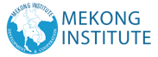

**Sustainable & Smart Tourism**

**Training Program**

Organized by Mekong Institute (MI)

Funded by Mekong – Korea Cooperation Fund (MKCF) November 2023

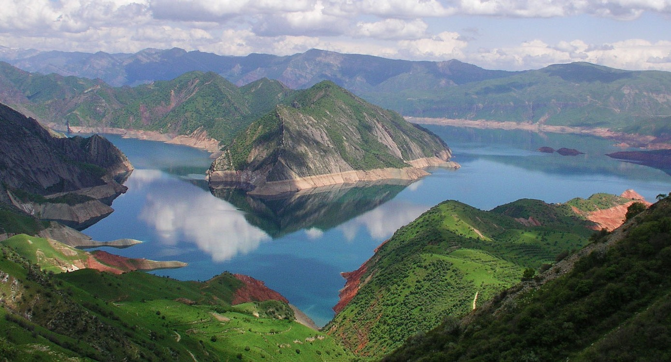

**Frameworks for Monitoring Sustainable Tourism**

**MODULE 4**

Trainer November 2023

1 2



**Monitoring Sustainable Tourism**

**Session 1**

Monday



* Reasons for Monitoring Sustainability
* Methodological Approaches
* Key Components of Measurement
* Aligning with Sustainability Values

30 October 2023 page 4

3 4



**Reasons for Monitoring Sustainability**

If you don’t MEASURE you cannot MANAGE

Sustainability includes a variety of sensitive Sociocultural, Economic and Environmental elements that we need to treat with a responsible way. We need to create solid evidence of the positive impact on these elements.

30 October 2023 page 5



**Reasons for Monitoring Sustainability**

A holistic transformation of a destination aiming for the long-term prosperity of its people and its natural environment, transforming its tourism-based economy on the principles of sustainability. This transformation is based on specific measurable actions with a desired outcome that we need to monitor.

30 October 2023 page 6

5 6

30 October 2023 page 9

30 October 2023 page 11

30 October 2023 page 12



**Reasons for Monitoring Sustainability**

Benchmarking from other Sustainable and Smart Tourism Destinations From a Strategy – To an Action Plan – To Measurable Outcomes

30 October 2023 page 7

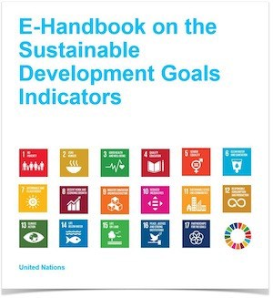

**Methodological Approaches**

* Sustainability Indicators
* Economic, Social and Environmental Balance
* Data, Statistics and Indicators

30 October 2023 page 8

7 8

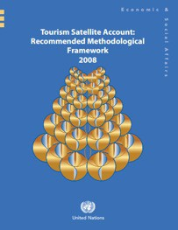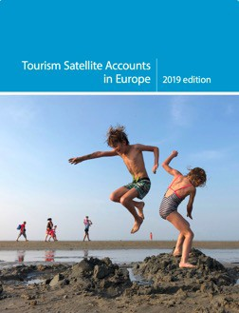

**Methodological Approaches**

Methodological Tools

Methological Framework for the

implementation of Tourism Satellite Accounts TSA (UN)

*UN – Tourism Satellite Account:*

*Recommended Methodological Framework, 2008*

Implementation Guide for TSA in Europe

*Tourism Satellite Accounts in Europe, 2019*

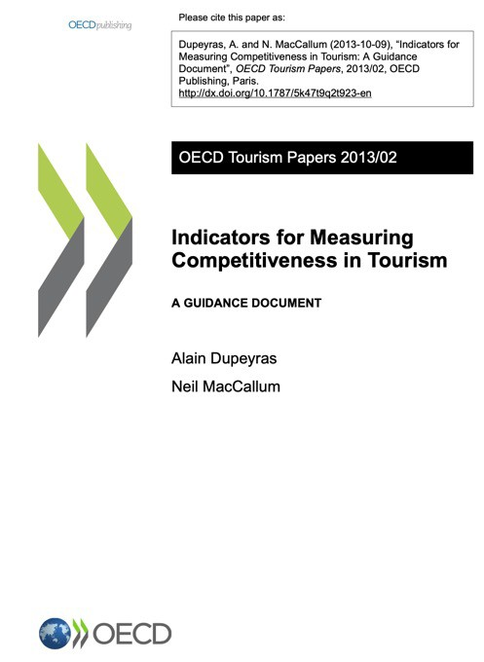

**Methodological Approaches**

Methodological Tools

Indicators for Measuring Competitiveness in Tourism

*OECD Tourism Reports 2013/02*

30 October 2023 page 10

9 10

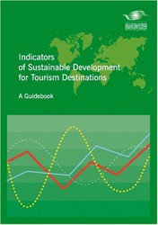

**Methodological Approaches**

Methodological Tools

Indicators Toolkit from EU

*The European Tourism Indicator System – ETIS Toolkit for Sustainable Destination Management, 2016*

Indicators Guide from UNWTO

*Indicators of Sustainable development for Tourism Destinations*

*– A Guidebook, 2004*



**Methodological Approaches**

Methodological Tools

Indicators Toolkit from EU

*The European Tourism Indicator System – ETIS Toolkit for Sustainable Destination Management, 2016*

Indicators Guide from UNWTO

*Indicators of Sustainable development for Tourism Destinations*

*– A Guidebook, 2004*

11 12

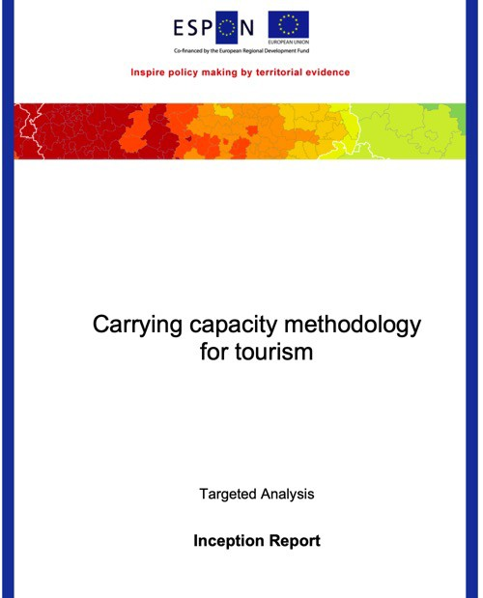

**Methodological Approaches**

Methodological Tools

Evaluating Carrying Capacity

*Carrying Capacity Methodology for Tourism, (EU-ESPON, 2020)*

30 October 2023 page 13



**Key Components of Measurement**

What we Measure?

**Examples of Key Measuring Areas**

1. Employment in Tourism
2. Tourism Seasonality
3. Managing Energy Sources
4. Managing Water Sources
5. Local Community’s Satisfaction Level
6. Managing Liquid Waste
7. Managing Solid Waste
8. Governance

30 October 2023 page 14

13 14



**Key Components of Measurement**

* Every place has its own needs and characteristics
* Various issues can be considered more important regionally
* All stakeholders need to agree to monitor these sensitive matters
* Some scientific assistance is needed & consultation
* International existing examples

30 October 2023 page 15



**Key Components of Measurement**

* Data Selection process
* Data Storing Process (Database)
* Data Analysis & Calculations
* Report Creation
* Present Data and Outcomes with Scientific validity

30 October 2023 page 16

15 16

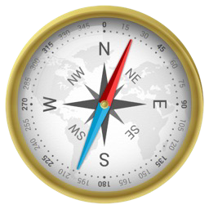

**Key Components of Measurement**

* Selected Regional Statistics
* Agreements for Access to Statistics & Data
* Primary Research (e.g visitors’ satisfaction)
* Developing a Regional Body to Manage the whole effort
* Engage all those who will be interested to learn from the Data Analysis

30 October 2023 page 17

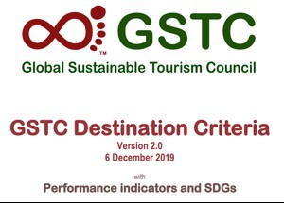

**Aligning with Sustainability Values**

* UN SDGs
* UNWTO
* GSTC
* Other Global Initiatives

30 October 2023 page 18

17 18



**Discussion about Monitoring Sustainable Tourism in Mekong Region**

|  |  |
| --- | --- |
| **Q & A Thank You!** | |
| **mekonginstitute.org mekonginstitute.org Mekong Institute** | **MekongInstitute** |
| **Mekong Institute** |  |
| 123 Mittraphap Rd., Muang District, Khon Kaen 40002, THAILAND |  |
| Tel. : +66 (0) 4320 2411 |  |
| Fax. : +66 (0) 4320 3656 |  |
| [Email : information@mekonginstitute.org](mailto:information@mekonginstitute.org) |  |

19 20



SESSION 2



**Sustainable & Smart Tourism**

**Training Program**

Organized by Mekong Institute (MI)

Funded by Mekong – Korea Cooperation Fund (MKCF) November 2023



**Sustainable Tourism Governance & Strategic Planning**

**MODULE 4**

Trainer November 2023

1 2



**Existing Tools for Measuring Sustainable Tourism**

**Session 2**

Monday



* Sustainability Indicators
* Categories and variety of Indicators
* Selecting the proper indicators for your place
* Agree on the expected outcomes

30 October 2023 page 4

3 4



**Sustainability Indicators**

There are specific ways that you can create proof and evidence about areas that are considered important for each tourism ecosystem.

A very common way is to use specific indicators that are measuring these sensitive areas. We generally call them sustainability indicators.

*“If you can't measure it, you can't manage it.”*

*Peter Drucker*

*“(…) providing the right data at the right time to the right people so that they can take the right decisions.”*

*Nic Smith*

30 October 2023 page 5

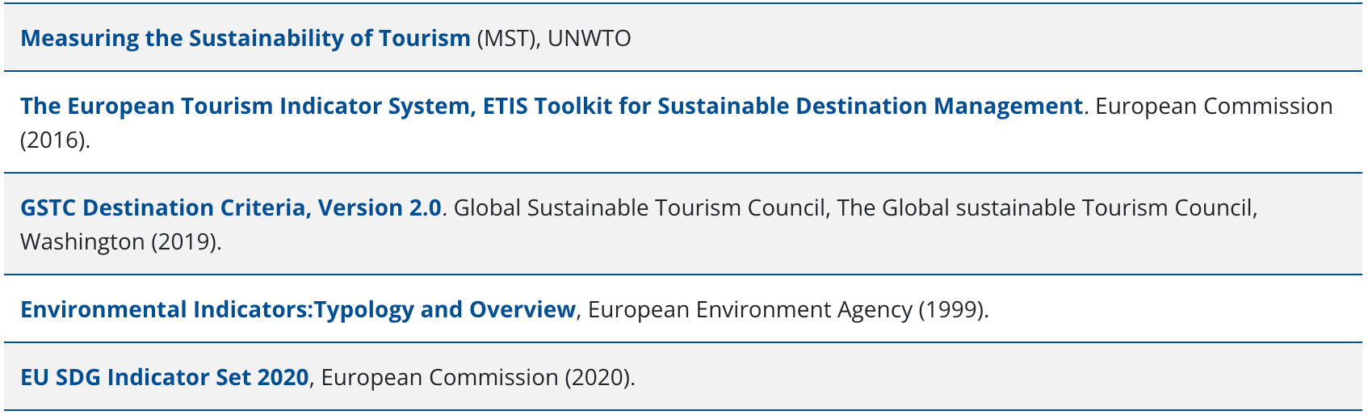

**Sustainability Indicators**

On a destination level there are various regional or global organizations that have created performance criteria and guidelines. Some of them are shown here:

30 October 2023 page 6

5 6

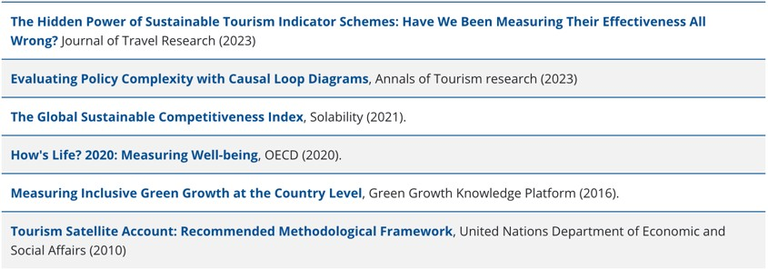

**Sustainability Indicators**

In any case the approach of each organization is related with the area of interest for the specific region and or the values that the organization is prioritizing.

30 October 2023 page 7

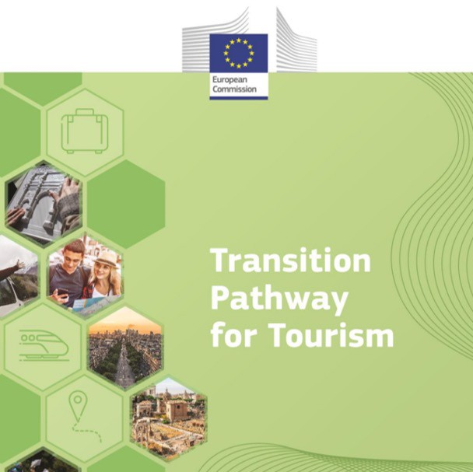

**Categories & Variety of Indicators**

The categories and the variety of indicators offered from all those organization is a good starting point to initiate a study that will support the local and regional efforts in the desired sustainability monitoring

30 October 2023 page 8

7 8

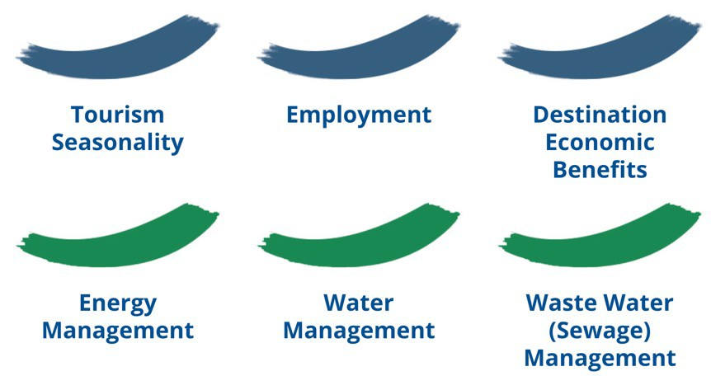

**Categories & Variety of Indicators**

Some indicators are created for areas that are considered important to be monitored. Here below are some common areas of interest on a global level. (1)

30 October 2023 page 9

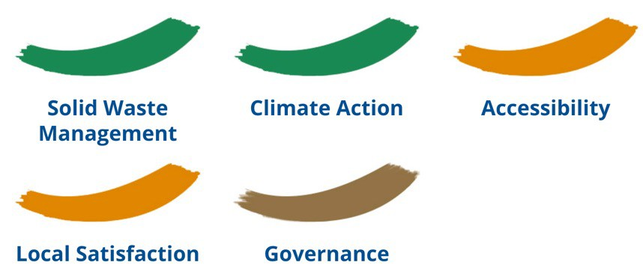

**Categories & Variety of Indicators**

Some indicators are created for areas that are considered important to be monitored. Here below are some common areas of interest on a global level. (2)

30 October 2023 page 10

9 10

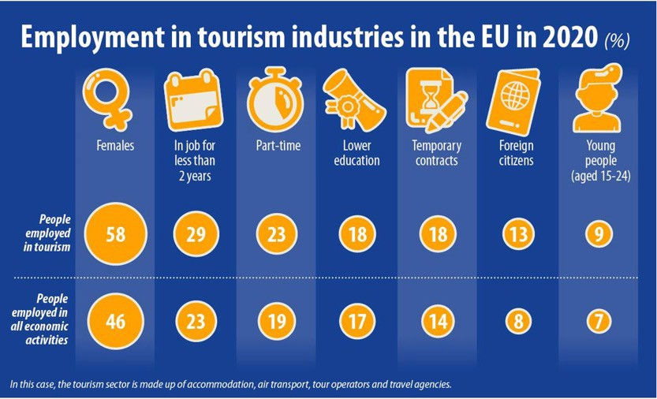

**Categories & Variety of Indicators**

Example (1): EU employment in Tourism

30 October 2023 page 11

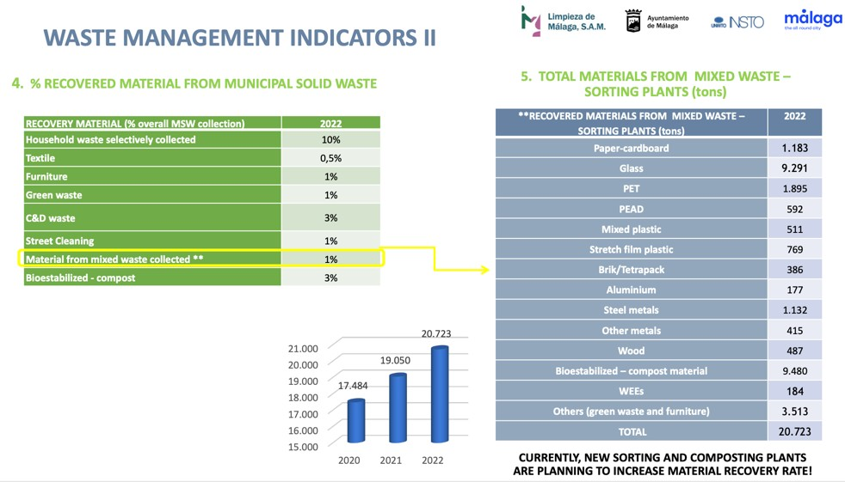

**Categories & Variety of Indicators**

Example (2):

MALAGA - SPAIN

Waste Management Indicators

30 October 2023 page 12

11 12

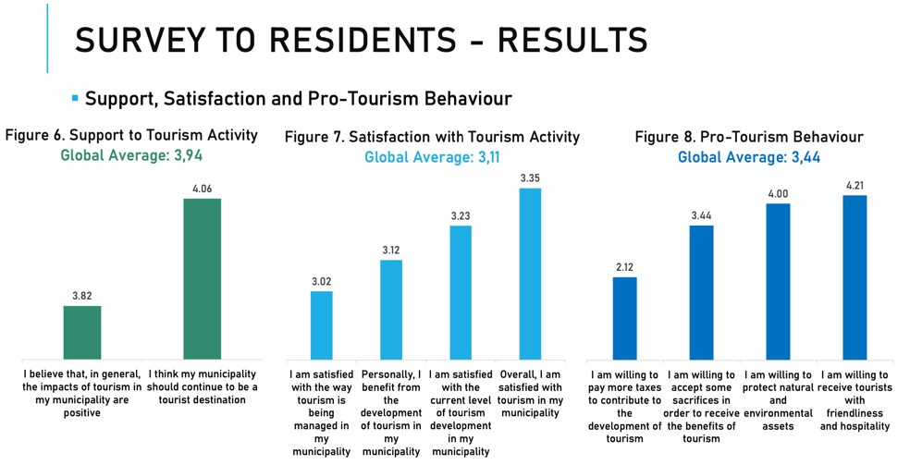

**Categories & Variety of Indicators**

Example (3): Residents’ Satisfaction – Algarve PORTUGAL

30 October 2023 page 13

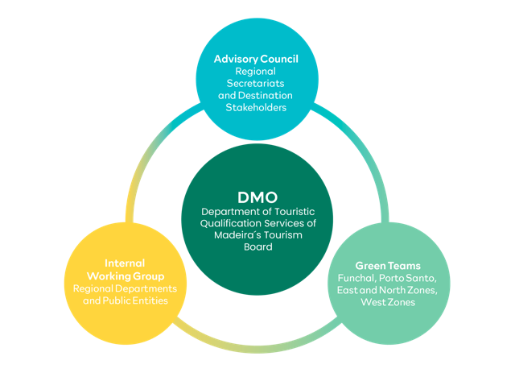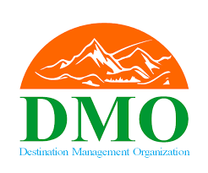

**Selecting the proper Indicators for your Place**

First there must be an open discussion among all stakeholders, including community bodies and experts, about what are the major sensitive areas that may need to be monitored.

A local or regional DMO can play a key role on that.

30 October 2023 page 14

13 14

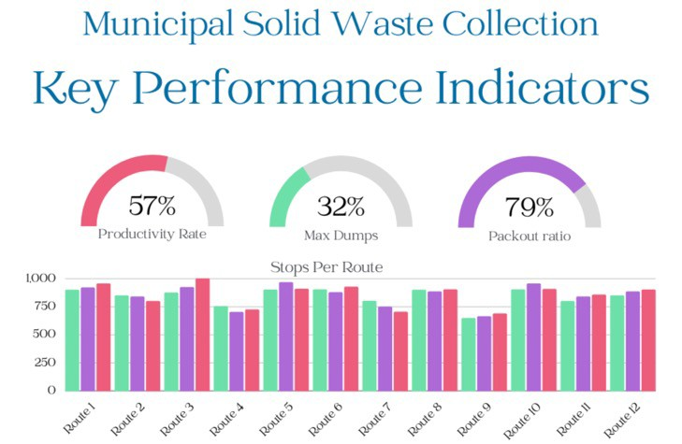

**Selecting the proper Indicators for your Place**

Second for each selected area of interest (e.g Waste Management) you select indicators that can provide evidence about the progress on managing waste in different time periods.

30 October 2023 page 15

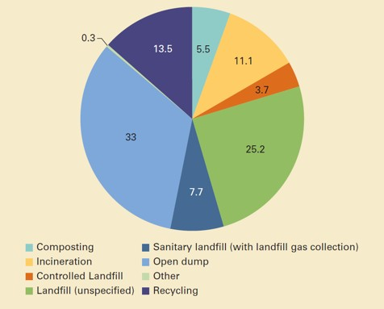

**Selecting the proper Indicators for your Place**

Third, you need to secure the validity of the resources of the primary data, the format of the data available and the accuracy of the information.

30 October 2023 page 16

15 16

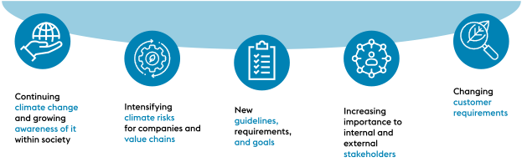

**Agree on the Expected Outcomes**

* Even if we agree what we expect from the indicators
* We need to be ready to see the evidence and hear the conclusions
* And based on that we need to be ready to create new policies-strategies
* AND take ACTIONS

30 October 2023 page 17



**Agree on the Expected Outcomes**

* The indicators are selected for a reason
* The indicators create outcomes
* These outcomes must be analyzed
* From the analysis, there will be some scientific conclusions

30 October 2023 page 18

17 18

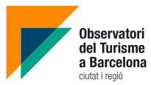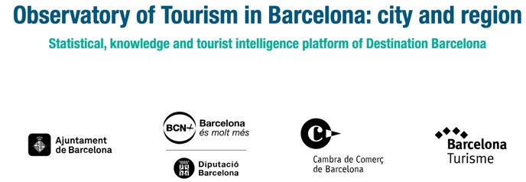

**Example of an Existing Monitoring Framework**

https://[www.observatoriturisme.barcelona/en](http://www.observatoriturisme.barcelona/en)

30 October 2023 page 19



**Discussion about options for Mekong Region**

19 20

|  |  |
| --- | --- |
|   **Q & A Thank You!** | |
| **mekonginstitute.org mekonginstitute.org Mekong Institute** | **MekongInstitute** |
| **Mekong Institute** |  |
| 123 Mittraphap Rd., Muang District, Khon Kaen 40002, THAILAND |  |
| Tel. : +66 (0) 4320 2411 |  |
| Fax. : +66 (0) 4320 3656 |  |
| [Email : information@mekonginstitute.org](mailto:information@mekonginstitute.org) |  |

21

SESSION 3



**Sustainable & Smart Tourism**

**Training Program**

Organized by Mekong Institute (MI)

Funded by Mekong – Korea Cooperation Fund (MKCF) November 2023



**Sustainable Tourism Governance & Strategic Planning**

**MODULE 4**

Trainer November 2023

1 2



**Existing Tools for Measuring Sustainable Tourism**

**Session 2**

Monday



* Sustainability Indicators
* Categories and variety of Indicators
* Selecting the proper indicators for your place
* Agree on the expected outcomes

30 October 2023 page 4

3 4



**Sustainability Indicators**

There are specific ways that you can create proof and evidence about areas that are considered important for each tourism ecosystem.

A very common way is to use specific indicators that are measuring these sensitive areas. We generally call them sustainability indicators.

*“If you can't measure it, you can't manage it.”*

*Peter Drucker*

*“(…) providing the right data at the right time to the right people so that they can take the right decisions.”*

*Nic Smith*

30 October 2023 page 5



**Sustainability Indicators**

On a destination level there are various regional or global organizations that have created performance criteria and guidelines. Some of them are shown here:

30 October 2023 page 6

5 6



**Sustainability Indicators**

In any case the approach of each organization is related with the area of interest for the specific region and or the values that the organization is prioritizing.

30 October 2023 page 7



**Categories & Variety of Indicators**

The categories and the variety of indicators offered from all those organization is a good starting point to initiate a study that will support the local and regional efforts in the desired sustainability monitoring

30 October 2023 page 8

7 8



**Categories & Variety of Indicators**

Some indicators are created for areas that are considered important to be monitored. Here below are some common areas of interest on a global level. (1)

30 October 2023 page 9



**Categories & Variety of Indicators**

Some indicators are created for areas that are considered important to be monitored. Here below are some common areas of interest on a global level. (2)

30 October 2023 page 10

9 10



**Categories & Variety of Indicators**

Example (1): EU employment in Tourism

30 October 2023 page 11



**Categories & Variety of Indicators**

Example (2):

MALAGA - SPAIN

Waste Management Indicators

30 October 2023 page 12

11 12



**Categories & Variety of Indicators**

Example (3): Residents’ Satisfaction – Algarve PORTUGAL

30 October 2023 page 13



**Selecting the proper Indicators for your Place**

First there must be an open discussion among all stakeholders, including community bodies and experts, about what are the major sensitive areas that may need to be monitored.

A local or regional DMO can play a key role on that.

30 October 2023 page 14

13 14



**Selecting the proper Indicators for your Place**

Second for each selected area of interest (e.g Waste Management) you select indicators that can provide evidence about the progress on managing waste in different time periods.

30 October 2023 page 15



**Selecting the proper Indicators for your Place**

Third, you need to secure the validity of the resources of the primary data, the format of the data available and the accuracy of the information.

30 October 2023 page 16

15 16



**Agree on the Expected Outcomes**

* Even if we agree what we expect from the indicators
* We need to be ready to see the evidence and hear the conclusions
* And based on that we need to be ready to create new policies-strategies
* AND take ACTIONS

30 October 2023 page 17



**Agree on the Expected Outcomes**

* The indicators are selected for a reason
* The indicators create outcomes
* These outcomes must be analyzed
* From the analysis, there will be some scientific conclusions

30 October 2023 page 18

17 18



**Example of an Existing Monitoring Framework**

https://[www.observatoriturisme.barcelona/en](http://www.observatoriturisme.barcelona/en)

30 October 2023 page 19



**Discussion about options for Mekong Region**

19 20

|  |  |
| --- | --- |
|   **Q & A Thank You!** | |
| **mekonginstitute.org mekonginstitute.org Mekong Institute** | **MekongInstitute** |
| **Mekong Institute** |  |
| 123 Mittraphap Rd., Muang District, Khon Kaen 40002, THAILAND |  |
| Tel. : +66 (0) 4320 2411 |  |
| Fax. : +66 (0) 4320 3656 |  |
| [Email : information@mekonginstitute.org](mailto:information@mekonginstitute.org) |  |

21

SESSION 4



**Sustainable & Smart Tourism**

**Training Program**

Organized by Mekong Institute (MI)

Funded by Mekong – Korea Cooperation Fund (MKCF) November 2023



**Sustainable Tourism Governance & Strategic Planning**

**MODULE 4**

Trainer November 2023

1 2



**Carrying Capacity Concept & Successful Examples for Sustainability Measurement**

**Session 4**

Monday



* Background for assessing Carrying Capacity
* Carrying Capacity Methodology (ESPON-EU)
* Overview of Results and Case Studies
* Strategic Guidelines
* Examples

30 October 2023 page 4

3 4



**Background for assessing Carrying Capacity (ESPON-EU)**

The aim of this ESPON Targeted Analysis project is to develop a methodology for measuring the carrying capacity of touristic destinations, based on a review of existing methodologies. This methodology was tested it in four case study destinations located in

Slovenia (Bled, Brežice and Divača) and one in a cross-border destination of Nova Gorica/Gorizia at the Slovenian and Italian border.

Final products of the project are a comprehensive handbook leading through the methodological steps to assess the carrying capacity of any destination, a supporting visualization tool (dashboard) as well as territorial evidence on the impact of tourism in the case study regions along with recommendations on managing tourism flows to ensure sustainable development of the region (case study reports).

30 October 2023 page 5

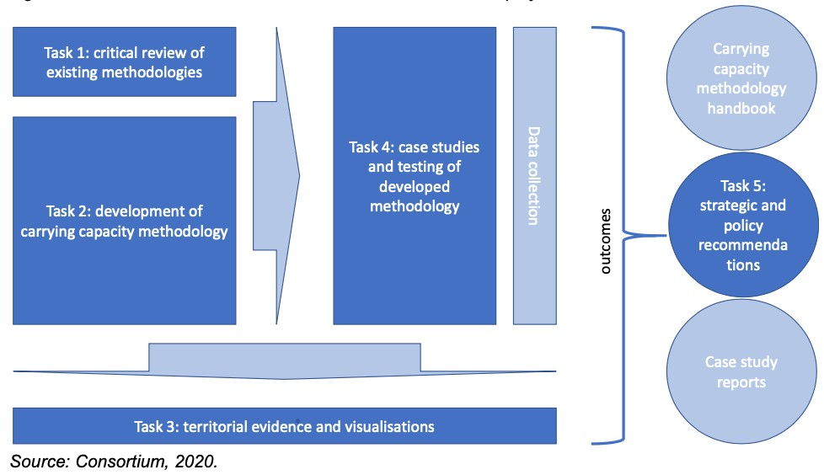

**Background for assessing Carrying Capacity**

The relation between different tasks and outcomes of this project is presented on the figure below.

30 October 2023 page 6

5 6

30 October 2



**Carrying Capacity Methodology**

Existing Methodology Review

* There is no single denominator for carrying capacity – a multitude of aspects in the socio-economic context of destinations are touched upon and carrying capacity is strongly related to the dimensions of sustainability and its conceptual components (i.e. economy, society and the environment).

Still the challenge is to establish a causality between tourism as a sub-sector of the economy and spatial phenomena (flows and concentration) and all these multiple aspects.

30 October 2023 page 7



**Carrying Capacity Methodology**

Existing Methodology Review

* There is no single way of capturing the carrying capacity along the different dimensions. The methodological approach meets this challenge by allowing for different ways to assess

normative borders for carrying capacities.

While for some indicators carrying capacity is to be understood as staying within a limit or getting closer to it (e.g. economic growth induced by tourism), for other indicators it would mean to stay within a corridor of an “optimal” condition (e.g. biodiversity within a tourist destination), while getting closer to the limit would indicate a critical condition. In other words, the method will have to be able to deal with various ways to describe and measure the target values of carrying capacity.

30 October 2023 page 8

7 8

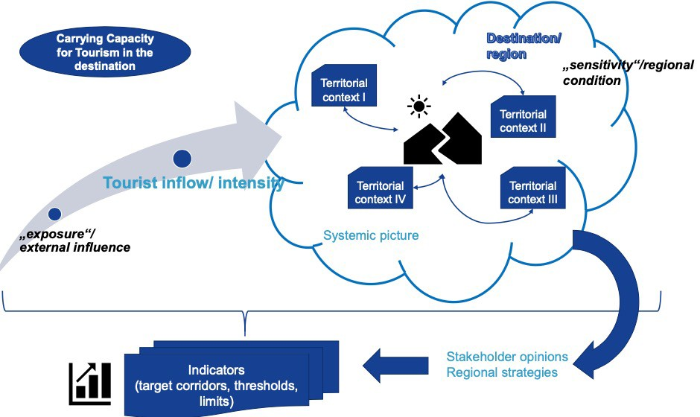

**Carrying Capacity Methodology**

023 page 9

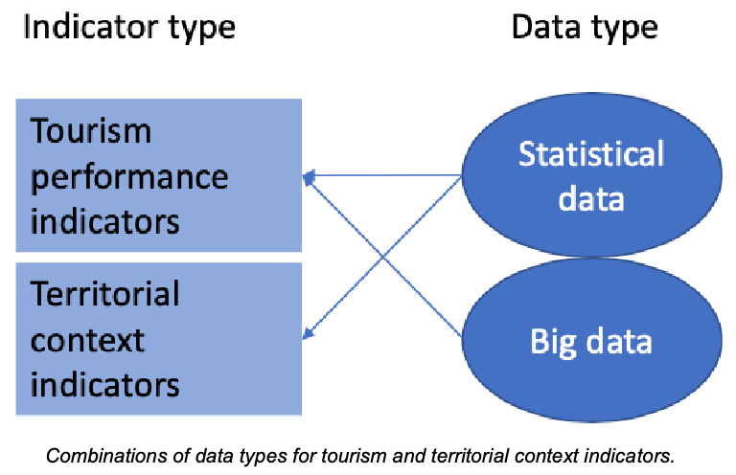

**Overview of Results and Case Studies**

Step 1: Destination’s overview

Step 2: Identification of causal loops between tourism and the territorial context Step 3: Measurement of tourism flows

Step 4: Identification of tourism impact based on tourism and territorial context Step 5: Identification of carrying capacity

30 October 2023 page 10

9 10

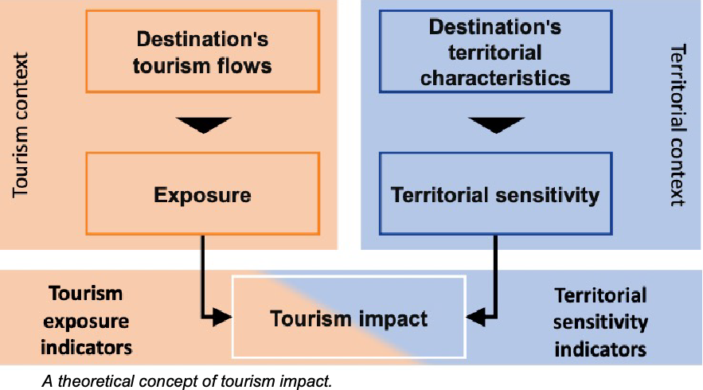

**Overview of Results and Case Studies**

Combining pairs of indicators in a grid to capture the relationship between the tourism and territorial context over time

30 October 2023 page 11

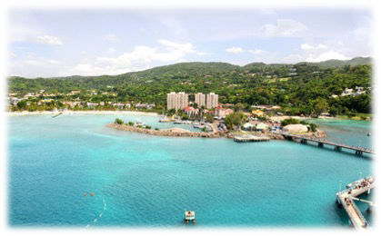

**Overview of Results and Case Studies**

Can you imagine a promising development plan? What are the main Actions to be implemented?

30 October 2023 page 12

11 12



**Strategic Guidelines**

**Evaluating the tourism and territorial context relationship by benchmarking**

* Carrying capacity itself is an “optimization problem” – assuming that there is a “border situation” of the territorial context, where one additional unit of input (in our case tourism intensity) will result in a crossing of the capacity

threshold.

* On the other hand we pointed out that there will be no strict threshold which may be established, but territorially specific situations or target corridors defining the carrying capacity.
* Still one crucial element of determining the carrying capacity of a tourist

destination will be the comparative element positioning the performance of a single destination vis-à-vis the threshold/ borderline of carrying capacity.

30 October 2023 page 13



**Strategic Guidelines**

**Indicator identification process**

* Compilation of a list of exemplary indicators based on the existing methodologies from the Literature
* Adaptation of the indicator list for specific destinations: consideration of destination-specific needs and policy goals (step 1 in the methodology) and development of a detailed systemic picture of tourism impacts.
* Finalisation of the indicator lists: the finalisation of the indicator lists focuses on the distribution of indicators along the three dimensions of sustainability

and an adequate allocation of context and tourism performance indicators.

* Identification of data sources: after the finalisation of the indicator list, the data sources for each indicator needs to be identified in cooperation with the stakeholders in the destination.

30 October 2023 page 14

13 14

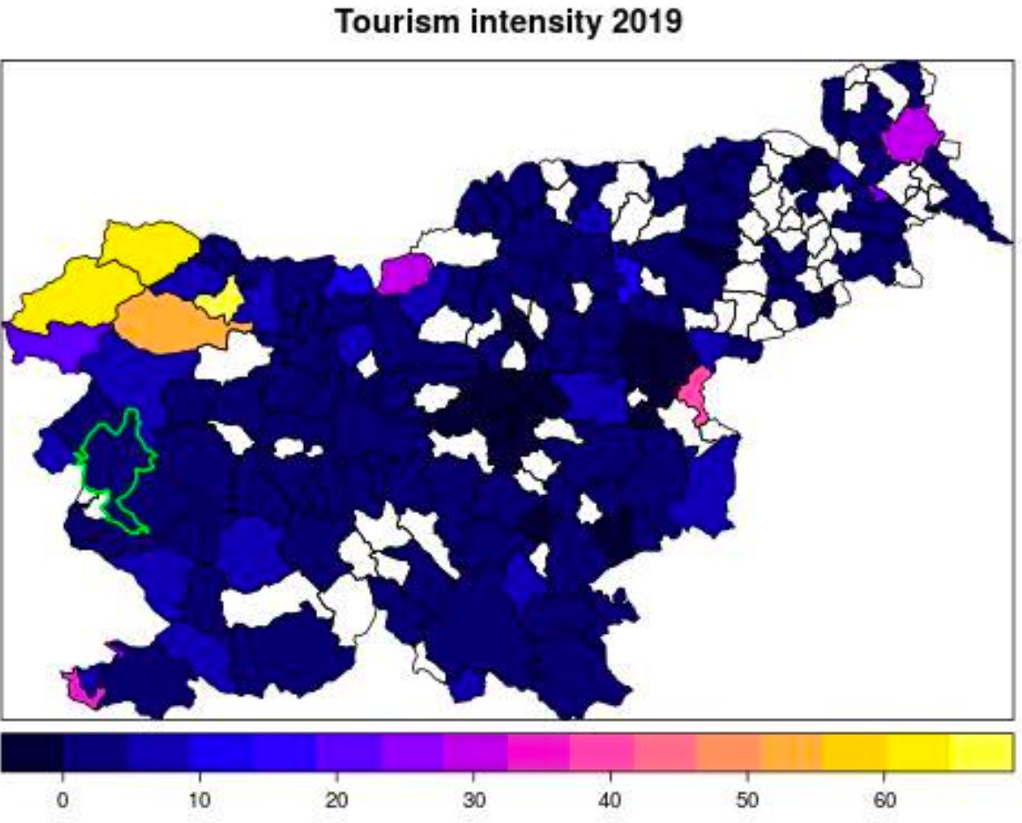

**Examples**

Nova Gorica

30 October 2023 page 15

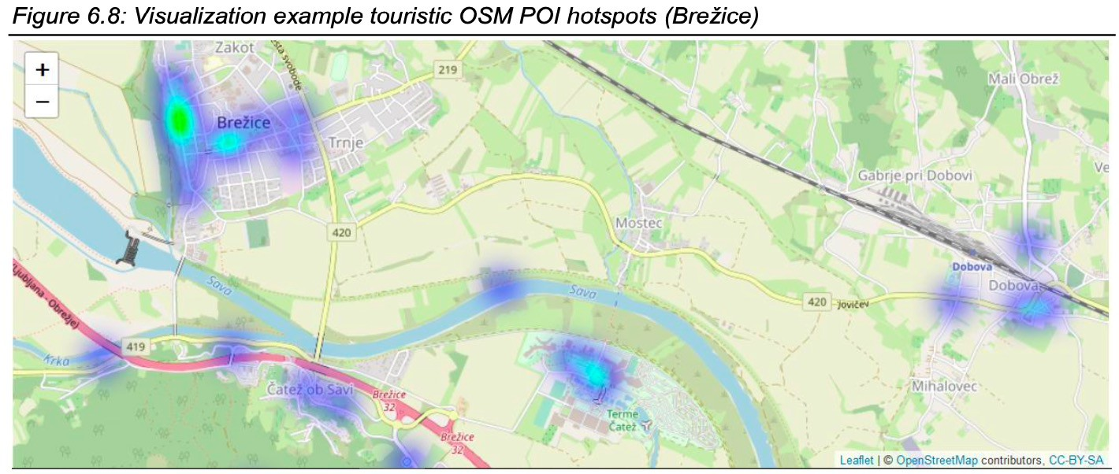

**Examples**

Brezice – Hot Spots

30 October 2023 page 16

15 16



**Discussion about Carrying Capacity in Mekong Region**

|  |  |
| --- | --- |
| **Q & A Thank You!** | |
| **mekonginstitute.org mekonginstitute.org Mekong Institute** | **MekongInstitute** |
| **Mekong Institute** |  |
| 123 Mittraphap Rd., Muang District, Khon Kaen 40002, THAILAND |  |
| Tel. : +66 (0) 4320 2411 |  |
| Fax. : +66 (0) 4320 3656 |  |
| [Email : information@mekonginstitute.org](mailto:information@mekonginstitute.org) |  |

17 18