**MODULE 5 - Contents of Session Plans**

**MODULE 5: Smart Tourism & Sustainability**

**Session 1: Introduction to Smart Tourism**

**Market Participants:** This session is intentionally designed to cater to a diverse and inclusive audience, encompassing a broad spectrum of individuals with a shared curiosity in exploring the convergence of technology and sustainable tourism practices. It welcomes the active participation of tourism professionals, who are at the forefront of the industry, technology enthusiasts with a passion for innovative solutions, government officials contributing to the policy landscape, and, essentially, anyone eager to delve into the dynamic realm where technology and sustainable tourism intertwine to shape the future of travel and hospitality.

The inclusive approach of this session underscores its commitment to creating an environment where diverse perspectives, ideas, and expertise intersect and flourish. The participation of seasoned tourism professionals ensures a pragmatic viewpoint, deeply rooted in industry experience, while technology enthusiasts infuse fresh, cutting-edge insights. Government officials bring their policy and regulatory expertise, adding the critical dimension of governance and compliance. All of this collective knowledge converges to ignite discussions, inspire innovation, and empower every participant to grasp the transformative potential of Smart Tourism in shaping the future of travel and hospitality. It is through this collaborative journey that the tourism industry can unlock new horizons of sustainability, efficiency, and unforgettable visitor experiences.

**Summary:** Module 5 embarks on an immersive exploration of Smart Tourism, an influential concept that underpins the future of sustainable travel and hospitality. In Session 1, we embark on a comprehensive journey into the fundamental tenets of Smart Tourism, unraveling the transformative potential of technology in optimizing tourism operations. The session strategically navigates through the domains where Smart Tourism policies find resonance and thrive, all while underscoring the indispensable role of innovation and creativity in manifesting the vision of Smart Tourism, where efficiency and sustainability harmoniously converge.

This session is a gateway to a world where tradition and innovation coexist, where Smart Tourism paves the way for a more responsible and enriching travel experience. It delves into the very essence of tourism, highlighting how the infusion of technology is reshaping the industry's landscape. Whether you are a seasoned tourism professional, an ardent technology enthusiast, a policymaker shaping the industry's future, or someone driven by a profound curiosity to explore the intersections of technology and sustainability, Session 1 provides a strong foundation for the dynamic journey that unfolds in Module 5. It is here that you begin to understand how Smart Tourism can transform the industry while embracing sustainability, and where you'll be equipped to embark on this transformative path.

**Key Words:** Smart Tourism, technology, tourism operations, sustainability, innovation, creativity.

**Objectives:**

1. Gain a comprehensive understanding of Smart Tourism and its significance in the tourism industry.
2. Recognize the potential applications of technology to enhance and optimize various aspects of tourism operations.
3. Identify key areas where Smart Tourism policies can be implemented to foster sustainable tourism practices.
4. Appreciate the role of innovation and creativity in the effective implementation of Smart Tourism strategies.

**Outcomes:** Upon the conclusion of Session 1, participants will emerge with a robust and comprehensive foundational understanding of Smart Tourism, arming themselves to comprehend its multifaceted impact on tourism operations and its symbiotic relationship with sustainability. They will discern the diverse domains where technology can be adeptly employed, all while appreciating the pivotal role of innovation in the effective implementation of Smart Tourism strategies.

Participants, whether they are seasoned tourism professionals well-versed in the industry's intricacies, technology enthusiasts eager to harness the power of innovation, policymakers shaping the future of travel and hospitality, or individuals driven by curiosity, will leave this session primed with knowledge. It's a knowledge that serves as a compass, guiding them through the evolving landscape of Smart Tourism and sustainability. The outcomes of Session 1 set the stage for a dynamic journey in Module 5, where technology and sustainability converge to shape the future of tourism.

**Methods:** Session 1 employs a meticulously designed and engaging blend of pedagogical techniques that ensure active participation and guarantee that participants leave with a profound comprehension of Smart Tourism's fundamental concepts and applications. These techniques encompass a variety of learning tools that cater to diverse learning styles and preferences.

Detailed presentations serve as the cornerstone of knowledge dissemination, offering participants comprehensive insights into the intricacies of Smart Tourism. These presentations, expertly crafted, guide participants through the complex landscape of technology and sustainable tourism, breaking down concepts and making them accessible.

Interactive group discussions create a dynamic environment where participants can actively engage with the content and with each other. These discussions serve as a platform for sharing ideas, exchanging perspectives, and collectively exploring the potential of Smart Tourism.

To further enhance the learning experience, real-world case studies are thoughtfully incorporated. These studies provide tangible examples that illustrate how Smart Tourism principles are applied in practice. By dissecting these cases, participants gain a deeper understanding of how technology and innovation can revolutionize tourism operations while upholding sustainability.

Collectively, these pedagogical methods serve as a scaffold for knowledge acquisition and retention. They empower participants to critically analyze, discuss, and apply Smart Tourism concepts in a collaborative and engaging learning environment. Whether they're tourism professionals with years of experience, tech enthusiasts with a penchant for innovation, government officials shaping policies, or individuals driven by a curiosity to explore this dynamic intersection of technology and sustainability, the methods employed in Session 1 ensure that everyone leaves with a profound understanding of Smart Tourism's transformative potential in the tourism industry.

**Materials:** Materials for Session 1 are meticulously curated to provide participants with a wealth of resources for in-depth exploration of Smart Tourism and its multifaceted applications within the dynamic landscape of the tourism sector. These resources encompass a diverse array of educational tools that cater to various learning preferences and objectives.

Comprehensive presentations serve as the cornerstone of the material, offering participants an exhaustive view of Smart Tourism. These presentations are meticulously crafted to break down complex concepts into digestible information, ensuring that participants have a solid foundation to build upon.

Illustrative case studies provide a real-world perspective, allowing participants to see how the principles of Smart Tourism are put into action. These cases serve as practical examples, showcasing successful implementations of technology and innovation within the tourism industry.

An assortment of reference materials supplements the core content, providing participants with the opportunity to delve deeper into specific areas of interest. These references encompass research papers, articles, and reports from experts and organizations at the forefront of the Smart Tourism movement.

Collectively, these materials empower participants to engage in self-guided exploration and further investigation of Smart Tourism concepts. Whether they are looking for a comprehensive overview, real-world examples, or specialized knowledge in particular domains, the materials for Session 1 offer a diverse set of resources to cater to a wide range of learning objectives.

**Content:**

• **Introduction to Smart Tourism (Approx. 20 minutes):** The "Introduction to Smart Tourism" (Approx. 20 minutes) segment serves as the foundational pillar of Module 5, where participants embark on a comprehensive exploration of the multifaceted concept of Smart Tourism. This session, carefully designed to accommodate a generous time allocation of approximately 20 minutes, unfolds the essential principles and intricacies of Smart Tourism, shedding light on its transformative role in elevating tourism operations while championing sustainability practices. It illuminates the dynamic relationship between technology and tourism, offering an in-depth understanding of how innovative approaches can synergize with sustainability goals. This segment presents a rich tapestry of information, immersing participants in the realm of Smart Tourism, a game-changer in the tourism industry. Through this extensive introduction, attendees gain a profound appreciation of the far-reaching impact of Smart Tourism, both as a driver of efficiency and as a catalyst for sustainable practices. It sets the stage for the subsequent sessions, emphasizing the critical role of technology, innovation, and creativity in shaping the future of tourism. As participants engage with this comprehensive exploration, they lay the foundation for a holistic understanding of Smart Tourism's dynamic landscape.

• **The Role of Technology (Approx. 15 minutes):** In the "The Role of Technology" section, which is generously allocated approximately 15 minutes, participants embark on a captivating journey into the technological realm that underpins the transformative power of Smart Tourism. This session unravels the intricate tapestry of technology's multifaceted role in the tourism industry, showcasing how innovative digital tools, smart devices, and cutting-edge solutions can be harnessed to revolutionize various facets of tourism operations. It goes beyond mere surface-level exploration, delving into the heart of how technology can elevate, streamline, and optimize different elements within the tourism ecosystem. Participants are invited to explore the tangible and practical ways in which technology can be applied to enhance the efficiency and sustainability of tourism practices. The session reveals technology's capacity to create smarter tourism experiences, from optimizing resource management to enhancing visitor engagement and everything in between. Through vivid case studies and illustrative examples, participants gain a comprehensive understanding of how technology can be a game-changer, not just in the tourism sector but also in the broader context of sustainability. This immersive journey into the heart of technology sets the stage for participants to recognize the profound implications of leveraging smart tools in the pursuit of a more sustainable and efficient tourism industry. As they engage with this multifaceted exploration, participants leave this session with a profound appreciation for the pivotal role of technology in shaping the future of tourism.

• **Smart Tourism Policies (Approx. 15 minutes):** In the "Smart Tourism Policies" section, thoughtfully allocated approximately 15 minutes, participants are guided through a comprehensive exploration of the strategic integration of Smart Tourism policies within the dynamic landscape of the tourism sector. This segment delves deep into the specific areas where the intelligent deployment of Smart Tourism policies can catalyze transformative change, elevating the efficiency, sustainability, and overall well-being of the entire tourism ecosystem.

Through engaging presentations, interactive discussions, and illustrative case studies, participants are provided with a roadmap to identify key touchpoints within the tourism sector where these policies can be most effectively applied. The session illuminates how Smart Tourism policies have the potential to optimize resource management, enhance visitor experiences, and foster a culture of sustainability.

Participants will emerge from this section with a profound understanding of how Smart Tourism policies serve as catalysts for reshaping the tourism industry, promoting innovation, and advancing the goals of sustainability. This knowledge equips them to recognize the untapped potential in applying intelligent policies and to appreciate how such policies can create a more efficient, sustainable, and harmonious tourism ecosystem. The valuable insights gained in this session empower participants to be not just observers but active agents of positive change in the realm of Smart Tourism.

• **Innovation and Creativity (Approx. 10 minutes):** In the "Innovation and Creativity" section, thoughtfully allocated approximately 10 minutes, participants embark on a transformative journey that illuminates the paramount significance of innovation and creativity in realizing the full potential of Smart Tourism. This pivotal segment of the session emphasizes how innovation and creativity are the dynamic driving forces that bridge the gap between theory and practice, transforming abstract ideas into tangible, sustainable actions.

Through engaging presentations, interactive exercises, and real-world case studies, participants are invited to explore the rich landscape of innovative solutions that have been harnessed in the realm of Smart Tourism. They discover how creative thinking can unlock the full power of technology, leading to innovative applications that enhance visitor experiences, streamline operations, and, most importantly, promote sustainability.

By the end of this section, participants are not only equipped with a profound understanding of the critical role innovation and creativity play in Smart Tourism but are also inspired to think beyond boundaries, fostering an environment of constant improvement and progress in their own tourism endeavors. This newfound insight empowers participants to embrace the potential for creative solutions in their roles as advocates for Smart Tourism and sustainability champions within the tourism industry.

**Session 2: Benefits from Smart Tourism to Communities, Companies, and Visitors**

**Market Participants:** The audience for Session 2 is intentionally diverse, encompassing a wide range of participants with shared curiosity in exploring the multifaceted benefits that Smart Tourism brings to various stakeholders within the tourism ecosystem. This inclusivity is a deliberate aspect of the session's design, allowing for a holistic perspective on the subject matter.

Tourism professionals, who form the backbone of the industry, play a pivotal role in shaping the future of travel and hospitality. Their active engagement in this session is essential to understanding how Smart Tourism can enhance the industry's operations and contribute to its sustainability.

Community representatives, including those from local communities in tourist destinations, bring a unique perspective to the discussion. Their insights help shed light on how Smart Tourism can positively impact the well-being of communities and contribute to more sustainable and responsible tourism practices.

Business owners within the tourism sector, ranging from small enterprises to larger companies, are critical stakeholders in the tourism ecosystem. Their participation allows for a nuanced exploration of how Smart Tourism can benefit businesses, drive innovation, and improve competitiveness.

Visitors, representing the end-users of tourism services and experiences, provide insights into what modern travelers expect and desire. Their perspective is invaluable in shaping visitor experiences through the application of smart technologies.

Individuals interested in understanding the multifaceted benefits of Smart Tourism represent a group of curious learners eager to explore the dynamic intersection of technology and tourism. Their active participation adds to the diversity of voices and perspectives in the session.

This diverse audience enriches the dialogue and ensures that the multifaceted benefits of Smart Tourism are comprehensively explored from various angles. It also reflects the interconnected nature of the tourism industry, where the well-being and satisfaction of one stakeholder group often depend on the actions and innovations of others. In sum, the session welcomes and values the contributions of a broad spectrum of participants who together form the complex tapestry of the tourism ecosystem.

**Summary:** Session 2 of Module 5 delves into the multifaceted advantages of Smart Tourism for communities, companies, and visitors, providing a comprehensive exploration of how this innovative approach revolutionizes the tourism landscape. In this session, participants embark on a journey to uncover the practical transformations ushered in by Smart Tourism, with a particular emphasis on the profound improvements it bestows upon local communities through the astute application of smart technology. Moreover, the session intricately examines the art of designing extraordinary and captivating visitor experiences through the creative deployment of smart technologies, thereby shining a spotlight on the transformational influence of Smart Tourism across the vast spectrum of the tourism ecosystem.

This session serves as a critical gateway to the dynamic world of Smart Tourism, offering participants a profound understanding of the real-world implications of embracing smart technologies in the context of travel and hospitality. By recognizing the multifaceted benefits of Smart Tourism, participants are empowered to contribute to the evolution of tourism practices, ultimately fostering a more sustainable, innovative, and visitor-centric tourism industry.

**Key Words:** Smart Tourism, benefits, communities, businesses, visitors, well-being, technology, visitor experiences.

**Objectives:**

1. Comprehend the practical changes and improvements that Smart Tourism can introduce for communities, businesses, and visitors.
2. Recognize how Smart Tourism enhances the well-being of local communities through the application of technology.
3. Learn how to design unique and appealing visitor experiences by harnessing smart technologies.

**Outcomes:** At the conclusion of Session 2, participants will emerge with a comprehensive and in-depth comprehension of the manifold practical benefits that Smart Tourism bestows upon communities, companies, and visitors within the tourism sector. Their newfound knowledge will enable them to adeptly identify and harness the transformative power of technology, using it to not only enhance the well-being of local communities but also to craft unparalleled and unforgettable visitor experiences through the innovative application of smart technologies. This profound understanding empowers participants to become catalysts of change within the tourism ecosystem, as they are poised to champion Smart Tourism's potential to create a more sustainable, efficient, and visitor-centric industry, ultimately shaping the future of travel and hospitality.

**Methods:** Session 2 deploys a multifaceted and engaging approach to pedagogy, skillfully utilizing a spectrum of teaching techniques. Through comprehensive and informative presentations, participants are provided with a rich and nuanced understanding of the multifaceted benefits that Smart Tourism delivers to communities, businesses, and visitors.

In tandem with this, interactive group discussions are meticulously structured to facilitate collaborative learning and the dynamic exchange of ideas among participants. This interactive element not only enhances engagement but also allows participants to delve deeply into the subject matter, extracting valuable insights from the collective wisdom of the group.

Practical exercises are thoughtfully incorporated into the session, providing participants with hands-on experience, where they can apply the concepts they have learned in a real-world context. These exercises serve to reinforce comprehension and foster the practical application of Smart Tourism principles.

Finally, real-world case studies are artfully woven into the session, presenting participants with tangible and relatable examples of how Smart Tourism has already made a transformative impact in various tourism contexts. These case studies offer a concrete view of the possibilities that await in the world of Smart Tourism.

Collectively, these diverse pedagogical methods ensure that participants not only grasp the theoretical underpinnings of Smart Tourism but also acquire the practical knowledge and skills necessary to harness its potential in their respective roles within the tourism ecosystem. Through this holistic approach, participants are not merely informed; they are empowered to be active contributors to the evolution of Smart Tourism practices.

**Materials:** The arsenal of materials provided for Session 2 is a meticulously curated collection of resources designed to enrich the learning experience of participants. Among the offerings are detailed presentations that serve as a comprehensive guide, delving into the multifaceted benefits of Smart Tourism for communities, businesses, and visitors within the tourism sector. These presentations are not just informative but are structured to facilitate a deep understanding of the subject matter.

Illustrative case studies are a valuable component of the materials. These real-world examples vividly showcase how Smart Tourism has been harnessed to bring about transformative changes in diverse tourism contexts. These case studies serve as beacons of inspiration, illuminating the potential and possibilities that can be harnessed in the realm of Smart Tourism.

Reference documents included in the materials offer participants a reservoir of additional insights and knowledge. These documents are carefully selected to complement the core learning materials, enabling participants to delve even deeper into specific aspects of Smart Tourism that pique their interest.

Together, this comprehensive set of learning materials empowers participants to explore the full spectrum of Smart Tourism's advantages, preparing them to make informed decisions and contributions to this transformative field. The materials are not just informative but are the stepping stones to active engagement and participation in the world of Smart Tourism.

**Content:**

* **Practical Benefits of Smart Tourism (Approx. 20 minutes):** Session 2 unfolds a rich tapestry of content, thoughtfully designed to immerse participants in the multifaceted world of Smart Tourism and its manifold benefits to communities, companies, and visitors. This section commences with an exploration of the "Practical Benefits of Smart Tourism," a segment that is both comprehensive and immersive, extending over approximately 20 minutes. Participants embark on a journey into the tangible transformations that Smart Tourism can bestow upon communities, businesses, and visitors. The session comes alive with a focus on real-world examples that eloquently illustrate these practical advantages. Through these vivid illustrations, participants are introduced to a world where Smart Tourism serves as a catalyst for meaningful change and progress.
* **Enhancing Community Well-being (Approx. 15 minutes):** In the subsequent part of Session 2, titled "Enhancing Community Well-being," which spans approximately 15 minutes, participants traverse the landscape of knowledge to gain profound insights into how Smart Tourism applications can meaningfully contribute to the well-being of local communities. Technology becomes a harbinger of positive impacts, and participants unravel the mechanisms through which it can improve the quality of life for community members. This section underscores the power of technology as an agent of change and progress.
* **Designing Unique Visitor Experiences (Approx. 15 minutes):** The session culminates with a tantalizing exploration of "Designing Unique Visitor Experiences," a segment that lasts around 15 minutes. Here, participants delve into the art of crafting experiences that are distinctive, appealing, and truly memorable for visitors. The creative utilization of smart technologies takes center stage as a vehicle for fostering innovation and sustainability within the tourism industry. This segment opens the door to a world where creativity meets technology, and the result is a dynamic, ever-evolving landscape of visitor experiences that are bound to leave an indelible mark.

The content within Session 2 is not merely informational; it is an immersive journey, an odyssey that invites participants to be active explorers in the fascinating realm of Smart Tourism. Through these meticulously crafted sections, they are equipped to navigate the transformative landscape of Smart Tourism with confidence and vision.

**Session 3: How Smart Tourism Contributes to Sustainable Tourism**

**Market Participants:** Session 3 of this module has been meticulously designed to be inclusive and accommodating, casting its net wide to engage with a diverse audience whose collective curiosity is drawn to the intriguing intersection of technology and sustainable tourism practices. This audience is as dynamic as the field itself, encompassing a broad spectrum of individuals, each bringing their unique perspective and expertise to the table. At its core, this session invites the active participation of seasoned tourism professionals, individuals who stand at the vanguard of the industry, with their wealth of knowledge and experience. But it doesn't stop there; this session is a welcoming embrace extended to technology enthusiasts, whose passion for innovative solutions fuels their exploration of the limitless possibilities within Smart Tourism. In a nod to the governance and policy landscape, government officials are beckoned to take a seat at this educational banquet, contributing their insights to a more sustainable future. Inclusivity is the watchword, as this session opens its doors to anyone eager to delve into the dynamic realm where technology and sustainable tourism intertwine to shape the future of travel and hospitality. Whether you're a seasoned professional, an enthusiastic techie, a policy-maker, or simply a curious mind, Session 3 has a place for you at the table. **Summary:** Session 3 serves as a dynamic exploration into the dynamic interplay between Smart Tourism and Sustainable Tourism. It unfolds a captivating narrative, inviting participants to traverse the multifaceted landscape where these two integral components of the tourism ecosystem converge. As the session unfolds, participants gain profound insights into the intricate web that connects Smart Tourism and Sustainable Tourism, understanding how Smart Tourism serves as a catalyst, accelerating the adoption of sustainability policies within the tourism sector. This isn't a passive examination; it's an active journey where participants discover how digital information and the vast expanse of big data are harnessed as powerful tools to efficiently manage and monitor sustainability. The session highlights not only the technical aspects but also the strategic dimension of employing smart channels for disseminating sustainability information to the relevant stakeholders. Participants emerge from this journey not just as informed observers but as active contributors to the sustainable tourism landscape, equipped with a deep understanding of the synergies that drive the industry towards a more sustainable and tech-driven future.

**Key Words:** Smart Tourism, Sustainable Tourism, sustainability policies, digital information, big data, communication.

**Objectives:**

1. Understand how Smart Tourism accelerates the implementation of sustainability policies in the tourism sector.
2. Explore the use of digital information and big data for efficient sustainability management.
3. Recognize the role of smart communication in disseminating sustainability information to stakeholders.

**Outcomes:** Upon successful completion of Session 3, participants emerge as adept navigators of the intricate relationship between Smart Tourism and Sustainable Tourism. Their journey leaves them with a comprehensive understanding of how Smart Tourism functions as a catalyst for advancing sustainability within the tourism sector. Participants acquire the nuanced knowledge necessary to appreciate how Smart Tourism expedites the implementation of sustainability policies, ensuring that they are not merely theoretical constructs but tangible practices integrated into the very fabric of the industry.

Moreover, participants become proficient in recognizing how digital information, coupled with the sheer volume of big data, becomes invaluable assets in the quest for efficient sustainability management. They understand how these vast resources are harnessed to monitor, assess, and optimize sustainable practices in real-time, transforming the abstract concept of sustainability into a concrete, data-driven reality.

The journey concludes with participants being well-versed in the art of smart communication. They understand that disseminating sustainability information is as crucial as its generation, and they appreciate how Smart Tourism leverages the efficiency of smart channels to reach and engage with a diverse array of stakeholders. These stakeholders span the spectrum from policymakers and businesses to local communities and the global travel community.

With this comprehensive understanding, participants are not just observers; they become catalysts themselves, actively contributing to the forward march of the tourism sector into a more sustainable, tech-driven, and interconnected future.

**Methods:** Session 3 is a dynamic and engaging journey, thoughtfully designed to cater to diverse learning preferences and ensure that participants depart with an enriched understanding of the intricate relationship between Smart Tourism and Sustainable Tourism.

At the heart of this educational experience are comprehensive presentations. These presentations serve as the foundation upon which participants build their knowledge. They provide a structured framework for understanding the multifaceted aspects of Smart Tourism and how it intertwines with sustainability in the tourism sector. The content is presented in a clear and engaging manner, making even complex concepts accessible to participants.

Interactive discussions form another pivotal element of the session. They serve as an intellectual arena where ideas converge, perspectives are exchanged, and insights are shared. Through discussions, participants have the opportunity to explore the nuances of Smart Tourism's impact on sustainability, guided by experienced facilitators who ensure that these discussions remain engaging and thought-provoking.

Complementing the theoretical aspects are real-world case studies. These case studies are windows into the practical application of Smart Tourism principles in real-world scenarios. By analyzing actual examples, participants gain a deep appreciation for how Smart Tourism accelerates sustainability in different contexts, be it urban tourism, ecotourism, or cultural heritage preservation.

Furthermore, the session incorporates collaborative exercises where participants actively apply their newfound knowledge. These exercises encourage hands-on learning, enabling participants to grasp how Smart Tourism contributes to sustainability by actively participating in exercises, simulations, and problem-solving activities. This practical dimension enhances retention and real-world applicability.

In sum, the multifaceted methods employed in Session 3 aim to accommodate a wide range of learning styles and preferences. By weaving together presentations, discussions, case studies, and interactive exercises, the session creates a holistic and immersive learning experience that leaves participants not only informed but also inspired to harness the potential of Smart Tourism for a more sustainable and interconnected tourism industry.

**Materials:** In Session 3, participants will be granted access to a rich repository of educational materials, meticulously curated to facilitate a deep and comprehensive exploration of the intricate relationship between Smart Tourism and Sustainable Tourism within the dynamic landscape of the tourism sector.

At the core of these materials are detailed presentations. These presentations are not merely slideshows but carefully crafted knowledge hubs. They serve as immersive guides that lead participants through the labyrinth of concepts, principles, and real-world examples. These presentations are designed to be comprehensive, offering a holistic view of how Smart Tourism catalyzes sustainability, leaving no stone unturned.

Illustrative case studies form another indispensable component of the learning materials. These case studies serve as windows into the practical realm, offering real-world instances where Smart Tourism strategies have been effectively harnessed to bolster sustainability in tourism. By analyzing these cases, participants gain valuable insights into the diverse applications of Smart Tourism in different tourism contexts, such as ecotourism, urban tourism, or cultural heritage preservation.

The learning experience is further enriched through reference documents. These documents provide participants with additional sources of information, enabling them to delve even deeper into specific topics of interest. Whether it's an academic paper, a sustainability report, or a government policy document, these references offer a more profound understanding of the intricate interplay between Smart Tourism and sustainability.

Altogether, the wealth of materials provided aims to cater to diverse learning styles and preferences. It ensures that participants have a trove of resources at their disposal, each contributing to a more holistic understanding of Smart Tourism's profound impact on sustainability within the tourism sector.

**Content:**

* **Accelerating Sustainability Policies (Approx. 20 minutes):** This segment embarks on a deep dive into how Smart Tourism acts as a catalyst, expediting the implementation of sustainability policies and practices within the tourism industry. Participants will traverse the landscape of mechanisms through which Smart Tourism effectively accelerates sustainability initiatives. By examining real-world examples and case studies, they will gain valuable insights into how Smart Tourism contributes to environmental conservation and the well-being of communities. This section underscores the power of technology in creating positive impacts on both local communities and the natural environment.
* **Leveraging Digital Information and Big Data (Approx. 15 minutes):** In this segment, the spotlight shifts to the role of digital information and big data in managing and measuring sustainability within the tourism sector. Participants will uncover the transformative potential of harnessing these powerful tools, enabling data-driven decision-making that leads to more effective and sustainable practices. The session will showcase successful instances where data analytics and digital technologies have been applied to enhance sustainability. By the end, participants will comprehend the profound impact that data can have on shaping sustainable tourism strategies, making them more efficient, impactful, and adaptable to changing circumstances.
* **Smart Communications for Sustainability (Approx. 15 minutes):** The final segment of Session 3 underscores the pivotal role of smart communication channels in disseminating sustainability information to stakeholders. Participants will gain insights into innovative communication strategies that are instrumental in promoting and supporting sustainable tourism practices. By exploring best practices and real-world examples, participants will discover how smart communication not only enhances the reach and impact of sustainability efforts but also empowers stakeholders to actively engage in the journey toward sustainability. This section illuminates the ways in which technology can bridge the gap between sustainability initiatives and the broader public, fostering a collective commitment to sustainable tourism.

**Session 4: Sustainable Tourism Strategy and Planning based on Smart and Digital Resources**

Session 5 is intentionally designed to accommodate a wide-ranging and diverse audience, offering an inclusive platform for individuals with varied interests and expertise. It extends a warm invitation to the following groups of participants:

1. **Tourism Professionals:** This session is tailored for tourism industry experts, including destination managers, tour operators, and hospitality professionals. It provides them with valuable insights into the fusion of smart and digital resources for sustainable tourism planning, enabling them to enhance the offerings and experiences within their destinations.
2. **Government Officials:** Government representatives at various levels, such as policymakers, urban planners, and sustainable development officers, are encouraged to participate. They will discover the instrumental role of technology in crafting sustainable tourism policies and strategies for the benefit of their regions and communities.
3. **Technology Enthusiasts:** Individuals with a fervor for innovative solutions and a penchant for technology-driven advancements in tourism are eagerly welcomed. This session allows tech enthusiasts to delve into the digital landscape of sustainable tourism, exploring opportunities for technological integration.
4. **Community Representatives:** Those with a vested interest in the well-being and development of local communities are a vital part of this session's audience. By attending, community members can gain insights into how sustainable tourism planning can empower their regions and foster economic and social growth.
5. **Destination Planning Enthusiasts:** This session extends an open invitation to anyone with a curiosity about the convergence of technology, sustainability, and destination planning. It welcomes participants who are eager to explore the dynamic realm where smart and digital resources intertwine to shape the future of travel and hospitality, regardless of their background or expertise.

The diversity of participants underscores the inclusive nature of this session, where collaborative learning and the exchange of ideas are paramount. By bringing together these varied perspectives, this session aims to inspire innovative solutions and foster discussions that can drive the tourism industry toward a more sustainable and technologically advanced future.

**Summary:**

In Module 5, Session 5 serves as an immersive journey into the intricate world of sustainable tourism strategy, brilliantly empowered by the dynamism of smart and digital resources. Comprising four pivotal segments, the session artfully guides participants through a transformative learning experience.

**1. Strategy and Planning for Tourism Destinations:** The odyssey commences with a profound exploration of the cornerstone of sustainable tourism - strategy and planning for destinations. Participants embark on a comprehensive journey, understanding the vital steps that lay the foundation for effective and sustainable tourism growth. From assessing the current situation to setting clear objectives, from market research to sustainability planning, and from marketing and promotion to continuous monitoring, this segment is an indispensable guide for crafting destination-specific strategies that harmoniously balance economic, environmental, and social well-being.

**2. Infusing Sustainability Values in the Strategy:** A deep dive into infusing sustainability values breathes life into the second segment. Participants are enlightened with three paramount methods to make their strategies resonate with responsible and eco-friendly tourism. By actively engaging communities, ensuring environmental conservation, and preserving cultural heritage, the session underscores the art of crafting strategies that not only attract responsible travelers but also fortify the long-term sustainability of the tourism industry.

**3. Use of Big Data and Digital Resources:** The session's third facet delves into the technological landscape, offering three pivotal steps to embrace Big Data and digital resources in destination strategy development. As participants venture into data collection and analysis, stakeholder collaboration and engagement, and strategy implementation and monitoring, they unlock the power of data-driven decision-making, better resource allocation, and the profound potential to realize their destination's growth and development goals.

**4. From Smart Strategy to Sustainable Tourism – Best Cases:** Culminating the expedition is a compelling showcase of real-world success stories where smart strategy has blossomed into sustainable tourism. Participants traverse the globe, visiting destinations like Antalya and Seville, and unravelling the excellence of accessibility, safety, acoustic pedestrian warning systems, and assisted bathing services. This segment becomes a wellspring of inspiration and practical insights for participants.

Session 5 equips participants with an arsenal of insights, strategies, and tools to craft and implement powerful, sustainable tourism strategies deeply entrenched in the realm of smart and digital resources. The journey is a transformative one, instilling the essence of responsible tourism, technological prowess, and the spirit of sustainability in each participant, ensuring a brighter future for the tourism industry.

**Key Words:**

* Sustainable tourism
* Destination strategy
* Smart resources
* Digital resources
* Infusing sustainability
* Big data
* Community engagement
* Environmental conservation
* Cultural heritage preservation
* Data-driven insights
* Stakeholder collaboration
* Continuous monitoring

**Objectives:**

In the vibrant landscape of Session 5, a tapestry of objectives unfurls, inviting participants to embark on an enriching learning odyssey. These four core objectives serve as guiding stars, illuminating the path to deeper understanding and practical wisdom:

**1. Understand the Key Steps in Sustainable Tourism Strategy Development:** Participants will traverse the foundational terrain of developing sustainable tourism strategies for destinations. They will grasp the importance of assessing the current situation, engaging stakeholders, setting objectives, conducting market research, fostering product development, integrating sustainability principles, crafting marketing and promotion strategies, and embracing the art of monitoring and evaluation.

**2. Learn to Infuse Sustainability Values into Strategies:** The session empowers participants to infuse sustainability values into their tourism strategies. They will discover the transformative ways of engaging local communities in decision-making processes, ensuring equitable distribution of tourism benefits, conducting environmental assessments, and promoting responsible behavior that respects and preserves the environment and cultural heritage.

**3. Explore the Use of Big Data and Digital Resources:** A digital expedition awaits as participants delve into the significance of Big Data and digital resources in destination strategy development. They will master the art of identifying relevant data sources, harnessing Big Data analytics tools, and unleashing the potential of geospatial analysis for informed decision-making. Moreover, they will understand the power of stakeholder collaboration, public engagement, strategy implementation, and data-driven marketing through digital resources.

**4. Gain Inspiration from Real-World Smart Strategy Success:** As the session unfolds, participants will be drawn into the inspiring narratives of destinations that have seamlessly transitioned from smart strategies to sustainable tourism. From Antalya to Seville, from acoustic pedestrian warning systems to noiseless schedules, and from accessible attractions to assisted bathing services, participants will garner insights, inspiration, and a profound appreciation for real-world success cases.

In their quest to grasp these objectives, participants will not only gain knowledge but also acquire the tools, insights, and inspiration to become champions of sustainable tourism strategy, driven by smart and digital resources. Each objective paves the way for a brighter and more sustainable future for tourism planning and destination development.Αρχή φόρμας

**Outcomes:**

As the curtain falls on Session 5, participants will emerge from this transformative experience bearing the fruits of comprehensive understanding and newfound wisdom. These outcomes serve as the compass by which their journey through the session is measured, representing the profound insights they will carry forward:

**1. Holistic Understanding of Sustainable Tourism Strategy:** Participants will part ways with the session possessing a holistic understanding of the multifaceted components entailed in crafting a sustainable tourism strategy. From assessing the current situation to fostering product development, integrating sustainability principles, and mastering the art of monitoring and evaluation, they will hold the keys to comprehensive strategy development for destinations.

**2. Mastery of Sustainability Values Infusion:** With an enlightened perspective, participants will grasp the vital importance of infusing sustainability values into their tourism strategies. They will understand the significance of community engagement, equitable benefit distribution, environmental conservation, and the preservation of cultural heritage, ensuring that their strategies stand as bastions of responsible and eco-friendly tourism.

**3. Proficiency in Utilizing Big Data and Digital Resources:** In the digital realm, participants will emerge as adept navigators, capable of identifying relevant data sources, harnessing the potential of Big Data analytics tools, and unlocking the power of geospatial analysis. They will be well-equipped to leverage the synergy of stakeholder collaboration, public engagement, strategy implementation, and data-driven marketing in their destination strategy development endeavors.

**4. Inspiration Drawn from Real-World Success:** The session's rich tapestry of real-world cases will infuse participants with inspiration and appreciation for destinations that have made the journey from smart strategies to sustainable tourism a reality. Their hearts and minds will be brimming with insights and success stories, igniting their own passions and propelling them to become catalysts for change in the world of tourism.

By the end of this enlightening session, participants will not only possess knowledge but also the tools, insights, and inspiration to embark on their own journeys of destination strategy development, infusing sustainability values, and harnessing digital resources for a brighter and more sustainable future in the realm of tourism. The outcomes serve as beacons guiding participants towards their roles as advocates for responsible and eco-conscious tourism.

**Methods:**

Within the tapestry of this dynamic session, a rich variety of teaching methods, meticulously curated to captivate and educate, unfurl like a vibrant mosaic. These methods, chosen with utmost care and precision, ensure that participants embark on a transformative journey brimming with interaction and engagement.

**1. Comprehensive Presentations:** Participants will be enveloped in a wealth of comprehensive presentations that will guide them through the intricacies of sustainable tourism strategy and planning. These presentations, facilitated by seasoned experts, provide the foundational knowledge required for their immersive learning experience.

**2. Interactive Discussions:** Through lively and interactive discussions, participants will engage in thought-provoking dialogues, exchanging ideas, perspectives, and insights. The collaborative nature of these discussions fosters an environment of active participation and knowledge sharing.

**3. Real-World Case Studies:** By delving into real-world case studies, participants will gain practical insights and inspiration. These tangible examples will illuminate the path to success, showing how destinations have transitioned from smart strategies to sustainable tourism, reinforcing the session's teachings.

**4. Collaborative Exercises:** An array of collaborative exercises will encourage participants to join forces, working collectively to tackle challenges and develop practical strategies. The power of teamwork and creative problem-solving will be harnessed in these exercises, mirroring real-world experiences.

**5. Interactive Activities:** Throughout the session, participants will be immersed in interactive activities, directly engaging with the material and applying newfound knowledge. These activities enable hands-on experience, transforming theoretical concepts into practical skills.

As this diverse array of teaching methods unfolds, participants will find themselves on an immersive educational journey, replete with opportunities for active participation, collaboration, and practical application. The overarching objective is to ensure that they not only comprehend the material but also become active agents of change in the realm of sustainable tourism strategy and planning, empowered by their multifaceted learning experiences.

**Materials:**

Participants in this enlightening session will find themselves immersed in a treasure trove of meticulously curated learning materials, designed to enrich their understanding and facilitate their journey through the world of sustainable tourism strategy development, harmoniously empowered by smart and digital resources.

**1. Detailed Presentations:** A comprehensive collection of detailed presentations, replete with valuable insights and expert guidance, will serve as the cornerstone of participants' learning experience. These presentations, thoughtfully structured, will unravel the complex tapestry of sustainable tourism strategy, leading participants towards profound comprehension.

**2. Illustrative Case Studies:** Participants will explore a compelling selection of illustrative case studies that breathe life into theoretical concepts. These real-world examples will showcase the successful fusion of smart strategies and sustainability, offering practical models for emulation and inspiration.

**3. Reference Documents:** An assortment of reference documents, including reports, articles, and scholarly resources, will be at participants' disposal. These documents serve as valuable compasses, guiding participants through the ever-evolving landscape of sustainable tourism strategy and planning.

**4. Interactive Tools:** Participants will have the opportunity to engage with interactive tools that amplify their learning experience. These dynamic resources will facilitate hands-on exploration, transforming theoretical knowledge into practical skills.

In this multi-faceted learning environment, participants will have access to a cornucopia of resources that cater to diverse learning styles and preferences. Whether delving into detailed presentations, drawing inspiration from case studies, consulting reference documents, or engaging with interactive tools, participants will find themselves well-equipped to navigate the intricate terrain of sustainable tourism strategy development, led by the guiding light of this rich array of materials.

**Content:**

This engaging and informative session unfolds across four enthralling segments, each brimming with captivating subtopics that captivate the imagination and deepen participants' understanding of sustainable tourism strategy development powered by smart and digital resources. Let us embark on this intellectual journey:

**1. Strategy and Planning for Tourism Destinations:**

* **Assessment of Current Situation:** The voyage begins with an exploration of the current landscape, unveiling the intricacies of destination assessment. Participants will delve into existing infrastructure, visitor demographics, tourism trends, and the far-reaching economic and environmental impacts of tourism.
* **Stakeholder Engagement:** A crucial juncture on our expedition, this segment spotlights the essential role of stakeholders. Government agencies, local communities, tourism businesses, and NGOs take the stage as participants learn to orchestrate harmonious collaboration and garner the support necessary for planning and implementation.
* **Setting Objectives and Goals:** Like a navigator charting a course, participants define clear and measurable objectives for tourism development. These objectives harmonize with the destination's long-term vision, embracing economic growth, environmental sustainability, and social well-being.
* **Market Research and Target Audience:** Our journey of discovery leads us to the shores of market research, where participants decipher the intricacies of identifying target markets and understanding the preferences and behaviors of potential visitors. This information is the compass guiding marketing strategies and the creation of tailored tourism products and services.
* **Product Development:** We set sail into the realm of product development, where participants learn to craft and diversify tourism experiences that resonate with the needs and interests of the target audience. This may encompass the creation of novel attractions, improvements to infrastructure, and enhancements to the overall visitor experience.
* **Sustainability Planning:** Sustainability unfurls its wings as an integral component of our odyssey. This section dives deep into the integration of sustainability principles, embracing the responsible management of environmental impacts, the preservation of cultural heritage, and the enhancement of local community well-being.
* **Marketing and Promotion:** Charting new courses in marketing and promotion, this segment unravels the intricacies of attracting tourists to the destination. Branding, advertising, digital marketing, and public relations become our guiding stars as we endeavor to raise awareness and stimulate demand.
* **Monitoring and Evaluation:** Our voyage reaches its pinnacle as we learn to navigate through the continuous monitoring of the destination's performance. Assessment reigns supreme, empowering the adjustment of strategies and the implementation of improvements, guided by the insights derived from feedback and data analysis.

**2. Infusing Sustainability Values in the Strategy:**

This segment leads us into the heart of sustainability, focusing on three key principles:

* **Community Engagement and Empowerment:** Like stewards of the land, we engage local communities in open dialogues, listening to their concerns and ideas. Partnerships are forged, allowing communities to play an active role in tourism development, paving the way for economic opportunities, jobs, and education.
* **Environmental Conservation:** We embark on a mission to preserve the natural world, avoiding overdevelopment and nurturing vital resources such as water, forests, and wildlife. Our arsenal includes eco-friendly infrastructure and practices, renewable energy sources, waste reduction and recycling, and low-impact transportation options. As educators, we enlighten tourists about the importance of respecting and preserving the environment, promoting responsible behavior and eco-conscious activities.
* **Cultural Heritage Preservation:** With the cultural tapestry of our destinations in mind, we strive to celebrate local customs, traditions, and cultural sites. Through responsible tourism guidelines, historic and cultural landmarks are shielded. Investment in cultural education programs and local artisans propels us towards authentic cultural experiences and the preservation of local heritage.

**3. Use of Big Data and Digital Resources:**

Our exploration of data-driven strategy development takes center stage:

* **Data Collection and Analysis:** In this segment, we equip participants with the skills to identify relevant data sources. Big Data analytics tools and geospatial analysis emerge as our guiding constellations, illuminating the path to data-driven decisions.
* **Stakeholder Collaboration and Engagement:** The importance of engaging local businesses, government agencies, and community stakeholders becomes apparent as we collaboratively work towards shared goals. The digital realm is our ally, enabling public engagement through surveys, feedback collection, and active participation in decision-making processes.
* **Strategy Implementation and Monitoring:** Converting data-driven insights into actionable strategies, we tread the path of implementation and monitoring. Data-driven marketing, facilitated by digital resources, amplifies our message and reaches our intended audiences with precision.

**4. From Smart Strategy to Sustainable Tourism – Best Cases:**

The crowning jewel of our journey, this segment transports participants to real-world destinations:

* **Accessibility and Safety: Antalya; Seville:** The vibrant cities of Antalya and Seville reveal their secrets to unlocking accessibility and safety, ensuring that pedestrian crossings are safer and more accessible for all.
* **Acoustic Pedestrian Warning Device System; Antalya:** The Acoustic Pedestrian Warning Device System serves as a beacon of innovation, enhancing safety and independence for the visually impaired and the elderly.
* **La Concha Beach, Assisted Bathing Service; San Sebastián:** The tide may pose challenges, but San Sebastián demonstrates its commitment to inclusivity with an assisted bathing service, offering mobility and access to everyone.

As we round the final bend of our expedition, we invite open and impassioned discussion about strategy for sustainable tourism, encouraging participants to share their insights and ideas. This enriching discourse serves as a fitting culmination of our remarkable journey.

In the end, this holistic session creates well-rounded and enlightened participants, primed with the knowledge and tools required to develop sustainable tourism strategies that harness the power of smart and digital resources. The compass guiding the future of sustainable tourism is in their hands, ready to lead the way towards responsible, eco-conscious, and successful destination planning and strategy.

PRESENTATIONS

SESSION 1



**Sustainable & Smart Tourism**

**Training Program**

Organized by Mekong Institute (MI)

Funded by Mekong – Korea Cooperation Fund (MKCF) November 2023



**Smart Tourism & Sustainability**

**MODULE 5**

Trainer November 2023

1 2



**Introduction to Smart Tourism**

**Session 1**

Monday



* Smart Tourism & Smart Destinations
* The role of Technology
* Smart Tourism Policies
* Innovation and Creativity

4 November 2023 page 4

3 4

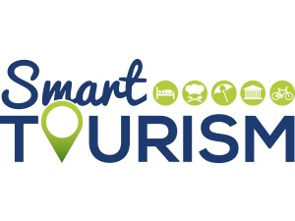

**Smart Tourism & Smart Destinations**

The aim of smart tourism is to develop information and communication infrastructure and capabilities to facilitate innovation, improve the visitor experience, and manage and collaboratively govern tourism more effectively (Gretzel et al., 2015).

The technologies that facilitate convergence have been identified as the major source of value creation, innovation and productivity for the future of tourism (APEC, 2019).

4 November 2023 page 5

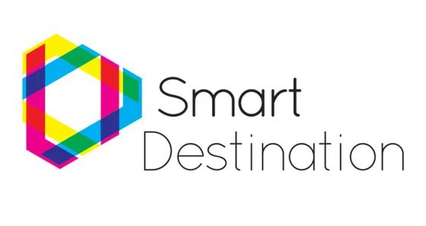

**Smart Tourism & Smart Destinations**

A smart destination is one with a strategy for technology, innovation, sustainability, accessibility and inclusivity along the entire tourism cycle: before, during and after the trip. A smart destination is also one with residents as well as tourists in mind, factoring multilingualism, cultural idiosyncrasies and seasonality into tourism planning.

This is why smart destinations are key to the transformation of the tourism sector. By continuously and accurately measuring, integrating and analyzing data for efficient decision-making, prioritization and anticipation of challenges, they create a seamless and exciting experience for tourists while managing local resources efficiently.

4 November 2023 page 6

5 6

4 Novemb



**Smart Tourism & Smart Destinations**

Smart destinations can make tourism governance more inclusive through inclusive entities, such as boards, trusts or foundations, which represent all public/private stakeholders in the destination. They can help ensure maximum accessibility in sites, products and services, eliminating barriers to mobility. And they allow us to analyse sustainable tourism management through different lenses.

4 November 2023 page 7

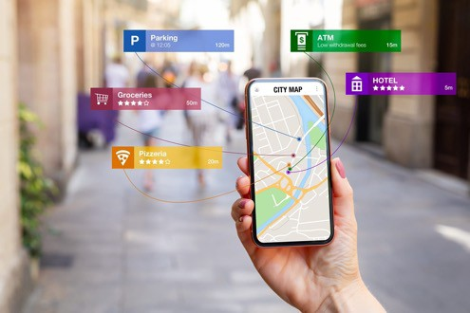

**Smart Tourism & Smart Destinations**

In tourism, digital-physical convergence is demonstrated by augmented reality, wearable technologies, and the Internet-of-Things to generate new hybrid products, services and experiences. Examples include e-bikes, e-scooters and e-cars which can be accessed anywhere, anytime with a mobile app, reducing the need for a front office presence and staff, to potentially be replaced by tech support and maintenance facilities. When scaled across cities, regions or a country, smart tourism development is possible.

4 November 2023 page 8

7 8



**The role of Technology**

The evolution and application of digital technologies are profoundly changing the way people live, work, travel and do business, and in the process, they are transforming and reshaping tourism. The scope and uptake of digital technologies varies across countries, sectors, organisations and places.

The resulting opportunities and barriers create an uneven playing field, which is exacerbated by a growing gap between tech-driven and globally connected tourism businesses, and traditional micro and small businesses often characterised by low-tech business practices.

4 November 2023 page 9



**The role of Technology**

Productivity-enhancing technologies (e.g. cloud computing, data analytics, revenue management software) have generally received low uptake in tourism, while innovative technologies (e.g. augmented reality, geotagging) are generating, customising and delivering in ever more novel ways, new

visitor products, services and experiences (OECD, 2018c).

Digital transformation is thus pushing tourism in new and often unpredictable directions. Digital technologies have important implications for tourism businesses of all sizes, for the structure and operation of tourism value chains and for the sector as a whole.

4 November 2023 page 10

9 10

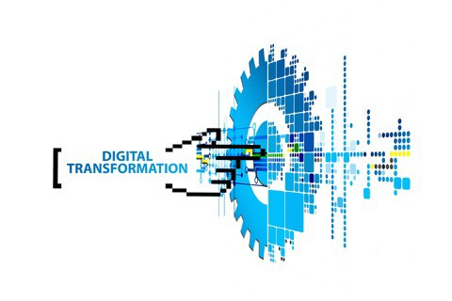

**The role of Technology Digital Transformation.**

Digitisation is the conversion of analogue data and processes into a machine- readable format, while digitalisation is the use of digital technologies and data as well as interconnection that results in new activities or changes to existing activities.

**Digital transformation** refers to the economic and societal effects of digitisation and digitalisation.

er 2023 page 11



**Smart Tourism Policies**

To develop policies fit for the digital age, it is necessary to:

1. Be aware of the main elements of the evolving digital technology ecosystem and some of the opportunities (and challenges) resulting from their application.
2. Understand the data revolution that is taking place, and how data and data flows affect individuals, the economy and society more broadly, and
3. Identify the key properties of digital transformation, including how they are driving new and evolving business models, and what their implications are for public policy.

4 November 2023 page 12

11 12

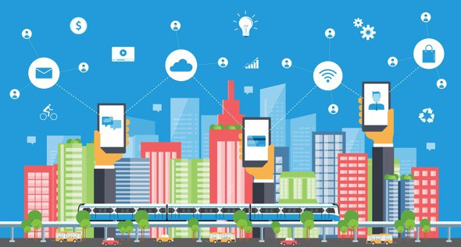

**Smart Tourism Policies**

Policies that support the development of business model innovation and regulatory systems that accommodate new business models and structures are important.

Business models have always been an important lever for growth, innovation and competitive advantage. To date, the digital transformation witnessed in tourism has been driven predominantly by new and innovative business models exploiting data analytics (i.e. by the digital natives turning data into intelligence), or through the adaptation and evolution of existing business models and value chains.

4 November 2023 page 13

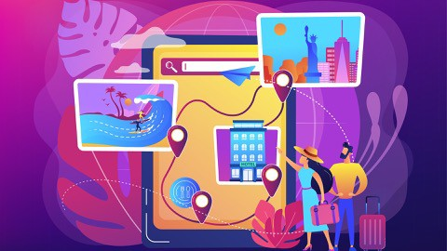

**Smart Tourism Policies**

The rapid pace of change in digital transformation has created challenges for policy makers. The existing policy environment and processes have struggled to keep up with rapid change and restructuring of business models and ecosystems, work, and global investment.

UNWTO (2019b) examined the challenges and complexity associated with enforcing existing rules and regulations in a review of new business models in the accommodation sector. The review highlighted that implementation is often hindered by lack of capacity, clear division of responsibilities and co-operation between the different responsible entities.

page 14

13 14

4 November 2023

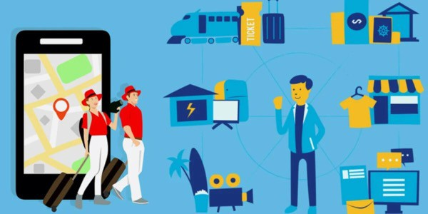

**Smart Tourism Policies**

Governments have an important role to play in creating the right framework conditions for the digital transformation of tourism business models and the wider tourism ecosystem. Integrated and coherent policy approaches are needed to leverage the opportunities of digitalisation while also addressing

challenges and minimising any negative consequences that may emerge. Policy work can also be positioned across a spectrum of tourism businesses (e.g. digital natives, hybrids and tourism SMEs with low levels of digitalisation).

4 November 2023 page 15



**Innovation and Creativity**

**Tourism Innovation through Technologies**

* Mobile Technology/Cloud Computing
* Data Analytics
* Artificial Intelligence (AI)
* Internet of Things (IoT)
* Augmented Reality/Virtual Reality (AR/VR)
* Blockchain
* Robotics & Automation

4 November 2023 page 16

15 16



**Innovation and Creativity**

**Creativity helps Tourism Organizations to stay afloat and move forward**

These **creative characteristics** include:

* Problem-solving skills
* Personal responsibility of tasks
* Openness to ideas and information
* Willingness to change and adapt
* Openness to new duties, roles or methods
* Interest in trying new things
* Facing challenges and uncertainty with optimism
* Able to question the status quo
* Able to empathize with other people

4 November 2023 page 17

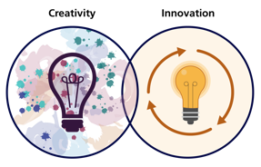

**Innovation and Creativity Innovation Needs Creativity**

The hospitality industry has been putting an emphasis on innovation. Industry professionals are encouraging their staff and management to be creative with everyday practices and offerings for guests.

“If you’re a creative person, then you can find new angles and new ways to solve new problems.”

4 November 2023 page 18

17 18

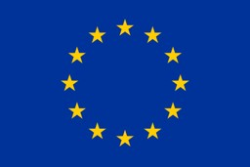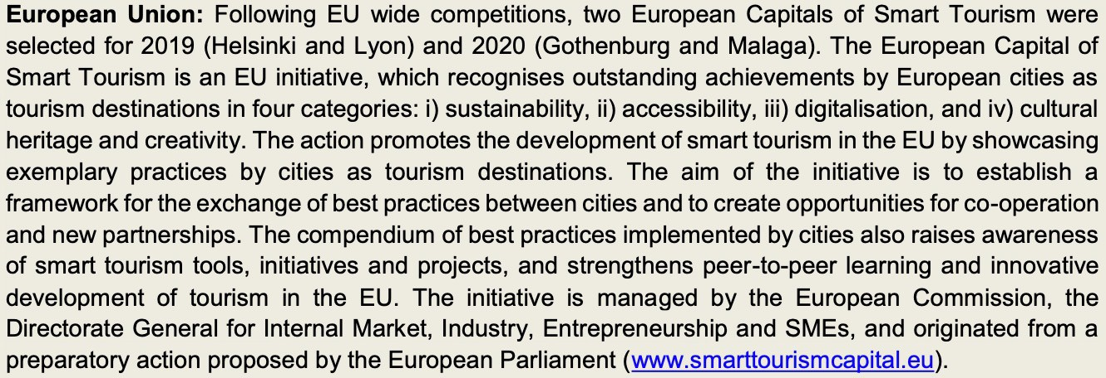

**Examples of Smart Tourism in various Regions**

4 November 2023 page 19

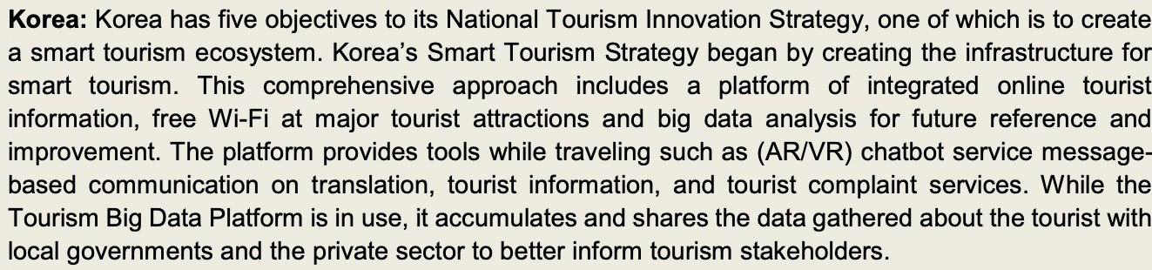

**Examples of Smart Tourism in various Regions**

4 November 2023 page 20

19 20



**Discussion about Technology & Tourism in Mekong Region**

|  |  |
| --- | --- |
| **Q & A Thank You!** | |
| **mekonginstitute.org mekonginstitute.org Mekong Institute** | **MekongInstitute** |
| **Mekong Institute** |  |
| 123 Mittraphap Rd., Muang District, Khon Kaen 40002, THAILAND |  |
| Tel. : +66 (0) 4320 2411 |  |
| Fax. : +66 (0) 4320 3656 |  |
| [Email : information@mekonginstitute.org](mailto:information@mekonginstitute.org) |  |

21 22

SESSION 2



**Sustainable & Smart Tourism**

**Training Program**

Organized by Mekong Institute (MI)

Funded by Mekong – Korea Cooperation Fund (MKCF) November 2023



**Smart Tourism & Sustainability**

**MODULE 5**

Trainer November 2023

1 2



**Benefits from Smart Tourism to Communities, Companies, and Visitors**

**Session 2**

Monday



* Practical Benefits from Smart Tourism
* Enhancing Community Well-Being
* Designing Unique Visitor Experiences

4 November 2023 page 4

3 4



**Practical Benefits from Smart Tourism**

Smart tourism will have a significant impact on the pace of transformation and the extent to which positive social, economic and environmental benefits will be able to scale (WEF, 2019). Facilitating the adoption of new technologies in tourism SMEs, empowering tourism SMEs to keep pace with evolving consumer demands, and supporting the digitalisation of marketing channels and business models and processes in tourism SMEs are important priorities for the sector.

4 November 2023 page 5

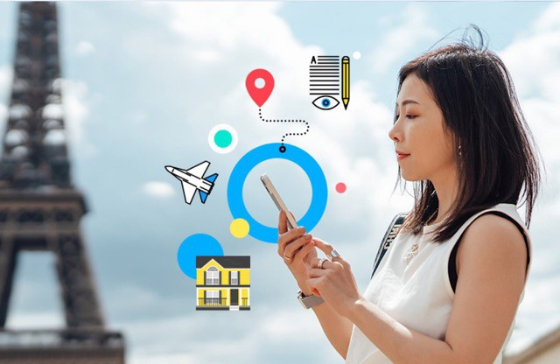

**Practical Benefits from Smart Tourism**

Considering business opportunities, digitalisation inspires innovative models, solutions and ecosystems. It opens up new roles for consumers and producers, making way for start-ups and upscaling existing businesses. While also helping meet supply and demand. Given that SMEs and micro enterprises make up the bulk of the business contribution to tourism the benefits of adopting smart technological applications are obvious.

4 November 2023 page 6

5 6



**Practical Benefits from Smart Tourism**

Considering business opportunities, digitalisation inspires innovative models, solutions and ecosystems. It opens up new roles for consumers and producers, making way for start-ups and upscaling existing businesses. While also helping meet supply and demand. Given that SMEs and micro enterprises make up the bulk of the business contribution to tourism the benefits of adopting smart technological applications are obvious.

4 November 2023 page 7



**Practical Benefits from Smart Tourism**

Some common benefits for companies are

1. Increased Revenue: Smart tourism can attract more tourists and encourage them to spend more, leading to increased revenue for businesses, including hotels, restaurants, and tour operators.
2. Data-Driven Insights: Companies can gather valuable data about customer preferences, behaviors, and trends, enabling them to tailor their services, marketing, and pricing strategies.
3. Operational Efficiency: Automation and technology can streamline operations, reduce costs, and improve customer service, ultimately enhancing profitability.

4 November 2023 page 8

7 8



**Practical Benefits from Smart Tourism**

Some common benefits for companies are

1. Marketing Opportunities: Smart tourism provides new avenues for marketing and advertising, helping businesses to reach a wider audience and target their promotions effectively.
2. Competitive Advantage: Companies that embrace smart tourism early gain a competitive edge and can establish themselves as leaders in the industry.

4 November 2023 page 9



**Enhancing Community Well-Being**

On a destination level the residents are able to benefit on various areas from smart tourism policies and implementation.

1. **Economic Development:** Smart tourism can stimulate economic growth in local

communities by increasing visitor numbers and spending. This can lead to the creation of jobs and the development of small businesses, such as local restaurants and shops.

1. **Preservation of Culture:** By promoting sustainable tourism practices, smart tourism can help preserve the cultural and historical heritage of a destination, ensuring that

communities can maintain their traditions and way of life.

4 November 2023 page 10

9 10



**Enhancing Community Well-Being**

On a destination level the residents are able to benefit on various areas from smart tourism policies and implementation.

1. **Infrastructure Improvement:** Increased tourism revenue can lead to investments in infrastructure, including transportation and public services, benefiting both residents and visitors.
2. **Safety and Security:** The advanced technological developments and the digital application are creating tools that can be used to increase safety and security measures and improve conditions within the destination for the local residents .

4 November 2023 page 11



**Enhancing Community Well-Being**

These and other benefits create a significant improvement to the quality of the daily life of the local communities. It is a matter of how the technological tools are used by governing authorities towards a more systematic integration of the digital tool for the services and the protection of the communities.

As a result, this improvement lead to much better conditions and actually to the well-being of the residents.

4 November 2023 page 12

11 12



**Designing Unique Visitors’ Experiences**

Smart tourism is improving many areas of the tourism chain where the vistors use from the travel decision making process to their trip and to their experience at the destination.

Some of the most important benefits from them are:

1. Enhanced Travel Experience:
   * Personalized Recommendations: Smart tourism technology can provide tailored

recommendations for activities, dining, and accommodations based on a visitor's preferences and past behavior.

* + Augmented Reality (AR) and Virtual Reality (VR): AR and VR applications can provide

immersive experiences, allowing tourists to explore destinations virtually before or during their trips.

4 November 2023 page 13

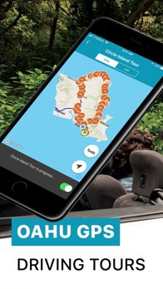

**Designing Unique Visitors’ Experiences**

2. Improved Accessibility:

* Navigation and Maps: Mobile apps and GPS navigation systems make it easier for tourists to find their way around unfamiliar destinations, reducing the risk of getting lost.
* Multilingual Support: Translation apps and services help overcome language barriers, making it easier to communicate and access local information.

4 November 2023 page 14

13 14



**Designing Unique Visitors’ Experiences**

3. Real-time Information:

* Live Updates: Smart technology provides real-time information on weather, traffic, and events, allowing tourists to adapt their plans and stay informed.
* Crowd Management: Apps and platforms can help tourists avoid overcrowded places and choose less crowded times to visit popular attractions.

4 November 2023 page 15

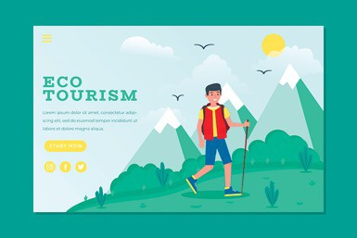

**Designing Unique Visitors’ Experiences**

4. Sustainable Tourism:

* Eco-friendly Travel: Technology can promote sustainable tourism practices, such as encouraging public transportation, reducing carbon footprints, and minimizing the environmental impact of tourism.
* Responsible Tourism: Apps and platforms can provide information on responsible travel options and eco-conscious accommodations and activities.

4 November 2023 page 16

15 16



**Designing Unique Visitors’ Experiences**

5. Efficiency and Convenience:

* Mobile Payments: Mobile wallets and contactless payment options make it convenient for tourists to pay for goods and services without the need for local currency.
* Online Booking: Technology simplifies the booking process for flights, accommodations, tours, and activities, allowing tourists to plan their trips with ease.

4 November 2023 page 17

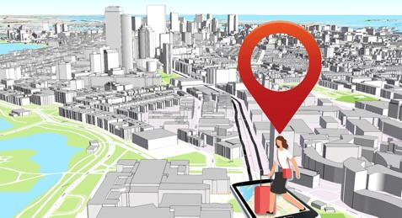

**Designing Unique Visitors’ Experiences**

6. Safety and Security:

* Emergency Services: Tourists can quickly access emergency services, local authorities, or medical assistance through mobile apps or smart devices.
* Location Sharing: Apps and wearables can enable tourists to share their location with family and friends for added safety.

4 November 2023 page 18

17 18



**Discussion about Benefits from Smart Tourism**

|  |  |
| --- | --- |
| **Q & A Thank You!** | |
| **mekonginstitute.org mekonginstitute.org Mekong Institute** | **MekongInstitute** |
| **Mekong Institute** |  |
| 123 Mittraphap Rd., Muang District, Khon Kaen 40002, THAILAND |  |
| Tel. : +66 (0) 4320 2411 |  |
| Fax. : +66 (0) 4320 3656 |  |
| [Email : information@mekonginstitute.org](mailto:information@mekonginstitute.org) |  |

19 20



SESSION 3



**Sustainable & Smart Tourism**

**Training Program**

Organized by Mekong Institute (MI)

Funded by Mekong – Korea Cooperation Fund (MKCF) November 2023



**Smart Tourism & Sustainability**

**MODULE 5**

Trainer November 2023

1 2



**How Smart Tourism Contributes to Sustainable Tourism**

**Session 3**

Monday



* Accelerating Sustainability Policies
* Leveraging Digital Information and Big Data
* Efficient Sustainability Management
* Smart Communication for Sustainability

4 November 2023 page 4

3 4



**Accelerating Sustainability Policies**

Smart tourism accelerates sustainability by leveraging data-driven decision- making, promoting sustainable mobility options, and enhancing resource management and conservation efforts. By integrating technology and eco-friendly practices into

their tourism strategies, destinations can reduce their environmental footprint and create a more sustainable and enjoyable experience for visitors..

4 November 2023 page 5



**Accelerating Sustainability Policies**

Here are three ways in which smart tourism can accelerate sustainability:

1. Data-Driven Decision Making:

Smart tourism relies on data analytics and real-time information to make more informed decisions about resource management, crowd control, and environmental impact. By collecting and analyzing data from various sources, such as visitor behavior, weather patterns, and energy consumption, destinations can optimize their operations.

For example, they can adjust transportation routes to reduce congestion and emissions, allocate resources more efficiently, and minimize energy usage in accommodations. This data-driven approach enables destinations to make sustainable

choices and reduce their ecological footprint.

4 November 2023 page 6

5 6

4 November 2023



**Accelerating Sustainability Policies**

2. Sustainable Mobility Solutions:

Smart tourism promotes sustainable transportation options, such as electric buses, bike-sharing programs, and ride-sharing services. By providing visitors with eco-friendly alternatives to traditional car rentals or taxis, destinations

can reduce traffic congestion, air pollution, and carbon emissions.

Additionally, smart tourism can integrate real-time information and mobile apps to encourage travelers to use public transportation, carpooling, or even walking and cycling for short distances. This not only reduces the environmental impact of tourism but also enhances the overall experience for visitors.

4 November 2023 page 7



**Accelerating Sustainability Policies**

3. Resource Management and Conservation:

Smart tourism technologies can help destinations better manage their natural resources and protect their ecosystems. For example, using sensors and data analytics, national parks and wildlife reserves can monitor the movement of

tourists to prevent overcrowding in sensitive areas, thereby minimizing environmental degradation.

Moreover, smart waste management systems can optimize the collection and recycling of waste in tourist areas, reducing litter and its negative impact on the environment. By preserving the natural beauty and biodiversity of their regions, destinations can ensure the long-term sustainability of their tourism industries.

4 November 2023 page 8

7 8



**Leveraging Digital Information and Big Data**

Promoting sustainable tourism through the use of digital information and big data is crucial for reducing the environmental and social impact of the tourism industry. Here are three ways to achieve this:

1. Data-Driven Destination Management:

Utilize big data analytics to monitor and manage tourist flows. By collecting and analyzing data from various sources, such as mobile apps, social media, and sensors, destinations can gain insights into tourist behavior and preferences. This information can be used to optimize transportation, crowd management, and resource allocation, reducing congestion and minimizing the environmental impact of over-tourism in

popular destinations.

4 November 2023 page 9



**Leveraging Digital Information and Big Data**

2. Personalized Eco-Friendly Travel Recommendations:

Develop digital platforms and applications that provide travelers with personalized recommendations for eco-friendly travel experiences. By analyzing user preferences, such as interests, travel history, and environmental values, these platforms can suggest sustainable destinations, accommodations, and activities.

Additionally, they can promote responsible practices, such as eco-conscious lodging, low-impact transportation options, and eco-tours, to encourage travelers to make more sustainable choices.

4 November 2023 page 10

9 10

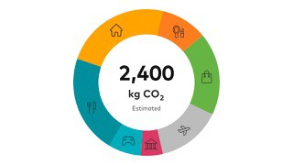

**Leveraging Digital Information and Big Data**

3. Carbon Footprint Tracking and Offset:

Implement digital tools that allow travelers to track and offset their carbon footprint during their trips. By integrating data from transportation, accommodation, and activities, tourists can easily calculate their environmental impact.

Many platforms now offer carbon offset options, allowing travelers to contribute to environmental initiatives to compensate for their emissions.

This not only raises awareness about sustainability but also provides a practical way for travelers to take responsibility for their carbon emissions

page 11

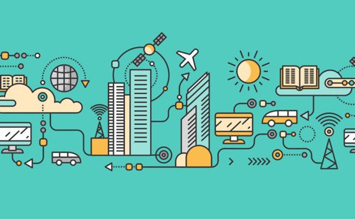

**Efficient Sustainability Management**

Smart tourism promotes efficiency in managing sustainable tourism by leveraging data-driven decision-making, optimizing resource management, and enhancing visitor engagement and education.

These technologies help destination managers make informed choices, reduce environmental impact, and promote responsible behavior among tourists, all of which contribute to the long-term sustainability of tourist destinations.

4 November 2023 page 12

11 12

4



**Efficient Sustainability Management**

Here are three ways in which smart tourism helps manage sustainable tourism more efficiently:

1. Data-Driven Decision-Making:

Smart tourism relies on the collection and analysis of data from various sources, such as sensors, mobile apps, and social media. This data provides valuable insights into tourist behavior, traffic patterns, and environmental impacts. By making use of this data, destination managers can make informed decisions about resource allocation, traffic management, and waste reduction.

For example, data can help identify peak tourist seasons, allowing for better planning of public transportation and waste collection, reducing congestion and environmental impact.

4 November 2023 page 13



**Efficient Sustainability Management**

2. Improved Resource Management:

Smart tourism enables more efficient resource management in sustainable tourism destinations. For instance, the Internet of Things (IoT) devices can monitor water and energy consumption in hotels and other facilities, helping to reduce waste and promote sustainability.

Additionally, smart grids and energy-efficient technologies can be implemented to better manage energy usage, while smart waste management systems can optimize waste collection routes and schedules, reducing the environmental impact of tourism.

4 November 2023 page 14

13 14



**Efficient Sustainability Management**

3. Enhanced Visitor Engagement and Education:

Technology plays a crucial role in educating tourists about responsible and sustainable behaviors. Mobile apps and augmented reality (AR) experiences can provide visitors with information about eco-friendly activities, cultural preservation, and responsible tourism practices.

By engaging tourists in a meaningful way, smart tourism helps raise awareness about sustainability and encourages visitors to make more responsible choices during their trips, such as reducing water and energy consumption, supporting local communities, and respecting natural habitats.

4 November 2023 page 15



**Smart Communication for Sustainability**

Smart digital communication can support sustainable tourism by providing real- time information, promoting responsible travel choices, and raising awareness among tourists about the need to protect natural and cultural resources.

These tools empower travelers to make informed decisions that minimize their environmental and social impact, thus contributing to the long-term sustainability of tourism destinations.

November 2023 page 16

15 16



**Smart Communication for Sustainability**

Here are three ways in which it can contribute to sustainable tourism:

1. Real-time Information and Guidance:

Smart digital communication tools such as mobile apps, websites, and social media platforms can provide travelers with real-time information about local attractions, events, and environmental conditions.

This enables tourists to make informed decisions about their activities, reducing the negative impact on sensitive ecosystems. For example, apps can offer real- time weather updates, trail conditions, and wildlife spotting tips, helping tourists plan their visits in a way that minimizes disruptions to natural habitats.

4 November 2023 page 17



**Smart Communication for Sustainability**

2. Sustainable Travel Recommendations:

Smart digital platforms can offer sustainable travel recommendations by suggesting eco-friendly accommodations, transportation options, and activities. They can provide information on hotels and tour operators that prioritize environmental conservation and community engagement.

This encourages tourists to support businesses that follow sustainable practices, thereby promoting responsible tourism and minimizing the environmental and social impact of their visits..

4 November 2023 page 18

17 18



**Smart Communication for Sustainability**

2. Sustainable Travel Recommendations:

Education and Awareness:

Digital communication can be used to educate and raise awareness among tourists about the importance of sustainable tourism. Through interactive websites, blogs, and social media, travelers can access information on local cultures, conservation efforts, and responsible travel guidelines. Interactive maps, audio guides, and virtual reality experiences can also help visitors understand the cultural and environmental significance of the places they are exploring. This education fosters a sense of responsibility and respect for the destinations they visit, leading to more sustainable travel behavior. 4 November 2023 page 19



**Discussion about Smart Suatainable Destinations**

19 20

|  |  |
| --- | --- |
|   **Q & A Thank You!** | |
| **mekonginstitute.org mekonginstitute.org Mekong Institute** | **MekongInstitute** |
| **Mekong Institute** |  |
| 123 Mittraphap Rd., Muang District, Khon Kaen 40002, THAILAND |  |
| Tel. : +66 (0) 4320 2411 |  |
|  |  |
| [Email : information@mekonginstitute.org](mailto:information@mekonginstitute.org) |  |

21

SESSION 4



**Sustainable & Smart Tourism**

**Training Program**

Organized by Mekong Institute (MI)

Funded by Mekong – Korea Cooperation Fund (MKCF) November 2023



**Smart Tourism & Sustainability**

**MODULE 5**

Trainer November 2023

1 2



**Sustainable Tourism Strategy and Planning based on Smart and Digital resources**

**Session 4**

Monday



* Strategy and Planning for Tourism Destinations
* Infusing Sustainability Values in the Strategy
* Use of Big Data and Digital resources
* From Smart Strategy to Sustainable Tourism – Best Cases

4 November 2023 page 4

3 4



**Strategy and Planning for Tourism Destinations**

Strategy and planning for tourism destinations involve several key steps to develop a

comprehensive and effective plan for sustainable tourism growth. While the specific steps may vary depending on the destination and its unique characteristics, the following eight main steps provide a general framework for the process:

1. Assessment of Current Situation:

Begin by conducting a thorough assessment of the destination's current tourism situation. This should include an analysis of existing infrastructure, visitor demographics, tourism trends, and the economic and environmental impacts of tourism.

1. Stakeholder Engagement:

Involve key stakeholders such as government agencies, local communities, tourism businesses, and NGOs in the planning process. Their input and support are crucial for successful planning and implementation.

4 November 2023 page 5



**Strategy and Planning for Tourism Destinations**

1. Setting Objectives and Goals:

Define clear and measurable objectives for tourism development. These objectives should align with the destination's long-term vision and consider factors like economic growth, environmental sustainability, and social well-being.

1. Market Research and Target Audience:

Conduct market research to identify target markets and understand the preferences and behaviors of potential visitors. This information is vital for creating marketing strategies and designing tourism products and services.

1. Product Development:

Develop and diversify tourism products and experiences that cater to the needs and interests of the target audience. This may involve creating new attractions, improving infrastructure, and enhancing the visitor experience.

4 November 2023 page 6

5 6



**Strategy and Planning for Tourism Destinations**

1. Sustainability Planning:

Integrate sustainability principles into the destination's tourism strategy. This includes managing environmental impacts, preserving cultural heritage, and ensuring the well- being of the local community. Sustainable practices are essential for long-term success.

1. Marketing and Promotion:

Develop a marketing and promotion plan to attract tourists to the destination. This should include branding, advertising, digital marketing, and public relations efforts to raise awareness and generate demand.

1. Monitoring and Evaluation:

Continuously monitor the performance of the destination and assess whether it is meeting its objectives. Adjust the strategy as needed and make improvements based on feedback and data analysis. Regular evaluation helps ensure the plan's effectiveness and

adaptability.

4 November 2023 page 7



**Infusing Sustainability Values in the Strategy**

Infusing sustainability values into tourism strategy and planning is essential for promoting responsible and eco-friendly tourism. Here are three ways to achieve this:

1. Community Engagement and Empowerment:

Involve local communities in the decision-making process when developing tourism strategies. Engage in open dialogues and listen to their concerns and ideas.

Develop partnerships with local communities, helping them take an active role in tourism development. Encourage community-based tourism initiatives.

Ensure that tourism benefits are distributed equitably among the local population, providing economic opportunities, jobs, and education. 4 November 2023 page 8

7 8



**Infusing Sustainability Values in the Strategy**

2. Environmental Conservation:

Conduct thorough environmental assessments and adopt sustainable development practices. Avoid overdevelopment, and protect natural resources such as water, forests, and wildlife.

Implement eco-friendly infrastructure and practices, such as renewable energy sources, waste reduction and recycling programs, and low-impact transportation options.

Educate tourists about the importance of respecting and preserving the environment. Enforce responsible behavior and promote eco-conscious activities, such as wildlife watching and eco-trekking.

4 November 2023 page 9



**Infusing Sustainability Values in the Strategy**

3. Cultural Heritage Preservation:

Recognize and celebrate the cultural heritage of the destination. Encourage tourists to respect local customs, traditions, and cultural sites.

Develop and enforce responsible tourism guidelines to protect historic and cultural landmarks. Limit visitor numbers if necessary to prevent over- tourism.

Invest in cultural education programs and local artisans, promoting authentic cultural experiences and supporting the preservation of local heritage.

4 November 2023 page 10

9 10



**Infusing Sustainability Values in the Strategy**

Incorporating these principles into tourism strategy and planning will help destinations not only attract tourists interested in responsible travel but also ensure the long-term sustainability of the tourism industry.

It's crucial to balance economic growth with environmental and social well- being, considering the needs of both tourists and the host communities.

4 November 2023 page 11



**Use of Big Data and Digital resources**

Developing a destination strategy using Big Data and digital resources involves leveraging data and technology to make informed decisions for the growth and development of a specific location or tourism destination.

Here are three key steps to support destination strategy development: Data Collection and Analysis:

1. Identify Relevant Data Sources
2. Big Data Analytics: Utilize Big Data analytics tools and techniques to process and analyze the collected data.

c. Geospatial Analysis: Geospatial data can be especially valuable in destination strategy

development.

4 November 2023 page 12

11 12



**Use of Big Data and Digital resources**

2. Stakeholder Collaboration and Engagement:

1. Engage Local Businesses and Government: Involve local businesses, government agencies, and community stakeholders in the strategy development process. Share your data-driven insights and collaborate to align interests and objectives. For example, if data shows that a particular area is underutilized, you can work with local businesses to develop new attractions or services.
2. Public Engagement: Use digital resources such as social media, websites, and mobile apps to engage with the public and gather their input. Run surveys, collect feedback, and encourage residents and visitors to participate in the decision- making process. This can help ensure that the strategy meets the needs and desires of the community.

4 November 2023 page 13



**Use of Big Data and Digital resources**

Strategy Implementation and Monitoring:

1. Actionable Insights: Translate the data-driven insights into actionable strategies.
2. Continuous Monitoring: Implement a system for continuous monitoring and feedback collection.
3. Data-Driven Marketing: Utilize digital resources for targeted marketing campaigns.

4 November 2023 page 14

13 14

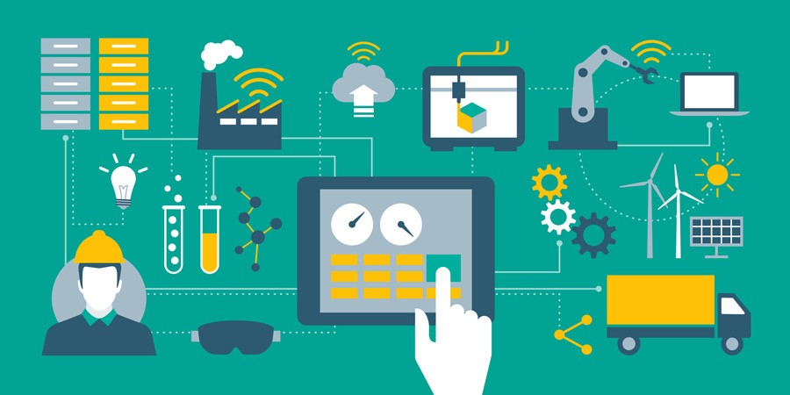

**Use of Big Data and Digital resources**

Incorporating Big Data and digital resources into destination strategy

development enables more informed decision-making, better resource allocation, and a higher likelihood of achieving the desired outcomes for the destination's growth and development.

It's important to combine data analysis with stakeholder collaboration and continuous monitoring for a comprehensive and effective approach.

4 November 2023 page 15

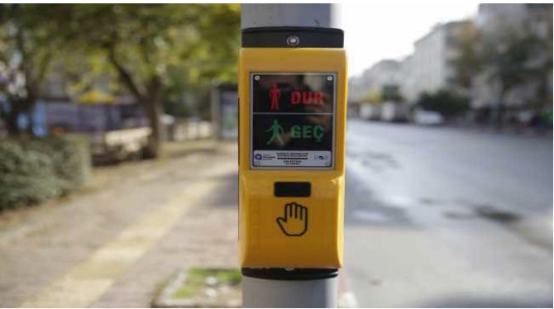

**From Smart Strategy to Sustainable Tourism: Best Cases**

**Accessibility and Safety: Antalya; Seville**

Acoustic Pedestrian Warning Device System; Antalya: The Acoustic Pedestrian Warning Device System applications were implemented at the intersections in different parts of the city in Antalya.

It aims to make the pedestrian crossings at signalised intersections safer and available for independent use for the visually impaired and elderly people. With the Acoustic Pedestrian Warning Device, when the pedestrian signal

transmitters change colour, audible messages are given to the pedestrians, allowing them to cross the street or wait.

Find out more at: https://raillynews.com/2020/12/Traffic-lights-will-speak-for-the-

visuallyimpaired-in-Antalya/

4 November 2023 page 16

15 16



**From Smart Strategy to Sustainable Tourism: Best Cases**

**Accessible and Safe celebrations; Seville:**

The city of Seville celebrates and hosts some of the most popular events around the world with millions of visitors allowing the public spaces to be transformed and explored. As a consequence, Seville has adopted a series

of accessibility measures such as integrated maps and routes that are

available on the SEVILLE ACCESSIBLE app as well as accessible signage at events.

A prime example of such measures is the Feria de Abril event that also has noiseless schedules and accessible attractions to provide an opportunity for everyone to enjoy these festivities.

4 November 2023 page 17

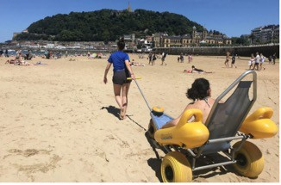

**From Smart Strategy to Sustainable Tourism: Best Cases**

**La Concha Beach, assisted bathing service; San Sebastián:**

The tide makes it difficult to install permanent footbridges during the summer season, however, the La Concha Beach has an assisted bathing service.

The latter includes the use of an “amphibious vehicle” that, with the help of one or two monitors, allows mobility both on the sand and in the water. This system allows people with reduced mobility to enjoy the beach.

A prime example of such measures is the Feria de Abril event that also has noiseless schedules and accessible attractions to provide an opportunity for everyone to enjoy these festivities.

4 November 2023 page 18

17 18



**Discussion about Strategy for Sustainable Tourism**

|  |  |
| --- | --- |
| **Q & A Thank You!** | |
| **mekonginstitute.org mekonginstitute.org Mekong Institute** | **MekongInstitute** |
| **Mekong Institute** |  |
| 123 Mittraphap Rd., Muang District, Khon Kaen 40002, THAILAND |  |
| Tel. : +66 (0) 4320 2411 |  |
| Fax. : +66 (0) 4320 3656 |  |
| [Email : information@mekonginstitute.org](mailto:information@mekonginstitute.org) |  |

19 20

