**MODULE 6 - Contents of Session Plans**

**MODULE 6: Developing Adaptive Capacities for Resilient Tourism Ecosystems**

**Session 1: Introduction to Smart Tourism**

**Market Participants:** This session caters to a diverse array of participants deeply interested in the intricate interplay between sustainability and resilience within the tourism industry. It welcomes professionals from the world of tourism, business entrepreneurs, SMEs, and all those passionate about establishing robust and adaptable tourism ecosystems. By the end of this session, individuals will gain profound insights into how to foster resilience and sustainability, ensuring the longevity of tourism in an ever-changing landscape.

**Summary:** Module 6 embarks on an extraordinary transformative odyssey, meticulously focusing on the intricacies surrounding the development of adaptive capacities indispensable for fostering and nurturing resilient tourism ecosystems. Our journey begins with the inaugural session, a cornerstone of paramount importance, as we lay the foundational groundwork for the profound exploration of the interconnected concepts of resilience and sustainability, revealing the intricate tapestry that binds them within the dynamic tapestry of the tourism industry. Over the course of this enlightening session, participants are invited to partake in a profound intellectual journey that promises to unravel the mysterious and unbreakable bonds shared between these two pivotal concepts, transcending the theoretical to embrace their practical implications. Furthermore, participants will be enlightened about the critical role played by resilience within business environments, with a keen focus on the unique and vital contributions made by small and medium-sized enterprises (SMEs) as they tread the path of sustainability and adaptability. Additionally, the session offers an in-depth exploration of the intricacies that underscore the process of nurturing resilience in tourism destinations, illuminating the multifaceted strategies and innovative approaches that lead to their unassailable fortitude and prosperity. This session, with its comprehensive exploration, serves as the fundamental cornerstone that sets the stage for a broader comprehension of the nuances that are instrumental in crafting and cultivating resilient tourism ecosystems, ensuring their unwavering sustainability in the face of ever-evolving challenges and opportunities. As we embark on this transformative expedition, participants are encouraged to embrace these insights and knowledge, using them as potent tools in shaping the future of the tourism landscape in an age defined by constant change and adaptation.

**Key Words:** Resilience, Sustainability, Tourism Ecosystems, Business Environments, Small and Medium-sized Enterprises (SMEs), Adaptive Capacities, Long-term Viability, Tourism Destinations

**Objectives:**

By the conclusion of this session, participants will:

1. Grasp the multifaceted relationship between sustainability and resilience.
2. Appreciate the significance of integrating resilience principles into various business environments, with a particular focus on SMEs.
3. Explore the dynamics of resilience within the context of tourism destinations, equipping themselves with knowledge essential for ensuring the long-term survival and prosperity of these ecosystems.

By the conclusion of this session, participants will have embarked on a profound intellectual voyage, and they will emerge enlightened and empowered with a treasure trove of knowledge and insights that will shape their understanding of the intricate interplay between sustainability and resilience. First and foremost, participants will master the multifaceted relationship that binds these two pivotal concepts together, transcending the boundaries of mere theoretical understanding to appreciate their deep practical implications. Participants will not only develop a comprehensive grasp of the symbiotic nature of sustainability and resilience but also recognize their indispensable significance within a variety of business environments. Of particular importance is the nuanced examination of how these principles are integrated into the world of small and medium-sized enterprises (SMEs), where they play a unique and vital role in ensuring sustainability and adaptability.

Furthermore, participants will explore the dynamic and evolving dynamics of resilience within the context of tourism destinations, delving into the multifaceted strategies and innovative approaches that underpin the journey towards resilience. Armed with this knowledge, participants will be well-prepared to navigate the complex landscape of the tourism industry, equipping themselves with the wisdom necessary for ensuring the long-term survival and prosperity of these vibrant ecosystems.

As the session draws to a close, participants will not merely be observers but active agents of change, armed with the profound understanding of how resilience and sustainability interact to create robust tourism ecosystems, capable of thriving and prospering in the face of evolving challenges and opportunities. This newfound wisdom, which extends beyond the boundaries of theory, will empower participants to shape the future of the tourism landscape, fostering adaptability and resilience in an age defined by constant transformation.

**Outcomes:** As this enlightening session draws to its conclusion, participants will emerge not as mere observers but as empowered individuals, well-equipped with a treasure chest of knowledge that they can use to navigate the complex and ever-evolving world of tourism ecosystems. Their journey within this session will have endowed them with a profound understanding of the profound and inseparable bond that unites the twin concepts of sustainability and resilience in the context of tourism. No longer will these principles be abstract or theoretical; instead, they will become practical tools in the participants' hands, ready to be wielded for the betterment of the tourism industry.

Particularly noteworthy is the heightened awareness that participants will gain about the indispensable role of resilience within business environments, with a specific focus on small and medium-sized enterprises (SMEs). These insights are not mere theoretical musings but essential knowledge that can be translated into real-world actions, helping businesses, especially SMEs, adapt and thrive in the face of challenges and opportunities.

Furthermore, as participants conclude this session, they will carry with them a profound and in-depth perspective on the dynamics of resilience within tourism destinations. This perspective will not be one of mere observation but one of engagement and influence, allowing them to shape the future of these vibrant ecosystems. Armed with these insights, participants are prepared to embark on the transformative journey of cultivating adaptive capacities that will form the bedrock of resilient tourism ecosystems.

In essence, the outcomes of this session extend far beyond a passive accumulation of knowledge. Participants will emerge as active agents of change, capable of fostering the adaptability, resilience, and sustainability of tourism ecosystems in the ever-evolving landscape of the industry.

**Methods:** Within the realm of this enlightening session, a rich tapestry of pedagogical methods awaits participants. It's not a passive journey but an active and immersive voyage that encompasses an array of engaging techniques designed to ensure a holistic understanding of the intricate concepts of resilience and sustainability in the context of tourism ecosystems.

The session begins with comprehensive presentations, where participants are provided with a solid theoretical foundation. They are not left to navigate these concepts in isolation; instead, they are guided with clarity and depth, making the subject matter accessible to all.

Yet, the journey doesn't end there. Through interactive discussions, participants are encouraged to think critically, express their opinions, and engage in vibrant exchanges of ideas. It's not just about receiving knowledge but also about actively participating in its creation and evolution.

Real-world case studies further deepen the learning experience. By examining practical examples, participants gain insights into how resilience and sustainability are not just theoretical constructs but real-world practices that can make a tangible impact. These case studies are like windows into the industry, offering a view of how these concepts play out in the dynamic and ever-changing world of tourism.

Immersive exercises form an integral part of the session. Participants don't just learn about resilience and sustainability; they experience them. Through these exercises, they actively engage with the concepts, apply them to real-world scenarios, and learn by doing. This hands-on approach ensures that the knowledge gained is not merely academic but practical and actionable.

Collectively, these methods ensure that participants embark on an educational voyage that is both comprehensive and immersive. The session serves as a platform for deep learning, where the participants delve deep into the concepts of resilience and sustainability, forging a profound understanding that can guide their actions in the real world. The interactive and engaging nature of the session fosters vibrant exchanges of ideas and insights, igniting thoughtful discussions among participants and ensuring a truly enriching learning experience.

**Materials:** On this enlightening journey, participants will have access to a wealth of learning materials carefully curated to enhance their understanding of the fundamental concepts of resilience and sustainability within tourism ecosystems. These materials are not just static resources but dynamic tools that empower participants to become catalysts of change in their respective domains.

At the core of this resource library are detailed presentations. These presentations are comprehensive guides, offering structured insights into the multifaceted concepts of resilience and sustainability. They serve as foundational reference points, ensuring that participants have a solid theoretical understanding to build upon.

Complementing these presentations are enlightening case studies. These real-world examples provide participants with practical insights into how resilience and sustainability are put into action in the tourism industry. By examining these cases, participants can bridge the gap between theory and practice, gaining a deeper appreciation for the impact of these concepts.

Informative reference documents further enrich the learning experience. These documents serve as repositories of knowledge, offering additional context and insights. They're not just resources for the present session but references that participants can return to whenever they seek to deepen their understanding of the subject matter.

In addition to presentations, case studies, and reference documents, thought-provoking tools are provided. These tools are designed to be interactive, engaging participants in active learning. They encourage participants to apply their knowledge, fostering a deeper understanding that goes beyond theory and into practical application.

Collectively, these materials serve as invaluable resources on this enlightening journey. They empower participants to not only comprehend the concepts of resilience and sustainability but also to apply this knowledge as they work towards developing adaptive capacities in their respective domains. This resource-rich environment ensures that participants are well-equipped to be agents of change in the ever-evolving landscape of the tourism industry.

**Content:**

1. **Understanding the Interplay Between Resilience and Sustainability (30 minutes):**
   * Delving into the profound and intricate relationship that exists between resilience and sustainability in the context of tourism ecosystems.
   * Scrutinizing how these two foundational concepts are deeply interwoven within the tourism industry, creating a symbiotic and dynamic connection.
   * Examining real-world examples of how sustainability initiatives contribute to the resilience of destinations, emphasizing the positive impact on local communities, the environment, and the economy.
   * Reflecting on the potential challenges and dilemmas that may arise when balancing sustainability goals with the need for resilience in tourism systems.
2. **Integrating Resilience into Business Environments, Particularly SMEs (25 minutes):**
   * Recognizing the pivotal role that resilience plays within various business environments and its profound significance for ensuring long-term success and adaptability.
   * Taking a closer look at how small and medium-sized enterprises (SMEs) can harness resilience principles to navigate the ever-changing landscape of the tourism industry.
   * Exploring case studies of SMEs that have effectively integrated resilience strategies into their business operations, showcasing the tangible benefits and lessons learned.
   * Discussing strategies to empower SMEs with the knowledge and tools to embrace resilience as a strategic advantage, even in the face of adversity.
3. **Fostering Resilience in Tourism Destinations (30 minutes):**
   * Peering deeply into the dynamics of resilience within the intricate fabric of tourism destinations, understanding the multifaceted factors that influence their adaptability and sustainability.
   * Acquiring critical insights into the strategies and measures that tourism ecosystems can employ to adapt and thrive in response to evolving challenges, ranging from economic fluctuations to climate change.
   * Analyzing real-world case studies of destinations that have successfully cultivated resilience, uncovering the lessons learned and best practices.
   * Engaging in discussions about the future of tourism, considering how the lessons of resilience can be applied to create robust and adaptable tourism ecosystems that benefit visitors, local communities, and the planet.

By offering a comprehensive exploration of the interconnectedness between resilience and sustainability, this session prepares participants to be agents of positive change in the ever-evolving landscape of the tourism industry, ensuring that their contributions to the industry are sustainable, responsible, and adaptive.

**Session 2: Challenges in Various Scales - The Need for CHANGE**

**Market Participants:** This comprehensive session in Module 6, aptly titled "Challenges in Various Scales - The Need for CHANGE," is designed to be an illuminating journey that caters to a diverse spectrum of enthusiastic participants deeply dedicated to the intricate realms of resilience and sustainability within the dynamic tourism industry. It extends a warm welcome to seasoned tourism professionals, visionary entrepreneurs, small and medium-sized enterprise (SME) proprietors, government representatives committed to shaping tourism policies, and all stakeholders deeply invested in unraveling the complexities and intricacies of the challenges that loom over the industry. These challenges, spanning a vast spectrum from the grand tapestry of global dynamics to the intricate threads of local impacts, call for proactive and purposeful resilience planning. As participants embark on this transformative voyage of knowledge and discovery, they are bound to emerge with profound insights into the resilience imperatives that underpin the very fabric of tourism businesses and destinations in a perpetually evolving world. This session seeks to empower them to become catalysts of change, equipped with the wisdom to navigate the multifaceted challenges and foster adaptive capacities, ensuring the sustainability and resilience of tourism ecosystems in an ever-shifting landscape.

**Summary:** Module 6 extends its captivating exploration with a unique two-in-one session, ingeniously weaving together the essential threads of Topics 2 and 3. Under the compelling title of "Challenges in Various Scales - The Need for CHANGE," this session stands as a beacon illuminating the intricate web of resilience and its undeniable importance across myriad domains. With an unwavering focus on the profound resonance of resilience at different scales, participants are beckoned to embark on a thought-provoking journey.

As the session unfolds, the tapestry of resilience is unveiled in a manner that leaves a lasting imprint. Participants are enlightened about the paramount significance of instilling resilience within business environments and, specifically, small and medium-sized enterprises (SMEs). They will delve deep into the labyrinth of challenges, spanning the colossal global landscape to the nuances of regional and local impacts. This in-depth exploration promises to provide clarity on the far-reaching impacts of these challenges, illustrating the pressing need for proactive preparations to embrace transformative CHANGE.

This masterful session is meticulously crafted to empower participants with a holistic comprehension of the formidable challenges that permeate the tourism industry. It serves as a compass, guiding them towards the shores of adaptive capacity – an essential attribute that can navigate these challenges adeptly and set the course for a resilient and sustainable future in the ever-evolving tourism landscape.

**Key Words:** Resilience, Sustainability, Challenges, Business Environments, SMEs, Global and Local Scales, Risk Management, Adaptive Capacity, Proactivity, Preparations for CHANGE.

**Objectives:**

By the end of this comprehensive session, participants will:

1. **Prioritize Resilience**: Understand why prioritizing resilience within business environments and SMEs is vital for long-term sustainability and success.
2. **Grasp Multi-Scale Challenges**: Recognize the multifaceted challenges, encompassing global dynamics and local impacts, shaping the future of the tourism industry.
3. **Analyze Impact and Urgency**: Analyze the wide-reaching impacts of these challenges and the urgency of preparing for transformative CHANGE.
4. **Embrace Proactivity**: Understand the significance of proactivity in business and governance, encompassing risk assessment and management, and preparation for CHANGE.
5. **Foster Adaptive Capacity**: Gain practical knowledge about the adaptive capacity necessary for companies and destinations to navigate and thrive in a dynamically changing environment.

As this extensive and enlightening session in Module 6 concludes, participants will emerge equipped with a comprehensive understanding of the critical components that guide resilient business environments and tourism destinations. They will prioritize resilience as an essential element for long-term success in the tourism industry, recognizing its fundamental role within both business environments and small and medium-sized enterprises (SMEs). Participants will further expand their horizons to encompass multi-scale challenges, comprehending the intricate web of global dynamics and localized impacts that shape the industry's future. The ability to analyze the profound impact and urgency associated with these challenges will be heightened, enabling participants to engage in proactive measures to ensure preparedness for transformative CHANGE.

Understanding the significance of proactivity in business and governance, participants will delve into the realms of risk assessment, risk management, and strategic preparations for CHANGE, acquiring invaluable insights into the proactive strategies that drive resilience. Furthermore, they will gain a practical understanding of the adaptive capacity required by companies and destinations to navigate and prosper within the dynamic landscape of the tourism industry. This session equips participants with a profound awareness of the multifaceted dimensions of resilience and proactivity, providing them with the tools and knowledge essential for addressing the industry's pressing challenges and fostering adaptive capacities for long-term success.

**Outcomes:** Upon the culmination of this enlightening and extensive session, participants will emerge as adept navigators of the intricate challenges that underscore the critical importance of resilience in both business environments and tourism destinations. They will have delved deep into the multifaceted forces, encompassing global dynamics and localized impacts, that sculpt the ever-evolving landscape of the tourism industry. This comprehensive exploration will empower participants to fully grasp the imperative nature of proactivity and adaptive capacity, fundamental aspects for effectively addressing the industry's pressing challenges.

With a treasure trove of knowledge and a comprehensive toolkit at their disposal, participants will not only be equipped to embrace transformative CHANGE but will also possess the insights and strategic acumen to pave the path toward resilience. These newfound capabilities ensure the long-term sustainability and prosperity of businesses and destinations, allowing them to thrive in a dynamic and ever-changing environment.

**Methods:** In this enlightening session, participants will be engaged through an extensive array of pedagogical approaches carefully designed to maximize their comprehension and interaction. The session encompasses insightful presentations, interactive discussions, real-world case studies, and practical exercises, providing participants with a diverse set of tools for active learning. These methods aim to stimulate thoughtful discussions and knowledge-sharing, ensuring that participants not only understand but deeply internalize the intricate challenges and strategies associated with resilience and proactivity in the dynamic tourism industry.

**Materials:** In addition to the engaging methods, participants will have access to a plethora of learning materials that enhance their educational experience. These materials encompass detailed presentations, enlightening case studies, informative reference documents, and practical tools carefully crafted to strengthen participants' grasp of resilience, proactivity, and adaptive capacity in the context of tourism companies and destinations. These materials are not only informative but also transformative, empowering participants to become influential agents of change who can apply their newfound knowledge to cultivate resilience and proactivity in their respective domains.

.

**Content:**

**Introduction (5 minutes):** Start by setting the stage for the session, emphasizing the significance of resilience in the tourism industry. Briefly introduce the key topics to be covered. Highlight that the session aims to provide a comprehensive understanding of the challenges faced by tourism companies and destinations and how proactive approaches can help address these challenges effectively.

**Prioritizing Resilience in Business Environments and SMEs (15 minutes):**

*Recognize the Critical Role of Resilience (5 minutes):* Begin by explaining why prioritizing resilience is essential for businesses. Emphasize that resilience is not just about bouncing back from adversity but also about adapting and thriving in the face of ever-evolving challenges. Provide real-world examples of businesses that have benefited from a resilient approach.

*Embracing Proactive Approaches within Business (10 minutes):* Delve into the concept of proactivity, including risk assessment and risk management. Explain how identifying potential risks and developing strategies to mitigate them can help businesses and SMEs thrive. Share case studies illustrating how proactive approaches have contributed to business resilience. Encourage participants to think about how they can apply these concepts to their own organizations.

**Understanding Challenges at Global and Local Scales (10 minutes):**

*Analyzing the Impacts of Challenges and the Need for CHANGE (10 minutes):* Explore the multifaceted challenges that affect the tourism industry on a global and local scale. Discuss challenges such as climate change, economic fluctuations, geopolitical events, and health crises. Explain the wide-reaching impacts of these challenges on businesses and destinations. Emphasize the need for CHANGE, which stands for Comprehensive Handling of Adaptation and Necessary Global Evolution, as a proactive response to these challenges. Share examples of destinations or businesses that have adapted successfully.

**Proactivity for Business and Governance (20 minutes):**

*Fostering Risk Assessment and Management (5 minutes):* Provide insights into the importance of risk assessment and management. Explain how identifying and analyzing potential risks can help organizations prepare for future challenges. Share practical tools and methodologies for risk assessment and management. Encourage participants to identify potential risks relevant to their specific business or destination.

*Preparing for Transformative CHANGE (5 minutes):* Discuss the concept of transformative CHANGE and its importance for adapting to dynamic shifts in the tourism industry. Explain that transformative CHANGE involves making fundamental shifts in strategies, operations, and structures to ensure sustainability and resilience. Provide examples of organizations that have undergone transformative CHANGE successfully and highlight the positive outcomes.

*Practical Considerations for Adaptive Capacity (10 minutes):* Focus on the practical aspects of building adaptive capacity. Discuss how organizations can enhance their ability to adapt to changing circumstances, emphasizing the importance of innovation, flexibility, and collaboration. Provide practical tips and strategies for fostering adaptive capacity within companies and destinations. Encourage participants to think about how they can apply these considerations to their own contexts.

**Interactive Discussion and Q&A (15 minutes):** Engage participants in an interactive discussion about the challenges and strategies discussed during the session. Encourage them to share their insights, experiences, and concerns. Address any questions or concerns through a Q&A session, facilitating thoughtful exchanges among participants. Summarize the key takeaways from the session and encourage participants to reflect on how they can apply these concepts to their own roles and organizations.

This comprehensive breakdown ensures that each section has its allocated time and content, allowing for a well-structured 75-minute session.

**Session 3: Social Change and Resilience. Application Difficulties and Solutions**

**Market Participants:** This concluding session within Module 6, titled "Social Change and Resilience: Application Difficulties and Solutions," welcomes a diverse assembly of participants dedicated to unraveling the complexities of applying resilience and CHANGE within the tourism industry, companies, and society. The session is designed for a broad audience, including tourism professionals, business leaders, social change advocates, and all stakeholders interested in understanding the intricacies of CHANGE application. It delves into the challenges and solutions related to social dynamics and resilience, offering valuable insights for fostering positive social and organizational transformations. By the end of this session, participants will gain profound insights into the complexities of driving CHANGE within society and companies, ensuring the long-term sustainability of tourism ecosystems and organizations.

**Summary:** Module 6 culminates in the transformative session titled "Social Change and Resilience: Application Difficulties and Solutions." In this final chapter, participants embark on an exploratory journey into the realm of social change and its application, complementing the overarching theme of resilience. This session meticulously addresses the challenges and intricacies of applying resilience and CHANGE within the complex social and organizational dynamics of the tourism industry. It unravels the resistance to CHANGE within society and companies while emphasizing the indispensable role of motivation and inspiration as catalysts for transformative application. The session culminates in a discussion about resilience as a robust defense system, capable of safeguarding diverse ecosystems. By the session's conclusion, participants will possess a profound understanding of the multifaceted world of social change and its intricate intersection with resilience, empowering them to foster positive and sustainable transformations within their spheres of influence.

**Key Words:** Social Change, Resilience Application, Resistance, Motivation, Inspiration, Defense System, Tourism Ecosystems, Sustainability

**Objectives:**

As participants journey through this final session, they will engage in a comprehensive exploration of CHANGE and adaptive capacities on the social level. The session aims to foster an understanding of the application challenges within society and organizations and equip participants with tools to address these challenges effectively. The specific objectives include:

1. **Explore the application of CHANGE and adaptive capacities at the social level:** Participants will delve into the intricacies of applying CHANGE and resilience concepts within the context of society, organizations, and the tourism industry, enabling them to comprehend the social dimensions of resilience.
2. **Understand resistance to CHANGE within society and companies:** The session will provide insights into the factors and forces that often resist CHANGE within social systems and organizations. Participants will gain a deeper understanding of the barriers to CHANGE and potential strategies to overcome them.
3. **Recognize the role of motivation and inspiration in driving CHANGE:** Participants will explore the transformative power of motivation and inspiration as driving forces for CHANGE. They will recognize the significance of fostering a motivating environment to facilitate social and organizational transformation.
4. **Appreciate resilience as a defense system for various ecosystems:** The session will emphasize the role of resilience as a protective mechanism for tourism ecosystems, companies, and broader social systems. Participants will gain an appreciation for resilience as a defense system capable of safeguarding and adapting to diverse challenges.

**Outcomes:** By the conclusion of this enlightening session, participants will emerge equipped with a profound understanding of the intricacies involved in applying CHANGE and adaptive capacities within social dynamics. They will recognize the challenges and resistance that often hinder transformative efforts within society and organizations. Furthermore, participants will appreciate the pivotal role of motivation and inspiration in driving successful CHANGE, acknowledging their significance in fostering a conducive environment for transformation. Additionally, the session will instill a deeper appreciation for resilience as a robust defense system, capable of safeguarding diverse ecosystems and organizations within the dynamic landscape of the tourism industry. Armed with this knowledge, participants will be better equipped to facilitate and lead positive social and organizational transformations, ensuring the long-term sustainability and resilience of tourism ecosystems and businesses.

**Methods:** The session "Social Change and Resilience: Application Difficulties and Solutions" employs a dynamic and engaging array of pedagogical methods to facilitate an enriching learning experience. Participants will actively engage with the session content through thought-provoking presentations, interactive discussions, and real-world case studies. The interactive nature of the session promotes lively exchanges of ideas, enabling participants to explore the complexities of applying resilience and CHANGE within social and organizational contexts. This approach fosters collaborative learning and empowers participants to gain practical insights into the challenges and solutions related to social dynamics and resilience. Through a well-balanced blend of presentation, interaction, and reflection, participants will develop a holistic understanding of how to drive transformative CHANGE within social and organizational spheres.

**Materials:** To guide participants through the enlightening journey of "Social Change and Resilience: Application Difficulties and Solutions," a comprehensive set of learning materials will be readily accessible. These materials encompass detailed presentations that illuminate the multifaceted aspects of CHANGE and adaptive capacities in the context of social dynamics. Additionally, enlightening case studies will provide practical examples and insights into real-world challenges and solutions related to social and organizational transformation. Participants will also have access to informative reference documents that further expand their knowledge base, offering deeper insights into the complexities of CHANGE application. Lastly, thought-provoking tools and resources will be available to empower participants to become effective agents of CHANGE within their respective spheres of influence. These materials serve as a valuable resource for participants as they navigate the intricacies of fostering resilience and driving positive transformations within the tourism industry and broader social ecosystems.

**Content:**

1. **Introduction (5 minutes):** Begin the session by introducing the topics covered and the importance of resilience within the tourism industry. Provide an overview of what participants can expect during the session.
2. **Explore the Application of CHANGE and Adaptive Capacities (15 minutes):**
   * Uncover the significance of applying CHANGE and adaptive capacities at the social level.
   * Recognize the challenges and intricacies involved in applying resilience within the context of society, organizations, and the tourism industry.
3. **Understanding Resistance to CHANGE (10 minutes):**
   * Delve into the factors and forces that often resist CHANGE within social systems and organizations.
   * Gain insights into the barriers and challenges associated with transformative efforts.
4. **Motivation and Inspiration as Tools for CHANGE (15 minutes):**
   * Explore the transformative power of motivation and inspiration as driving forces for CHANGE.
   * Recognize the significance of fostering a motivating environment to facilitate social and organizational transformation.
5. **Resilience as a Defense System (10 minutes):**
   * Emphasize the role of resilience as a protective mechanism for tourism ecosystems, companies, and broader social systems.
   * Gain an appreciation for resilience as a robust defense system capable of safeguarding and adapting to diverse challenges.
6. **Interactive Discussion and Q&A (15 minutes):**
   * Engage participants in a discussion about their understanding of the challenges and solutions related to social dynamics and resilience.
   * Address any questions or concerns through a Q&A session, fostering thoughtful exchanges among participants.

**Session 4: Sustainable Tourism Strategy and Planning based on Smart and Digital Resources**

**Market Participants:** The MEK NG HERITAGE Digital Platform session caters to a diverse array of stakeholders in the tourism and heritage sectors, including tourism promotion agencies, private tour and travel operators, tourism enterprises such as hotels, restaurants, entertainment centers, souvenir shops, and local crafts, creative artists and performers, worldwide travelers, investors, tour guides, tourism media and social media influencers, universities and hospitality education institutions, and training centers, among others. The session welcomes these participants who are passionate about embracing innovative digital solutions to enhance the heritage and tourism experience within the Mekong Region. It serves as a platform for collaboration and knowledge-sharing among these stakeholders, fostering a comprehensive understanding of the MEK NG HERITAGE Digital Platform's potential impact.

**Summary:**

The session introduces the MEK NG HERITAGE Digital Platform, designed to offer a comprehensive repository of information on key attractions, tourism services, and products in five project locations within the Mekong Region. This valuable resource benefits both local residents and tourists by providing a user-friendly interface for accessing cultural information and travel resources. Users of the app can gain deep insights into heritage sites, explore their historical significance, and discover captivating stories. The primary purpose of this platform, both from the demand and supply sides, is to provide updated information for international travelers visiting Mekong heritage sites, maximize their travel experiences, and facilitate SMEs' access to international travelers while enhancing visibility for tourism operators. The MEK NG HERITAGE Digital Platform aims to offer valuable customer data and market insights for data-driven decision-making, involving various stakeholders such as tourism promotion agencies, private tour and travel operators, and other entities within the heritage and tourism sectors.

**Key Words:**

* Digital Platform
* Mekong Region
* Heritage Sites
* Tourism Services
* User-Friendly
* Cultural Information
* International Travelers
* SMEs
* Market Insights
* Data-Driven
* Convenience
* Personalization
* Navigation
* Environmental Impact
* Memory Keeping
* Marketing Channel

**Objectives:**

The MEK NG HERITAGE Digital Platform serves as an innovative and comprehensive solution designed to reshape the heritage and tourism landscape in the Mekong Region. In this session, we embark on a journey of discovery, introducing the platform and its transformative capabilities. We delve into its multifaceted benefits, which extend to both travelers and businesses operating within the tourism sector. This digital platform stands as a testament to the evolving nature of the industry, where it plays a pivotal role in ensuring that travel experiences are maximized to their fullest potential. By unearthing its purpose and significance, we unlock a world of possibilities, not only for travelers eager to explore the rich cultural tapestry of the Mekong Region but also for the enterprises that cater to their needs. The session is designed to cultivate a profound understanding of the platform's potential among various stakeholders, encouraging collaboration and knowledge-sharing. As we embrace this cutting-edge solution, we collectively recognize the paramount importance of data-driven decision-making in the tourism sector, which propels us toward a future where innovation and customer experiences take center stage. Together, we embark on a journey of transformation, where the MEK NG HERITAGE Digital Platform is poised to redefine the heritage and tourism landscape in the Mekong Region.

**Outcomes:** As a result of this session, participants will gain a profound understanding of the MEK NG HERITAGE Digital Platform, recognizing its potential to revolutionize the heritage and tourism experience in the Mekong Region. They will appreciate how this platform caters to both the demand and supply sides of tourism by providing updated information for international travelers and assisting SMEs in reaching these travelers. Participants will also grasp the importance of data-driven business decisions, which can lead to innovation and enhanced customer experiences. This session equips stakeholders in the heritage and tourism sectors with valuable insights into the future of digital tourism platforms and encourages them to embrace this innovative solution to stay competitive and relevant in a rapidly evolving industry.

**Methods:**

* **Presentation and Introduction of the MEK NG HERITAGE Digital Platform:** We'll begin with a comprehensive presentation and introduction to the MEK NG HERITAGE Digital Platform, unveiling its capabilities and transformative potential.
* **Case Studies and Demonstrations of Platform Features:** Through real-world case studies and live demonstrations, participants will gain practical insights into the platform's features and its practical application.
* **Interactive Discussion and Knowledge-Sharing:** Engage in vibrant and interactive discussions, fostering knowledge-sharing among participants and stakeholders.
* **Data-Driven Decision-Making Insights:** Delve deep into the realm of data-driven decision-making, understanding how analytics and insights can reshape the tourism landscape.
* **Collaboration Opportunities among Stakeholders:** Explore the collaborative opportunities this platform offers to various stakeholders, from tourism businesses to heritage site managers.
* **Q&A and Knowledge Exchange:** Foster a dynamic Q&A session and encourage participants to exchange knowledge and insights, ensuring a thorough understanding of the platform.

**Materials:**

* **Detailed Presentation on the MEK NG HERITAGE Digital Platform:** Participants will have access to a comprehensive presentation offering in-depth information about the platform's capabilities and potential.
* **Case Studies Highlighting Platform Implementation:** Gain insights from practical case studies that showcase how the platform has been successfully implemented in real-world scenarios.
* **Reference Documents on Data-Driven Decision-Making:** Access a wealth of reference documents that shed light on the importance of data-driven decision-making in the tourism sector.
* **Tools and Resources for Stakeholder Collaboration and Knowledge-Sharing:** Equip yourself with practical tools and resources that facilitate collaboration and knowledge-sharing among stakeholders.
* **Information on the Mekong Region's Heritage Sites and Tourism Services:** Participants will have access to a valuable resource that offers insights into the heritage sites and tourism services of the Mekong Region, enhancing their understanding of the region's offerings.

**Content:**

**Introduction and Platform Overview (10 minutes):** We'll embark on this enlightening journey by introducing the MEK NG HERITAGE Digital Platform, emphasizing its pivotal role in transforming the heritage and tourism sectors of the Mekong Region. Participants will gain a profound understanding of the platform's significance and how it stands as a beacon of innovation and progress for the region's cultural and tourism landscape.

**Platform Benefits for Travelers and Businesses (15 minutes):** We will delve into the platform's multifaceted benefits, catering to both travelers and tourism-related businesses. As we explore how the platform serves the demand and supply sides of tourism, participants will recognize the profound impact it has on the experiences of international travelers while also enhancing the reach and customer base for SMEs. Importantly, we will highlight the critical importance of data-driven decision-making, which is at the heart of innovation and enriched customer experiences, ultimately fostering sustainable growth in the tourism sector.

**Platform Features and Demonstrations (20 minutes):** This segment will immerse participants in the practical aspects of the MEK NG HERITAGE Digital Platform. By dissecting its user-friendly interface, data-driven insights, and robust marketing capabilities, participants will gain a comprehensive understanding of how this digital solution can reshape the heritage and tourism landscape in the Mekong Region. Real-world demonstrations will bring the platform's features to life, showing its potential for revolutionizing heritage and tourism experiences.

**Interactive Discussion and Collaboration Opportunities (15 minutes):** Encouraging vibrant and interactive discussions, we will provide a platform for participants to explore and share their insights. We will explore the potential of the platform and the collaborative opportunities it offers to various stakeholders. This inclusive approach fosters a sense of shared responsibility and collective action for the betterment of the Mekong Region's heritage and tourism sectors.

**Q&A and Knowledge Exchange (15 minutes):** In this closing segment, we will address any questions or concerns through a dynamic Q&A session. Participants will be encouraged to exchange their knowledge and insights, ultimately enriching their understanding of the MEK NG HERITAGE Digital Platform. This collaborative session empowers participants to embrace digital solutions as a means of elevating the heritage and tourism experiences throughout the Mekong Region, ensuring a vibrant and sustainable future for the sector.

PRESENTATIONS

SESSION 1



**Sustainable & Smart Tourism**

**Training Program**

Organized by Mekong Institute (MI)

Funded by Mekong – Korea Cooperation Fund (MKCF) November 2023



**Developing Adaptive Capacities for Resilient Tourism Ecosystems.**

**MODULE 6**

Trainer November 2023

1 2



**Resilience and Sustainability**

**Session 1**

Monday



* Comprehend the interplay between sustainability and resilience.
* Recognize the significance of integrating resilience into business environments, including SMEs.
* Explore the resilience of tourism destinations.

3 November 2023 page 4

3 4



**Comprehend the interplay between sustainability and resilience.**

Resilience for tourism destinations refers to their ability to adapt, recover, and thrive in the face of disruptions, such as natural disasters or crises, while sustaining their appeal and infrastructure.

There is a need for a more resilient tourism industry to address current and future challenges

4 November 2023 page 5

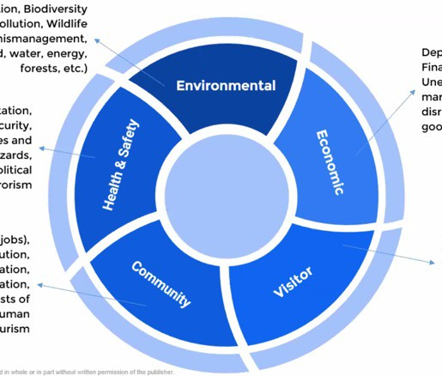

Climate Crisis, Pollution, Waste Management, Biodiversity loss

Unsafe Food and water, Bad Hygiene conditions, Pandemics, Political Instability, Terrorism

*PATA.org*

4 November 2023 page 6

Insufficient Infrastructure , Old-fashioned management and IT systems, Negative

Image (Social Media), Slow adaptation to new trends

Inequalities (Income-Resources), Dependance on Tourism (Employment), Cultural

Degradation, Overtourism

GDP relying on Tourism, Economic crisis, Seasonality, Supply chain disruptions,

Economic Leakage

**Comprehend the interplay between sustainability and resilience.**

**The 5 Areas of Resilience for Tourism Destinations**

5 6

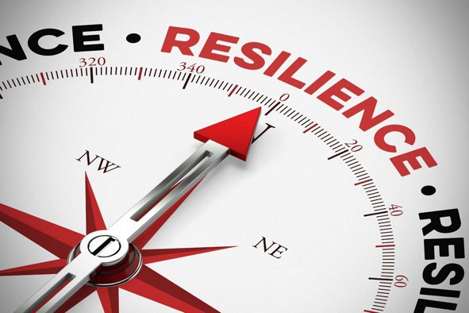

**Comprehend the interplay between sustainability and resilience.**

Resilience is a **Process**, but it is also an **Outcome**

Allows Destinations to *Cope* with Challenges and *Recover* after a Crisis

**Managing Crises**

* Risk Assessment
* Risk Management
* Adaptive Capacity

4 November 2023 page 7

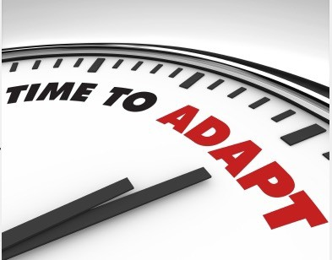

**Comprehend the interplay between sustainability and resilience.**

**Adaptive Capacity**

* Strengthening Abilities– *Organizations, Economy, Society*
* Developing Advanced Infrastructures
* Priority in Local Supply and Demand
* Diversification of Tourism Products and Services

4 November 2023 page 8

7 8

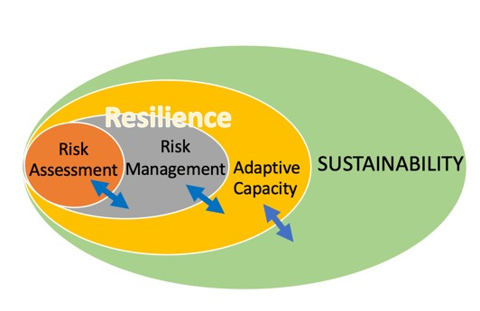

**Comprehend the interplay between sustainability and resilience.**

1. **Risk Assessment**
2. **Risk Management**
3. **Adaptive Capacity**
4. **Sustainability**

Sustainability is therefore not enough. Before a destination can be sustainable, it must first be resilient

4 November 2023 page 9



**Integrating resilience into business environments, including SMEs.**

Small and medium-sized enterprises (SMEs) are crucially important to societies and economies around the world, accounting for 99% of all businesses and three-quarters of all jobs in those sectors most affected by the Covid-19 crisis across the Organisation for Economic Co-operation and Development (OECD)

countries.

4 November 2023 page 10

9 10



**Integrating resilience into business environments, including SMEs.**

Digital tools can help SMEs and entrepreneurs weather the storm in the short term and strengthen resilience to shocks in the longer-term.

Digital applications can offer immediate solutions to increasing cost pressures (e.g. energy bills), but also help SMEs strengthen their business model in the longer term;

4 November 2023 page 11



**Integrating resilience into business environments, including SMEs.**

However, the digital transformation of SMEs cannot happen overnight, as, despite the recent acceleration, long-standing barriers remain. The lack of digital skills and of reliable internet connection continues to hinder or limit

the digital transition of SMEs across many destinations. Skills shortages weigh on SME recovery, on their capacity to adapt to a volatile business environment and embrace long term transformations.

4 November 2023 page 12

11 12



**Integrating resilience into business environments, including SMEs.**

Furthermore the digital transition has the potential to facilitate SME sustainability, but trade-offs must be taken into account. The transition towards more sustainable economies and societies has become an ever more important objective for many destinations. SMEs play an important part in this transition, given the relatively large share of CO2 emissions they are responsible for but also their potential to develop and implement Eco-innovations and greener business practices.

4 November 2023 page 13

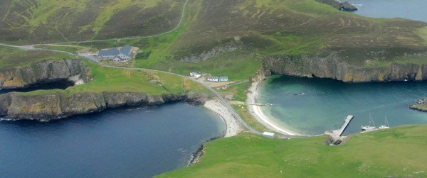

**Explore the resilience of tourism destinations.**

Resilience in the face of changing circumstances - Fair Isle, Shetland

While Fair Isle is far from being an independent state, the island’s Community Council have sought to refocus the community’s economic focus from what was essentially subsistence agriculture to a much

more diverse set of goals, of which tourism is a major part. They are focused on improving amenities on the island rather than developing the economy, so the major improvements in housing quality and utilities have undoubtedly helped in establishing the population’s confidence and resilience.

4 November 2023 page 14

13 14



**Explore the resilience of tourism destinations.**

Threats and obstacles to resilience Insights from Greece’s wine tourism

There is evidence indicating implications for both policy makers and planners involved in the design of long-term wine tourism strategies. The conceptualization of shocks and stressors that affect the resilience of the Greek wine tourism system proposes a ‘roadmap’ towards the development of the sector in a sustainable manner. Wine tourism can become a catalyst for the wine producing value chain infusing quality infrastructure and experience-oriented frameworks.

4 November 2023 page 15



**Explore the resilience of tourism destinations.**

The sustainability of small business resilience - The local tourism industry of Yogyakarta, Indonesia a decade after the crisis

Yogyakarta, with a population of half a million people has been described as the most popular tourist destination on Java due to its proximity to the temples of Borobudur and Prambanan.

Based on a study comprising ethnographic methods, the research reveals that local tourism businesses show remarkable resilience during a decade of crisis affecting the Indonesian tourism industry. This resilience has to be understood in terms of its embeddedness in a package of livelihood strategies.

4 November 2023 page 16

15 16



**Explore the resilience of tourism destinations.**

Tourism and resilience on Jersey. Culture, environment, and sea

Sustainability and resilience, in Jersey is based on cultural tourism, environmental tourism, and sea tourism, it has emerged that each contributes cultural capital for the island in terms of their importance for the tourism industry at a time when resilience has underpinned a re-thinking of the nature of this

industry. At the same time as preserving cultural and environmental heritage as island capital, the sea has been utilized in a context of aiming to grow the tourism industry.

4 November 2023 page 17



**Discussion about Resilience in Mekong Region**

17 18

|  |  |
| --- | --- |
|   **Q & A Thank You!** | |
| **mekonginstitute.org mekonginstitute.org Mekong Institute** | **MekongInstitute** |
| **Mekong Institute** |  |
| 123 Mittraphap Rd., Muang District, Khon Kaen 40002, THAILAND |  |
| Tel. : +66 (0) 4320 2411 |  |
| Fax. : +66 (0) 4320 3656 |  |
| [Email : information@mekonginstitute.org](mailto:information@mekonginstitute.org) |  |

19

SESSION 2



**Sustainable & Smart Tourism**

**Training Program**

Organized by Mekong Institute (MI)

Funded by Mekong – Korea Cooperation Fund (MKCF) November 2023



**Developing Adaptive Capacities for Resilient Tourism Ecosystems.**

**MODULE 6**

Trainer November 2023

1 2



**Challenges in Various Scales - The need for CHANGE**

**Session 2**

Monday



* Current and Future Challenges in Tourism
* Proactivity in Governance and Businesses
* Risk Assessment and Change Dynamics
* Change Management

4 November 2023 page 4

3 4

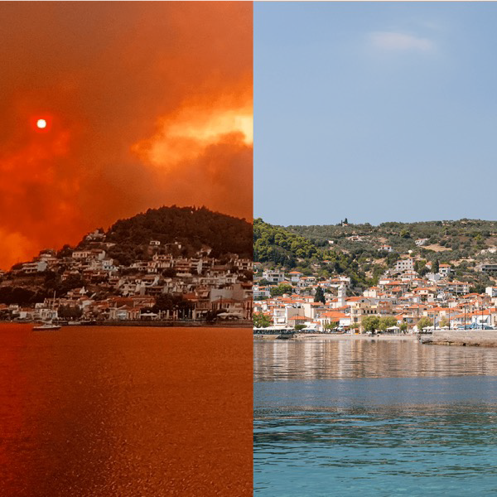

**Current and Future Challenges in Tourism**

Covid-19 disrupted most industries, but especially travel and tourism.

The pandemic has changed consumer behaviour in ways which are still playing out. There is the possibility of new variants causing short-notice border restrictions in the future.

Aside from Covid, international travel remains hampered by confusion, concern and unpredictability. Here, we

look at the main challenges facing travel and tourism in a fast-changing world.

4 November 2023 page 5



**Current and Future Challenges in Tourism Inflation and the rising costs of travel**

Airfares are at record highs

Lodging prices – for hotels and motels etc. – are volatile

Car rentals have seen big increases – as of May 2022, prices were around 70% higher than in May 2019

4 November 2023 page 6

5 6

4 No



**Current and Future Challenges in Tourism Short staffing affects ability to meet customer expectations**

Many travel businesses laid off or lost staff during the pandemic – reportedly, a total of 62 million tourism-related jobs were lost worldwide in 2020. Now that leisure demand is building again, businesses have struggled to hire enough replacements. Short staffing explains the scenes of airport chaos we’ve seen, not just in the UK but around the world.

4 November 2023 page 7



**Current and Future Challenges in Tourism Remote workers have created a new travel niche**

The increase in remote working and digital nomads has created a new travel niche. With workers untethered from the office, they now have scope to work from other locations. These travellers have a particular set of attributes or requirements:

* Above average buying power
* Greater flexibility on travel dates
* A need for a quiet, comfortable space to work – perhaps away from crowded tourist areas
* Fast and reliable Wi-Fi
* Access to wellness-related amenities, such as gyms or healthy meals on the go
* The flexibility to reschedule leisure activities to accommodate work

4 November 2023 page 8

7 8



**Current and Future Challenges in Tourism**

**Consumers are increasingly concerned about sustainability**

According to Sustainable Travel International, tourism is responsible for about 8%

of the world’s carbon emissions. Businesses are under pressure from both

consumers and governments to become more sustainable. The tourism industry

faces the challenge of adding decarbonisation to its value proposition. In practice,

this means re-examining what travel should look like and how sustainable

practices can be incorporated. This will require collaboration across the whole industry.

4 November 2023 page 9

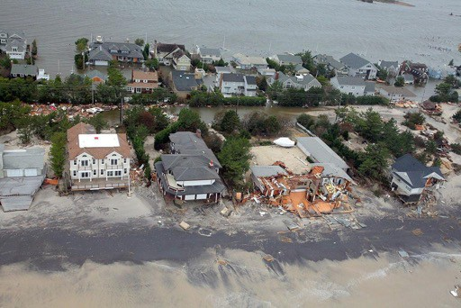

**Current and Future Challenges in Tourism Disasters – both man-made and natural – are an ever-present threat**

As any tourism business knows – especially those with operations in major cities – security risks such as terrorist attacks or political unrest are a grim reality, alongside threats from natural disasters such as pandemics, tsunamis, earthquakes, floods, volcanoes, avalanches, mega fires and so on.

vember 2023 page 10

9 10



**Proactivity in Governance and Businesses**

In today's rapidly evolving business landscape, companies increasingly recognize the importance of Environmental, Social, and Governance (ESG) factors in their operations. Ethical considerations and the potential for financial benefits and risk mitigation drive the proactive adoption of a corporate ESG agenda.

4 November 2023 page 11



**Proactivity in Governance and Businesses**

Proactive public services should be the norm. Importantly, proactive provision requires a joined-up approach, breaking apart siloes between organizations and departments as they pool together data. This means reimagining the function and design of state institutions not building digital channels for analogue services.

4 November 2023 page 12

11 12



**Risk Assessment and Change Dynamics**

Tourism risk management process is concerned with identifying

and analysing the risks (‘the chance of something happening that will have an impact upon objectives’) to a destination or organisation and deciding what can and should be done about them. They are logical and systematic problem-solving

and decision making processes.

The tourism industry should be involved in both crisis management (the

organisational process) and disaster management (the multi-agency, community- based process).

4 November 2023 page 13

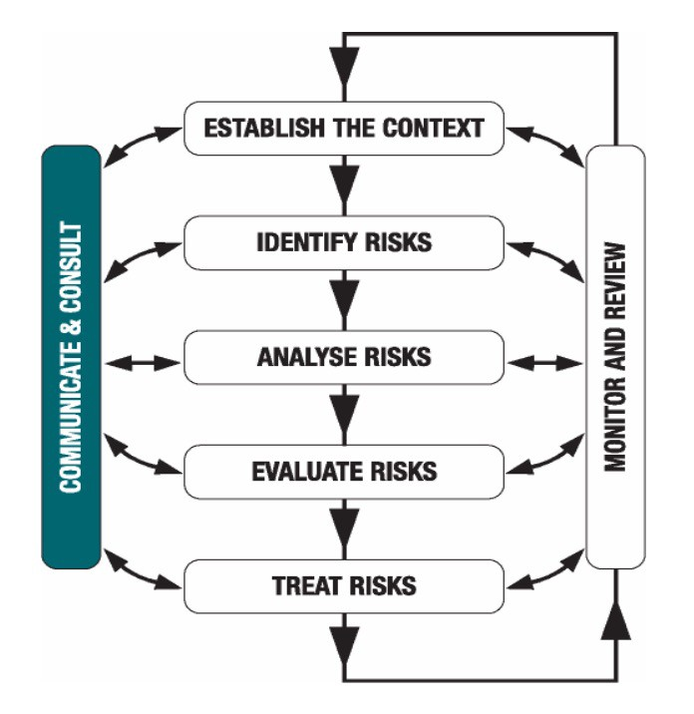

**Risk Assessment and Change Dynamics**

Tourism risk management process steps.

* Establish the Context
* Identify Risks
* Analyse Risks
* Evaluate Risks
* Treat Risks

4 November 2023 page 14

13 14



**Risk Assessment and Change Dynamics**

Tourism needs to adopt to become resilient. This needs CHANGEs in various levels and in different extend. The CHANGE is always including minor or bigger risks. It can create turbulences and therefore Risk Management is also contributing to CHANGE MANAGEMENT

4 November 2023 page 15

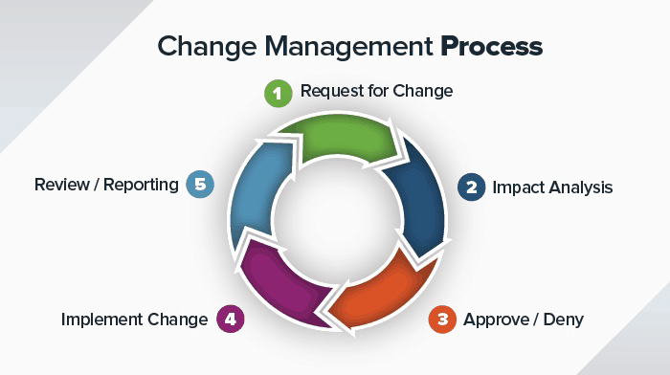

**Change Management**

Change management is a systematic approach to dealing with the transition or transformation of an organization's goals, processes or technologies.

The purpose of change management is to implement strategies for effecting change, controlling change and helping people to adapt to change.

4 November 2023 page 16

15 16



**Change Management**

**Transformation & Change Leadership**

Transformational leaders manage by establishing a relationship with employees and building a common “vision” for change. Change leaders, on the other hand, focus on the specific change occurring and how to effectively implement the Change

**CHANGE** can be small and incremental, or it can be large and complex. But it is something that needs to be constantly monitored and maintained.

**TRANSFORMATION** is almost always large and significant. Transformation is an internal fundamental evolution of your beliefs of why you perform certain actions. Transformation may not require any external influence to maintain, but it does require foundational shifts from within.

4 November 2023 page 17



**Discussion about Challenges in Mekong Region**

17 18

|  |  |
| --- | --- |
|   **Q & A Thank You!** | |
| **mekonginstitute.org mekonginstitute.org Mekong Institute** | **MekongInstitute** |
| **Mekong Institute** |  |
| 123 Mittraphap Rd., Muang District, Khon Kaen 40002, THAILAND |  |
| Tel. : +66 (0) 4320 2411 |  |
| Fax. : +66 (0) 4320 3656 |  |
| [Email : information@mekonginstitute.org](mailto:information@mekonginstitute.org) |  |

19

SESSION 3



**Sustainable & Smart Tourism**

**Training Program**

Organized by Mekong Institute (MI)

Funded by Mekong – Korea Cooperation Fund (MKCF) November 2023



**Developing Adaptive Capacities for Resilient Tourism Ecosystems.**

**MODULE 6**

Trainer November 2023

1 2



**Social Change and Resilience. Application Difficulties and Solutions**

**Session 3**

Monday



* Explore the Application of CHANGE and Adaptive Capacities
* Understanding Resistance to CHANGE
* Motivation and Inspiration as Tools for CHANGES
* Resilience as a Defense System

4 November 2023 page 4

3 4

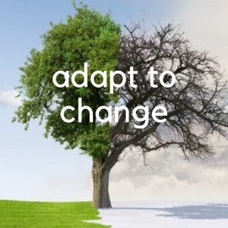

**Explore the Application of CHANGE and Adaptive Capacities**

Sustainable & Resilient Development policies increasingly focus on building capacities to respond to change (adaptation), and to drive change (innovation).

As CHANGE is a challenging task, adaptation abilities are essential to minimize the risks of negative impacts from the CHANGE process.

4 November 2023 page 5



**Explore the Application of CHANGE and Adaptive Capacities**

Some potential challenges related to CHANGE are

* Lack of stakeholder support.
* No direction from management.
* Lack of funds.
* Inadequate members to do the work.
* Lack of governance and proper change management framework.
* Ambiguity about the need for change.
* Uncertainty or disbelief that the change could be positive

4 November 2023 page 6

5 6



**Explore the Application of CHANGE and Adaptive Capacities**

Some potential challenges related to CHANGE are

* Lack of Clarity.
* Ineffective Change Communication. ...
* Strategic Shortcomings.
* Change Resistant Culture. ...
* Lack of Organizational Buy-In. ...
* Change Fatigue.

4 November 2023 page 7



**Understanding Resistance to CHANGE**

Resistance to change is unwillingness to adapt to new circumstances or ways of doing things. It can happen with individuals, teams, or within organizations.

There are many reasons for resistance, but at its heart, resistance is rooted in fear of the unknown. People are biologically wired to look for patterns and predictability, and any uncertainty — even if it’s anticipated or positive — can trigger anxiety.

4 November 2023 page 8

7 8



**Understanding Resistance to CHANGE**

Resistance to change is common and can come in many forms. It can be subtle or overt, and it can be seen in both individuals or groups of people.

Some examples might be missed meetings, sarcastic remarks, criticism, nitpicking, or even sabotage.

The good news is, no matter what form it manifests, overcoming resistance to change is possible. However, organizations need to first understand the causes of resistance to more effectively address it.

4 November 2023 page 9

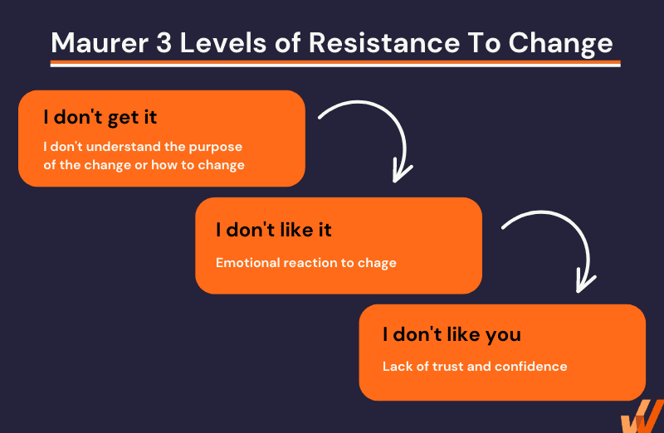

**Understanding Resistance to CHANGE**

Three Levels of Resistance

1. I don’t get it.
2. I don’t like it
3. I don’t like you

4 November 2023 page 10

9 10

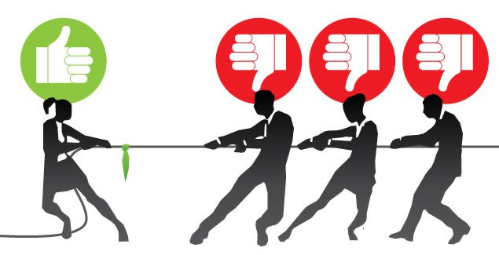

**Understanding Resistance to CHANGE**

To overcome resistance to change, communicate the benefits, involve stakeholders, provide support, and address concerns.

Create a clear vision and demonstrate the positive impact of the change to inspire acceptance and cooperation.

4 November 2023 page 11



**Motivation and Inspiration as Tools for CHANGE**

If people are motivated towards change everything else becomes easier, they will:

* Easily develop and stick to a vision for change because more people can see themselves in the new situation and understand how it impacts them in an overall positive way.
* Seek to develop and hone their own change management skills, rather than wait to be sent to training they don’t actively engage with

4 November 2023 page 12

11 12

4



**Motivation and Inspiration as Tools for CHANGE**

If people are motivated towards change everything else becomes easier, they will:

* More freely provide resources for change management rather than holding on to them to protect their own interests
* Create and execute Change Management plans easily because everyone is aligned and committed to delivering their assignments and sticking to deadlines.

4 November 2023 page 13



**Motivation and Inspiration as Tools for CHANGES**

Inspiration is something that Leaders are able to do. The have the charisma to open new doors for attractive and realistic situations.

The are able to have a positive sentimental and psychological impact to people around them.

People start to feel additional energy and strong willingness.

4 November 2023 page 14

13 14



**Resilience as a Defense System**

Resilience is a valuable concept when it comes to defending against external threats. It refers to an individual's or an organization's ability to withstand, adapt to, and recover from adversity and challenges.

4 November 2023 page 15



**Resilience as a Defense System**

Resilience is a critical strategy for defending against and responding to crises of all types, whether they are natural disasters, economic downturns, public health emergencies, or other unexpected challenges. Some ways to strengthen your resilience as a defense system.

* Crisis Preparedness
* Emotional and Psychological Resilience
* Community Resilience
* Economic Resilience

November 2023 page 16

15 16

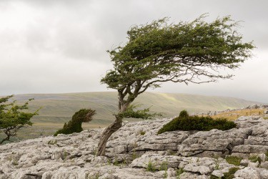

**Resilience as a Defense System**

Some ways to strengthen your resilience as a defense system.

* Education and Training
* Infrastructure Resilience
* Government and Policy Resilience
* Global Collaboration
* Adaptive Capacity

4 November 2023 page 17



**Discussion about potential CHANGEs in Mekong Region**

17 18

|  |  |
| --- | --- |
|   **Q & A Thank You!** | |
| **mekonginstitute.org mekonginstitute.org Mekong Institute** | **MekongInstitute** |
| **Mekong Institute** |  |
| 123 Mittraphap Rd., Muang District, Khon Kaen 40002, THAILAND |  |
| Tel. : +66 (0) 4320 2411 |  |
| Fax. : +66 (0) 4320 3656 |  |
| [Email : information@mekonginstitute.org](mailto:information@mekonginstitute.org) |  |

19

SESSION 4



**Sustainable & Smart Tourism**

**Training Program**

Organized by Mekong Institute (MI)

Funded by Mekong – Korea Cooperation Fund (MKCF) November 2023

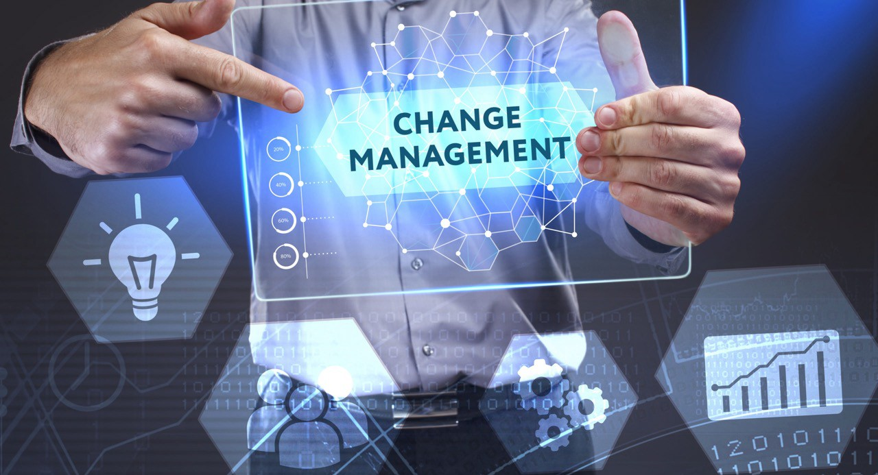

**Developing Adaptive Capacities for Resilient Tourism Ecosystems.**

**MODULE 6**

Trainer November 2023

1 2



**Sustainable Tourism Strategy and Planning based on Smart and Digital resources**

**Session 4**

Monday



* Smart Applications for Sustainable Tourism
* Presenting the MEKONG-HERITAGE Digital Platform
* Analyzing the functions of the Application
* Practicing the use of the Applications
* Exploring the benefits from the Application in the framework of Smart & Sustainable Tourism

4 November 2023 page 4

3 4



**Smart Applications for Sustainable Tourism**

Travellers use travel apps as a medium for online ticketing, hotel booking, getting destination details, locating local attractions and food outlets; exploring new destinations; finding reviews about a destination they plan to visit; sharing pictures from their travel; posting feedback on a destination, airline, hotel etc.

It is something that we all familiar to use but there are deferent levels on sustainability values.

4 November 2023 page 5

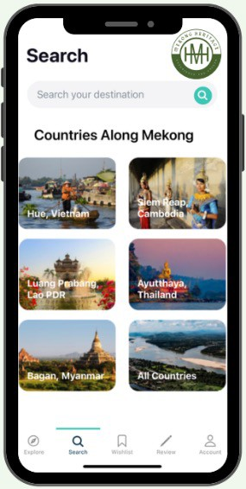

**Presenting the MEKONG-HERITAGE Digital Platform**

Heritage is a valuable resource for almost all destinations. In many cases places with long history and strong heritage can benefit a lot highlighting important and attractive elements that

actually are part of the place DNA and they are shaping the destination’s BRAND.

So Mekong Region is maximizing the heritage values for the benefit of the visitors but also the local communities

4 November 2023 page 6

5 6

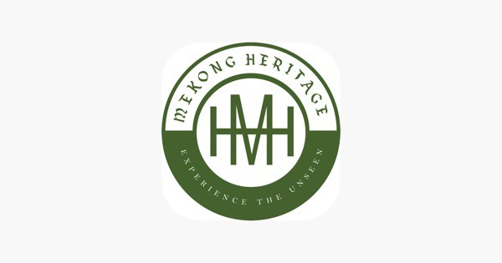

**Presenting the MEKONG-HERITAGE Digital Platform**

The applications introduces the unique traditions and historical significance of the vibrant communities in the Mekong region.

Explores key attractions, tourism services, and local products in Ayutthaya of Thailand, Bagan of Myanmar, Hue of Vietnam, Luang Prabang of Laos, and Siem Reap of

Cambodia, with a user-friendly interface.

Emerges diverse heritage sites and their fascinating stories, connecting visitors to the rich past and with a global community dedicated to preserving and celebrating the Mekong's cultural legacy.

4 November 2023 page 7



**Analyzing the functions of the Application**

**Mek ng Heritage**

**Digital Platform**

Explore

Share Experience

Save Places

wish list

SUSTAINABLE AND SMART TOURISM DEVELOPMENT IN MEKONG REGION

Supported by Mekong-Republic of Korea Cooperation Fund (MKCF)

7 8

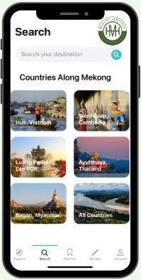

**Analyzing the functions of the**

**Application**

**AB O UT**

Designed to provide comprehensive information on

1. key attractions,
2. tourism services, and
3. products of the five project locations within the Mekong Region.

Serves as a valuable resource for both local residents and tourists through offering a user-friendly interface that allows easy access to a wealth of cultural information and travel resources.

By utilizing the app, users can gain insights into the diverse heritage sites, explore their historical significance, and discover the fascinating stories behind them.

Main purpose of the App

Demand side: To provide updated information for the

international travelers who are willing to visit to 5 Mekong heritage sites, To maximize travel experiences visiting the heritage destinations.

Supply side: To help SMEs approach international travelers, to help tourism operators to increase their visibility to travelers

while gaining valuable customers’ analytical data and market insights that will help them to make better data-driven business

decisions for innovation.

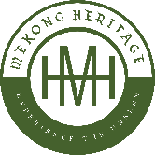

**For Whom**

* Tourism promotion agencies
* Private tour and travel operators
* Tourism enterprises
  + Hotels
  + Restaurants
  + Entertainment centres
  + Souvenir shops
  + Local crafts, and etc.
* Creative artists/performers
* Worldwide Travelers
* Investors
* Tour guides
* Tourism media/ social media

Analyzing the functions of the Application

influencers

* /hospitality

Universities

education

* Training centres among others.

Source: [w w w .vectorstock.com /23456486](http://www.vectorstock.com/23456486)

9 10

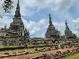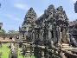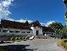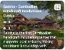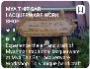

1991

PO Is [127]

1992

[478]

1993

[168]

1995

[226]

2019

[154]

**Main Categories – 1,153 POIs Main Functions**

Google App

He ritage Attractions

Play

Store

Explore

Ac com m oda tions

* Unique feature

Share Experience

Re staurants

Save Places

wish list

* Multimedia content
* Interactive map
* Contact
* Personalized REC
* Info addable

Othe rs



**Exploring the benefits from the Application in the framework of Smart & Sustainable Tourism**

A big variety of benefits from a single smart applications. Benefits that are contribute to the sustainability of the region in a very efficient and SMART way

4 November 2023 page 12

11 12

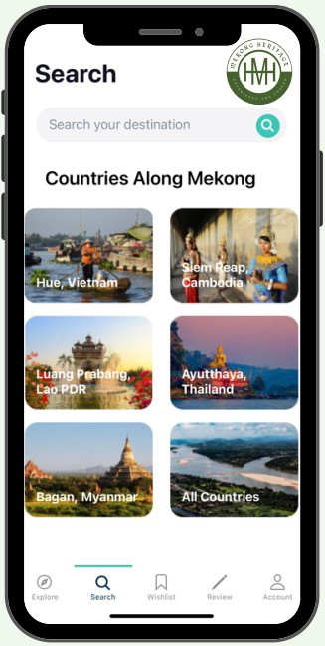

**BENEFiTS**

Convenience Information Updates Personalization Review and Rating

Navigation Booking and Reservations

Cost Saving Travel itineraries Heritage and Local

Insights Safety Features Environmental Impact Feedback and Support Memory Keeping

Marketing Channel

Etc.



**Practicing the use of the Applications**

**Mek ng Heritage**

**Digital Platform**

Explore

Share Save

Experience Places

wish list

SUSTAINABLE AND SMART TOURISM DEVELOPMENT IN MEKONG REGION

Supported by Mekong-Republic of Korea Cooperation Fund (MKCF)

13 14



**Discussion about the use of the Application**

|  |  |
| --- | --- |
| **Q & A Thank You!** | |
| **mekonginstitute.org mekonginstitute.org Mekong Institute** | **MekongInstitute** |
| **Mekong Institute** |  |
| 123 Mittraphap Rd., Muang District, Khon Kaen 40002, THAILAND |  |
| Tel. : +66 (0) 4320 2411 |  |
| Fax. : +66 (0) 4320 3656 |  |
| [Email : information@mekonginstitute.org](mailto:information@mekonginstitute.org) |  |

15 16