Modules & Session Plan

Module 1: Understanding the Tourism Value Chain and the Tourism Ecosystem through System Thinking

Module Title  Understanding the Tourism Value Chain and the Tourism Ecosystem through System Thinking. | Module Code:  MI-SSTD001 | Module Training Time  5 sessions of 75’ each
Reference Textbooks  - Partale, K. (2020). The tourism value chain: Analysis and practical approaches for development cooperation projects. Bonn, Germany: Deutsche Gesellschaft für Internationale Zusammenarbeit (GIZ).  - Day, Jonathon & Morrison, Alastair M & Lehto, Xinran. (2018). The Tourism System, 8th edition. |  | Other References  Printed and Electronic material and notes will be distributed during the training session to all participants.
Trainer - Instructor  TBD |  | Phone No. | Email
Module Description

This module covers the concepts of Tourism Value Chain and Tourism Ecosystem, in an analytical way emphasizing in practical explanations and case examples. Additionally, the concept of System Thinking in Tourism is introduced in a way to provide a detailed view on the big picture and explain the importance of a holistic approach for tourism managers and practitioners. .

Module Objective
By the completion of the module the trainees will:
- become familiar with the concepts of Tourism Value Chain and Tourism Ecosystem.
- be introduced to essential administrative and governance frameworks that allow innovative tourism development
- be able to implement processes of System Thinking within the Tourism Ecosystem.
- be able to develop methods and concepts for local and regional tourism destinations.
- Be able to analyze complex tourism environments and apply holistic approach on the field

Module Assessments  Structured 30 minute quiz to reflect the knowledge delivered during the training will be applied at the end of the last session.  The quiz will be a combination of  - True/False Questions  - Multiple Choice Questions  - Short Open Questions |  | Trainer-Instructor Engagement  The trainer-educator will be equipped and prepared with specific typed notes, reference texts, presentations and analyzed case studies. Additionally, a few in class activities will be proposed in detail.
Module 1 Schedule & Plan

Session | Subject | Activities / Supporting Materials
1  (75’) | Topic 1 – Introducing the Value Chain & Tourism (1)  •Regional value added as a target  •What you need to know about Value Chain  •Tourism: What you need to know | Group work: Introduce Value Chains from your own experiences and regions.  Discussion: Challenges on specific Value Chains  PPT 001-01  Discussion Questions  Notes for existing case as example
2  (75’) | Topic 2 – Introducing the Value Chain & Tourism (2)  • Tourism Services vs Tourism Experiences  • Value-adding Strategies in the Tourism Sector  • Innovation and Creativity in Tourism | Group work: How Value Chains interact with Tourism  Discussion: Impacts form specific examples  PPT 001-02  Discussion Questions  Notes and existing case as example
3  (75’) | Topic 3 – How to use Value Chain in the Tourism Sector  •Defining the Value Chain  •Initiating Value Networks  •Analyzing the Value Chain  •Defining Objectives and Developing Solutions | Group work: Efficient Solutions for balanced benefits between value chains and Tourism  Discussion: Examples of Strategies in this direction  PPT 001-03  Discussion Questions  Notes for existing case study as example
4  (75’) | Topic 4 – Developing Supply Chains  •DMO Development & stakeholders’ integration  • Circular Economy  •Developing the supply chain in line with socio-cultural and environmental Criteria  •Integrating Digital transformation | Group work: Design-Propose a regional DMO structure.  Discussion: Various DMO models and structures  PPT 001-04  Discussion Questions  Notes for existing DMO structures
5  (75’) | Topic 5 – Tourism System & System Thinking  •The Complexity of Tourism  •Translating System Thinking into Tourism  •Global vs Local Tourism Systems  •The Glocal Tourism Systems Approach | Group Assignment: Propose a DMO structure for a specific given destination. Highlight the Systemic approach on a global and local level.  Individual Assignment: Describe a Tourism Ecosystem framework through your own role, background, or organization.  PPT 001-05  Supporting Articles about Tourism Ecosystems and DMO guidelines  Assessments Rubrics

Contents and Session Plans

Module 1: Understanding the Tourism Value Chain and the Tourism Ecosystem through System Thinking

Session 1: Introducing the Value Chain & Tourism (1)

Contents

- Open Discussion

The participants will be engaged in a discussion to express their perception about the local values-regional values that…

ANEX B. Module 1 SLIDES

Session 1.

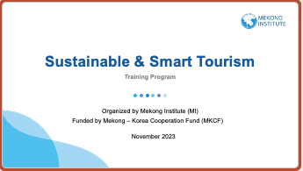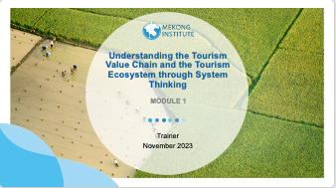

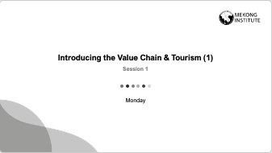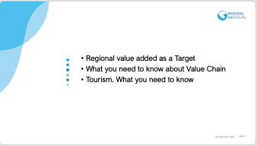

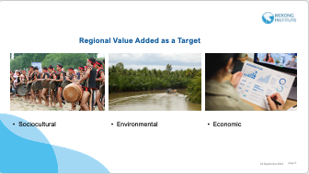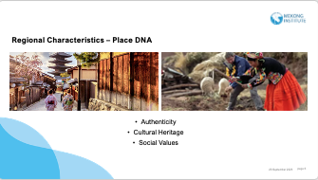

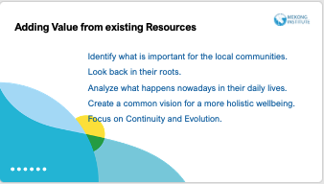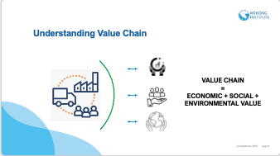

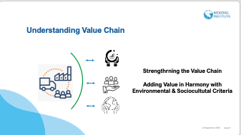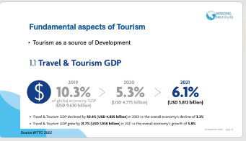

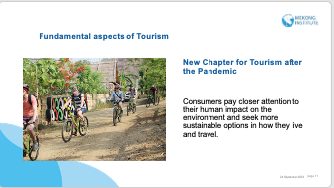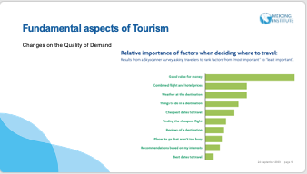

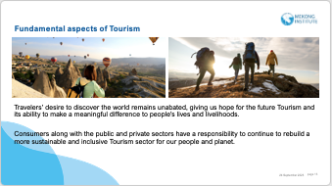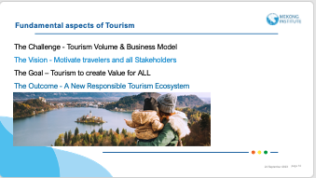

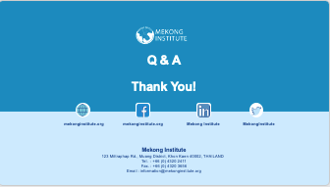

Session 2.

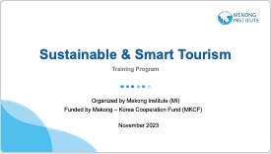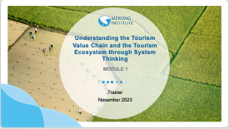

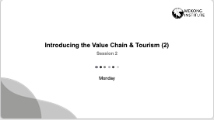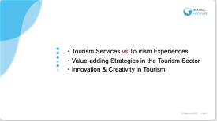

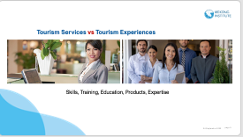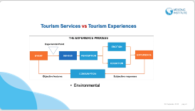

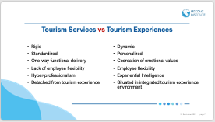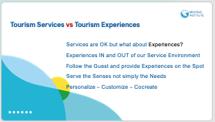

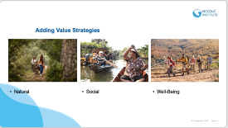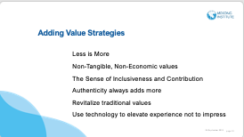

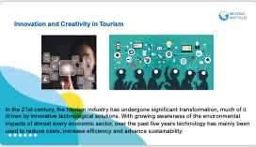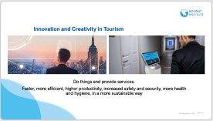

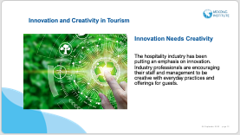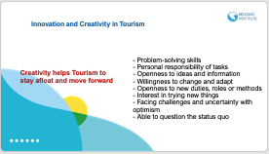

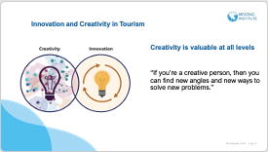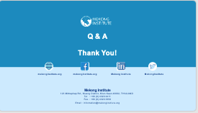

Session 3.

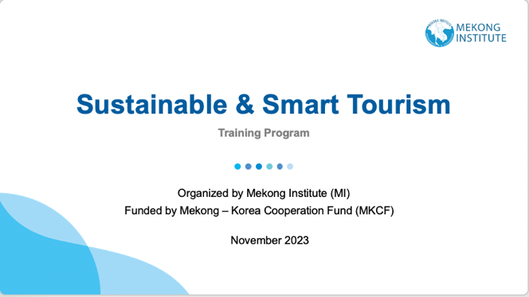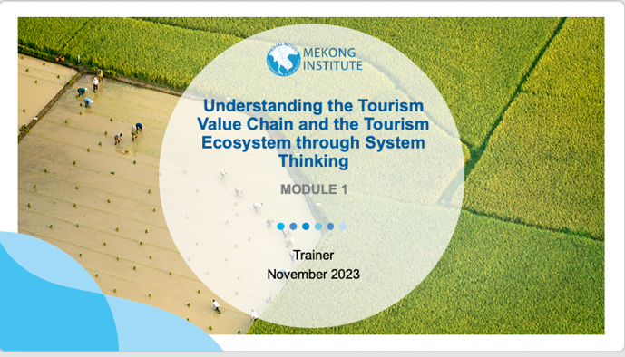

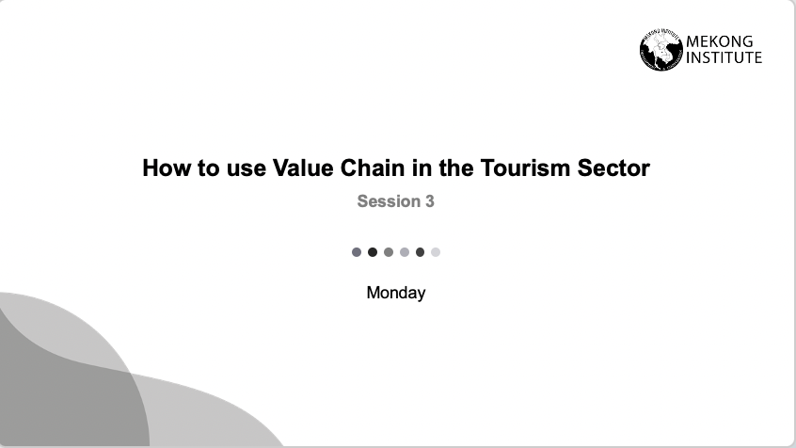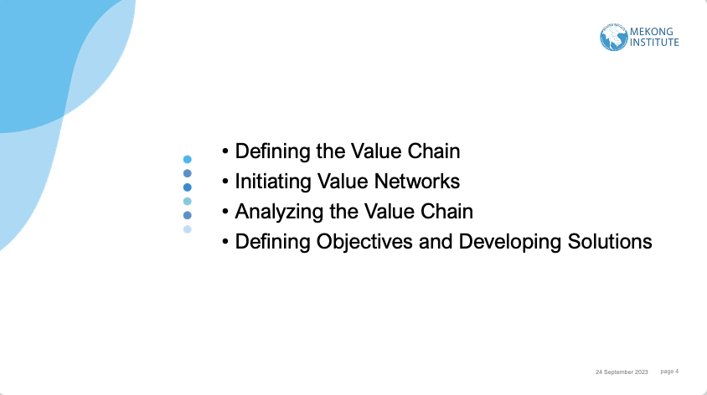

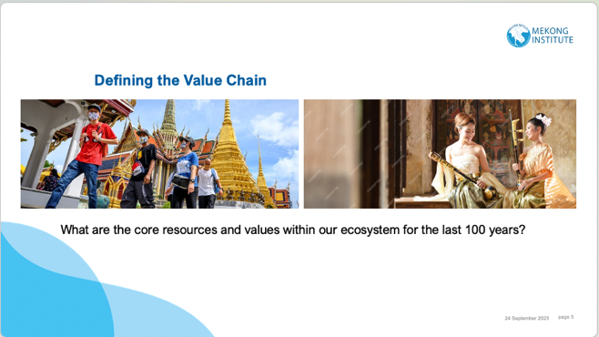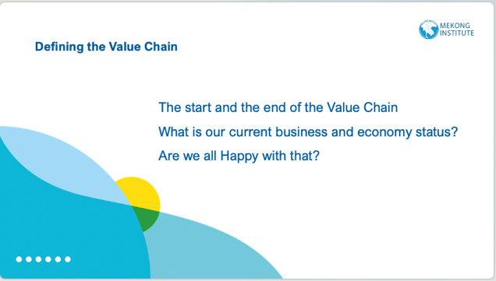

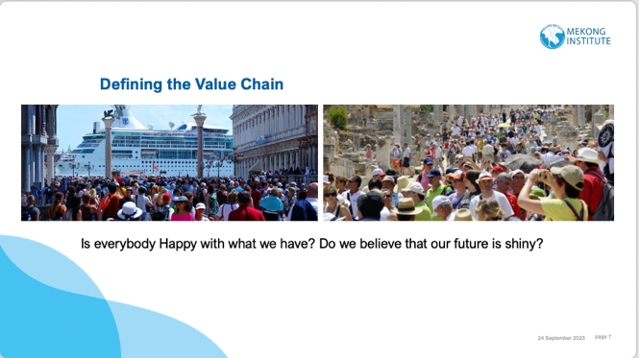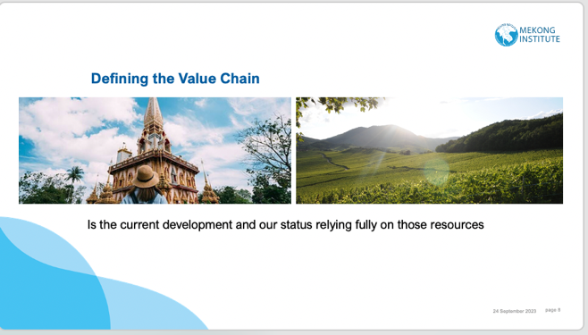

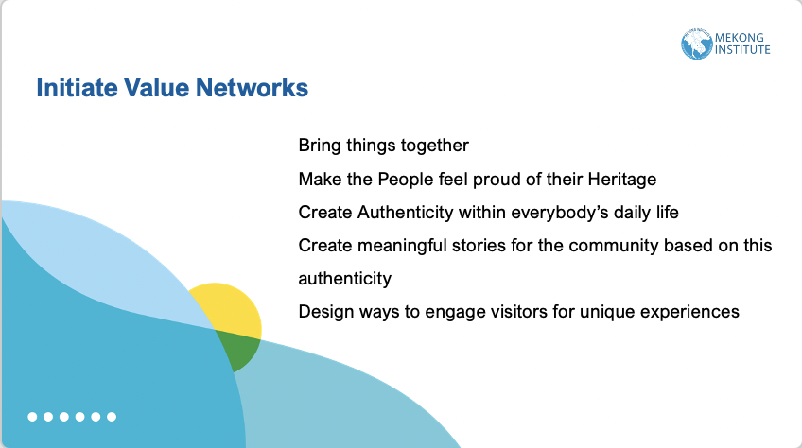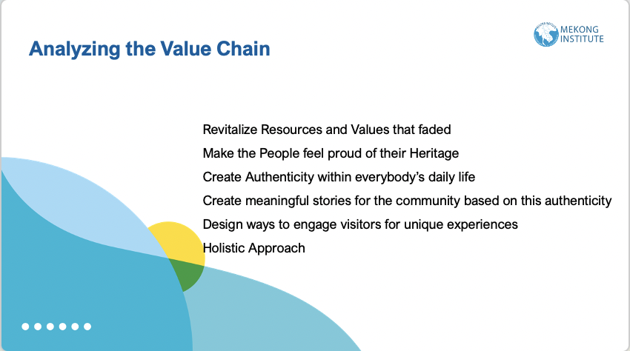

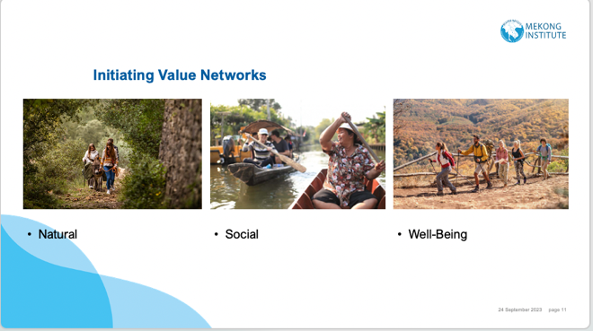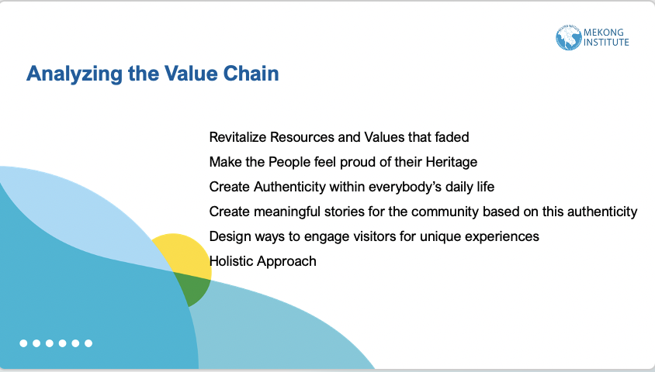

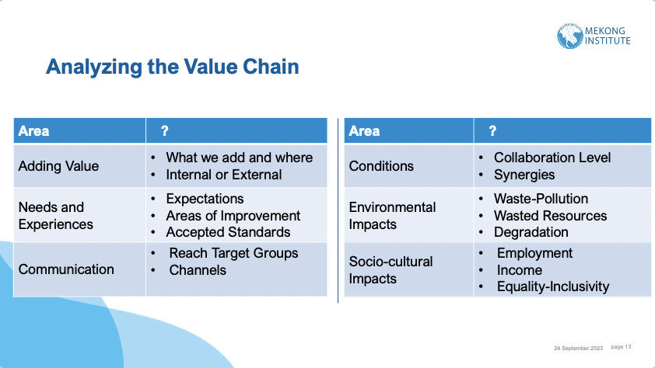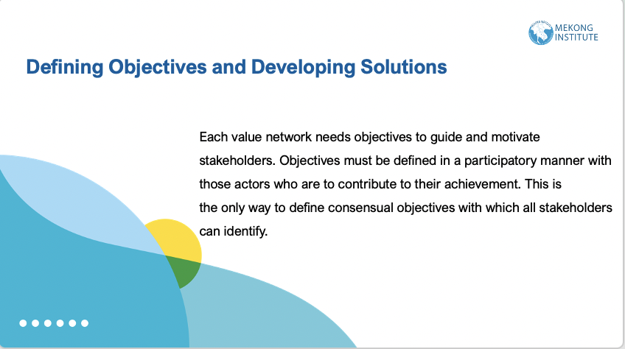

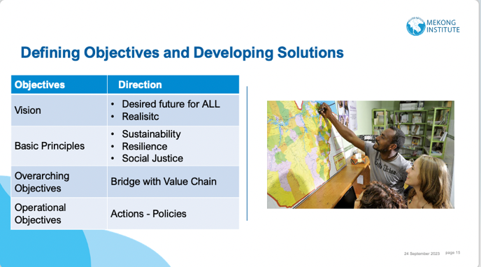

Session 4.

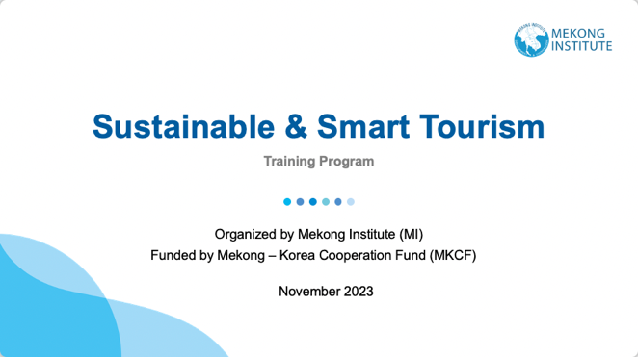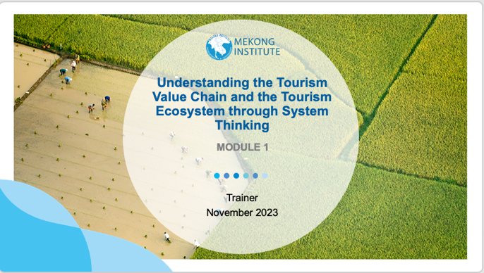

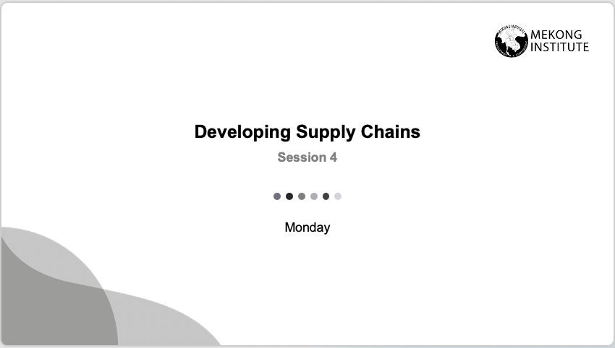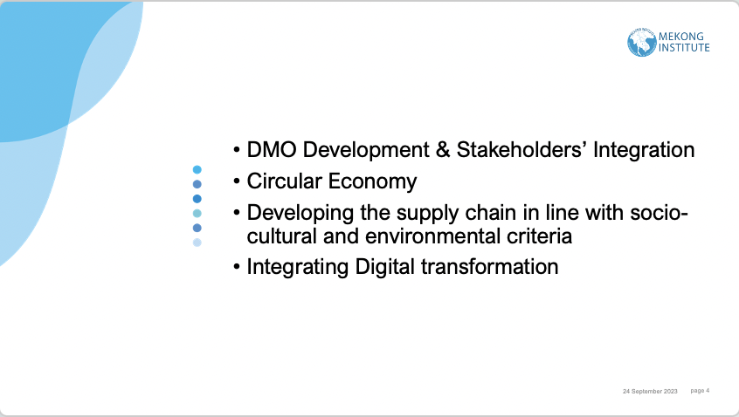

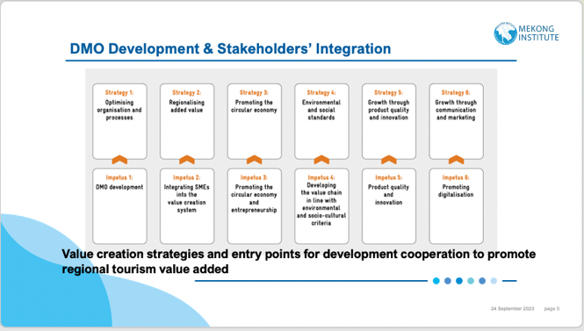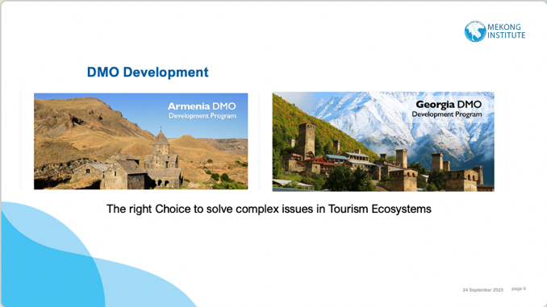

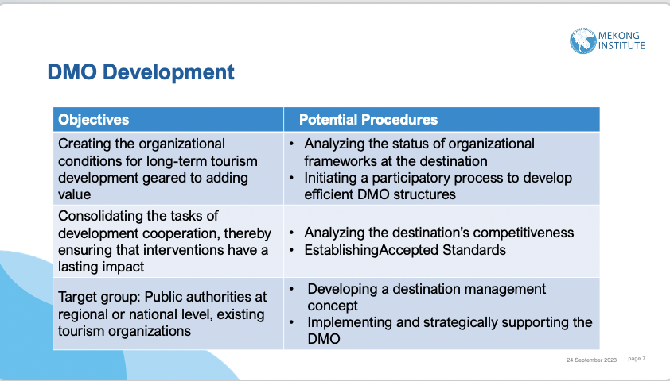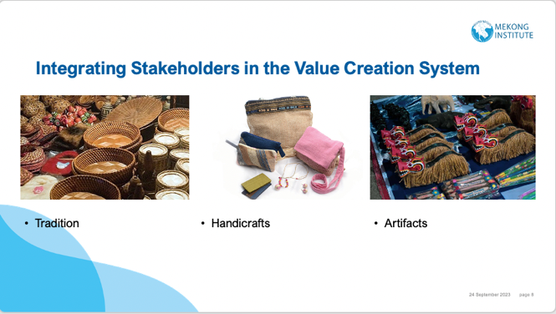

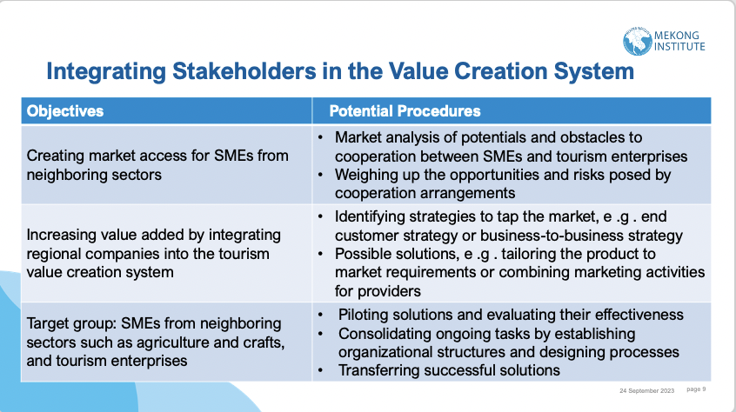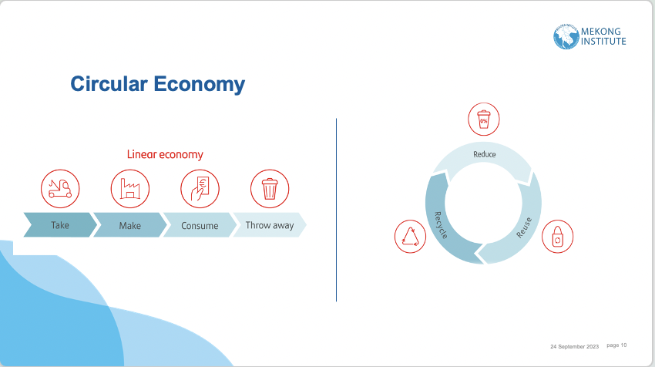

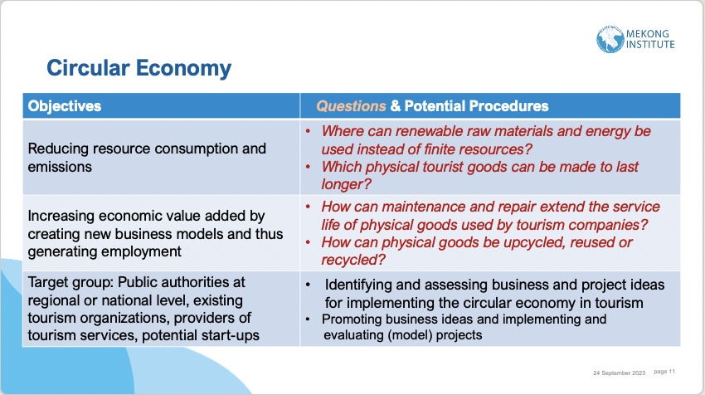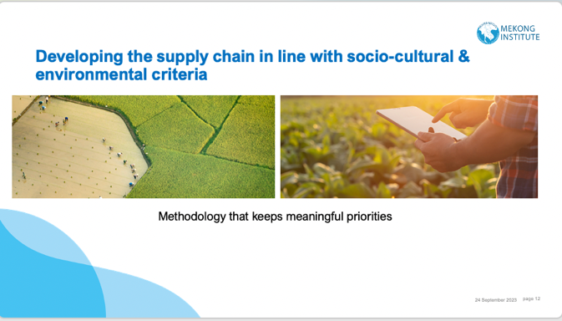

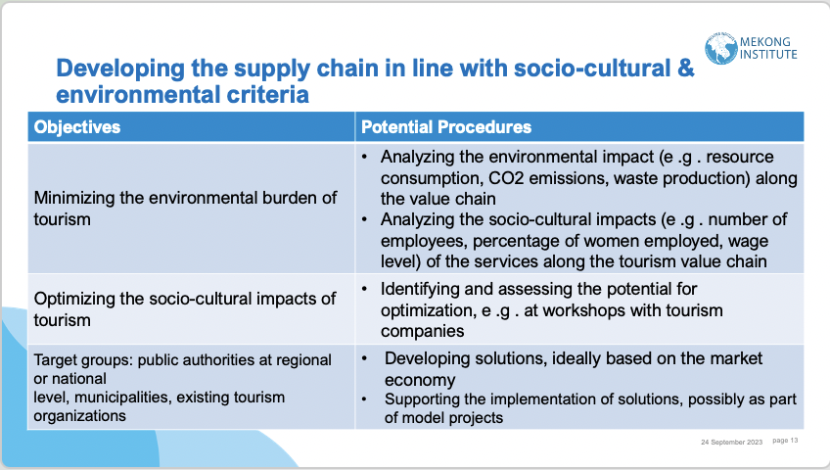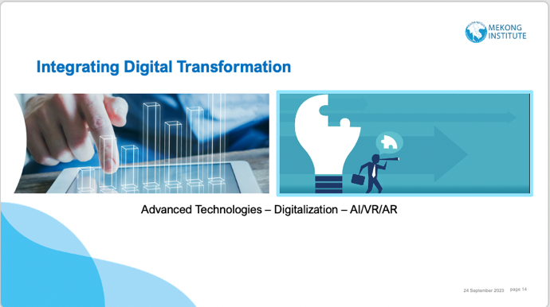

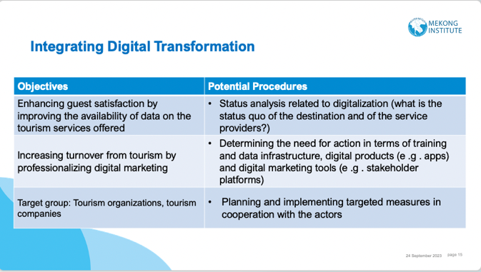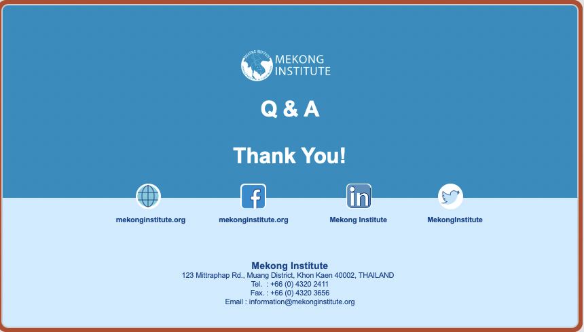

Session 5.

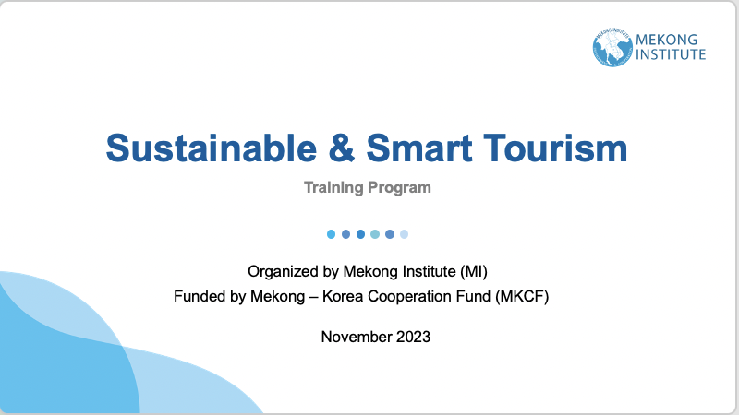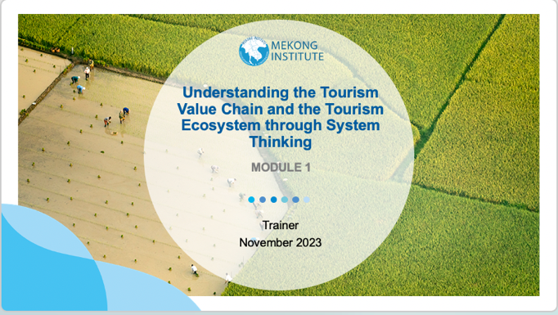

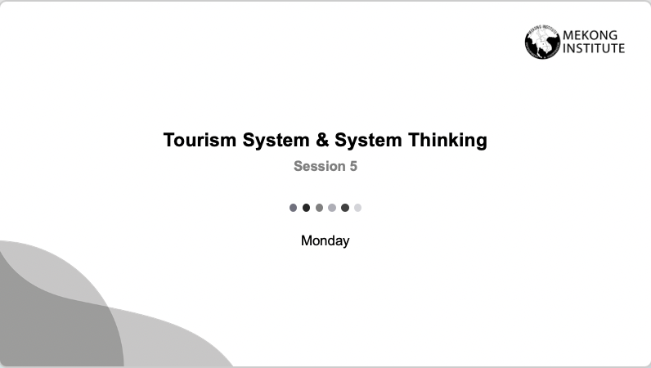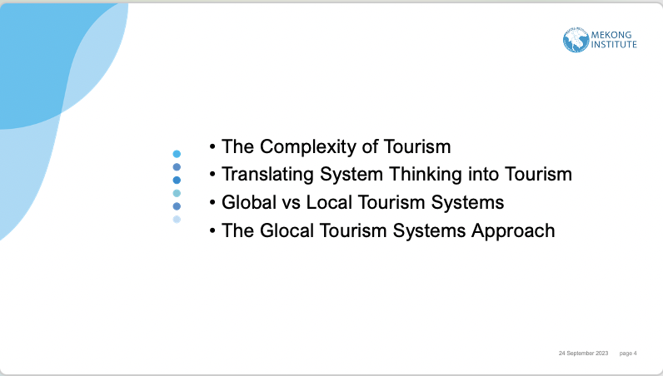

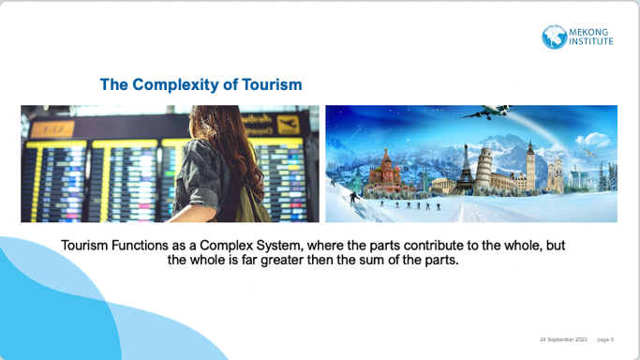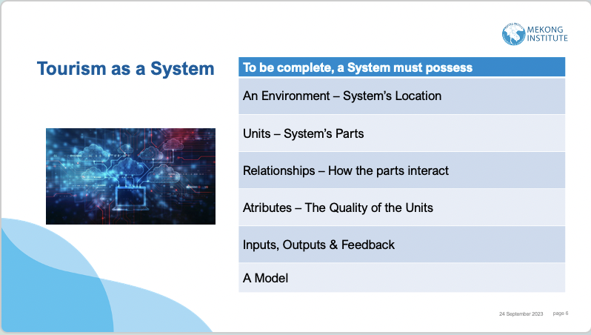

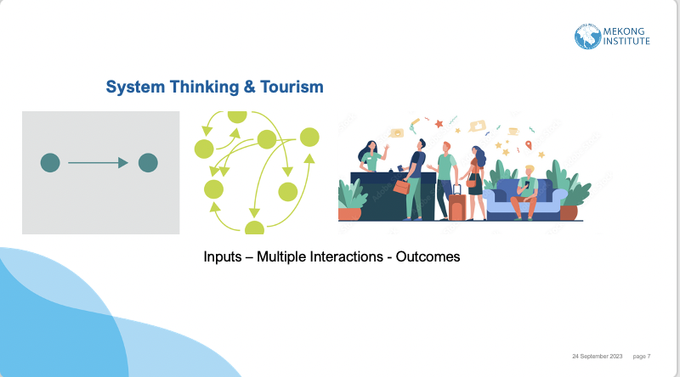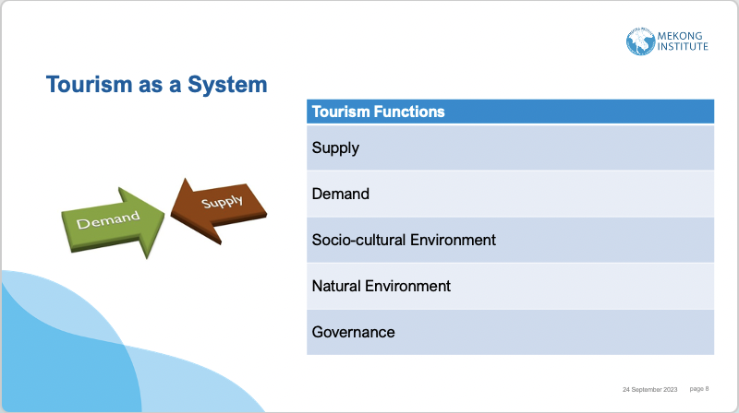

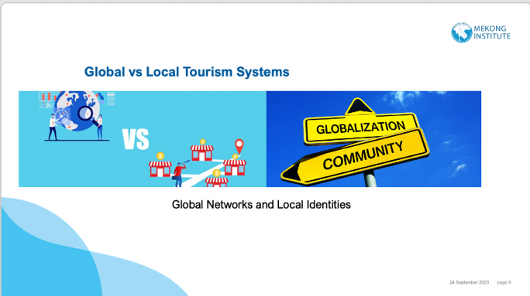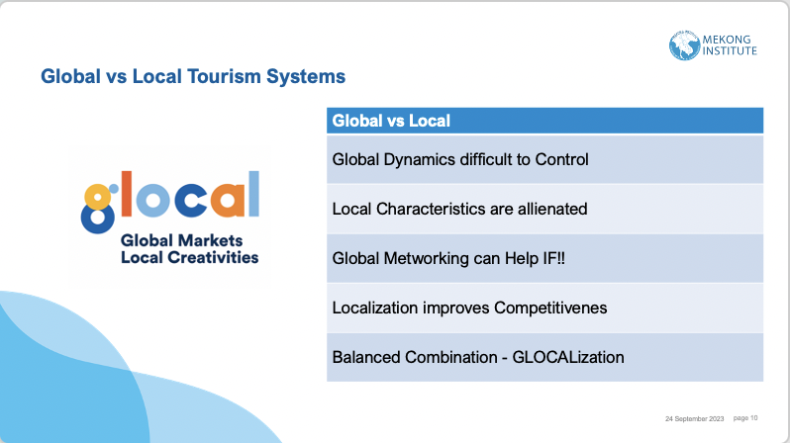

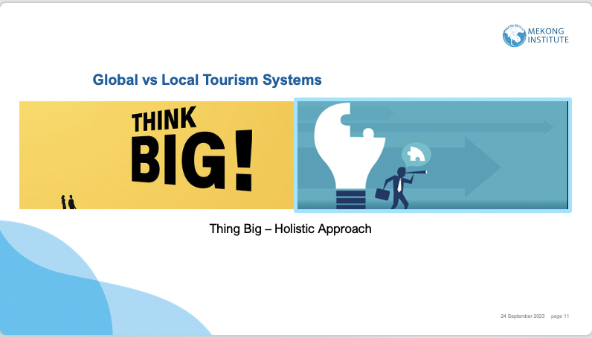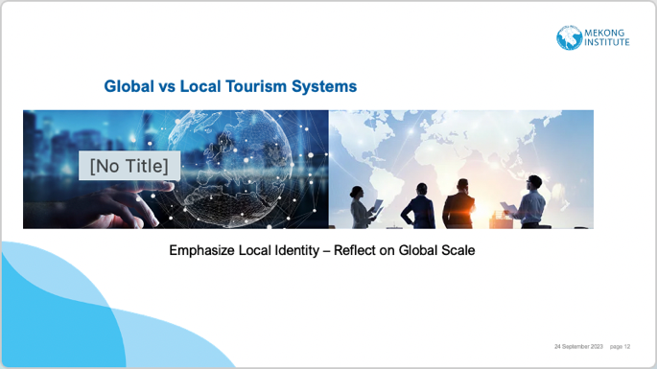

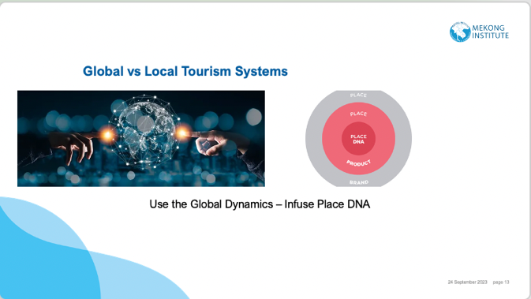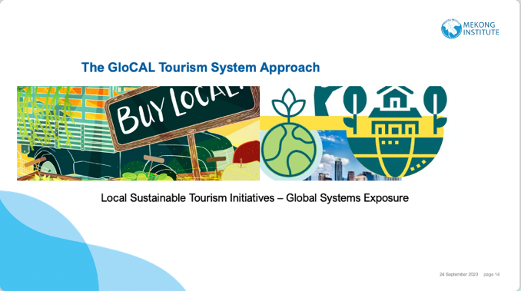

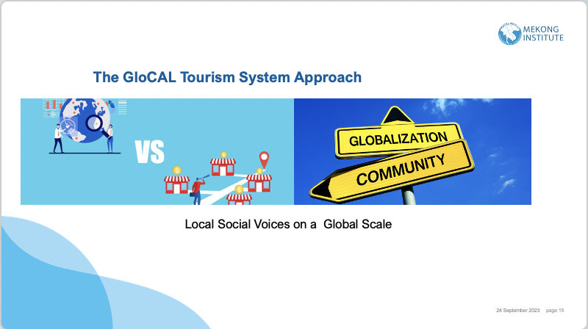

Annex C.

Groupwork Session 1 & 2

Introduction to Value Chains: Unleashing the Potential of Sustainable Development

In today's dynamic world, urban and rural areas, each with their unique communities and abundant environmental and socio-cultural resources, play a pivotal role in shaping their own development trajectories. At the heart of this development lie the intricate value chains, encompassing various economic activities, stakeholders, and resources. Traditionally, value chains have been primarily seen as engines for creating economic benefit, but the scope has evolved. It's no longer sufficient to focus solely on economic gains; we must now also prioritize achieving a harmonious and balanced well-being for the communities within these regions.

Unlocking Sustainable Development: A Holistic View of Regional Value Chains
In our ever-evolving world, urban and rural areas, each with its distinct communities and abundant environmental and socio-cultural resources, act as the architects of their own destinies. These locales are far more than geographic entities; they are dynamic ecosystems of interconnected activities, stakeholders, and resources, shaping their paths to development. Traditionally, value chains were perceived primarily as engines driving economic benefit. However, times have changed. Economic prosperity alone is no longer the ultimate goal. Today, we stand at the crossroads where we must not only seek economic growth but also strive to foster balanced well-being within the very communities these value chains touch.

Deconstructing the Value Chain: An In-Depth Analysis

Before embarking on innovative approaches, it's paramount to grasp the intricate components of a value chain that permeates your region, whether it's a bustling urban hub or a serene rural enclave. A holistic value chain encompasses a multitude of essential elements, each playing a crucial role in the intricate dance of regional development:
- Resource Base: This foundation comprises the wealth of natural, cultural, and human resources available in your region. It encompasses the pristine landscapes, historical landmarks, and the rich knowledge and skills of your local communities.
- Production and Processing: At the heart of any value chain lies the activities involved in transforming raw materials, local skills, or knowledge into tangible goods or services. This phase often brings to the forefront local industries, artisans, service providers, and more.
- Distribution and Marketing: Here, we delve into the processes that facilitate the journey of your products or services to reach consumers. It may encompass intricate transportation networks, bustling marketplaces, or modern online platforms.
- Consumption: This is where the end-users of your region's offerings come into play. These end-users can vary significantly, from tourists exploring historical sites to consumers relishing locally produced goods.
- Feedback Loop: An indispensable component, the feedback loop, involves actively seeking and listening to the voices of stakeholders. It entails measuring impacts, soliciting suggestions, and continuously adapting the value chain to ensure it aligns harmoniously with the well-being and sustainability goals of the region.
Reenvisioning Your Value Chain for Sustainable Well-being
Now, the real challenge lies in reshaping your region's value chain to prioritize balanced well-being for the communities residing within. To achieve this, let's explore innovative approaches and strategies:
- Community-Centered Development: Position local communities at the epicenter of your value chain. Empower them with skills, resources, and opportunities to participate fully in, and benefit from, value chain activities. This might entail fostering community-based tourism initiatives, cultivating cooperative enterprises, or safeguarding and promoting cultural traditions.
- Sustainable Resource Management: Ensure the sustainable stewardship of your region's resources. Implement eco-conscious practices, protect fragile natural habitats, and promote responsible tourism to preserve the environment for generations to come.
- Cultural Preservation and Promotion: Capitalize on your region's unique cultural heritage to create authentic and immersive experiences for visitors. Support local artisans, traditions, and cultural events, celebrating and safeguarding your cultural identity.
- Innovation and Technology: Embrace innovation and technology to streamline value chain processes. This could encompass digital marketing strategies, e-commerce platforms for local products, or the integration of smart tourism solutions to enhance visitor experiences.
- Collaborative Partnerships: Foster synergistic partnerships between the public and private sectors, NGOs, and local communities. These collaborations can create a unified and supportive ecosystem. Joint initiatives have the potential to amplify the impact of your value chain efforts manifold.

Case Study Comparison: Drawing Lessons from Jordan

We have included an attached case study from Jordan, which offers invaluable insights into the potential of value chain approaches for regional development. As we navigate through this training course, we will examine this case in detail, assessing its relevance in our current context, and identifying any crucial elements or opportunities for enhancement.
Together, as we progress through this course, we invite you to think expansively, share your experiences, and engage in thought-provoking discussions. Our collective journey aims to explore how the reinvention of value chains can serve as a catalyst for sustainable development and foster enhanced well-being within the unique regions you represent.

Case Example 1: Jordan – Pioneering the Value Chain Approach for National Tourism Strategy

In the face of contemporary challenges that have cast a shadow over Jordan's economic landscape, the nation's unwavering commitment to tourism emerges as a beacon of hope and prosperity. Jordan recognizes that tourism isn't merely an industry but a vital catalyst for its future economic resurgence. To unlock the full potential of this sector, Jordan embarks on a journey that hinges on a well-crafted strategy and a pragmatic action plan, fortified by the necessary policy frameworks.
Traditionally, Jordan's tourism success was largely an inheritance; it's their bold vision for the future that promises to carve a new legacy through strategic investments.

The Cornerstone Principle: Optimizing the Triple Bottom Line

At the heart of Jordan's tourism strategy lies a foundational principle that resonates with a global call for sustainable development: tourism should deliver the utmost benefits to the nation's economy, its people, and the communities that breathe life into the country. This visionary approach, if realized to its full potential, promises a multitude of transformative outcomes:

Economic Prosperity: The value chain approach holds the promise of rejuvenating Jordan's economic landscape, promising a surge in economic activity. By strategically identifying and nurturing various components within the tourism sector, the nation can unlock new avenues of prosperity. This goes beyond traditional tourism paradigms; it involves a holistic approach that integrates communities, local businesses, and environmental assets into the broader economic fabric. The potential for growth and wealth creation for its citizens becomes a compelling reason to prioritize this approach.

Government Revenue: A well-structured value chain approach not only benefits individual citizens but also reinforces the financial capacity of the government. Tourism-related revenue streams can be a consistent source of income, empowering the government to allocate resources for critical public services and infrastructure development. By investing in tourism and reaping its economic rewards, Jordan can establish a more robust financial footing.

Employment Opportunities: In a nation that seeks to address urban-rural disparities, tourism emerges as a key solution. The value chain approach can act as a catalyst for employment generation, transcending urban boundaries to reach rural areas. As tourism-related activities expand, they offer a diverse array of job opportunities, from hospitality and travel services to cultural preservation and ecotourism initiatives. This inclusivity in job creation aligns with the nation's broader social and economic objectives.

Regional and Rural Development: The ripple effects of a well-structured value chain approach extend far beyond traditional urban hubs. Jordan's commitment to tourism as a driver of regional and rural development can bring about transformative changes. By strategically investing in tourism assets and infrastructure in these areas, the nation can harness the untapped potential of its diverse landscapes and cultural heritage. This, in turn, can alleviate regional disparities, boost local economies, and create thriving communities.

A Pillar of the Economy: The value chain approach doesn't view tourism as a standalone sector; rather, it envisions it as a foundational pillar of Jordan's economy. This perspective emphasizes that tourism is not merely an industry that operates in isolation but an integral part of the nation's economic ecosystem. By nurturing this sector and aligning it with broader economic goals, Jordan can build a strong, competitive, and resilient tourism industry that serves as a driving force for its overall economic stability.

Analysis:
The value chain approach presented in Jordan's case offers a comprehensive roadmap for leveraging tourism as a multi-dimensional tool for economic and societal advancement. By placing economic prosperity at the forefront, the nation recognizes the need for strategic investment and innovation in the tourism sector. However, this approach is not without its challenges. Successful implementation will require significant financial resources, which can only be secured through a clear mandate from the government and robust public-private partnerships. Moreover, the strategy underscores the importance of tourism not as an isolated industry but as an integral part of Jordan's economic identity, a shift in perspective that necessitates coordinated efforts across various sectors. Jordan's rich natural and historical heritage represents a unique asset, yet the path to realizing its full potential is fraught with complexities. Only through an integrated and comprehensive approach, underpinned by strong leadership and collaboration, can Jordan truly harness the transformative power of tourism for the 21st-century economy.

However, these transformative goals can only be realized with a commitment to substantial investment. To secure the requisite funding, it's imperative for both the government and political leadership to unequivocally establish tourism as an economic and social priority, deserving of mandated resources.
The successful realization of this vision also hinges on the creation of a dynamic public-private partnership in Jordan. This partnership, characterized not only by verbal commitments but also by the establishment of practical "partnership infrastructures," is poised to be the driving force behind this cooperative effort.

Moreover, the Jordan Tourism Bureau, entrusted with the pivotal role of nurturing and managing the Public/Private Sector Partnership, must proactively support the private sector, recognizing it as the driving force capable of generating sustainable growth, economic benefits, and employment opportunities.

Jordan's unique blend of natural wonders and historic treasures represents an unparalleled asset for its tourism industry. However, the path to achieving the ambitious targets and reaping the benefits outlined in this strategy is undeniably challenging. Only through an unwavering commitment to a comprehensive and integrated approach can Jordan fully harness the boundless potential of tourism, transforming it into a dependable growth sector that propels the nation's economy into the 21st century.

The Jordan National Tourism Strategy serves as a well-defined roadmap, providing invaluable guidance to steer Jordan's tourism sector toward a period of sustained growth. It features clearly articulated objectives and targets, making it easily accessible for monitoring by Jordan's key stakeholders.

In the words of Jordan's approach to strategy setting:

"I do not set the strategies. In Jordan, the economy is private sector-led, so we challenge the private sector to propose the strategy for their sector, and we respond to and facilitate their requirements."

This approach underscores the collaborative spirit that underscores Jordan's commitment to charting a promising future through tourism

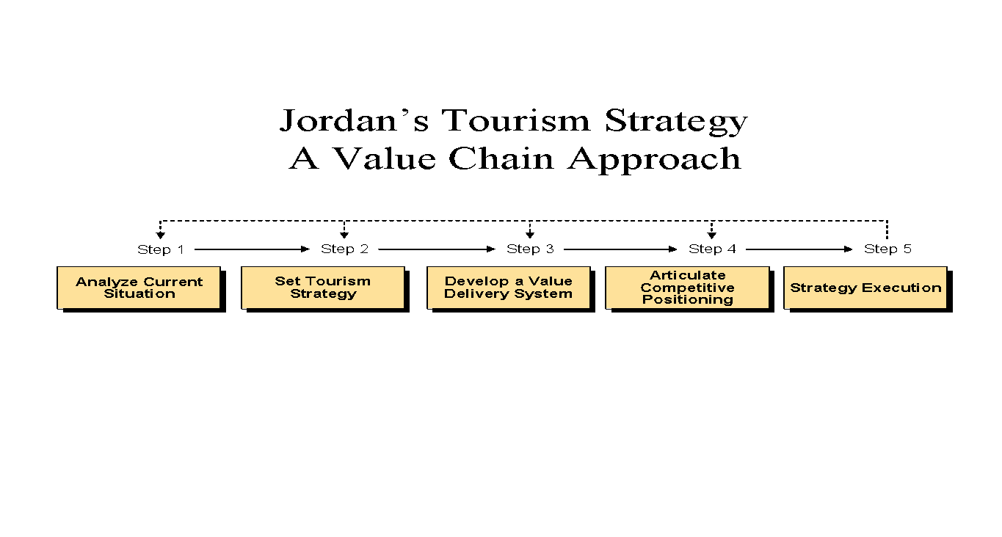
Session 1 & 2: Discussion Questions

Introduction:
As we embark on this enlightening discussion, we delve into the intricacies of Value Chain Approaches in the realm of tourism development. Our journey begins by critically evaluating the case of Jordan, a nation grappling with economic challenges while envisioning tourism as a central pillar for its future prosperity. In scrutinizing Jordan's approach, we aim to discern whether it reflects the evolving dynamics of the global tourism landscape or if it stands as a relic of the past. This assessment serves as the backdrop against which we will compare and contrast our own Value Chain Approaches, each uniquely tailored to our regions and communities. As we delve into these discussions, we shall not only pinpoint potential shortcomings but also explore innovative strategies to enhance the effectiveness of our approaches. Moreover, we shall contemplate the integration of sustainability and resilience elements into our Value Chains, recognizing their pivotal role in navigating the ever-changing tourism terrain. Our journey promises a profound exploration of the past, present, and future of Value Chain Approaches in the context of tourism, aiming to chart a path towards holistic well-being for our communities.

- Critique of Jordan's Value Chain Approach: In examining Jordan's Value Chain Approach for its National Tourism Strategy, critically assess its relevance in the contemporary global tourism landscape. Discuss whether the approach appears to be outdated and elucidate your reasoning.

- Strategic Gaps in Jordan's Value Chain Approach: Delve into the intricacies of Jordan's case study and identify key elements and strategic components that might be perceived as missing or inadequately emphasized within their Value Chain Approach. Articulate how addressing these gaps could enhance its effectiveness.

- Comparative Value Chain Analyses: Drawing from your group's outlined Value Chain Approach tailored to your respective regions or areas, conduct a comparative analysis against Jordan's case. Examine both similarities and divergences, highlighting unique aspects of your approach that can serve as catalysts for achieving a more balanced well-being within your communities.

- Overcoming Implementation Challenges: Discuss the foreseeable challenges and impediments regions or nations might encounter when endeavoring to implement a comprehensive Value Chain Approach for tourism development. Offer well-thought-out strategies and insights to mitigate these challenges, ensuring a smoother path to successful implementation.

- Sustainability and Resilience Integration: Given the dynamic nature of the global tourism industry, contemplate how elements of sustainability and resilience can be seamlessly integrated into a Value Chain Approach. Explore the potential synergies between these concepts to fortify tourism ecosystems against future uncertainties.

Conclusion:
In the culmination of our discussions, we have traversed a multifaceted terrain of Value Chain Approaches within the domain of tourism development. Our scrutiny of Jordan's case illuminated the need for adaptability and evolution in response to the contemporary tourism landscape. Through thoughtful critiques, we unveiled strategic gaps and underscored the importance of addressing these lacunae to optimize the benefits reaped from tourism. As we compared our individual Value Chain Approaches, we discovered the richness of diversity, with each approach offering unique insights and potential pathways towards balanced well-being for our communities.
Crucially, our dialogue also delved into the pragmatic challenges of implementation, recognizing that the path to realizing these approaches is not devoid of obstacles. Nevertheless, our collective wisdom generated strategies to surmount these challenges, reaffirming our commitment to the sustainable and resilient growth of tourism ecosystems.
In our quest to integrate sustainability and resilience, we harnessed the power of innovation, acknowledging that these elements are not merely optional but imperative for the longevity and vibrancy of our tourism sectors.
As we draw the curtain on this discussion, we do so with enriched perspectives and a shared commitment to fostering holistic well-being through tourism. The Value Chain Approach, when harnessed with adaptability, innovation, and sustainability at its core, becomes a formidable tool in our collective journey towards a prosperous future for our regions, communities, and the global tourism industry.

Session 3.

Group Work Session 3.

Overarching objectives of value-adding tourism development

Considering that you want to apply added value to a specific study area there are three main objectives that are critical for your strategy.

  - Increasing Economic value
  - Optimizing the environmental impacts of tourism
  - Improving the Sociocultural Impacts of Tourism

For each one of the three objectives you need to specify specific policies that can create tangible outcomes.
Indicate also the indicators that could allow measurement on the achievements for each one of these policies.

Discussion Topic Session 3

Specify policies that are operationally specified, and they increase local value in its economic, environmental and social dimensions.

The local Tourism Authority is announcing the following operational objectives.

- Improve product and services quality.
- Optimize Communication and Marketing.
- Improve cooperation and processes.
- Modify basic principles and framework conditions
- Promote Sustainable Mobility

Based on the above objectives specify 3-5 policies related to each objective
Additionally comment what tools can be used to monitor the progress of these policies.

Session 4.

Case Example1.Integrating Stakeholders

Luang Prabang Handicraft Association

Linking up regional crafts with the tourism value chain in Laos
Luang Prabang night market is one of the five main tourist attractions in Laos. The problem is that most of the merchandise consists of cheap imports from China and Vietnam. This means most of the tourism value added goes abroad.
The EU Switch Asia Project entitled ‘Luang Prabang Handle with Care’ therefore aimed to make regional crafts products market-ready and to integrate them into the tourism value chain. The underlying thought was also that regional products from individual village artisans are more authentic and of higher quality.
The project was based on the collaborative development of prototypes. To develop products that are in demand among tourist target groups, the project brought the local microbusinesses into contact with interna- tional designers. The products that proved suitable for the market based on market tests were described in detail in catalogues, training concepts and videos.
The aim was to share the generated knowledge and to produce large numbers of items with support from many different factories. Marketing, distribution and the related logistics processes were the critical factors for success, alongside product design, with which producers needed assistance.
Further Reading

Opening tourism sector opportunities for Lao food products and skills.

https://unctad.org/system/files/official-document/unceb2017d3_SECO_LA_en.pdf

Questions

- In the specific case what is the benefit for the stakeholders from this integration policy?
- How this integration supports added value to the local tourism economy?
- What are the general social impacts of this policy?
- What additional value goes towards the visitors side from this policy?

Case Example 2. Circular Economy

Using innovative business models to reduce plastic waste in Thailand

Thailand is the largest consumer of plastic in Southeast Asia, with a consumption of 40 kilograms of plastic per capita and year . Ninety per cent of the plastic used is not recycled . Most of it lands up in the sea and makes Thailand the sixth largest polluter at global level . There is therefore an urgent need for action in order to comply with the Sustainable Development Goals (SDGs) . The GIZ project Advance SCP (Advancing and measuring sustainable consumption and production) and the GIZ lab of tomorrow therefore jointly launched an innovation process .
In mid-September, over 60 representatives of more than 40 organisations met at a four-day inno- vation workshop in Bangkok to develop sustainable business models to reduce single-use plastics . In eight interdisciplinary teams, participants from large corporations such as TUI and BASF worked together with those from medium-sized enterprises and start-ups, and research and civil society organisations . Coaches helped them fuse their expertise and find innovative solutions using design thinking and business design methods . The teams with the most promising concepts will receive further support from experts in coming months to realise their business ideas and pilot their prod- ucts on the market . The ideas include a packaging-free system for food delivery services; a social enterprise that cooperates with major markets to increase the popularity of recycled materials; a bonus system for reusing coffee cups; a consulting firm for sustainability in the tourism sector; a deposit system that uses innovative recycling methods, and a machine that sells unpackaged rice .
If these ideas are put into practice, this will have a positive influence on value added in a number of ways: increased guest satisfaction, support for the circular economy and employment based on new business models .

For more information: www.lab-of-tomorrow.com/node/161

Discussion Questions

- Is Circular Economy possible in all cases?
- Propose a circular supply chain example from your own city-region.
- Analyze tangible benefits from that circular example

Session 5.

Setting up DMOs – Same processes with different Outcomes

Group Work 1 - The Case of Indonesia

Indonesia is an example for the targeted establishment of several DMOs . Initiated by the Indonesian Ministry of Tourism and supported by Swisscontact, four DMOs have been set up since 2009 that are responsible both for tourism development and for marketing .
The results achieved illustrate the potential impact DMOs can have, especially when they cooperate with each other . One example is the programme to improve service quality that
is implemented locally by a large pool of qualified trainers and experts . The programme includes coaching and toolkits for professionalising tourism enterprises and helping them develop the range of services they offer .

For more information: www.bit.ly/2R1yYHe

After reading carefully the case please prepare your answers to the following questions:

- What are the common characteristics of the four DMO’s in Indonesia?
- Are there any differences? If yes, what are the reasons behind these differences?

DMO and Destination Tourism Strategy – GSTC Guidelines

Individual Assignment1 – Developing DMOs

- The GSTC criteria require the development of a Destination Management Strategy designed to support the long-term sustainability of the destination. The long-term strategy - and the actions plans to achieve it - should:

- be suited to the scale of the destination
- developed with stakeholders and publicly available
- based on sustainability principles and
- aligned with other sustainability plans in the community.

GSTC criteria encourage destinations to assess their tourism assets - environmental, cultural, social - as a foundation for the planning process. Planning should be collaborative, engaging a range of stakeholders. Planning should also consider broader socio-economic, cultural and environmental issues.
The GSTC criteria also highlight a number of components of sustainable destination management that require dedicated planning. These plans may be integrated into the destination management strategy or stand-alone plans, aligned with the destination management strategy.

- The GSTC criteria suggest that each destination should have plans in place to:

- Protect culture and heritage
- Protect the environment
- Mitigate and adapt to climate change.3 4
- Encourage Tourism Businesses to adopt Sustainable Tourism Practices
- Visitor Management
- Risk and Crisis Management
- Safety and Security Plans5
- Workforce Development

In your assignment answer the following questions:

- What are the directions for your long-term strategy at your destination? How are you going to implement this strategy?
- What are your plans briefly about some, if not all, the suggested destination criteria from GSTC?

