MODULE 2 - Contents of Session Plans

Module 2: Introduction of Sustainable Tourism and the Need for a Regenerative Approach

Session 1 - Introducing Sustainable Tourism (1)

Market Participants: This session is designed for a diverse range of market participants, including tourism professionals, local and regional destination managers, government representatives, tourism entrepreneurs, and anyone interested in the principles of sustainable tourism. Participants may include current and future stakeholders in the tourism industry who seek to gain a comprehensive understanding of sustainable tourism practices.
Summary: Session 1 provides a comprehensive introduction to sustainable tourism. Participants will explore the core concepts, historical background, and contextual relevance of sustainable tourism. By delving into the definitions and fundamental principles of sustainability in the tourism sector, this session aims to equip participants with the foundational knowledge required to navigate the contemporary tourism landscape responsibly.
Key Words: Sustainable Tourism, Definitions, Historical Context, Responsible Tourism, Principles, Tourism Practices
Objectives: By the end of this session, participants will:
- Gain familiarity with the concept of sustainable tourism.
- Comprehend the historical and contextual background of sustainable tourism.
- Recognize the significance of sustainable tourism strategies and policies.
Outcomes: After this session, participants will be able to:
- Define the key concepts of sustainable tourism.
- Understand the historical development of sustainable tourism practices.
- Explain the relevance of sustainable tourism strategies and policies in the modern tourism landscape.
Methods:
- Lecture-style presentations for foundational knowledge.
- Interactive discussions to encourage participant engagement.
- Visual aids, diagrams, and historical references to enhance comprehension.
Materials:
- Presentation slides covering key concepts.
- Reference materials and historical documents for background.
- Interactive materials for engaging discussions and activities.
Content:
- Introduction to Sustainable Tourism (15 minutes): The session begins with an introduction to the overarching theme of sustainable tourism and its importance in the modern tourism landscape.
- Definitions and Background (20 minutes): Participants delve into the definitions and background of sustainable tourism, unraveling the core principles that underpin responsible travel practices.
- Historical Context (20 minutes): The historical evolution of sustainable tourism is explored, tracing its development and pivotal moments in the context of the broader tourism industry.
- Significance of Sustainable Tourism Strategies (15 minutes): This segment highlights the significance of sustainable tourism strategies and policies in steering the industry towards ethical and responsible outcomes.
- Interactive Discussion (5 minutes): Participants engage in an interactive discussion to consolidate their understanding, pose questions, and clarify concepts.
- Q&A and Conclusion (5 minutes): The session concludes with a question-and-answer segment, allowing participants to seek clarifications and summarize key takeaways.

Session 2 - Introducing Sustainable Tourism (2)

Market Participants: This session caters to a diverse audience, including tourism industry professionals, government officials, educators, and individuals seeking a deeper understanding of sustainable tourism. It welcomes participants with varying levels of expertise, from newcomers to seasoned practitioners.
Summary: Building upon the foundational knowledge gained in Session 1, Session 2 delves further into the multifaceted realm of sustainable tourism. The session provides a comprehensive exploration of the sociocultural and environmental sustainability pillars, emphasizing the practical application of these principles within local and regional tourism ecosystems. Additionally, it highlights the pivotal role of innovation and creativity in advancing sustainable tourism.
Key Words: Sociocultural sustainability, environmental sustainability, local and regional ecosystems, sustainable tourism integration, innovation, creativity.
Objectives:
- In-Depth Exploration of Sociocultural and Environmental Sustainability Pillars: Participants will undertake a thorough examination of the sociocultural and environmental dimensions of sustainable tourism, delving into the intricate interplay between these two pillars.
- Practical Approaches to Sustainable Tourism Integration: Participants will acquire a profound understanding of the practical methodologies for embedding sustainability within local and regional tourism ecosystems, focusing on the real-world application of sustainable tourism principles.
- Unveiling the Catalytic Role of Innovation and Creativity: The session will reveal how innovation and creativity serve as powerful catalysts, driving sustainable tourism to new heights through innovative practices and creative problem-solving.
Outcomes: By the conclusion of Session 2, participants will have gained a profound understanding of the sociocultural and environmental dimensions of sustainable tourism. They will possess the knowledge and insight necessary to implement sustainable tourism principles at the local and regional levels, fostering responsible tourism practices. Furthermore, participants will recognize the transformative potential of innovation and creativity in elevating sustainable tourism development.
Methods: Session 2 employs a blend of interactive presentations, group discussions, and hands-on activities to encourage active participation, collaborative learning, and knowledge exchange among participants. Real-world case studies and scenarios are utilized to promote a practical understanding of the topics discussed.
Materials: Participants will be provided with a comprehensive set of course materials, including informative presentations, detailed case studies, and supplementary readings. These resources aim to facilitate an in-depth exploration of sustainable tourism principles and their practical applications.
Content:
Section 1: Sociocultural, Environmental & Economic Sustainability Pillars (Approx. 25 minutes)
- Sociocultural Sustainability: A deep dive into the sociocultural dimensions of sustainable tourism, exploring how it encompasses aspects such as preserving local traditions, supporting community livelihoods, and respecting cultural heritage. Real-world case studies will highlight the significance of sociocultural sustainability and its role in responsible tourism.
- Environmental Sustainability: An in-depth exploration of the environmental dimensions of sustainable tourism, emphasizing the preservation of natural resources, biodiversity, and ecosystems. Participants will gain a profound understanding of how sustainable tourism contributes to the protection and conservation of the environment. Practical examples and scenarios will illustrate the real-world impact of environmental sustainability efforts.
- Economic Sustainability: A deeper analysis that economic performance cannot be sustained for a long term if it does not take into serious consideration the social and environmental footprint that is occurred.

Section 2: Integrating Sustainability into Local and Regional Tourism Ecosystems (Approx. 25 minutes)
- Practical Applications of Sustainable Tourism: This section delves into practical methodologies for embedding sustainability within local and regional tourism ecosystems. Participants will explore case studies of destinations that have successfully integrated sustainable practices into their operations, providing inspiration and guidance for implementing sustainability in their own regions.
- Collaboration and Stakeholder Engagement: A focus on the importance of collaboration and stakeholder engagement in local and regional sustainability efforts. Participants will learn how to build effective partnerships with local communities, businesses, and government agencies to create a cohesive approach to sustainable tourism.
Section 3: Innovation and Creativity as Catalysts for Sustainable Tourism (Approx. 25 minutes)
- The Transformative Power of Innovation: Participants will discover how innovation plays a transformative role in sustainable tourism. Real-world examples of innovative practices, from eco-friendly technologies to unique visitor experiences, will showcase the incredible potential of innovation in driving sustainability.
- Creative Problem-Solving for Sustainability: A spotlight on creative problem-solving as an essential tool for addressing sustainability challenges. Through interactive activities and case studies, participants will develop their creative thinking skills and learn how to apply creative problem-solving techniques to sustainability issues.

Session 3 - Regenerative Tourism (1)

Market Participants: This session accommodates a diverse audience, including tourism industry professionals, policymakers, educators, and individuals with a vested interest in the future of tourism. It caters to both newcomers and seasoned practitioners who aim to grasp the revolutionary concept of regenerative tourism.
Summary: In Session 3, we introduce the paradigm-shifting concept of Regenerative Tourism. It sets out to illuminate what sets regenerative tourism apart from traditional sustainability efforts. Participants will delve into the profound meaning of regenerative tourism and its clear distinction from sustainability. This session explores the vital role of ecological restoration, preserving sociocultural values, and fostering the growth of local communities. By actively engaging with this session, participants will gain a profound understanding of the essence of regenerative tourism and its crucial role in addressing contemporary global challenges.
Key Words: Regenerative tourism, ecological restoration, sociocultural preservation, community development, sustainable innovation.
Objectives:
- Grasp the Concept of Regenerative Tourism: Participants will develop a clear understanding of regenerative tourism as a pioneering approach that transcends traditional sustainability by actively focusing on healing and restoring the environment and sociocultural elements.
- Embrace the Significance of Ecological Restoration: Delve into the central importance of ecological restoration within the regenerative tourism framework, examining its role in preserving and revitalizing the environment.
- Recognize Tourism's Role in Sociocultural Preservation: Participants will gain insights into how tourism can protect and celebrate sociocultural values, supporting the vitality of local communities.
Outcomes: Upon completing Session 3, participants will be well-versed in the principles of regenerative tourism. They will comprehend how regenerative tourism differs from conventional sustainability, focusing on active restoration and sociocultural preservation. Participants will recognize the essential role of tourism in safeguarding sociocultural values and empowering local communities to thrive.
Methods: Session 3 employs an interactive approach, including engaging presentations, group discussions, real-world case studies, and participatory activities to stimulate robust participant involvement. These methods foster an immersive and comprehensive understanding of regenerative tourism.
Materials: Attendees will have access to a comprehensive set of learning materials, which includes informative presentations, in-depth case studies, and supplemental readings. These materials are designed to facilitate a profound exploration of regenerative tourism and its practical applications.
Content:
Section 1: Understanding Regenerative Tourism (Approx. 25 minutes)
- Regenerative Tourism Unveiled: A comprehensive introduction to the concept of regenerative tourism, including its defining characteristics and how it distinguishes itself from traditional sustainability. Participants will gain a solid grasp of the overarching principles that guide regenerative tourism practices.
- Beyond Sustainability: This section explores the key reasons why regenerative tourism goes beyond sustainability, emphasizing the active role it plays in healing and restoring the environment and communities. Real-life examples of regenerative tourism initiatives will illuminate these concepts.
Section 2: Ecological Restoration in Regenerative Tourism (Approx. 25 minutes)
- The Essence of Ecological Restoration: Delve into the critical role of ecological restoration in regenerative tourism. Participants will examine how regenerative tourism practices facilitate the preservation, revitalization, and restoration of natural ecosystems.
- Real-World Applications: Participants will be exposed to real-world examples of ecological restoration projects that embody regenerative tourism values. These case studies will provide tangible insights into how regenerative tourism contributes to ecological balance and restoration.
Section 3: Protecting Sociocultural Values and Empowering Communities to Thrive (Approx. 25 minutes)
- Safeguarding Sociocultural Values: A focused exploration of how tourism serves as a safeguard for sociocultural values, traditions, and heritage. Real-life cases will spotlight how regenerative tourism actively contributes to the preservation of these vital elements.
- Empowering Local Communities: Participants will examine the strategies and initiatives that empower local communities and small and medium-sized enterprises (SMEs) through regenerative-focused training. The session will underscore the role of tourism in enhancing the vitality of local communities.

Session 4 - Regenerative Tourism (2)

Market Participants: This session appeals to a broad spectrum of individuals, ranging from tourism industry professionals to community leaders and those with a deep interest in reshaping tourism practices to benefit both local communities and the environment.
Summary: Session 4 builds upon the exploration of Regenerative Tourism, emphasizing the critical importance of inclusivity in the tourism industry. Participants will delve into the profound significance of inclusivity, which can bridge social and economic disparities, unifying communities and promoting economic equality. The session elevates social well-being as a fundamental goal of tourism, aiming to enhance the overall quality of life for both local communities and visitors. Moreover, participants will uncover strategies and approaches that empower local communities and SMEs through specialized regenerative training, creating a robust foundation for community growth. By the end of this session, participants will appreciate the vital role of inclusivity and empowerment in the journey towards regenerative tourism.
Key Words: Inclusivity, economic equality, social well-being, local community empowerment, regenerative training.
Objectives:
- Grasp the Significance of Inclusivity: Participants will gain a profound understanding of how inclusivity serves as a cornerstone in fostering a sustainable and regenerative tourism industry. It will become evident that inclusivity is not merely an option but an essential element in responsible tourism practices.
- Recognize Tourism's Role in Bridging Gaps: This session spotlights the pivotal role of tourism in bridging social and economic disparities. By bridging these gaps, tourism unites communities and contributes to the achievement of economic equality. Participants will recognize the tourism sector's potential to be a force for positive change.
- Elevate Social Well-Being: Social well-being is elevated as a core goal of tourism. It's not solely about environmental sustainability; it's about enhancing the overall quality of life for local communities and visitors alike. Participants will understand how tourism can contribute to a higher standard of living for all stakeholders.
- Unlock the Power of Local Community Empowerment: Participants will delve into the strategies and approaches that empower local communities and small and medium-sized enterprises (SMEs) through specialized regenerative training. The session will highlight the potential of tourism to strengthen local communities, fostering economic growth, and supporting the sustainable development of SMEs.
Outcomes: Upon completing Session 4, participants will possess a well-rounded understanding of the pivotal role of inclusivity in regenerative tourism. They will comprehend how inclusivity can bridge social and economic disparities, fostering community unity and economic equality. Participants will also recognize social well-being as a core goal of tourism, promoting an improved quality of life for local communities and visitors. Furthermore, they will be equipped with the knowledge and strategies to empower local communities and SMEs through specialized regenerative training, ultimately driving community development and fostering sustainability.
Methods: Session 4 incorporates a dynamic mix of teaching methods, including interactive presentations, group discussions, real-world case studies, and participatory activities. These diverse methods encourage active participation and facilitate a profound understanding of the significance of inclusivity and empowerment in regenerative tourism.
Materials: Participants will have access to a comprehensive set of learning materials, including informative presentations, in-depth case studies, and additional readings. These materials are thoughtfully designed to support a deep exploration of inclusivity, social well-being, and local community empowerment within the context of regenerative tourism.
Content:
Section 1: Embracing Inclusivity in Tourism (Approx. 25 minutes)
- The Imperative of Inclusivity: This section explores the fundamental role of inclusivity in the tourism industry. Participants will gain a profound understanding of how inclusivity aligns with the principles of responsible and regenerative tourism.
- Bridging Social and Economic Gaps: The session delves into the practical implications of inclusivity, particularly in bridging social and economic disparities. By understanding the role tourism can play in uniting communities and promoting economic equality, participants will gain valuable insights into creating a more equitable tourism ecosystem.
Section 2: Elevating Social Well-Being (Approx. 25 minutes)
- A Holistic Approach to Social Well-Being: This segment elevates social well-being as a primary goal of tourism. Participants will explore how tourism can contribute to the overall quality of life for local communities and visitors.
- Strategies for Enhancing Social Well-Being: Real-world examples and case studies will shed light on strategies for enhancing social well-being within the tourism sector. Participants will uncover practical approaches and initiatives to create an enriching experience for all stakeholders.
Section 3: Empowering Local Stakeholders and SMEs (Approx. 25 minutes)
- Local Stakeholderrs Empowerment: This section emphasizes the strategies that empower local communities through specialized regenerative training. Participants will gain insights into the unique role of tourism in driving community growth.
- Supporting SMEs for Sustainable Development: The session highlights the critical support tourism can provide to small and medium-sized enterprises. Participants will examine how empowering SMEs fosters sustainable development and contributes to the broader objectives of regenerative tourism.

PRESENTATIONS

SESSION 1



Sustainable & Smart Tourism
Training Program

Organized by Mekong Institute (MI)
Funded by Mekong – Korea Cooperation Fund (MKCF) November 2023

Introduction of Sustainable Tourism and the Need for a Regenerative Approach
MODULE 2

Trainer November 2023
1 2





Introducing Sustainable Tourism (1)
Session 2

Monday

- Introduction to Sustainable Tourism
- Definitions & Background
- Historical Context
- Significance of Sustainable Tourism Strategies
- Interactive Discussion – Q&A

15 October 2023 page 4
3 4

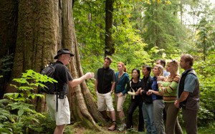

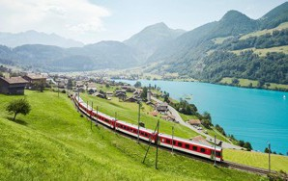
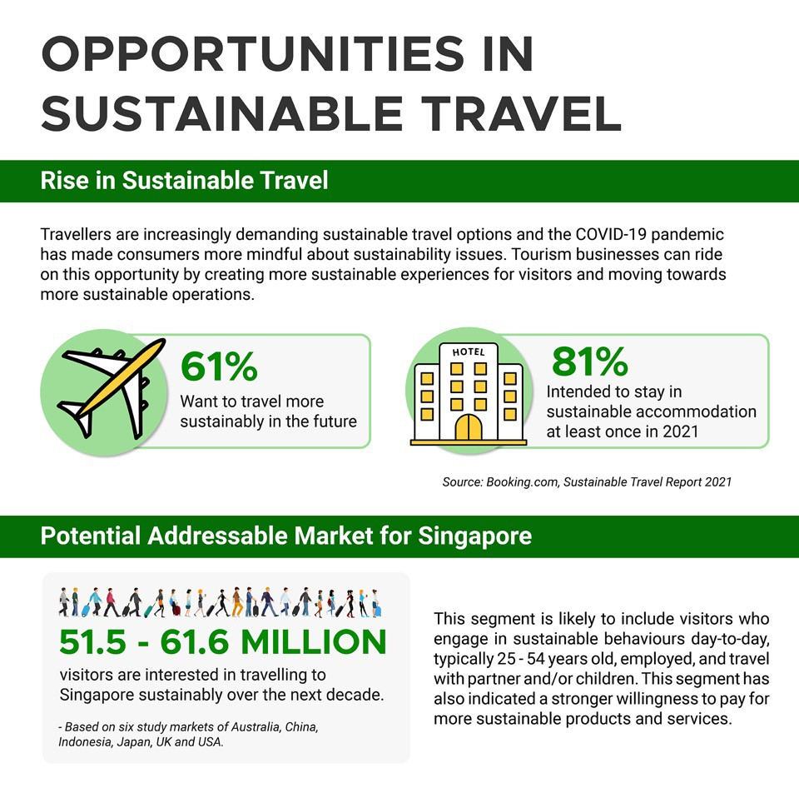

Introduction to Sustainable Tourism

Sustainable tourism has emerged as a vital concept in recent years, driven by the pressing need to protect our planet's natural resources and cultural heritage.

15 October 2023 page 5

Importance of Sustainable Tourism

When surveyed in 2022, over 80 percent of global travelers said that sustainable tourism is important.

15 October 2023 page 6
5 6
15

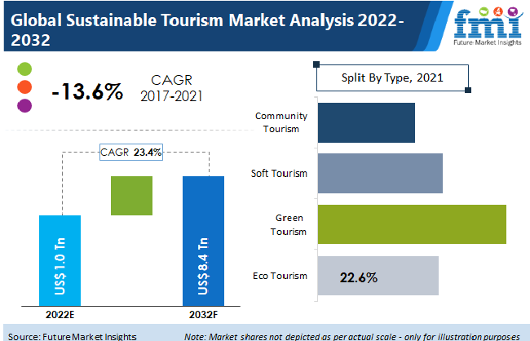

Importance of Sustainable Tourism

15 October 2023 page 7

Definitions & Background

Sustainable Tourism refers to sustainable practices in and by the tourism industry. It is an aspiration to acknowledge all impacts of tourism, both positive and negative. It aims to minimize the negative impacts and maximize the positive ones.

15 October 2023 page 8
7 8



Definitions & Background
tourism activities that can be maintained indefinitely in their environmental, social, economic and cultural contexts and despite their effect on these areas of life (UNEP & UNWTO, 2005).
'Sustainable tourism' or 'tourism in the green economy' has been defined as
15 October 2023 page 9
Definitions & Background
Tourism Organization as “tourism that takes full account of its current and future economic, social and environmental impacts, addressing the needs of visitors, the industry, the environment and host communities.” (2023)
Sustainable tourism is defined by the UN Environment Program and UN World
15 October 2023 page 10
9 10

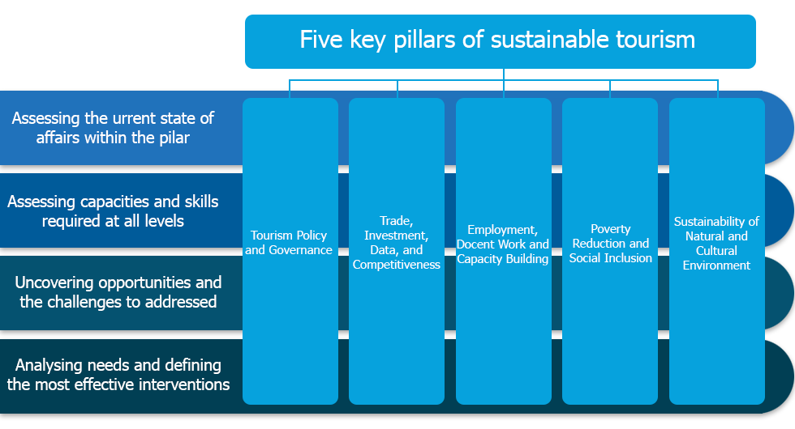

The 5 Pillars for Sustainable Tourism Development

October 2023 page 11

Definitions & Background

Sustainable tourism is defined by the UN Environment Program and UN World Tourism Organization as “tourism that takes full account of its current and future economic, social and environmental impacts, addressing the needs of visitors, the industry, the environment and host communities.” (2023)

15 October 2023 page 12
11 12



Historical Context

- Alternative Tourism
- Eco Tourism
- Responsible Tourism
- Green Tourism
- Sustainable Tourism
- Regenerative Tourism

Significance of Sustainable Tourism Strategies

On a local, regional or national level, sustainability strategies are essential to unify all stakeholders under a common long-term vision for their place.
Tourism can be a unique recourse of prosperity and well-being for the communities and for all stakeholders

15 October 2023 page 14
13 14

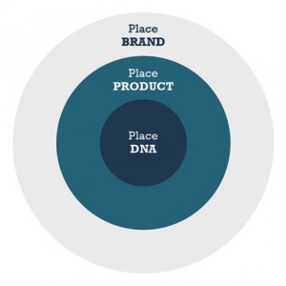


Significance of Sustainable Tourism Strategies

Each strategy must be developed according to the unique characteristic of its place.
We need to consider seriously the place DNA.
We can briefly read brief strategy statements from various organization and authorities.

15 October 2023 page 15

Significance of Sustainable Tourism Strategies

Sustainable tourism strategy of Spain 2030
Objective of sustainable tourism strategy of Spain 2030
The government of Spain, through the secretariat of state of tourism, is developing the strategy of sustainable tourism of Spain 2030, a national agenda of tourism for the challenges of the
sector in the medium and long term, pushing the three pillars of sustainability: socio-economic, environmental and territorial. For this, it has promoted a participatory process which involves
the sector and the autonomous communities.

15 October 2023 page 16
15 16



Significance of Sustainable Tourism Strategies

Sustainable tourism strategy of India

National Strategy for Sustainable Tourism
National Strategy for sustainable tourism aims to mainstream sustainability in Indian
tourism sector and ensure a more resilient, inclusive, carbon neutral and resource efficient tourism while safeguarding natural and cultural resources.

15 October 2023 page 17

Significance of Sustainable Tourism Strategies

Sustainable tourism strategy of India

National Strategy for Sustainable Tourism
National Strategy for sustainable tourism aims to mainstream sustainability in Indian
tourism sector and ensure a more resilient, inclusive, carbon neutral and resource efficient tourism while safeguarding natural and cultural resources.

15 October 2023 page 18
17 18

Discussion about Sustainability Strategies in Mekong Region

Q & A Thank You!
mekonginstitute.org mekonginstitute.org Mekong Institute | MekongInstitute
Mekong Institute
123 Mittraphap Rd., Muang District, Khon Kaen 40002, THAILAND
Tel. : +66 (0) 4320 2411
Fax. : +66 (0) 4320 3656
Email : information@mekonginstitute.org

19 20

SESSION 3

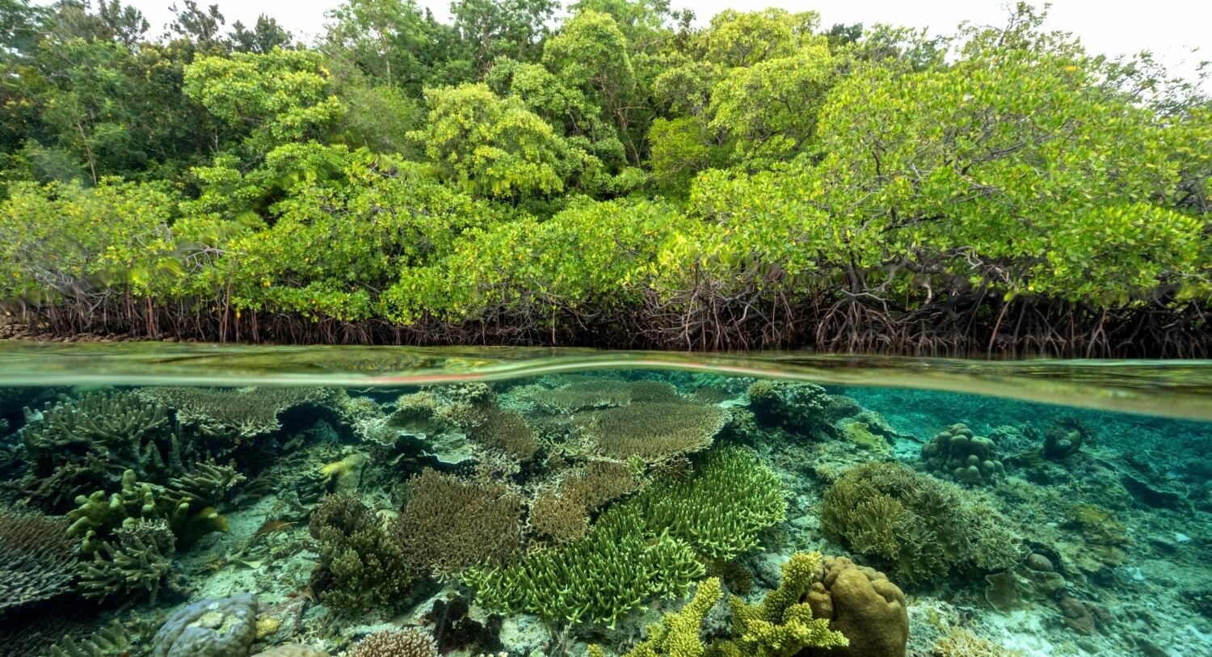

Sustainable & Smart Tourism
Training Program

Organized by Mekong Institute (MI)
Funded by Mekong – Korea Cooperation Fund (MKCF) November 2023

Introduction of Sustainable Tourism and the Need for a Regenerative Approach
MODULE 2

Trainer November 2023
1 2

Regenerative Tourism
Session 3

Wednesday

- Understanding Regenerative Tourism
- Ecological Restoration in Regenerative Tourism
- Protecting Sociocultural Values and Empowering Communities to Thrive

15 October 2023 page 4
3 4

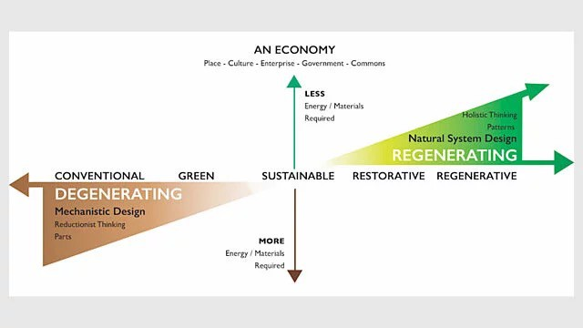
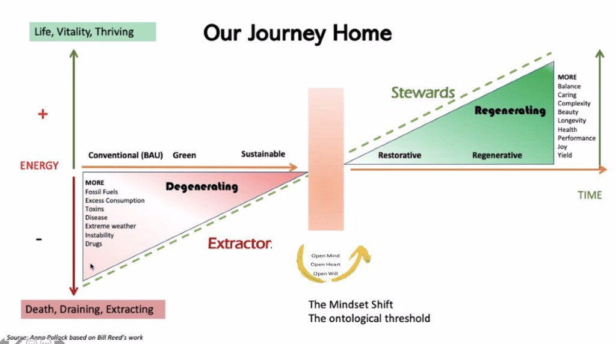

Understanding Regenerative Tourism

Regenerative tourism ensures that tourism gives back more to people and places than it takes. Tourism must add more than only economic value, it must actively enrich our communities and help protect and restore our environment.

15 October 2023 page 5
Understanding Regenerative Tourism

15 October 2023 page 6
5 6



Understanding Regenerative Tourism

Beyond Sustainability

Valuing Ecosystem Function higher than material things is the paradigm shift that determines whether we understand the meaning of our lives and survive or whether we remain ignorant and selfish and destroy our own habitat trying to gain more wealth or more power. If we reach this level of understanding, not only can everyone live on the Earth but the natural systems on Earth can reach their optimal ability to sustain life.
— John D. Liu (2016)

15 October 2023 page 7

Understanding Regenerative Tourism

Beyond Sustainability

"Sustainability" implies a state of balance, of maintaining what is already present without causing further damage. But we have already crossed numerous environmental boundaries. Our climate is changing at an unprecedented rate, biodiversity is decreasing, and our soils are degraded. Simply put, we missed the sustainability boat. (Paul Hawken)

“Sustainability is about survival. The goal of sustainability is to find a way to live that doesn't cause harm to anything else. But we are way past sustainability.”

15 October 2023 page 8
7 8

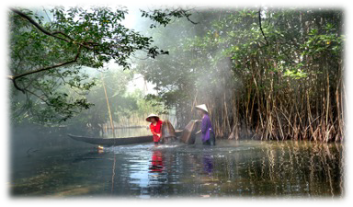

Understanding Regenerative Tourism

Beyond Sustainability

A regenerative culture encompasses everything from regenerative agriculture, which restores soil health and biodiversity, to regenerative economics, which aims to circulate wealth in equitable, inclusive ways. It encompasses social regeneration too, building resilient communities that can adapt to change and are fair and inclusive.

It is about evolving consciously, learning from nature and traditional indigenous knowledge, and creating systems that benefit all forms of life.

15 October 2023 page 9

Ecological Restoration in Regenerative Tourism
Ecological restoration
It is the process of assisting the recovery of an ecosystem that has been degraded, damaged, or destroyed to reflect its intrinsic values and to provide goods and services that people value. The aim is to return the ecosystem to the condition it would have
been in if degradation had not occurred, accounting for anticipated change.

15 October 2023 page 10
9 10


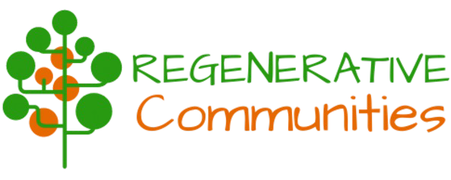

Ecological Restoration in Regenerative Tourism
Ecological restoration

Regeneration is usually used as a synonym for restoration, but it is slightly different as in its meaning it also considers design and economic approaches.
The origin of the term comes from the scientific and biological world, where “regeneration” is used to describe the ability of some organisms to recreate certain parts of their bodies after being damaged. This ability is called “regenerative capacity”.

15 October 2023 page 11

Protecting Sociocultural Values and Empowering Communities to Thrive
Why Creating Regenerative Cultures?

The short answer to why we should aim to create regenerative cultures together is simple: choosing the path of regeneration and cooperation will create a greater level of wellbeing, health, happiness and equality for everyone and all life; and in the process
of co-creating a better future together, our lives will be more meaningful, fulfilling,
creative and fun.

15 October 2023 page 12
11 12

Protecting Sociocultural Values and Empowering Communities to Thrive

Why Creating Regenerative Cultures?

There is a wave of change manifesting a more thriving world, including people living or longing to live in community, in closer relationship with the rest of life.

Regenerative Community Development, based on life’s and nature’s principles, provides a viable path toward that more thriving world and toward successful intentional communities.

15 October 2023 page 13

Protecting Sociocultural Values and Empowering Communities to Thrive
Empowering Local Communities?

Regenerative Communities are collaborating with local social impact organizations to create a new Collaborative Governance Model.

Bringing together communities using a holistic approach to foster collective wellbeing, increasing potential for rural and regional towns to thrive.

15 October 2023 page 14
13 14

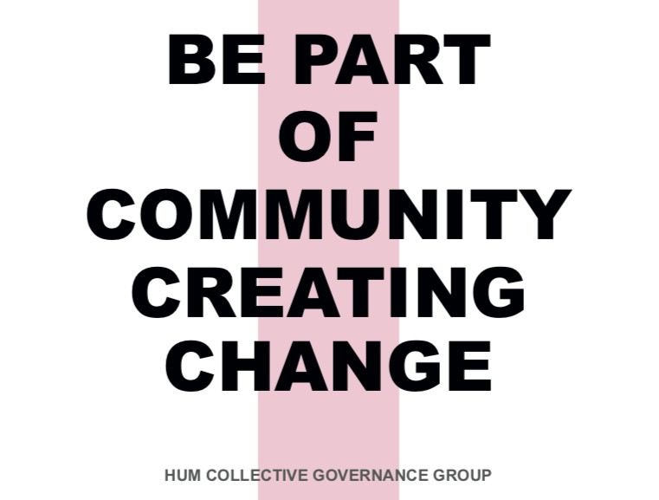


Protecting Sociocultural Values and Empowering Communities to Thrive

Empowering Local Communities

Discussing Cases of Regenerative Communities

A new Collaborative Governance Model for HUM (Australia)

15 October 2023 page 15

Discussion about Regenerative Communities
15 16

Q & A Thank You!
mekonginstitute.org mekonginstitute.org Mekong Institute | MekongInstitute
Mekong Institute
123 Mittraphap Rd., Muang District, Khon Kaen 40002, THAILAND
Tel. : +66 (0) 4320 2411
Fax. : +66 (0) 4320 3656
Email : information@mekonginstitute.org
17

SESSION 4

Sustainable & Smart Tourism
Training Program

Organized by Mekong Institute (MI)
Funded by Mekong – Korea Cooperation Fund (MKCF) November 2023

Introduction of Sustainable Tourism and the Need for a Regenerative Approach
MODULE 2

Trainer November 2023
1 2

Regenerative Tourism (2)
Session 4

- Embracing Inclusivity in Tourism
- Elevating Well-Being
- Empowering Local Stakeholders and SME’s

15 October 2023 page 4
3 4

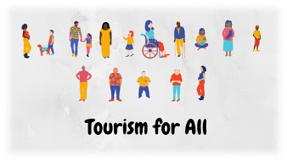

Embracing Inclusivity in Tourism

Tourism for All – Inclusive Tourism

Tourism can Promote stable, inclusive and qualified jobs as well as social security benefits for all.
Regional actors should help destinations to become more inclusive, responsible,
attractive and competitive. This entails the use of certifications, labels and ethical
codes to ensure proper social, economic and environmental performance, best-in- class market value and good reputation, compared with traditional business models.
15 October 2023 page 5

Embracing Inclusivity in Tourism

Tourism for All – Inclusive Tourism

The social and physical accessibility, affordability and inclusion of all kinds of visitors shall be guaranteed, so as to extend customers bases and improve the ethical footprint.
The destinations should enhance differentiation, competitiveness and diversification of their products and services through investments in innovation and R&D.

15 October 2023 page 6
5 6



Embracing Inclusivity in Tourism
Bridging Social & Economic Gaps

Global economic integration has been a source of prosperity for many years, but is coming under growing political pressure partly due to uneven sharing of the benefits of growth. It is perceived as one of the causes of increased inequalities and a source of
disempowerment for individuals and communities. (OECD)

15 October 2023 page 7

Embracing Inclusivity in Tourism
Bridging Social & Economic Gaps

To improve the opportunities of the next generation we must address the unequal outcomes of current generations.

Addressing the spatial dimension of inequalities between urban and rural areas would have a great impact on reducing overall inequalities.

15 October 2023 page 8
7 8

Elevating Social Well-being Sustainability & Social Well-being
Social sustainability aims to create inclusive societies, reduce inequality, and ensure long-term well-being for all people while preserving social cohesion and justice.

Sustainable tourism development supports and ensures the economic, social and cultural well being of the communities in which tourism takes place. (UNESCO)

15 October 2023 page 9

Elevating Social Well-being Sustainability & Social Well-being
Elevating Social Well-being needs responsible approach in various areas

- Income and Revenues
- Employment
- Strengthening of the local economy and of long-term economic viability
- Improvement of living conditions
- Participation and local control
- Satisfaction with Tourism
- Strengthening of social and cultural patterns
15 October 2023 page 10
9 10

Empowering Local Stakeholders and SMEs Sustainability & Local Stakeholders
Stakeholders are vital to the implementation of a sustainability strategy and are essential partners in achieving sustainability goals.

Stakeholders play a critical role in sustainability. Why? Because an ESG strategy requires management systems for risk and performance improvement. And stakeholders are a central component of risk management.

15 October 2023 page 11

Empowering Local Stakeholders and SMEs Sustainability & SMEs
By conducting stakeholder engagement and sentiment monitoring you will be able to identify and prioritize environmental and social issues that must be addressed, as well as develop solutions that meet their needs.

Additionally, stakeholders can serve as a powerful force for change within an organization. They can help to raise awareness of sustainability issues and encourage others to get involved in the effort.

15 October 2023 page 12
11 12



Empowering Local Stakeholders and SMEs Sustainability & SMEs

Sustainable development in SMEs can be defined as the concept and practice undertaken by small, micro-, or medium-sized businesses which embraces business conducted in a socially responsible manner with regard to the way
they relate to local and global social, environmental, and economic issues.

15 October 2023 page 13

Empowering Local Stakeholders and SMEs Sustainability & SMEs
The concept of sustainability engagement goes beyond passive awareness or superficial gestures. It encompasses the active participation and involvement of SMEs in promoting and adopting sustainable practices.
This approach seeks to raise awareness, encourage action, and motivate SMEs to genuinely integrate sustainable behaviors into their daily operations.

15 October 2023 page 14
13 14



Empowering Local Stakeholders and SMEs Sustainability & SMEs – Successful Cases
The Business Case for Sustainability in Malaysian SMEs

SMEs in Malaysia are vital to the country’s economy, accounting for 38.3% of the gross domestic product (GDP) and employing nearly 70% of the labour force. Consequently, SMEs are crucial to achieving Malaysia’s SDGs, which aim to strike a balance between economic growth and social and environmental sustainability.

15 October 2023 page 15

Empowering Local Stakeholders and SMEs Sustainability & SMEs – Successful Cases
Batik Boutique is a social enterprise that provides training and employment opportunities to women from low-income communities while producing high-quality batik products. The company’s production process utilises natural dyes and recycled materials, and it has won multiple sustainability awards.
Batik Boutique’s products are popular with customers who appreciate the social and environmental benefits of the company’s operations.

15 October 2023 page 16
15 16


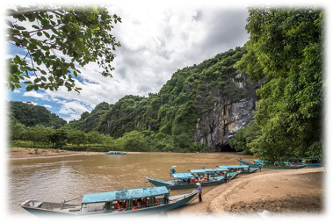

Empowering Local Stakeholders and SMEs Sustainability & SMEs – Successful Cases
The Hive Bulk Foods is a zero-waste grocery store that provides an extensive selection of unpackaged, organic, and locally sourced food items. The store encourages customers to bring their own containers and offers reusable packaging for those who require it. The Hive Bulk Foods has been recognized for its innovative business model and a number of sustainability awards.

15 October 2023 page 17

Discussion about Inclusivity & SMEs in Mekong Region
17 18

Q & A Thank You!
mekonginstitute.org mekonginstitute.org Mekong Institute | MekongInstitute
Mekong Institute
123 Mittraphap Rd., Muang District, Khon Kaen 40002, THAILAND
Tel. : +66 (0) 4320 2411
Fax. : +66 (0) 4320 3656
Email : information@mekonginstitute.org
19

SESSION 2

Sustainable & Smart Tourism
Training Program

Organized by Mekong Institute (MI)
Funded by Mekong – Korea Cooperation Fund (MKCF) November 2023

Introduction of Sustainable Tourism and the Need for a Regenerative Approach
MODULE 2

Trainer November 2023
1 2

Introducing Sustainable Tourism (2)
Session 2

Tuesday

- Sociocultural, Environmental & Economic Sustainability
- Integrating Sustainability into Local and Regional Tourism Ecosystems
- Innovation & Creativity as Catalysts for Sustainable Tourism

15 October 2023 page 4
3 4

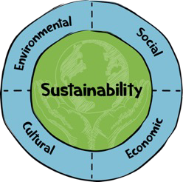


Sociocultural, Environmental & Economic Sustainability

A proper balance among Environmental, Sociocultural and Economic dimension of the destination can support a sustainable development

15 October 2023 page 5
Sociocultural, Environmental & Economic Sustainability
What is Social Sustainability?
Social sustainability is about making sure that communities and societies can thrive
and continue to exist in a healthy, fair, and equal way. It focuses on improving people's
quality of life, fostering strong relationships, and ensuring everyone has the chance to fulfill their potential.
15 October 2023 page 6
5 6

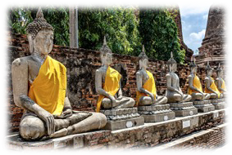

Sociocultural, Environmental & Economic Sustainability

What Is Cultural Sustainability?

Cultural Sustainability is the idea of protecting and sustaining the world’s cultural heritage. It is about ensuring that future generations can enjoy the same cultural experiences and traditions that we enjoy today.

15 October 2023 page 7

Sociocultural, Environmental & Economic Sustainability

What is Environmental Sustainability?

Environmental sustainability means preserving natural resources so that future generations can enjoy the benefits they bring. Much of environmental sustainability involves balancing the extent to which natural resources are used compared to their
availability. If society consistently consumes natural resources at a faster rate than nature can replenish them, this is unsustainable.

15 October 2023 page 8
7 8




Sociocultural, Environmental & Economic Sustainability

What is Economic Sustainability?

Economic sustainability refers to practices that support long-term economic growth without negatively impacting social, environmental, and cultural aspects of the community.

15 October 2023 page 9

Integrating Sustainability into Local and Regional Tourism Ecosystems
Integration

For each destination a different process but with similar goals is implemented. The outcome reflects a customized way of embedding sustainability into the local or regional

15 October 2023 page 10
9 10


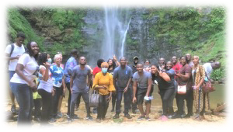

Integrating Sustainability into Local and Regional Tourism Ecosystems
The Case of Byron Bay (NZ)
Sustainable Streets program in Byron Bay

In each participating neighborhood, residents get together for sustainability workshops and build bonds in the neighborhood, whilst raising points to fund their own local sustainability project!

15 October 2023 page 11

Integrating Sustainability into Local and Regional Tourism Ecosystems
Ghana: Community based tourism initiative

A project that has created new tourism products based on sustainability principles at the local community level, transforming the country’s tourism offer and revealing challenges for government support structures

15 October 2023 page 12
11 12

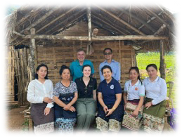
Integrating Sustainability into Local and Regional Tourism Ecosystems
Lao PDR – Collaboration Case
Inclusive and strategic basin planning in Lao PDR
the Government of Lao PDR is undertaking an ambitious program to develop river basin plans for all major basins in the country. River basin planning seeks to understand and manage the different needs and interests of the many water users in a basin. It seeks to reach agreement on basin governance arrangements and action plans to support economic and social
development, whilst enabling environmental sustainability.
15 October 2023 page 13

Innovation and Creativity as Catalysts for Sustainable Tourism

The Transformative Power of Innovation

The tourism sector is currently evolving from a mainly logistical industry towards a sector that is driven by technology and innovation. Many developing countries and emerging economies are currently leapfrogging ahead with highly innovative product
approaches that can contribute efficiently to Sustainable Development

15 October 2023 page 14
13 14

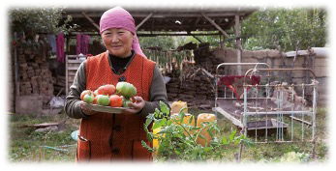

Innovation and Creativity as Catalysts for Sustainable Tourism

The Transformative Power of Innovation

In the quest for sustainable innovation, we’re seeking a new process, product or service, that adds value to a market and makes a positive impact on the environment and society.

15 October 2023 page 15

Innovation and Creativity as Catalysts for Sustainable Tourism

Creative Problem-Solving for Sustainability

Creating new source of income for Farmers in Kyrgyzstan

Promoting Sustainable Economic Development in Kyrgyzstan focused on promoting farms and their services . The development of agrotourism services was identified as a suitable solution for achieving the set objectives . Agrotourism combines rural tourism with agricultural offerings and addresses an environmentally aware group of individuals who enjoy nature .

15 October 2023 page 16
15 16



Discussion about Innovative and Creative Ideas for Mekong Region
17 18

