Training Program on Sustainable and Smart Tourism in the Mekong Region

October 2023

Sustainable and Smart Tourism

Training Package Design Statement
This document will be available to all participants of the training program.

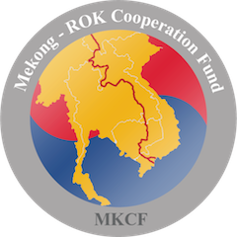

Funded by
MKCF Mekong – Korea Cooperation Fund

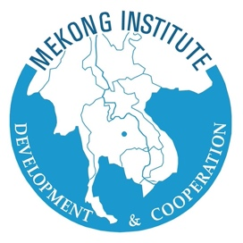

Organized by
Mekong Institute
2.1 Training Modules

2.1.2 Module 2: Introduction of Sustainable Tourism and the Need for a Regenerative approach.

Session 1 - Introducing Sustainable Tourism (1)
Introduction: Welcome to Topic 1 of Module 2, where we dive into the world of sustainable tourism. In this session, we'll provide an overview of sustainable tourism, its definitions, and its relevance in the modern tourism landscape.
Rationale: Understanding the foundations of sustainable tourism is crucial as it forms the basis for responsible tourism practices. This session aims to clarify the definitions and background of sustainable tourism, ensuring participants have a solid grasp of the subject.
Objectives: By the end of this session, participants will:
- Gain familiarity with the concept of sustainable tourism.
- Comprehend the historical and contextual background of sustainable tourism.
- Recognize the significance of sustainable tourism strategies and policies.

Session 2 - Introducing Sustainable Tourism (2)
Introduction: Welcome to Topic 2, where we continue our exploration of sustainable tourism. In this session, we will delve deeper into the sociocultural and environmental sustainability pillars, explore methods for integrating sustainability into local and regional tourism ecosystems, and discuss the role of innovation and creativity in advancing sustainable tourism.
Rationale: Sustainable tourism extends beyond preserving natural resources; it also encompasses sociocultural aspects. This session highlights the multifaceted nature of sustainability in tourism, emphasizing the need for holistic approaches.
Objectives: By the end of this session, participants will:
- Examine the sociocultural and environmental sustainability pillars.
- Explore strategies for integrating sustainability into local and regional tourism ecosystems.
- Recognize the catalyzing role of innovation and creativity in sustainable tourism development.

Session 3 - Regenerative Tourism (1)
Introduction: Welcome to Topic 3, where we introduce the concept of Regenerative Tourism. In this session, we will explore what distinguishes regenerative tourism from traditional sustainability efforts. We will delve into the concept of ecological restoration, preserving sociocultural values, and fostering thriving local communities.
Rationale: Regenerative tourism represents a paradigm shift from conventional sustainability by focusing on actively healing and restoring our environment and communities. This session underscores the imperative of regenerative tourism in addressing pressing global challenges.
Objectives: By the end of this session, participants will:
- Comprehend the meaning of regenerative tourism and its differentiation from sustainability.
- Appreciate the significance of ecological restoration in regenerative tourism.
- Understand the role of tourism in protecting sociocultural values and supporting local communities.

Session 4 - Regenerative Tourism (2)
Introduction: Welcome to Topic 4, where we continue our exploration of Regenerative Tourism. In this session, we will delve into inclusivity in the tourism industry, bridging social and economic gaps, promoting social well-being as a goal for tourism, and empowering local communities and SMEs through regenerative-focused training.
Rationale: Regenerative tourism is not just about conservation but also about creating opportunities for local communities and ensuring equitable participation in tourism. This session emphasizes the importance of inclusive and empowering tourism practices.
Objectives: By the end of this session, participants will:
- Understand the concept of inclusivity in the tourism industry.
- Recognize the role of tourism in bridging social and economic gaps.
- Appreciate the importance of social well-being as a goal for tourism.
- Explore strategies for empowering local communities and SMEs through regenerative-focused training.

